Concurrent Task Performance Enhances Procedural Skill Unlearning

Matthew J. Crossley¹, F. Gregory Ashby² & W. Todd Maddox³

¹ Department of Psychology, University of California, Berkeley

² Department of Psychological & Brain Sciences, University of California, Santa Barbara

³ Department of Psychology, University of Texas, Austin

March 13, 2014

Address: Matthew J. Crossley
Department of Psychology
University of California
Berkeley, CA 94720

Email: mjcrossley@berkeley.edu
Phone: (510) 642-0135
Fax: (510) 642-0135
Running Head: Cognitive Load Potentiates Unlearning

Abstract
Skill learning is often plagued by the development of bad habits that are difficult to correct. Moreover, the most problematic aspect of all current treatments for addiction and other maladaptive states is relapse. Thus, a variety of perspectives highlight the need for effective intervention protocols that can erase bad habits and replace them with stable good behaviors. Relapse is often estimated in laboratory settings as the amount of savings in relearning following an intervention protocol that causes some trained behavior to disappear. Savings is often inferred by observing that relearning occurs more quickly than original learning We recently reported the efficacy of various intervention protocols in unlearning procedural categorization (Crossley, Ashby & Maddox, 2013, J. of Experimental Psychology: General). This work demonstrated that an intervention protocol composed of random feedback effectively reduced accuracy during intervention, but did not eliminate savings in relearning (i.e., intervention failed to induce true unlearning). However, an intervention protocol composed of a mixture of random and veridical feedback did eliminate savings (i.e., caused true unlearning). This article shows that concurrently performing a demanding working memory task during an intervention phase consisting of random feedback reduces or fully eliminates savings in relearning. This suggests that the mechanism that protects learning during random feedback relies on prefrontal mechanisms.
Introduction
Huge amounts of time and money are spent every year on efforts to correct bad habits and eliminate dangerous or maladaptive behaviors. Yet almost all of these efforts must be classified as failures, either because they never show any efficacy, or because of high recidivism rates. Thus, discovering experimental protocols that could effectively cause the unlearning of skilled behaviors could be of enormous societal (and theoretical) importance. The present experiment describes a simple experimental intervention that appears to cause the successful unlearning of a skilled behavior.
One test of whether an unlearning protocol was successful is to measure savings in relearning. Such experiments, common in the instrumental conditioning literature, first train a targeted behavior (e.g., a lever press to a tone), and then expose participants to an intervention protocol that causes this behavior to disappear. Next, participants relearn the behavior under the original training conditions. If the behavior truly was unlearned, then the relearning should occur at exactly the same rate as the original acquisition. If the relearning occurs more quickly (i.e., rapid reacquisition), then savings are said to occur and it is assumed that the memory of the behavior survived the intervention protocol (at least partially). Savings in relearning is incredibly common across all forms of procedural skill learning, which reflects our anecdotal observation that bad habits are notoriously difficult to correct.
The present experiment examined savings in relearning in an information-integration (II) category-learning task. A basic category-learning task requires participants to learn a many-to-one mapping between stimuli and two or more responses. Stimuli are presented one per trial and category membership is learned through trial-and-error across many trials. II tasks are those in which stimuli are assigned to categories in such a way that it is difficult or impossible to infer via explicit logical reasoning. More technically, II tasks are those in which accuracy is maximized only if information from two or more non-commensurable stimulus dimensions is integrated at some pre-decisional stage (Ashby & Gott, 1988). The II task we used, along with illustrations of example trials, is shown in Figure 1. Note that each stimulus is a single black line that varies in length and orientation. The diagonal lines denote the category boundaries. Note that no simple verbal rule (e.g., short lines belong to category A, etc.) correctly separates the lines into the four categories. Nevertheless, many studies have shown that with enough practice, people reliably learn such categories, and the evidence is good that II category learning uses procedural memory and requires dopamine-dependent reinforcement learning in the striatum (e.g., Ashby & Maddox, 2005).
INSERT FIGURE 1 ABOUT HERE
The II task used here included acquisition (300 trials), intervention (400 trials), and reacquisition (150 trials) phases. These phases differed in the nature of the feedback provided after each response. During acquisition and reacquisition, feedback indicated whether each response was correct or incorrect. The feedback was random during the intervention phase – indicating a correct response with probability ¼ and an incorrect response with probability ¾, regardless of what response was actually made. Every stimulus in all three phases of Experiment 1 was a line (as in Figure 1) that varied across trials in length and orientation. Identical II category structures were used in all three phases. These are represented abstractly in Figure 1. Also note that the categories overlap slightly such that the best possible accuracy is 95%. In these ways, this task is identical to the task used in Experiment 1 of Crossley et al. (2013).
Crossley et al. (2013) found that an intervention protocol composed of purely random feedback did not eliminate savings. This implies that the brain possesses a mechanism through which it can detect when feedback has become random, and protect learning from being erased or overwritten during this time. The goal of the present experiment was to determine if this mechanism depends on prefrontal resources. Our approach was to attempt to interfere with the efficacy of this protective mechanism by reducing the neural resources available to it. Specifically, we introduced a concurrent numerical Stroop task (Algom, Dekel, & Pansky, 1996; Besner & Coltheart, 1979; Stroop, 1935) during a subset of acquisition and intervention categorization trials. Concurrent secondary tasks have long been thought to reduce resources available for a primary task (Pashler, 1994). In this case, the primary task is detecting the onset of random feedback and protecting learning. Moreover, the evidence is strong that variants of the Stroop task rely on prefrontal resources (Bench et al., 1993). Thus, if the mechanism that detects the change to random feedback depends on prefrontal resources, then concurrent numerical Stroop performance should impair the performance of this mechanism. If so, then random feedback should cause true unlearning. On the other hand, if the protective mechanism is independent of prefrontal resources then the presence or absence of the Stroop task should have no effect on savings. We included a concurrent Stroop component on trials 251-350 in condition 1, 251-450 in condition 2, 251-550 in condition 3 and 400-650 in condition 4.

Methods

Participants
There were 30 participants in Conditions 1 and 2, 28 participants in Condition 3, and 27 participants in Condition 4. All participants completed the study and received course credit for their participation. All participants had normal or corrected to normal vision. To ensure that our analyses included only participants who performed well above chance on the category-learning task - while sufficiently attending to the concurrent numerical Stroop – two exclusion criteria were applied. First, a learning criterion of 40% correct (25% is chance) during acquisition trials 200-250 was applied. Note that these trials correspond to the last 50 trials of initial learning in which no dual task was present across all four conditions. Second, any participant whose mean overall performance on the Stroop task was less than 85% correct was excluded. Using these criteria, we excluded 8 participants from Condition 1, 11 participants from Condition 2, 7 participants from Condition 3, and 9 participants from Condition 4. The experimental design for each condition is shown in Figure 2.
INSERT FIGURE 2 ABOUT HERE
Stimuli
Stimuli were black lines that varied across trials only in length (pixels) and orientation (degrees counterclockwise rotation from horizontal). The stimuli are illustrated graphically in Figure 1, and were identical to those used by Crossley et al. (2012).

Procedure
Participants in all conditions were told that they were to categorize lines on the basis of their length and orientation, that there were four equally-likely categories, and that high levels of accuracy could be achieved. The experiment included three phases: acquisition (300 trials), intervention (400 trials), and reacquisition (150 trials). During acquisition and reacquisition, feedback was based on the participant’s response, whereas feedback was random during the intervention. Participants were given no prior instructions about the phases, and the transition from one phase to another occurred without any warning to the participant.
At the start of each non-Stroop trial, a fixation point was displayed for 1 second and then the stimulus appeared. The stimulus remained on the screen until the participant generated a response by pressing the “Z” key for category A, the “W” key for category B, the “/” key for category C, or the “P” key for category D. Written instructions informed participants of the category label to button mappings. An “invalid key” message was displayed if any other button was pressed. The word “Correct” was presented for 1 second if the response was correct or the word “Wrong” was presented for 1 second if the response was incorrect (except during the intervention phase in which feedback was completely random).
Stroop trials began with a fixation point that was displayed for 1 second. The category stimulus and the Stroop stimuli (numbers flanking the category stimulus) were displayed simultaneously. After 200 ms the Stroop stimuli were replaced by white rectangles which remained on the screen until they made a category response. Responses emitted before the Stroop stimuli were replaced by white rectangles were not accepted. Feedback about the category response was given immediately in the same fashion as on non-Stroop trials. The word “value” or “size” then appeared on the screen prompting participants to indicate which side contained the numerically larger or the physically larger number. Participants pressed the ‘F’ key to choose the number on the left or the ‘J’ key to choose the number on the right. The word “Correct” was then again presented for 1 second if the response to the Stroop task was correct or the word “Wrong” was presented for 1 second if the response was incorrect. See Figure 1 for example trials both including and excluding the Stroop component. The Stroop task was included on trials 251-350 in condition 1, 251-450 in condition 2, 251-550 in condition 3 and 400-650 in condition 4.
Participants were instructed to try their hardest on both task components but to prioritize performance on the Stroop task. Both the category learning task and the Stroop task were explained to participants prior to beginning the experiment, and on screen messages warned them when the Stroop component would begin, and again when it would end. These messages read, “You will now perform both the categorization task and the paired numbers task simultaneously. Keep trying your hardest!” and “You have now finished the section with the paired numbers task. You will now be shown only the line categorization task. Keep trying your hardest.” 85% of Stroop trials the numerically larger number was physically smaller. The proportion of Stroop trials that prompted “size” or “value” was split 50/50. Accuracy on the numerical Stroop task was indicated at the top of the screen when they received feedback regarding their performance on the concurrent task on each trial. This score was displayed in green if it was above 80% and red if it was below 80%.

Results

Accuracy-based results

The top panel of Figure 3 displays the mean accuracy for each 25-trial block in all conditions. During intervention, a response was coded as correct if it agreed with the category membership shown in Figure 1. Recall that the categories and feedback were identical in all conditions throughout the entire experiment, with the exception of the concurrent Stroop task components. Note that participants from all conditions were able to learn the categories, and that accuracy dropped significantly during intervention.

Figure 4 shows the amount of savings in each condition, where savings is defined as mean accuracy during the 150 trials of reacquisition minus the mean accuracy during the first 150 trials of acquisition. Note that positive savings imply that reacquisition was faster than acquisition. Figure 4 shows that conditions 1 and 2 showed essentially no savings, condition 4 showed a marginal trend towards savings, and condition 3 showed negative savings (i.e., an interference).

INSERT FIGURES 3 AND 4 ABOUT HERE

All effects in a 4 condition (1, 2, 3, 4) × 3 phase (Acquisition, Intervention, Reacquisition) repeated measures ANOVA were significant [Condition: F(3, 69) = 6.56, p < 0.001; Phase: F(2, 2596) = 120.05, p < 0.001; Interaction: F(6, 2596) = 4.93, p < 0.001]. The key result was that conditions 1 and 2 showed no evidence of any savings [1: t(2586) = 0.11, p = 0.91; 2: t(2586) = 0.74, p = 0.46], condition 4 showed evidence of modest savings [t(2586) = 1.82, p = 0.07], and condition 3 showed a significant impairment. [t(2586) = -2.35, p < 0.05]. Any between-condition comparisons of savings is complicated by the results of several pairwise comparisons that show significant differences between the groups during acquisition and intervention (See Table 1 for details). In particular, i) during both acquisition and intervention, accuracy in condition 3 was higher than in condition 1 or 2, ii) during intervention, accuracy in condition 4 was higher than in condition 1, and iii) during reacquisition, accuracy in conditions 3 and 4 was higher than in conditions 1 and 2. Even so, note that none of these results have any effect on our within-condition estimate of savings.

INSERT TABLES 1 ABOUT HERE

Decision Bound Modeling
Optimal performance on the category structures used here can only be obtained via a procedural strategy. Even so, explicit strategies can yield better-than-chance performance, and some explicit strategies can even generate accuracy levels similar to those observed in our experiment. Since our goal is to examine savings in procedural learning, we must carefully rule out the contribution to savings from explicit strategies. Toward this end, we partitioned the data from each participant into blocks of 100 trials and fit different types of decision bound models to each block of data from every participant (e.g., Maddox & Ashby, 1993; Ashby, Waldron, Lee, & Berkman, 2001). One type of model assumed an explicit, rule-based decision strategy, one type assumed a procedural strategy, and one type assumed random guessing. The parameters were estimated using the method of maximum likelihood and the Bayesian Information Criterion (BIC) was used for model comparison. See Appendix 1 of Crossley et al. (2012) for more details.
Table 2 shows the number of participants in the four conditions best fit by a model of these three types. Note that the percentage of participants using a procedural strategy during the last block of acquisition ranges across conditions from 64% (condition 1) to 72% (condition 4), and that this proportion drops in every condition. The largest drop occurs in condition 4 (a drop of 33%) and the smallest drop occurs in condition 1 (a drop of 14%). In conditions 1, 2, and 3 this drop in procedural-strategy users is driven almost entirely by an increase in the number of guessers, but in condition 4 the drop is driven by an increase in the number explicit rule users. This suggests that although condition 4 showed the best evidence for savings (though only marginally significant), this most likely reflects a shift to suboptimal rule-based responding and does not reflect a true recovery of the response strategy used during acquisition.

INSERT TABLE 2 ABOUT HERE
Discussion
We previously reported savings in procedural categorization after an intervention phase in which the feedback suddenly, and without any warning to the participants, became completely random (Crossley et al., 2013). If learning had continued in the presence of the random feedback, then the random stimulus-category label associations that were rewarded should have overwritten the memory traces of the categorization responses learned during acquisition. For this reason, the significant savings observed by Crossley et al. (2013) strongly suggests that the categorization memory traces were preserved during the random feedback intervention. The present experiment tested whether the mechanism that detected the change to random feedback depended on executive function.
Our results strongly support this hypothesis. Three of our four conditions showed no evidence of any savings during relearning, and the modest savings that were seen in condition 4 were much less than the savings reported by Crossley et al. (2013). Thus, our results are consistent with the following interpretation. The dual-task, which requires working memory and executive attention, interfered with the ability of participants to detect that the feedback had suddenly become random. In the absence of such detection, learning continued during the random feedback intervention. The random feedback however, reinforced random stimulus-category associations, and these random associations over-wrote the category learning that occurred during acquisition. As a result, adding a dual task to a random feedback intervention appears to cause true category unlearning. Note that this hypothesis correctly predicts that the poorest unlearning should occur in condition 4, because this is the only dual-task condition in which the dual task did not overlap with the transition to random feedback.
Crossley et al. (2013) proposed a model that assumed that procedural category learning is instantiated via plasticity at cortical-striatal synapses and that this plasticity is gated by striatal cholinergic interneurons (called TANs for tonically active neurons). This model assumes that the TANs act as a gate on procedural learning, and that during periods of random feedback they prevent the modification and expression of procedural skills. The model successfully accounts for a broad array of savings-based phenomena, while simultaneously respecting a range of neurobiological constraints including single-cell recordings from striatal projection neurons and TANs. This model did not, however, specify a neurobiological mechanism through which the TANs could become sensitive to the presence of random feedback. This article was aimed at testing the hypothesis that this mechanism depends on prefrontal resources, and our results are indeed consistent with this idea.

References – Needs updating
Algom, D., Dekel, A., & Pansky, A. (1996). The perception of number from the separability of the stimulus: The Stroop effect revisited. Memory & Cognition, 24(5), 557-572.
Bench, C., Frith, C. D., Grasby, P. M., Friston, K. J., Paulesu, E., Frackowiak, R. S. J., & Dolan, R. J. (1993). Investigations of the functional anatomy of attention using the Stroop test. Neuropsychologia, 31(9), 907-922.
Ashby, F. G., Alfonso-Reese, L. A., Turken, A. U., & Waldron, E. M. (1998). A neuropsychological theory of multiple systems in category learning. Psychological Review, 105, 442-481.
Ashby, F. G., & Crossley, M. J. (2011). A computational model of how cholinergic interneurons protect striatal-dependent learning. Journal of Cognitive Neuroscience, 23, 1549-1566.
Ashby, F., Ell, S., & Waldron, E. (2003). Procedural learning in perceptual categorization. Memory & Cognition, 31, 1114–1125.
Ashby, F. G., & Gott, R. E. (1988). Decision rules in the perception and categorization of multidimensional stimuli. Journal of Experimental Psychology: Learning, Memory and cognition, 14, 33-53.
Ashby, F. G., & Maddox, W. T. (2005). Human category learning. Annual Review of Psychology, 56, 149-178.
Ashby, F. G., & Waldron, E. M. (1999). On the nature of implicit categorization. Psychonomic Bulletin & Review, 6, 363-378.
Ashby, F. G., Waldron, E. M., Lee, W. W., & Berkman, A. (2001). Suboptimality in human categorization and identification. Journal of Experimental Psychology: General, 130, 77-96.
Bienenstock, E.L., Cooper, L.N., & Munro, P.W. (1982). Theory for the development of neuron selectivity: Orientation specificity and binocular interaction in visual cortex. Journal of Neuroscience, 2, 32–48.
Bouton, M. E., Todd, T. P., Vurbic, D., & Winterbauer, N. E. (2011). Renewal after the extinction of free operant behavior. Learning & behavior, 39(1), 57-67.
Crossley, M. J., Ashby, F. G., & Maddox, W. T. (2012). Erasing the engram: The unlearning of procedural skills. Journal of Experimental Psychology: General.
Ermentrout, B. (1996). Type i membranes, phase resetting curves, and synchrony. Neural Computation, 8, 979–1001.
Gershman, S., Blei, D., & Niv, Y. (2010). Context, learning, and extinction. Psychological Review, 117, 197-209.
Higgins, S. T., Budney, A. J., & Bickel, W. K. (1995). Outpatient behavioral treatment for cocaine dependence: One-year outcome. Experimental and Clinical Psychopharmacology, 3, 205-212.
Izhikevich, E. (2007). Dynamical systems in neuroscience: The geometry of excitability and bursting. Cambridge, MA: The MIT press.
Kirkwood, A., Rioult, M.G. & Bear, M.F. (1996). Experience-dependent modification of synaptic plasticity in visual cortex. Nature, 381, 526-528.
Kruschke, J. K. (2011). Models of attentional learning. In E. M. Pothos and A. J. Wills (eds.), Formal Approaches in Categorization, pp. 120-152. Cambridge University Press.
Lewandowsky, S., & Kirsner, K. (2000). Expert knowledge is not always integrated: A case of cognitive partition. Memory & Cognition, 28, 295–305.
Maddox, W. T., & Ashby, F. G. (1993). Comparing decision bound and exemplar models of categorization. Perception & Psychophysics, 53, 49-70.
Maddox, W., Ashby, F., Ing, A., & Pickering, A. (2004). Disrupting feedback processing interferes with rule-based but not information-integration category learning. Memory & Cognition, 32, 582–591.
Maddox, W., Bohil, C., & Ing, A. (2004). Evidence for a procedural-learning based system in perceptual category learning. Psychonomic Bulletin & Review, 11, 945–952.
Matsumoto, N., Minamimoto, T., Graybiel, A., & Kimura, M. (2001). Neurons in the thalamic cm-pf complex supply striatal neurons with information about behaviorally signiﬁcant sensory events. Journal of Neurophysiology, 85, 960-976.
Nakajima, S., Tanaka, S., Urshihara, K., & Imada, H. (2000). Renewal of extinguished lever-press responses upon return to the training context. Learning & Motivation, 31, 416–431.
Nakajima, S., Urushihara, K., & Masaki, T. (2002). Renewal of operant performance formerly eliminated by omission or noncontingency training upon return to the acquisition context. Learning and Motivation, 33, 510–525.
Rall, W. (1967). Distinguishing theoretical synaptic potentials computed for different soma-dendritic distributions of synaptic input. Journal of Neurophysiology, 30(5), 1138-1168.
Redish, A. D., Jensen, S., Johnson, A., & Kurth-Nelson, Z. (2007). Reconciling reinforcement learning models with behavioral extinction and renewal: Implications for addition, relapse, and problem gambling. Psychological Review, 114, 784-805.
Sanborn, A.N., Griffiths, T.L., & Navarro, D.J. (2010). Rational approximations to rational models: Alternative algorithms for category learning. Psychological Review, 117, 1144-1167.
Schultz, W., Dayan, P., & Montague, P. (1997). A neural substrate of prediction and reward. Science, 275, 1593-1599.
Tobler, P., Dickinson, A., & Schultz, W. (2003). Coding of predicted reward omission by dopamine neurons in a conditioned inhibition paradigm. The Journal of Neuroscience, 23, 10402-10410.
Waldschmidt, J., & Ashby, F. G. (2011). Cortical and striatal contributions to automaticity in information-integration categorization. Neuroimage, 56, 1791-1802.
Yang, L.-X., & Lewandowsky, S. (2004). Knowledge partitioning in categorization: Constraints on exemplar models. Journal of Experimental Psychology: Learning, Memory, & Cognition, 30, 1045-1064.
Author Notes
We especially thank Micajah Spoden for help with programming and members of the Maddox Lab for all data collection. This research was supported in part by the U.S. Army Research Office through the Institute for Collaborative Biotechnologies under grant W911NF-09-D-0001, by grants P01NS044393 from the National Institute of Neurological Disorders and Stroke and DA032457 from the National Institute of Drug Abuse, and by grant FA9550-12-1-0355 from AFOSR.

Figure and Table Legends
Table 1. Post-hoc pairwise comparisons. Shaded cells indicate significant differences.
Table 2. Number of participants in the four conditions whose responses were best accounted for by a model that assumed a procedural decision strategy, a rule-based strategy, or random guessing, and the percentage of responses accounted for by those models.
Figure 1. Top Left: Sequence of events on an example trial without the Stroop component. Top Right: Sequence of events on an example trial including the Stroop component. Bottom Left: A few examples of stimuli that might be used in an information-integration (II) category-learning experiment. Right: The category distributions used here.
Figure 2. Experiment design. See text for further details.
Figure 3. Experiment 1 accuracy. Each block includes 25 trials, and bands represent SEM. Top Panel: Accuracy in every condition throughout the entire experiment. Bottom Panel: Simulated results obtained from the model shown in Figure 5. Blocks 1-12 were in the acquisition phase, blocks 13-28 were in the intervention phase, and blocks 29-34 were in the reacquisition phase.
Figure 4. Savings in each condition defined as the mean accuracy during the 150 trials of reacquisition minus the mean accuracy during the first 150 trials of acquisition. Error bars represent 95% confidence intervals on the mean accuracy per condition.

Table 1. Post-hoc pairwise comparisons. Shaded cells indicate significant differences.

 | Acquisition Phase | Intervention Phase | Reacquisition Phase
1 – 2 | t(77) = 0.71, p = 0.48 | t(70) = -1.31, p = 0.19 | t(104) = -0.19, p = 0.85
1 – 3 | t(74) = -2.95, p < 0.01 | t(68) = -4.36, p < 0.001 | t(100) = -2.11, p < 0.05
1 – 4 | t(62) = -0.86, p = 0.40 | t(58) = -2.98, p < 0.01 | t(82) = -2.17, p < 0.05
2 – 3 | t(269) = -4.39, p < 0.001 | t(238) = -3.66, p < 0.001 | t(409) = -2.21, p < 0.05
2 – 4 | t(75) = -1.54, p = 0.13 | t(69) = -1.80, p = 0.08 | t(101) = -2.02, p < 0.05
3 – 4 | t(73) = 1.90, p = 0.06 | t(67) = 1.03, p = 0.31 | t(98) = -0.24, p = 0.81

Table 4. Number of participants in the four conditions whose responses were best accounted for by a model that assumed a procedural decision strategy, a rule-based strategy, or random guessing, and the percentage of responses accounted for by those models.
 | Condition 1 |  |  |  | Condition 2
 | A3 |  | R1 |  | A3 |  | R1
 | N | % | N | % | N | % | N | %
Procedural | 14 | 68.0 | 11 | 53.4 | 13 | 70.3 | 8 | 65.1
Rule-Based | 8 | 62.0 | 5 | 46.4 | 6 | 75.3 | 6 | 61.3
Guessing | 0 | NA | 6 | NA | 0 | NA | 5 | NA

 | Condition 3 |  |  |  | Condition 4
 | A3 |  | R1 |  | A3 |  | R1
 | N | % | N | % | N | % | N | %
Procedural | 15 | 68.0 | 10 | 58.2 | 13 | 71.2 | 7 | 60.3
Rule-Based | 6 | 65.8 | 6 | 56.3 | 5 | 62.0 | 10 | 57.2
Guessing | 0 | NA | 5 | NA | 0 | NA | 1 | NA

Note. A3 = the last 100 trials of acquisition, R1 = the first 100 trials of reacquisition, N = the number of participants contained in a given cell, and % = the percentage of responses accounted for by a particular model.

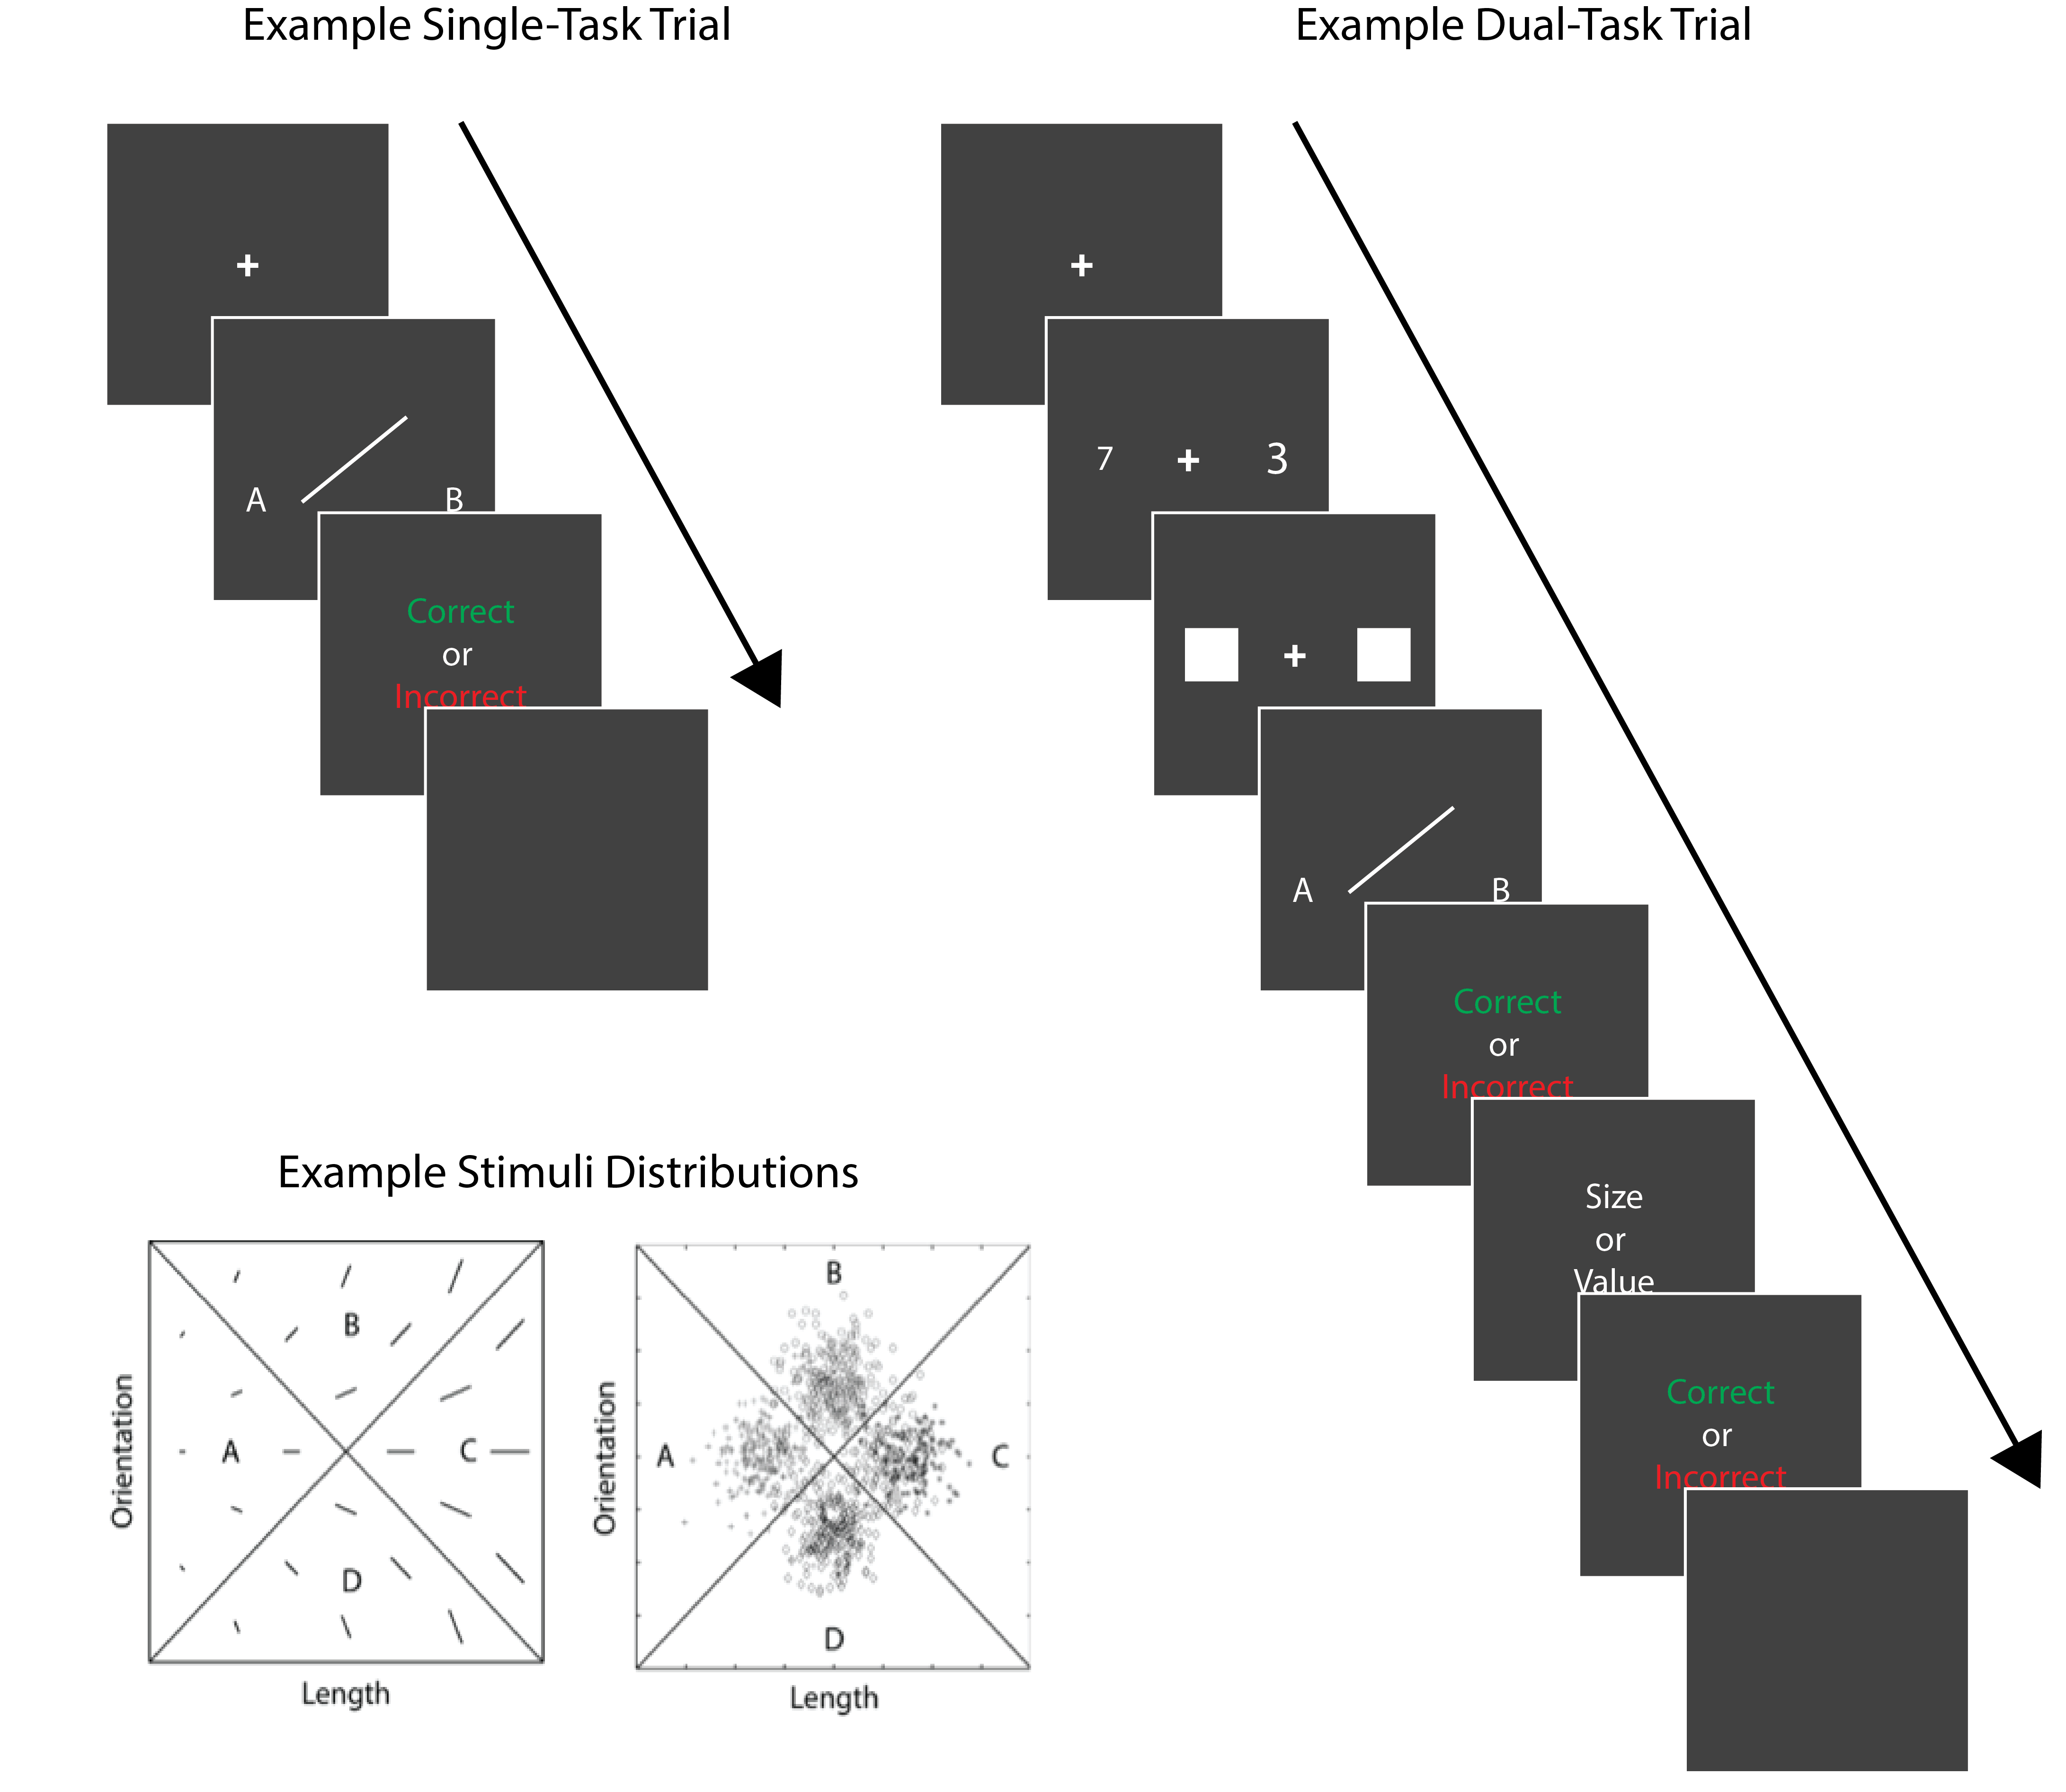
Figure 1. Top Left: Sequence of events on an example trial without the Stroop component. Top Right: Sequence of events on an example trial including the Stroop component. Bottom Left: A few examples of stimuli that might be used in an information-integration (II) category-learning experiment. Right: The category distributions used here.

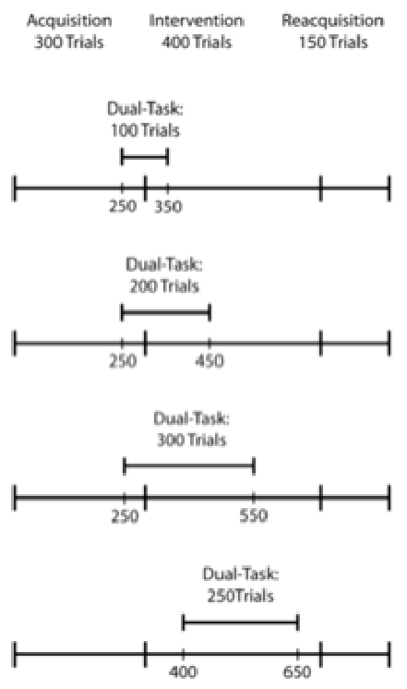

Figure 2. Experimental design. See text for further details.

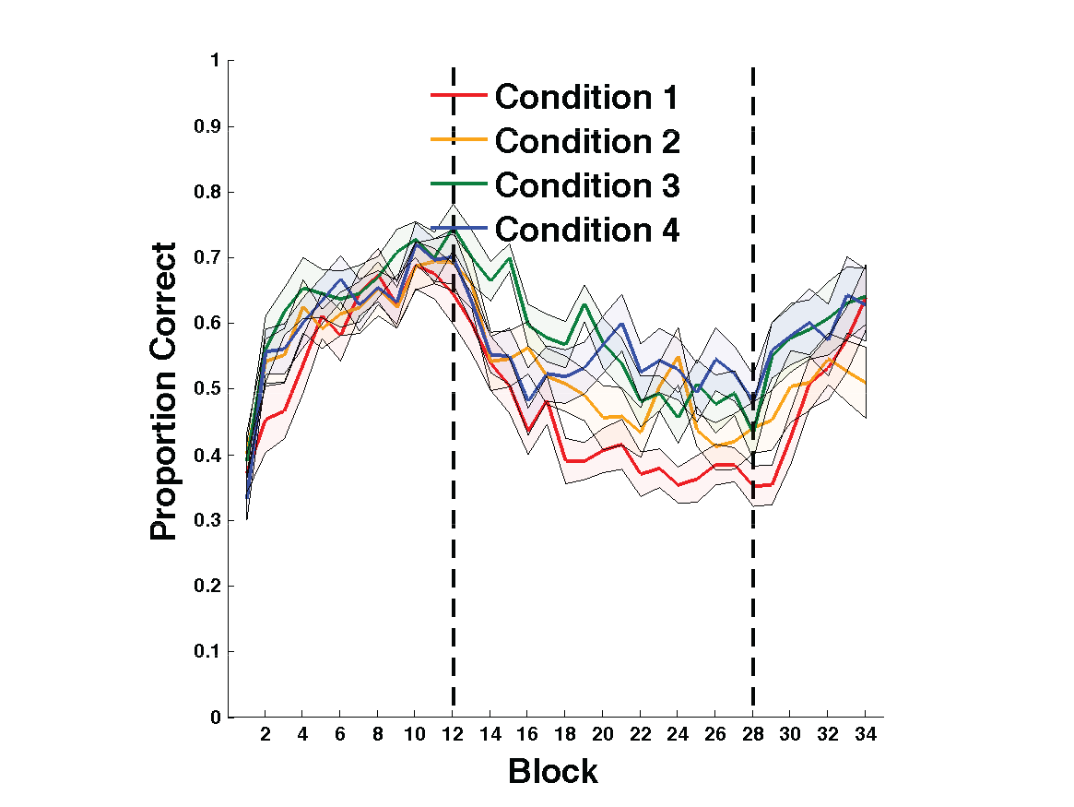
Figure 3. Experiment 1 accuracy. Each block includes 25 trials, and bands represent SEM. Accuracy in every condition throughout the entire experiment. Blocks 1-12 were in the acquisition phase, blocks 13-28 were in the intervention phase, and blocks 29-34 were in the reacquisition phase.

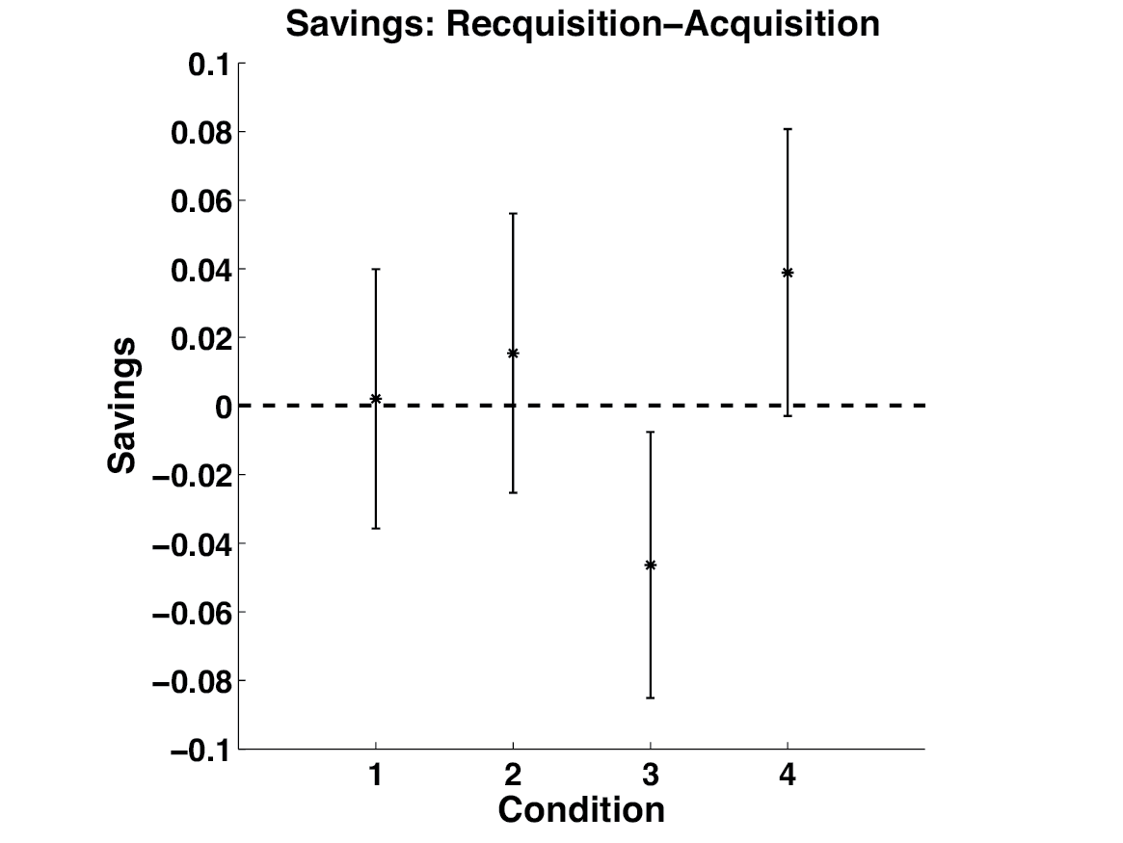
Figure 4. Savings in each condition defined as the mean accuracy during the 150 trials of reacquisition minus the mean accuracy during the first 150 trials of acquisition. Error bars represent 95% confidence intervals on the mean accuracy per condition.

