**A Concurrent Numerical Stroop Task Increases the Vulnerability of Procedural Skills to Unlearning**

Matthew J. Crossley1, F. Gregory Ashby2 & W. Todd Maddox3

1 Department of Psychology, University of California, Berkeley

2 Department of Psychological & Brain Sciences, University of California, Santa Barbara

3 Department of Psychology, University of Texas, Austin

February 10, 2014

Address: Matthew J. Crossley

Department of Psychology

University of California

Berkeley, CA 94720

Email: [mjcrossley@berkeley.edu](mailto:ashby@psych.ucsb.edu)

Phone: (510) 642-0135

Fax: (510) 642-0135

Running Head: Cognitive Load Potentiates Unlearning

**Abstract**

We recently reported the efficacy of various intervention protocols in unlearning procedural categorization (Crossley, Ashby & Maddox, 2012, J. of Experimental Psychology: General). This work demonstrated that an intervention protocol composed of random feedback effectively reduced accuracy during the intervention, but lead to massive savings in relearning (i.e., failed to induce true unlearning). However, an intervention protocol composed of a mixture of random and veridical feedback eliminated savings in relearning (i.e., caused true unlearning). This article shows that performing a concurrent numerical Stroop task during an intervention of random feedback reduces or else fully eliminates savings in relearning. This suggests that the mechanism that protects learning during random feedback relies on prefrontal mechanisms.

**Introduction**

The propensity for relapse is often estimated experimentally by measuring savings in relearning following an intervention protocol that causes some trained behavior to disappear (e.g., a lever press in simple instrumental conditioning paradigms). Savings of the original learning is often inferred by observing that relearning occurs more quickly than original learning (e.g., rapid reacquisition). Savings in procedural skill learning is by far the norm, and discovering tools that can eliminate savings (generate unlearning) are of the utmost importance to the development of effective treatments.

The present experiment examined savings in relearning in an information-integration (II) category-learning task. II categorization tasks are those in which the stimuli are assigned to categories in such a way that accuracy is maximized only if information from two or more non-commensurable stimulus dimensions is integrated at some pre-decisional stage (Ashby & Gott, 1988). Typically, the optimal strategy in II tasks is difficult or impossible to describe verbally (which makes it difficult to discover via logical reasoning). An example of an II task is shown in Figure 1. In this case the four categories are each composed of single black lines that vary in length and orientation. The diagonal lines denote the category boundaries. Note that no simple verbal rule correctly separates the lines into the four categories. Nevertheless, many studies have shown that with enough practice, people reliably learn such categories, and the evidence is good that II category learning uses procedural memory and requires dopamine-dependent reinforcement learning in the striatum (e.g., Ashby & Maddox, 2005).

The II task used here included an acquisition (300 trials), intervention (400 trials), and a reacquisition (150 trials) phase. These phases differed in the nature of the feedback provided after each response. During acquisition and reacquisition, feedback indicated whether each response was correct or incorrect. The feedback was random during the intervention phase – indicating a correct response with probability ¼ and an incorrect response with probability ¾, regardless of what response they actually made. Every stimulus in all three phases of Experiment 1 was a line (as in Figure 1) that varied across trials in length and orientation. Identical II category structures were used in all three phases. These are represented abstractly in Figure 1. Also note that the categories overlap slightly such that the best possible accuracy is 95%. In these ways, this task is identical to the task used in Experiment 1 of Crossley et al. (2012).

The present experiment diverges from Crossley et al. (2012) in that some trials included a concurrent numerical Stroop task. The idea here was that if the mechanism that protects procedural learning during random feedback is dependent on prefrontal mechanisms, than a concurrent Stroop task should share it’s resources and therefore interfere with it’s ability to protect learning. On the other hand, if the protective mechanism is independent of prefrontal resources than we will observe massive savings independent of the presence or absence of the Stroop task. We included a concurrent Stroop component on trials 251-350 in condition 1, 251-450 in condition 2, 251-550 in condition 3 and 400-650 in condition 4.

INSERT FIGURE 1 ABOUT HERE

**Methods**

*Participants*

There were 30 participants in Conditions 1 and 2, 28 participants in Condition 3, and 27 participants in Condition 4. All participants completed the study and received course credit for their participation. All participants had normal or corrected to normal vision. To ensure that our analyses included only participants who performed well above chance on the category learning task - while sufficiently attending to the concurrent numerical Stroop – two exclusion criteria were applied. First, a learning criterion of 40% correct (25% is chance) during acquisition trials 200-250 was applied. Note that these trials correspond to the last 50 trials of initial learning in which no dual task was present across all four conditions. We additionally excluded any subject whose mean overall performance on the Stroop task was less than 85% correct. Using these criteria, we excluded 8 participants from Condition 1, 11 participants from Condition 2, 7 participants from Condition 3, and 9 participants from Condition 4. The experimental design for each condition is shown in Figure 2.

INSERT FIGURE 2 ABOUT HERE

*Stimuli*

Stimuli were black lines that varied across trials only in length (pixels) and orientation (degrees counterclockwise rotation from horizontal). The stimuli are illustrated graphically in Figure 2, and were identical to those used by Crossley et al. (2012).

*Procedure*

Participants in all conditions were told that they were to categorize lines on the basis of their length and orientation, that there were four equally-likely categories, and that high levels of accuracy could be achieved. At the start of each non-Stroop trial, a fixation point was displayed for 1 second and then the stimulus appeared. The stimulus remained on the screen until the participant generated a response by pressing the “Z” key for category A, the “W” key for category B, the “/” key for category C, or the “P” key for category D. Written instructions informed participants of the category label to button mappings. An “invalid key” message was displayed if any other button was pressed. The word “Correct” was presented for 1 second if the response was correct or the word “Wrong” was presented for 1 second if the response was incorrect (except during the intervention phase in which feedback was completely random).

Stroop trials began with a fixation point that was displayed for 1 second. The category stimulus and the Stroop stimuli (numbers flanking the category stimulus) were displayed simultaneously. After 200 ms the Stroop stimuli were replaced by white rectangles for another 200 ms. After this interval, the rectangles disappeared and the participants were required to make a category response. Feedback about the category response was given immediately in the same fashion as on non-Stroop trials. The word “value” or “size” then appeared on the screen prompting participants to indicate which side contained the numerically larger or the physically larger number. Participants pressed the ‘F’ key to choose the number on the left or the ‘J’ key to choose the number on the right. The word “Correct” was then again presented for 1 second if the response to the Stroop task was correct or the word “Wrong” was presented for 1 second if the response was incorrect.

Participants were instructed to try their hardest on both task components but to prioritize performance on the Stroop task. Both the category learning task and the Stroop task were explained to participants prior to beginning the experiment, and on screen messages warned them when the Stroop component would begin, and again when it would end. These messages read, “You will now perform both the categorization task and the paired numbers task simultaneously. Keep trying your hardest!” and “You have now finished the section with the paired numbers task. You will now be shown only the line categorization task. Keep trying your hardest.” 85% of Stroop trials the numerically larger number was physically smaller. The proportion of Stroop trials that prompted “size” or “value” was split 50/50. Accuracy on the numerical Stroop task was indicated at the top of the screen when they received feedback regarding their performance on the concurrent task on each trial. This score was displayed in green if it was above 80% and red if it was below 80%.

* Did the white rectangles masking Stroop stimuli remain on the screen until a category response was made or did they disappear after 200 ms?
* What happened if they pushed a button before 200 ms or during the 400 ms total Stroop interval?
* Were there any response time deadlines?

**Results**

*Accuracy-based results*

The top panel of Figure 3 shows the mean accuracy for every 25-trial block of each condition. During intervention, a response was coded as correct if it agreed with the category membership shown in Figure 1. Recall that the categories and feedback were identical in all conditions throughout the entire experiment, with the exception of the concurrent Stroop task components. Note that participants from all conditions were able to learn the categories, and that accuracy dropped significantly during intervention. Figure 4 shows that conditions 1, 2 and 4 trended towards savings, but failed to reach significance, and condition 3 showed an interference. A qualitative description of the statistics we used follows in the next paragraph and numerical details can be found in Tables 1 through 3.

INSERT FIGURE 3 ABOUT HERE

To test these conclusions formally we first performed a 4 conditions (1, 2, 3, 4) × 3 phase (Acquisition, Intervention, Reacquisition) repeated measures ANOVA. All effects in the ANOVA (Condition, Phase, and Interaction) were significant. We then computed several within-phase, between-condition differences of estimated least squares means. These tests indicated that accuracy in condition 3 was higher than it was in condition 1 or 2, but no different from performance in condition 4. During intervention, accuracy in condition 3 was higher than it was in conditions 1 or 2, but not condition 4. Accuracy in condition 4 was higher than condition 1 during intervention. During reacquisition, accuracy in conditions 3 and 4 were higher than in conditions 1 and 2. Conditions 3 and 4 were not different from each other. We estimated savings in each condition by computing the within-condition, between-phase differences of estimated least squares means (first 150 trials of acquisition - reacquisition). These tests showed that conditions 1, 2, and 4 trended towards savings but failed to reach significance, and condition 3 showed a significant impairment.

INSERT FIGURE 4 ABOUT HERE

INSERT TABLES 1 THROUGH 3 ABOUT HERE

*Decision Bound Modeling*

Optimal performance on the category structures used here can only be obtained via a procedural strategy. However, explicit strategies can nevertheless yield better-than-chance performance (e.g., the accuracies observed here). Since our goal is to examine savings in procedural learning, we must carefully rule out the contribution to savings from explicit strategies. To this end, we partitioned the data from each participant into blocks of 100 trials and fit different types of decision bound models (e.g., Maddox & Ashby, 1993; Ashby, Waldron, Lee, & Berkman, 2001) to each block of data from every participant. One type assumed a rule-based decision strategy, one type assumed an II (i.e., procedural) strategy, and one type assumed random guessing. See Appendix 1 of Crossley et al. (2012) for more details.

Table 2 shows the number of participants in the four conditions best fit by a model of these three types. Note that there is a similar proportion of II users during the last block of acquisition in every condition (about 69%) and that this number is reduced by a similar amount in every condition (about 45%). In conditions 1, 2, and 3 this drop in II users is driven almost entirely by an increase in the number of guessers, but that in condition 4 this drop is driven by an increase in the number RB users. This suggests that while condition 4 showed the best evidence for savings (though it failed to reach significance), this most likely reflects a shift to suboptimal RB responding and does not reflect a true recovery of the response strategy used during acquisition.

INSERT TABLE 2 ABOUT HERE

**Discussion**

We previously reported savings in procedural categorization after an intervention of random feedback (crossley et al. 2013). The current results show that a concurrent numerical Stroop task can significantly reduce or else eliminate savings in this paradigm. The trend towards savings in condition 4 suggests that it is critical for the Stroop task to be introduced prior to the transition from the acquisition phase to the intervention phase. The significant interference in condition 3, but not in conditions 1 or 2, suggests that the longer the Stroop task remains present during the intervention, the less savings will be observed.

Crossley et al. (2013) proposed a model that assumed that procedural category learning is instantiated via plasticity at cortical-striatal synapses and that this plasticity is gated by striatal cholinergic interneurons (called TANs for tonically active neurons). They assumed that the TANs act as a gate on procedural learning, and that during periods of random feedback they learn to prevent the modification and expression of procedural skills. This model successfully accounted for a broad array of savings-based phenomena, while simultaneously respecting a range of neurobiological constraints including single-cell recordings from striatal projection neurons and TANs. This model did not, however, specific a neurobiological mechanism through which the TANs could become sensitive to the presence of random feedback. This article was aimed at testing the hypothesis that mechanism depends on prefrontal resources, and our results are indeed consistent with this idea.

**References – Needs updating**

Ashby, F. G., Alfonso-Reese, L. A., Turken, A. U., & Waldron, E. M. (1998). A neuropsychological theory of multiple systems in category learning. *Psychological Review, 105*, 442-481.

Ashby, F. G., & Crossley, M. J. (2011). A computational model of how cholinergic interneurons protect striatal-dependent learning. *Journal of Cognitive Neuroscience, 23*, 1549-1566.

Ashby, F., Ell, S., & Waldron, E. (2003). Procedural learning in perceptual categorization. *Memory & Cognition*, *31*, 1114–1125.

Ashby, F. G., & Gott, R. E. (1988). Decision rules in the perception and categorization of multidimensional stimuli. *Journal of Experimental Psychology: Learning, Memory and cognition, 14*, 33-53.

Ashby, F. G., & Maddox, W. T. (2005). Human category learning. *Annual Review of Psychology, 56,* 149-178*.*

Ashby, F. G., & Waldron, E. M. (1999). On the nature of implicit categorization. *Psychonomic Bulletin & Review*, *6*, 363-378.

Ashby, F. G., Waldron, E. M., Lee, W. W., & Berkman, A. (2001). Suboptimality in human categorization and identification. *Journal of Experimental Psychology:* *General*, *130*, 77-96.

Bienenstock, E.L., Cooper, L.N., & Munro, P.W. (1982). Theory for the development of neuron selectivity: Orientation specificity and binocular interaction in visual cortex. *Journal of Neuroscience*, 2, 32–48.

Bouton, M. E., Todd, T. P., Vurbic, D., & Winterbauer, N. E. (2011). Renewal after the extinction of free operant behavior*. Learning & behavior*, 39(1), 57-67.

Crossley, M. J., Ashby, F. G., & Maddox, W. T. (2012). Erasing the engram: The unlearning of procedural skills. *Journal of Experimental Psychology: General.*

Ermentrout, B. (1996). Type i membranes, phase resetting curves, and synchrony. *Neural Computation*, *8*, 979–1001.

Gershman, S., Blei, D., & Niv, Y. (2010). Context, learning, and extinction. *Psychological Review*, *117*, 197-209.

Higgins, S. T., Budney, A. J., & Bickel, W. K. (1995). Outpatient behavioral treatment for cocaine dependence: One-year outcome. *Experimental and Clinical Psychopharmacology, 3*, 205-212.

Izhikevich, E. (2007). *Dynamical systems in neuroscience: The geometry of excitability and bursting*. Cambridge, MA: The MIT press.

Kirkwood, A., Rioult, M.G. & Bear, M.F. (1996). Experience-dependent modification of synaptic plasticity in visual cortex. *Nature*, 381, 526-528.

Kruschke, J. K. (2011). Models of attentional learning. In E. M. Pothos and A. J. Wills (eds.), *Formal Approaches in Categorization*, pp. 120-152. Cambridge University Press.

Lewandowsky, S., & Kirsner, K. (2000). Expert knowledge is not always integrated: A case of cognitive partition. *Memory & Cognition, 28,* 295–305.

Maddox, W. T., & Ashby, F. G. (1993). Comparing decision bound and exemplar models of categorization. *Perception & Psychophysics*, *53*, 49-70.

Maddox, W., Ashby, F., Ing, A., & Pickering, A. (2004). Disrupting feedback processing interferes with rule-based but not information-integration category learning. *Memory & Cognition*, *32*, 582–591.

Maddox, W., Bohil, C., & Ing, A. (2004). Evidence for a procedural-learning based system in perceptual category learning. *Psychonomic Bulletin & Review*, *11*, 945–952.

Matsumoto, N., Minamimoto, T., Graybiel, A., & Kimura, M. (2001). Neurons in the thalamic cm-pf complex supply striatal neurons with information about behaviorally signiﬁcant sensory events. *Journal of Neurophysiology*, *85*, 960-976.

Nakajima, S., Tanaka, S., Urshihara, K., & Imada, H. (2000). Renewal of extinguished lever-press responses upon return to the training context. *Learning & Motivation, 31*, 416–431.

Nakajima, S., Urushihara, K., & Masaki, T. (2002). Renewal of operant performance formerly eliminated by omission or noncontingency training upon return to the acquisition context. *Learning and Motivation*, *33*, 510–525.

Rall, W. (1967). Distinguishing theoretical synaptic potentials computed for different soma-dendritic distributions of synaptic input*. Journal of Neurophysiology, 30*(5), 1138-1168.

Redish, A. D., Jensen, S., Johnson, A., & Kurth-Nelson, Z. (2007). Reconciling reinforcement learning models with behavioral extinction and renewal: Implications for addition, relapse, and problem gambling. *Psychological Review*, *114*, 784-805.

Sanborn, A.N., Griffiths, T.L., & Navarro, D.J. (2010). Rational approximations to rational models: Alternative algorithms for category learning. Psychological Review, 117, 1144-1167.

Schultz, W., Dayan, P., & Montague, P. (1997). A neural substrate of prediction and reward. *Science*, *275*, 1593-1599.

Tobler, P., Dickinson, A., & Schultz, W. (2003). Coding of predicted reward omission by dopamine neurons in a conditioned inhibition paradigm. *The Journal of Neuroscience*, *23*, 10402-10410.

Waldschmidt, J., & Ashby, F. G. (2011). Cortical and striatal contributions to automaticity in information-integration categorization. *Neuroimage*, *56,* 1791-1802.

Yang, L.-X., & Lewandowsky, S. (2004). Knowledge partitioning in categorization: Constraints on exemplar models. *Journal of Experimental Psychology: Learning, Memory, & Cognition*, *30*, 1045-1064.

**Author Notes**

We especially thank Micajah Spoden for help with programming and members of the Maddox Lab for all data collection. This research was supported in part by the U.S. Army Research Office through the Institute for Collaborative Biotechnologies under grant W911NF-09-D-0001, by grants P01NS044393 from the National Institute of Neurological Disorders and Stroke and DA032457 from the National Institute of Drug Abuse, and by grant FA9550-12-1-0355 from AFOSR.

**Figure and Table Legends**

**Table 1**. Repeated measures mixed design ANOVA. The F statistics were calculated based on Satterthwaite's approximation for denominator degrees of freedom, rounded down to the nearest integer. Shaded cells indicate significant differences.

**Table 2**. Post-hoc comparisons estimated by differences of Least Squares Means. Shaded cells indicate significant differences.

**Table 3**. Savings estimated as the first 6 blocks of Acquisition - Reacquisition. Shaded cells indicate significant differences.

**Table 4**. Number of participants in the four conditions of the Experiment whose responses were best accounted for by a model that assumed an information-integration (II) decision strategy, a rule-based strategy, or random guessing, and the percentage of responses accounted for by those models.

**Figure 1.** Left: A few examples of stimuli that might be used in an information-integration (II) category-learning experiment. Right: The category distributions used here.

**Figure 2.** Experiment design. See text for further details.

**Figure 3.** Experiment 1 accuracy. Each block includes 25 trials, and bands represent SEM. Top Panel: Accuracy in every condition throughout the entire experiment. Bottom Panel: Simulated results obtained from the model shown in Figure 5. Blocks 1-12 were in the acquisition phase, blocks 13-28 were in the intervention phase, and blocks 29-34 were in the reacquisition phase.

**Figure 4.** Savings in each condition defined as the mean accuracy during the the first 150 trials of acquisition - the mean accuracy during reacquisition. Error bars represent 95% confidence intervals on the mean accuracy per condition.

**Table 1**. Repeated measures mixed design ANOVA. The F statistics were calculated based on Satterthwaite's approximation for denominator degrees of freedom, rounded down to the nearest integer. Shaded cells indicate significant differences.

|  |  |
| --- | --- |
| **Repeated Measures Mixed Design ANOVA** | |
|  |  |
| Condition | *F*(3, 69) = 6.56, *p < 0.001* |
| Phase | *F*(2, 2596) = 120.05, *p < 0.001* |
| Interaction | *F*(6, 2596) = 4.93, *p < 0.001* |

**Table 2**. Post-hoc comparisons estimated by differences of Least Squares Means. Shaded cells indicate significant differences.

|  |  |  |  |
| --- | --- | --- | --- |
|  | **Acquisition Phase** | **Intervention Phase** | **Reacquisition Phase** |
| 1 – 2 | *t*(77) = 0.71, *p = 0.48* | *t*(70) = -1.31, *p = 0.19* | *t*(104) = -0.19, *p = 0.85* |
| 1 – 3 | *t*(74) = -2.95, *p < 0.01* | *t*(68) = -4.36, *p < 0.001* | *t*(100) = -2.11, *p < 0.05* |
| 1 – 4 | *t*(62) = -0.86, *p = 0.40* | *t*(58) = -2.98, *p < 0.01* | *t*(82) = -2.17, *p < 0.05* |
| 2 – 3 | *t*(269) = -4.39, *p < 0.001* | *t*(238) = -3.66, *p*  < 0.001 | *t*(409) = -2.21, *p < 0.05* |
| 2 – 4 | *t*(75) = -1.54, *p = 0.13* | *t*(69) = -1.80, *p* = 0.08 | *t*(101) = -2.02, *p < 0.05* |
| 3 – 4 | *t*(73) = 1.90, *p = 0.06* | *t*(67) = 1.03, *p* = 0.31 | *t*(98) = -0.24, *p* = 0.81 |

**Table 3**. Savings estimated as the first 6 blocks of Acquisition - Reacquisition. Shaded cells indicate significant differences.

|  |  |
| --- | --- |
| **Savings Based on Initial Blocks** | |
| 1 | *t*(2586) = -0.11, *p = 0.91* |
| 2 | *t*(2586) = -0.74, *p = 0.46* |
| 3 | *t*(2586) = 2.35, *p < 0.05* |
| 4 | *t*(2586) = -1.82, *p = 0.07* |

**Table 4**. Number of participants in the four conditions of the Experiment whose responses were best accounted for by a model that assumed an information-integration (II) decision strategy, a rule-based strategy, or random guessing, and the percentage of responses accounted for by those models.

|  |  |  |  |  |  |  |  |  |
| --- | --- | --- | --- | --- | --- | --- | --- | --- |
|  | **Condition 1** | | | | **Condition 2** | | | |
|  | A3 | | R1 | | A3 | | R1 | |
|  | N | % | N | % | N | % | N | % |
| **II** | 14 | 68.0 | 11 | 53.4 | 13 | 70.3 | 8 | 65.1 |
| **RB** | 8 | 62.0 | 5 | 46.4 | 6 | 75.3 | 6 | 61.3 |
| **Guessing** | 0 | NA | 6 | NA | 0 | NA | 5 | NA |

|  |  |  |  |  |  |  |  |  |
| --- | --- | --- | --- | --- | --- | --- | --- | --- |
|  | **Condition 3** | | | | **Condition 4** | | | |
|  | **A3** | | **R1** | | **A3** | | **R1** | |
|  | **N** | **%** | **N** | **%** | **N** | **%** | **N** | **%** |
| **II** | 15 | 68.0 | 10 | 58.2 | 13 | 71.2 | 7 | 60.3 |
| **RB** | 6 | 65.8 | 6 | 56.3 | 5 | 62.0 | 10 | 57.2 |
| **Guessing** | 0 | NA | 5 | NA | 0 | NA | 1 | NA |

*Note*. A3 = the last 100 trials of acquisition, R1 = the first 100 trials of reacquisition, N = the number of participants contained in a given cell, and % = the percentage of responses accounted for by a particular model.

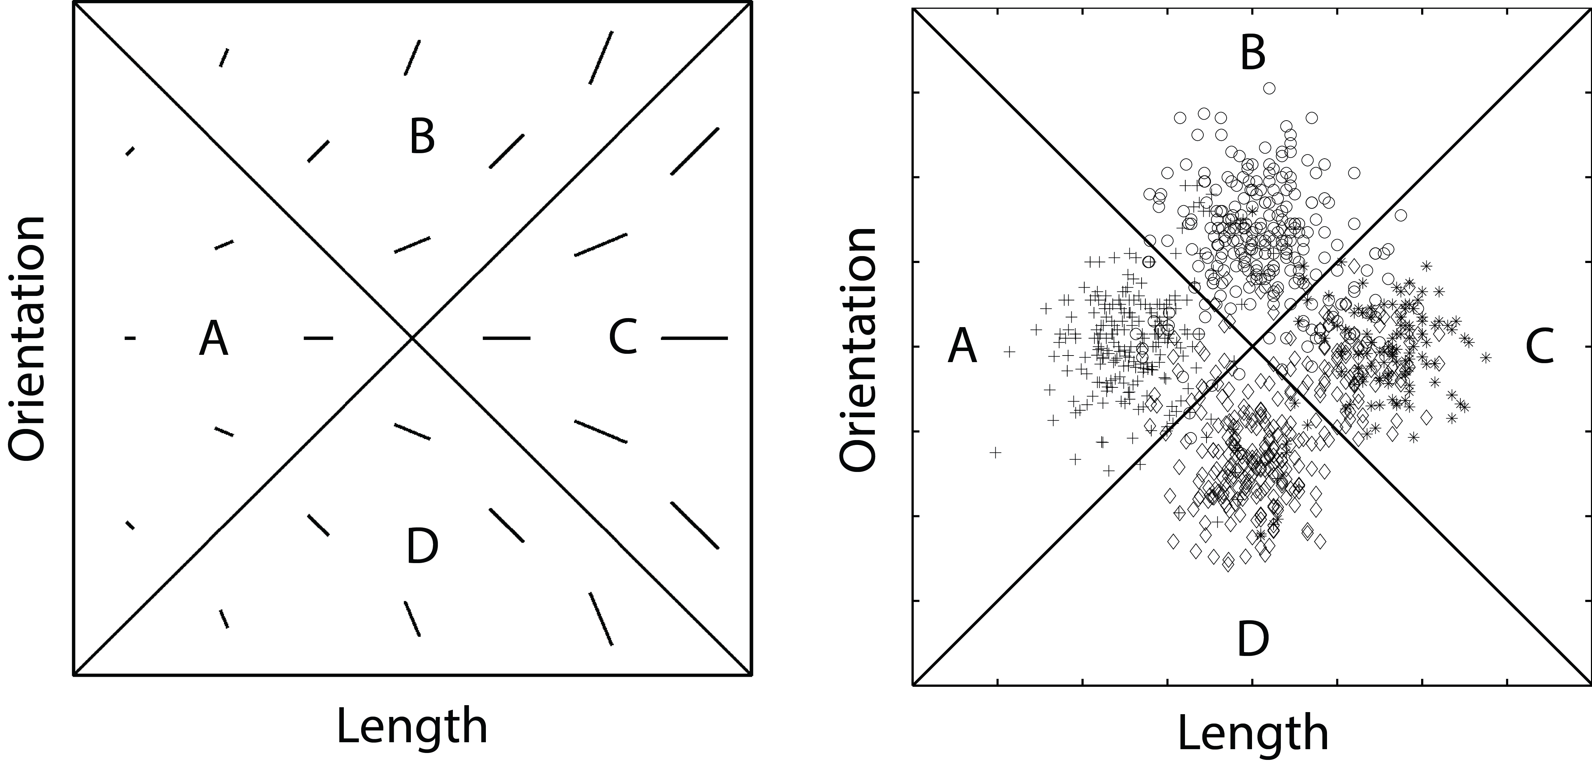

**Figure 1.** Left: A few examples of stimuli that might be used in an information-integration (II) category-learning experiment. Right: The category distributions used here.

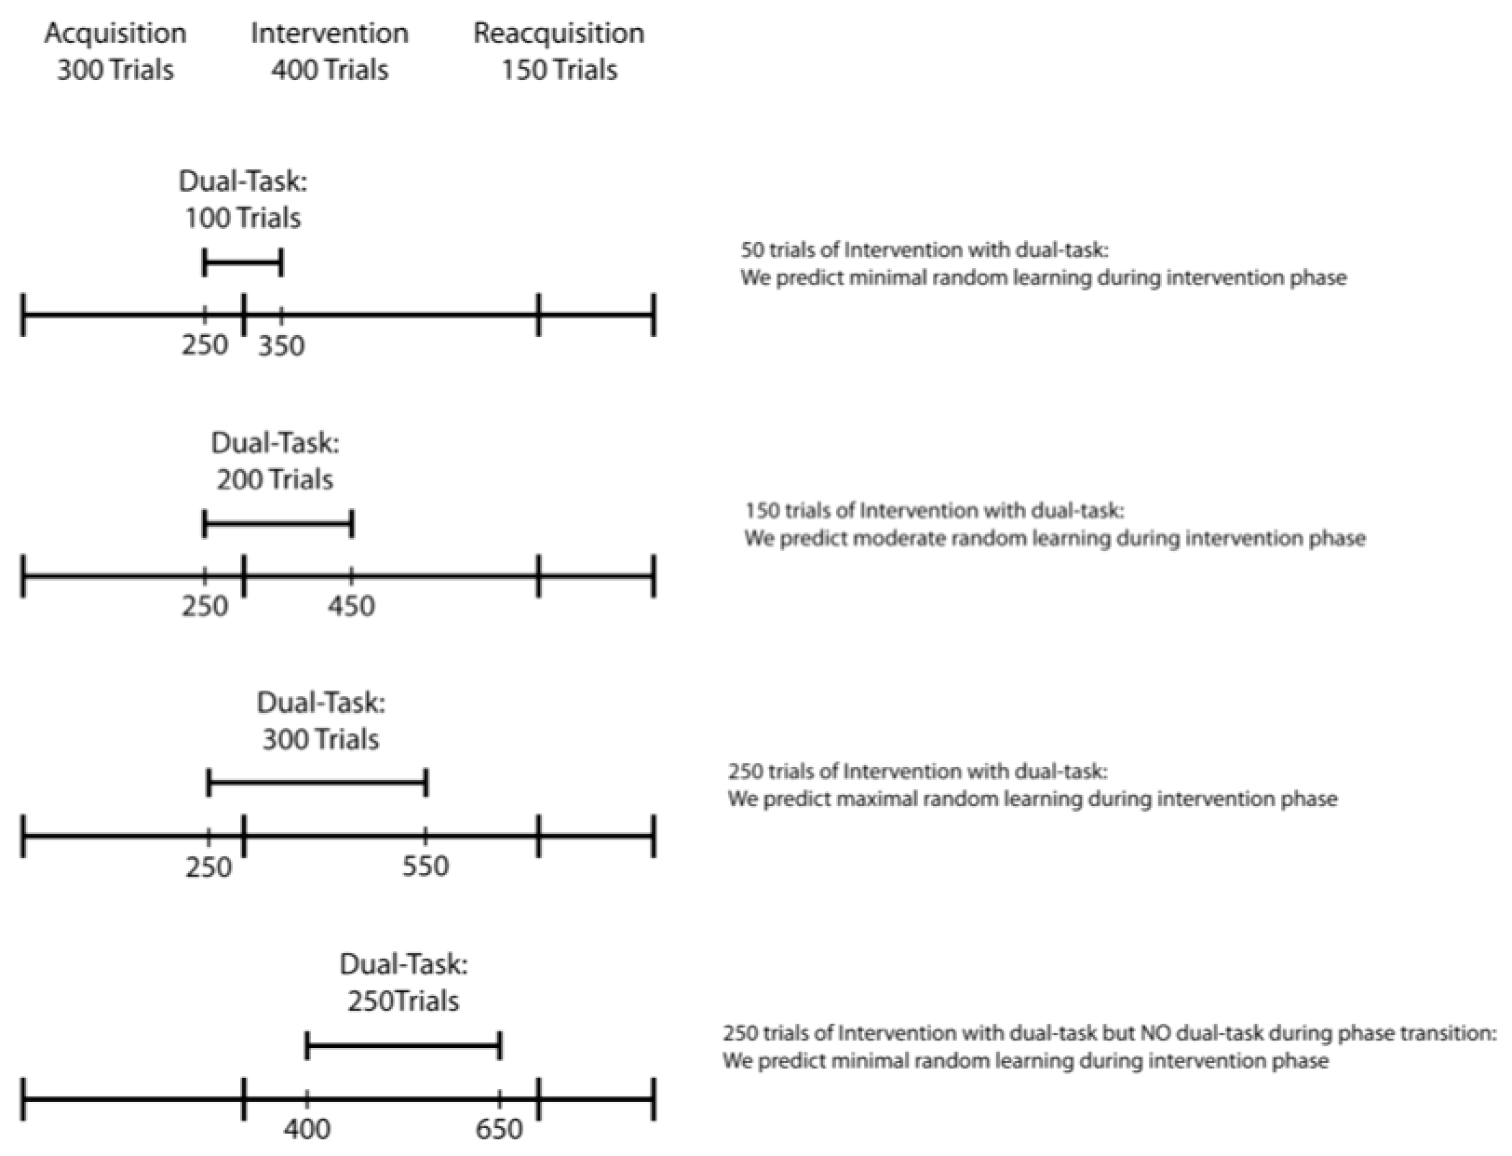

**Figure 2.** Experiment design. See text for further details.

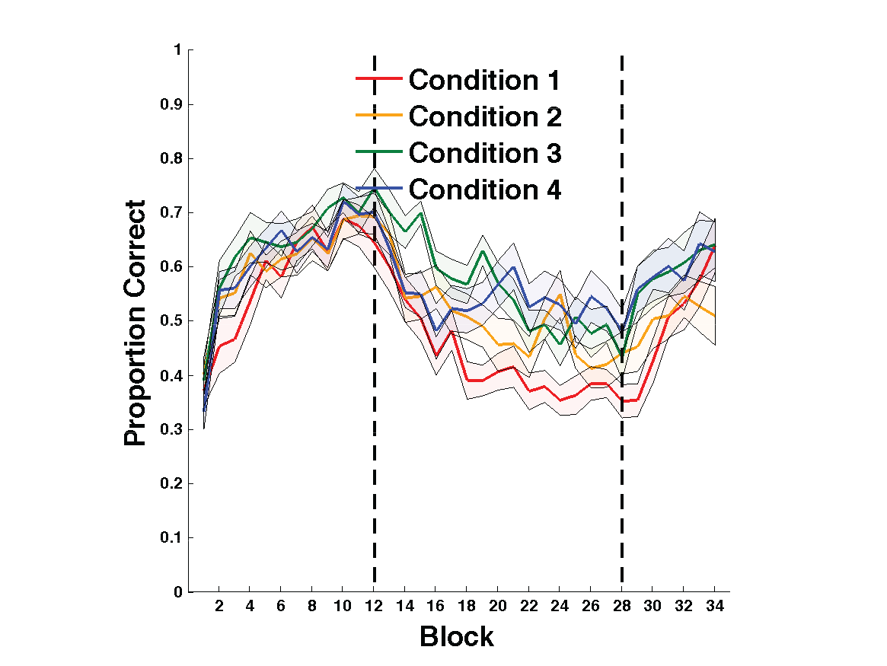

**Figure 3.** Experiment 1 accuracy. Each block includes 25 trials, and bands represent SEM. Top Panel: Accuracy in every condition throughout the entire experiment. Bottom Panel: Simulated results obtained from the model shown in Figure 5. Blocks 1-12 were in the acquisition phase, blocks 13-28 were in the intervention phase, and blocks 29-34 were in the reacquisition phase.

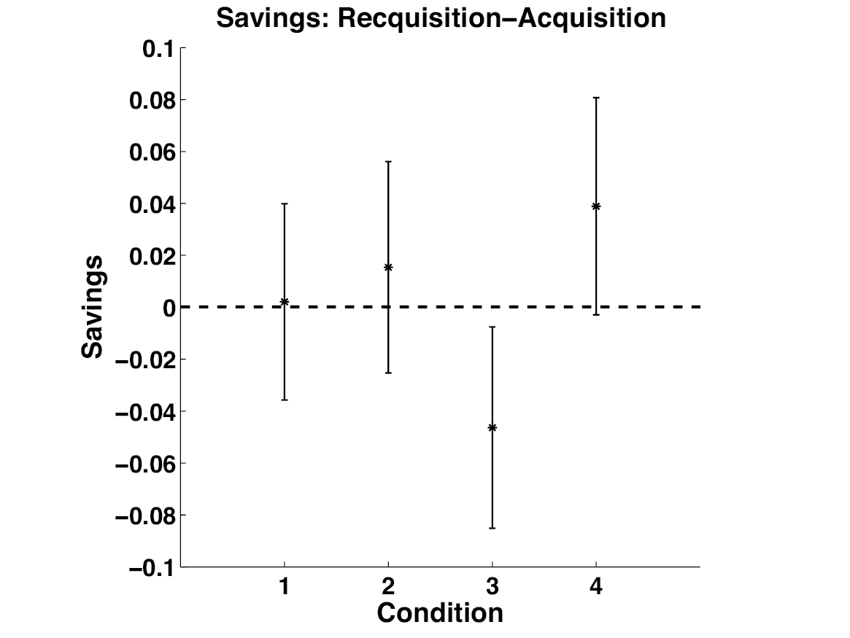

**Figure 4.** Savings in each condition defined as the mean accuracy during the the first 150 trials of acquisition - the mean accuracy during reacquisition. Error bars represent 95% confidence intervals on the mean accuracy per condition.