**Instruction**

version: 1.0

This instruction will guide you through every step on using the assessment tool.

# CrosslinkAssessment (GUI)

* 1. **Initialal work**

Copy the topic file assigned to you to the asssment folder which is located under current package path:

**assessment/inbox**

**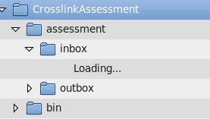**

**HERE**

* 1. **Lauching the program**
* On Unix-like system (e.g. Linux)

$sh run.sh

* On Windows

Double click on the run.bat or execute it in the command line console.

* 1. **Task**

Assess the relevancy between anchors in source English Wikipedia articles and their associated pages in other languages: Chinese, Japanese, or Korean.

* 1. **Usage**

Main GUI

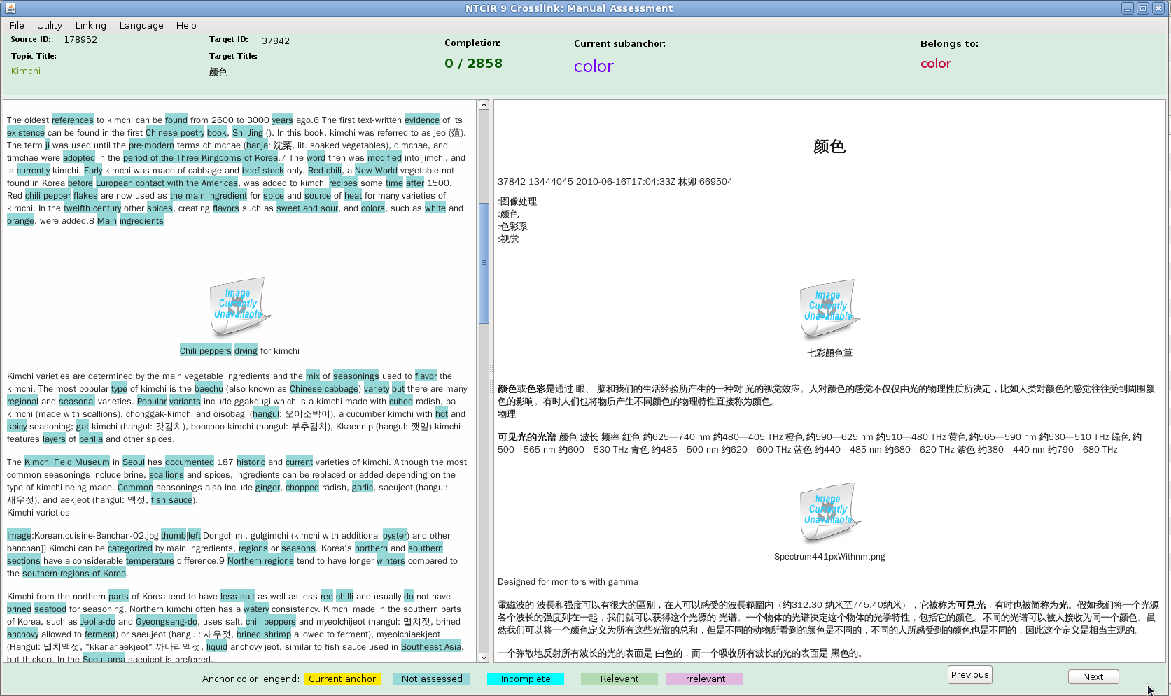

If you think some anchors are irrelevant, move the mouse cursor over the anchors and right click.

Source document With anchors highlighted

Right click if irrelevant

Left click if relevant

Move mouse over the target document, do the right click or left click

Target link (document) for current selected anchor

Compound Anchor

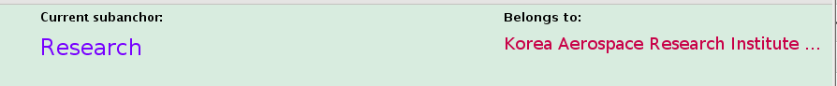

A compund anchor may contain many overlapping subanchors. For example, a compound anchor—*Korean Aerospace Research Institute* can contain subanchors: *Korea, Research, Aerospace Research*

* For current anchor, right click will only mark the current selected subanchor irrelevant. This will be particularly useful if it is a mix of relevant and irrelevant anchors in a compound anchor.
* If you are not sure if you correctly mark an article relevant or not, you can always press the “Previous” or “Next” button to go back or move forward to check.
* If an target article can’t be displayed properly, just right click (mark irrelevant).

Irrelevant Anchor Samples

|  |  |  |
| --- | --- | --- |
| **irrelevant_anchors_more_eaten.png** |  |  |
| **irrelevant_anchors_1960s.png** |  |  |
| **irrelevant_anchors_A.png** |  |  |
| **irrelevant_anchors_It.png** |  |  |
|  |  |  |
| **irrelevant_anchors_Kim_hi.png** |  |  |

For those anchors, you can right click on them straightaway. The makred irrelevant anchors are highlighted in dark pink color.

# Basic Assessment Guidelines

* Basically, only name entities can be qualified as relevant anchors. For other forms of words (e.g. verb), they can be marked as relevant if you think they are absolutely germane (related and relevant).
* For compound anchors, if the anchor is deemed reasonable (e.g. "Red Square") then each prospective link for the anchor will be assessed. At that point the "Red" link and the "Square" link will be assessed irrelevant, but "Red Square" link, "the Cafe Pushkin" link and the "Kremlin" link may be assessed as relevant.
* Chronological items (year, date, century, e.g. 1600s, 16th) and numbers (e.g. 1000, 17) must be marked as irrelevant
* There is no limit on the number of relevant links
* **Overall, there is no a universal rule for what text should be anchored, and anchors should be relevant only when you feel comfortable to.**

Most importantly, please mark the article relevant/irrelevant only if you are confident about it, and please don’t rush to the end for a quick finish.

# Assessment Result

When you finish assessing one topic, please send the result back to Eric Tang via email [lingxiang.tang@gmail.com](mailto:lingxiang.tang@gmail.com). The finished result is located in the assessment package:

resources/Pool/POOL\_BACKUP/zh

or

resources/Pool/POOL\_BACKUP/ja

or

resources/Pool/POOL\_BACKUP/ko

that depends on the language you are assessing.

# Qustion

If you have any question, please contact lingxiang.tang@gmail.com

**THANK YOU**