Bible Desktop User Manual

- Introduction
“Let the word of Christ dwell in you richly...” (Col 3:16) is our desire for you. From daily reading to deep, serious Bible study, Bible Desktop lets you do it all. With over 300 Bibles, Commentaries, Daily Devotions, Dictionaries and other theological works in more than 40 different languages, Bible Desktop is the perfect addition to your library.

- Installation
Bible Desktop is available for Windows (98SE to Vista), Mac (Panther, Tiger and Leopard) and Unix (Linux, AIX, BSD, and so forth). Bible Desktop requires Sun's Java version 1.4 or later. It runs best with the most recent version. Bible Desktop will run with as little as 32M of RAM but 256M or more is best.

Download Bible Desktop from http://www.crosswire.org/bibledesktop/download.html , choosing the installer for your platform. The information on that web page provides complete instructions on installation.

- Startup Screen
The splash screen below is displayed as Bible Desktop initializes. Clicking on the screen will make it go away, but the program will continue to start. An initialization status bar is present at the bottom of the splash.
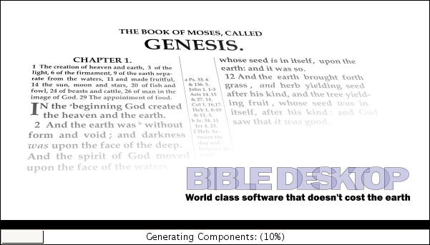
- First Run
The first time Bible Desktop is run it will not find any Bibles and will prompt you to install at least one.

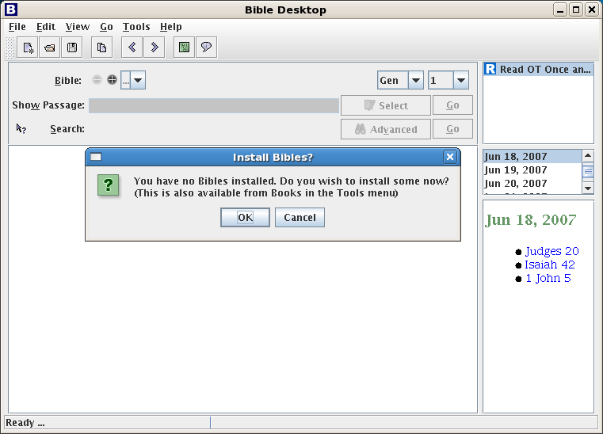
When you click OK, it will access the Internet to get a list of all the books that are available. If you live in a country or at a company which monitors your internet activity, you may want to find another means of obtaining Sword modules. Note that Bible Desktop refers to Sword modules as books.

If you click Cancel, Bible Desktop will not be useful. At least until you get some Sword Bibles.

- Main Window
Assuming that you have installed a Bible, you will now see something like the following. It will differ based upon the books that you have installed. It consists of a Bible viewer and a viewer of other books.

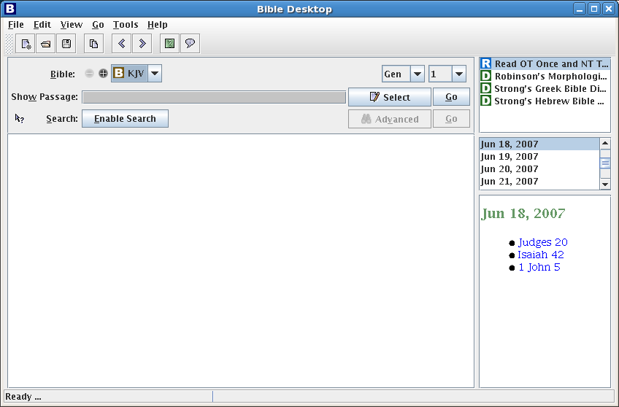
  - Bible View Area
The Bible View Area consists of a Bible selection menu(s), a quick navigation, a passage selection area, a search area, a passage sidebar (not visible, by default), and a Bible text display.

    - Bible Selection Menu(s)
The “-” and “+” buttons will add and remove drop-down lists of all installed Bibles. The “+” button will be disabled when you cannot add any more. Likewise, the “-” will be disabled when only one is showing. The left-most translation is used for searching. And all are use to show requested passages and search results.
    - Passage Selection Area
The text field labeled “Show Passage” allows you to enter the passage(s) to display in the Bible Text Display. You don't have to use whole Bible book names when typing, you can use pretty much what ever makes sense to you. You can use a period or a colon to separate chapters from verses. You can use a dash to indicate a range, as in “Gen 1.3-2.5” or “Gen 1.3-10” When you have more than one range just use spaces, semi-colons or commas to separate them. You don't have to repeat the book name or chapter name, when the later verse is in the same book or chapter, as in “Gen 1.1 5-7 2.3-15” Bible Desktop can figure out what you mean most of the time. After entering the desired verse(s), either hit enter or click the button labeled ‘Go’ to the right of the text field. Alternatively, you can choose passages using the Select Passage Dialog, below.

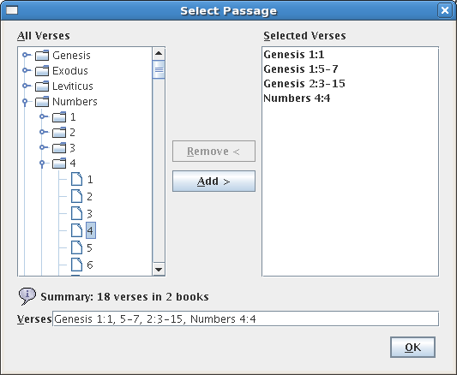

To use this dialog, the user clicks the ‘Select’ icon adjacent to the text field. The Select Passage dialog presents the user with a collapsible tree view of the Bible in the left column of the dialog. When collapsed, each book and chapter is represented by a file folder icon with an expand control (here it is a lever, but it might be a “+” and “-” signs) before it. Double clicking on the folder or clicking on the expand control will expand the tree to show the indented contents of the folder. Doing that again will collapse it. You can select books, chapters and verses and then clicking the ‘Add >’ button to add them. You can select multiple verses for addition by using the CTRL or SHIFT key in the typical fashion. The right column displays the currently selected verses. The verses are also shown in the text field at the bottom of the dialog. Verses and ranges can be removed by clicking on an entry in the right column, then clicking on the ‘Remove <’ button. When the desired verses are listed in the ‘Selected’ column, the user clicks ‘OK’ to dismiss the dialog and loads the values into the ‘Show Passage’ field of the Passage Selection Area. The requested passage will be fetched immediately.

    - Search Area
The Search Area allows the user to search Bible texts for words or phrases. It is located directly below the Passage Selection Area on the main window. This section describes the components that make up the Search Area.

      - Quick Search Help
The Quick Search Help Icon (located to the left of the ‘Search:’ label) presents the following explanation of the Quick Search Syntax. The syntax allows users to create complex searches.

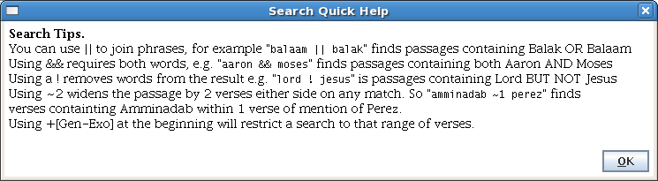
      - “Enable Search” Button
To make searches faster and more effective Bible Desktop uses a search index for each Bible translation. Before you can perform a search, you will need to let Bible Desktop build the index for you, by clicking on the “Enable Search” button. It should take 2 to 5 minutes to build an index, depending on how capable your computer is. If you have more than one Bible selected, it will index the first one.

While it is building, you can use Bible Desktop to do other things. Just not searching. If for any reason you want to cancel the indexing, just click on the red button in front of the progress bar.

      - Entry Area
When a search index is present for the translation, the Index Button is replaced with a text entry field. In here you can type any search request you wish and either hit enter or click on “Go”. All searches are case insensitive. When the search is done, you will see a dialog box letting you know how many matching verses were found.
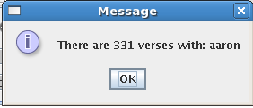
      - Advanced Search Options
The “Advanced” button brings up the Advanced Search dialog, below. Advanced search serves two purposes: It shows the proper way to write search requests and it makes available “Prioritization.”
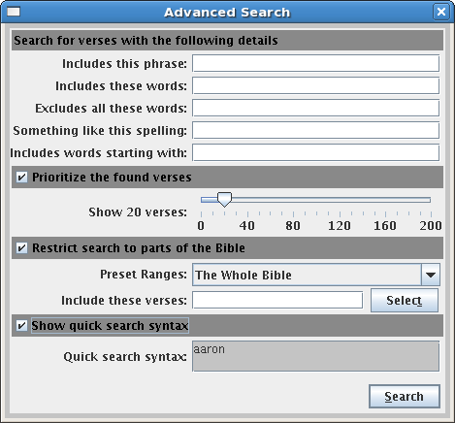

Detailed Search: You can specify what you want to search.
Include this phrase: will find all verses with that exact phrase.
Includes these words: will find all verses that have all those word.
Excludes all these words: will find verses that have none of the given words.
Something like this spelling: will find verse that have words remotely like the given words. This is very useful for names that are hard to spell or whose spelling varies.
Include words starting with: will find all verses that match one or more of the word prefixes. This is useful for finding various forms of a word, for example, grace and

Prioritization: You can choose to prioritize the returned verses, returning only the closest matches. This is very useful for finding a particular verse you cannot remember exactly. If you set the number of verses to be shown to 0, it will show all verse in priority order. Otherwise, it only show you the number of verses you requested. This option remains in effect until you uncheck it. This is the only Advanced Search option that is persistent.

Range Restriction: The middle portion of the dialog is optional and allows the operator to restrict the range of the search to a limited portion of the Bible. The user can restrict the search range by selecting a preset value from the pull-down menu. The following preset ranges are available:

- The Whole Bible
- All Prophecy (Deu 28, Isa-Mal, Rev)
- Old Testament (Gen-Mal)
- New Testament (Mat-Rev)
- The Pentateuch (Gen-Deu)
- History (Josh-Est)
- Poetry (Job-Song)
- Major Prophets (Isa-Dan)
- Minor Prophets (Hos-Mal)
- Gospel and Acts (Mal-Act)
- Letters to People (Rom-Heb)
- Letters from People (Jam-Jude)

You can also select a custom range. The custom range is defined in one of two ways, just like the “Show Passage” text entry. You can either type or use the “Select Passage” dialog.

Search Syntax: will show you how the query is built.

There are other search features that are not covered by this dialog:
Keywords: “+”, “&&” and “AND” do the same thing, finding verses with both terms. Note “+” is attached to the word needing to be present, while “&&” and “AND” are between two terms that need to be sought.

“||” and “OR” do the same thing, finding verses with either term.

To exclude “-”, “!” and “NOT” will find verses not having. The “-” needs to be attached to the word, but the other two stand before.

Please note, if you want to search for the word “or”, “and” or “not” then don't capitalize them.

Parentheses: You can use parentheses to make very complex queries.

Proximity Search: Typically a search request must be satisfied by each verse. Sometimes, this is not useful. You can use “~5” to find a verse that is near another. For example “Jesus ~5 John” will find all verses with Jesus that are within 5 verses of those with John.

Additional Range Restrictions: The range restriction must be at the front of the search request and is a passage surrounded by []. If it is preceded by a “+” then the search is restricted to those verses. But if it is preceded by a “-” then those verses are excluded. If you don't prefix it, then that verse will be added even if it does not otherwise match.

Note Search: If the Bible you are searching has notes, you can search just notes with “note:(....)” then you will just search notes. This syntax is very picky. There can be no space before or after the “:” and “note” must be in all lowercase. If the search is just a single word then the parentheses are not needed.

Strong's Number Search: You can search for verses with a particular Strong's Number. This uses a form similar to Note Search. “strong:h3068” will find all verses that have YHWH in them. Prefix Hebrew numbers with H or h and Greek with G or g. You can follow the letter with any number of zeros and then the number. If the Bible does not have Strong's numbers it won't find anything.

Heading Search: Some Bibles have headings. You can search these with “heading:(...)”.

Cross Reference Search: Some Bibles have cross-references. You can search for these with “xref:(....)”. Within the parentheses, you can use anything that Bible Desktop will recognize as a verse, verse range or passage.

    - Passage Sidebar
The Passage Sidebar allows the user to modify the amount of text displayed in the Bible Text Display. By default the Passage Sidebar is not shown. You will need to enable it on the View menu. The Passage Sidebar is opened/closed using the arrows to the left of the Bible Text Display. The figure below shows the Main Display Window with the Passage Sidebar displayed.

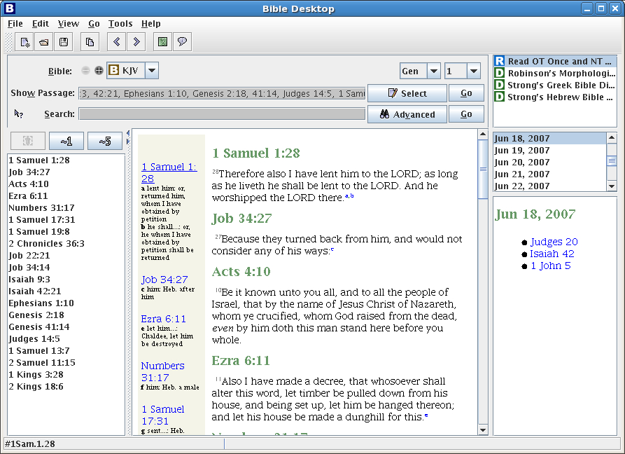

The sidebar contains a list of all passages currently displayed. It also contains three buttons above the list. The leftmost button allows the operator to highlight a passage in the list and delete it from the list. The remaining buttons are ‘expand’ buttons. The first expand button (‘~1’) adds one verse of context on either side of the passage. The second expand button (‘~5’) adds five verses of context on either side of the selected passage.

  - Dictionary/Commentary Area
The Dictionary/Commentary Area allows the user to access Bible study tools such as dictionaries, commentaries, and handbooks. This area is located on the right side of the Main Display Window. It is divided into three sections, described below.

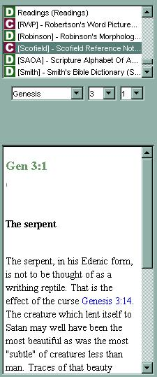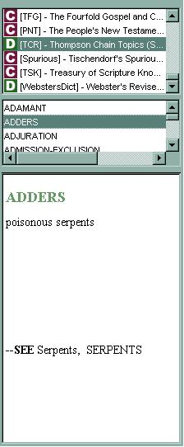
Book Selector

Item Selector

Book Text Display

    - Book Selector
The scrolled list at the top of the Dictionary/Commentary Area contains the currently loaded books other than Bibles. Each book is preceded by an icon indicating it's type. “D” for dictionaries, “R” for Daily Devotionals or Daily Readings. “C” for Commentaries. And all other books get “O”.

    - Item Selector
The middle section of the Dictionary/Commentary Area controls which portions of the selected book are displayed. As shown in the figures above, the selector changes with the book chosen by the user. The selector may be a series of pull-down menus (e.g. Book/Chapter/Verse) or a scrolled list (e.g. Dictionary entries, Strong’s numbers, Days of the Year) or a table of contents in tree form.

    - Book Text Display
Bible Desktop presents the text requested by the user (via the Book and Item Selectors) in this display area.

  - Status Area
The Status Area appears at the bottom of the Main Display Window. It is shown in the figure below. This area gives feedback for long running operations such as downloading a book or

    - Status/Hint Display
The leftmost portion of the Status Area displays current program status as well as hints that expand on the program Tool Tip text.

  - Menus
The Bible Desktop menus provide the user control over the performance of the program. Many of the menu items have keyboard shortcuts listed next to the menu item title. These shortcuts work in an identical fashion to the menu items themselves.

    - File

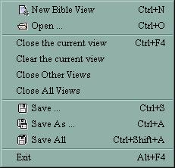

      - New Bible View
This option adds another Bible View in a tab (or sub-window) to the Bible View Area. Initially it will be untitled, but it's title will track the last passage lookup or search request.

      - Open
This option opens a previously saved verse list (.lst) file. The verses contained in the file are loaded in the currently selected Bible View.

      - Close the Current View
This option removes the currently selected Bible View from the Bible View Area.

      - Clear the Current View
This option clears the passages from the currently selected Bible View in the Bible View Area.

      - Close Other Views
This option removes all but the currently selected Bible View from the Bible View Area.

      - Close All Views
This option removes all tabs (or sub-windows) from the Bible View Area.

      - Save
This option allows the user to save the set of verses in the currently selected Bible View as a verse list (.lst) file. If a file has not been created, a ‘Save As’ dialog is displayed, allowing the user to select the location for the file. This file can later be loaded using the ‘Open’ option, above.

      - Save As
This option allows the user to save the set of verses in the currently selected Bible View as a verse list (.lst) file. A ‘Save As’ dialog is displayed, allowing the user to select the location for the file. This file can later be loaded using the ‘Open’ option, above.

      - Save All
This option allows the user to save the set of verses in each Bible View as a verse list (.lst) file. A ‘Save As’ dialog is displayed, allowing the user to select the locations for the files. These filed can later be loaded using the ‘Open’ option, above.

      - Exit
This option terminates Bible Desktop.

    - Edit
The only entry under the Edit Menu is Copy. This option allows the user to copy highlighted text from the Bible Text Display.

    - View
The View Menu controls the display options for the Main Window. The figure below shows the View Menu. The options are discussed in the following sections.

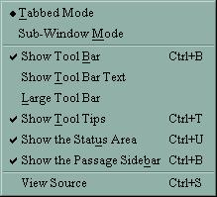

      - Tabbed Mode
This option changes the Bible View Area so it displays each view as a separate tab (see ). A circle next to the option indicates that it is selected. This option is mutually exclusive from the Sub-Window Mode option, below.

      - Sub-Window Mode
This option changes the Bible View Area so it displays each view as a separate sub-window (see ). A circle next to the option indicates that it is selected. This option is mutually exclusive from the Tabbed Mode option, above.

      - Show Tool Bar
Toggling this option allows the user to determine whether or not the Tool Bar shortcut buttons are displayed below the menus (see ). A check mark next to the option indicates that it is selected.

      - Show Tool Bar Text
Toggling this option allows the user to determine whether or not the Tool Bar shortcut buttons have descriptive text displayed below them. A check mark next to the option indicates that it is selected.

      - Large Tool Bar
Toggling this option allows the user to determine whether the Tool Bar shortcuts are displayed using large or small buttons. A check mark next to the option indicates that it is selected.

      - Show Tool Tips
Toggling this option allows the user to determine whether the Tool Tips are displayed. Tool Tips are small, informational notes that appear when the user places a cursor over a menu item or button. A check mark next to the option indicates that it is selected.

      - Show the Status Area
Toggling this option allows the user to determine whether the Status Area is displayed (see ). A check mark next to the option indicates that it is selected.

      - Show the Passage Sidebar
Toggling this option allows the user to determine whether the Passage Sidebar is available for display (see ). A check mark next to the option indicates that it is selected.

      - View Source
Selecting this option displays the Source Viewer, as shown in the figure below. This window allows the user to view the raw Bible text in one of three formats, each in its own tab. The Source Viewer has a Copy Button that allows the user to copy selected text to the clipboard.

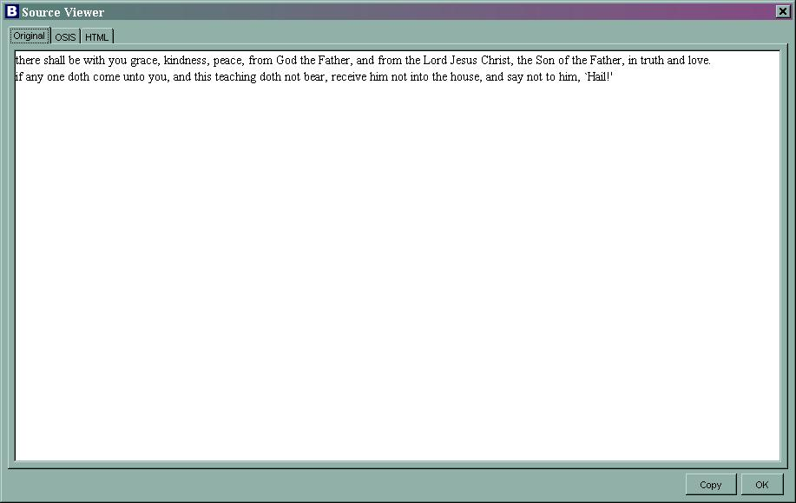

    - Tools
The Tools Menu give the user more advanced configuration options. The menu is shown in the figure below and the menu items are discussed in the following sections.

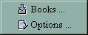

      - Books
Selecting the Books item displays the Available Books dialog, shown below.
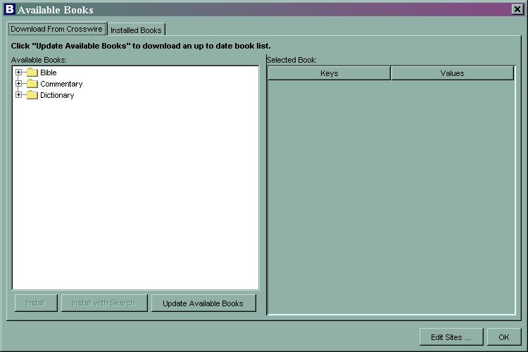

The dialog contains two tabs—one that allows the user to download more books from Crosswire, and one that shows the currently installed books. The ‘Edit Sites…’ button presents the Edit Update Sites dialog (shown below), allowing the operator to specify new download sites.

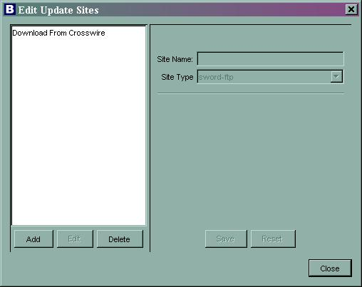

      - Options
Selecting the Options menu item displays the Desktop Options dialog. The figure below shows the dialog. There are five categories of options (Bibles, Bible View, Sword Module, Passages, Application) displayed in the dialog. The option category is selected by clicking on the title in the left hand portion of the dialog.

        - Options – Bibles
The Bibles option category is shown below. This category presents three pull-down menus. The first selection determines what Bible translation is the default used for new views. The second and third selections determine the default dictionary and commentary used in the Dictionary/Commentary Area (see ).

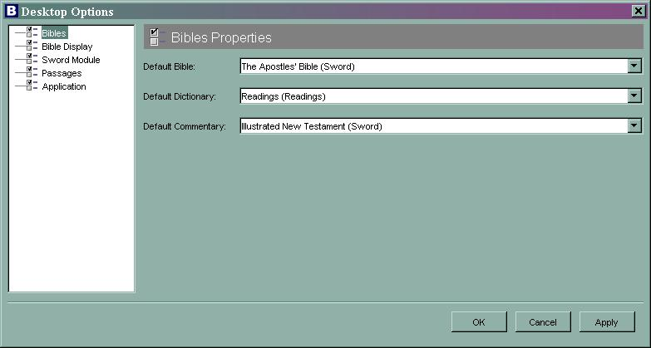

        - Options – Bible Display
The Desktop Options dialog with the Bible Display option category selected is shown below.

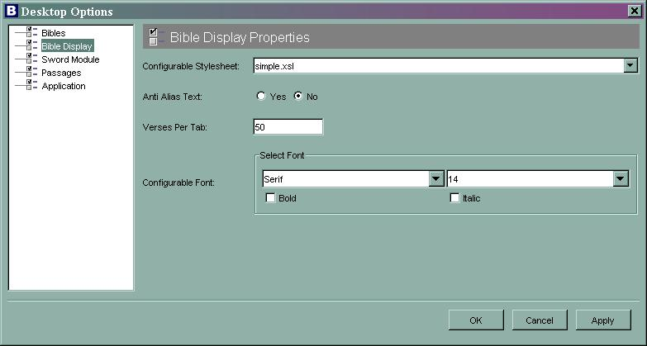

The first selection (“Configurable Stylesheet:”) determines the style applied to books when using the configurable styler. The available stylesheets are simple.xsl, cutandpaste.xsl, and cutandpaste2.xsl). The second selection determines whether anti-alias text is used when displaying Bible text. The third selection establishes the verse limit for each tab/sub-window. The final selection area allows the user to select the font type and size as well as bold and italic options.

        - Options – Sword Module
The Desktop Options dialog with the Sword Module option category selected is shown below.

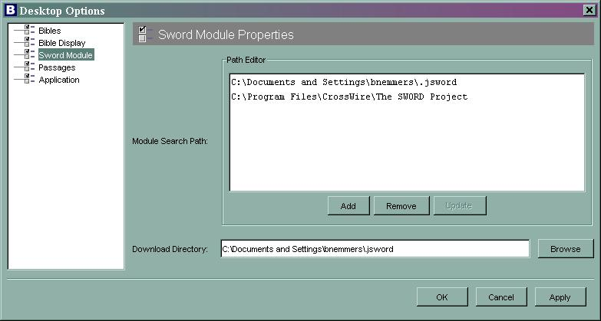

This option category allows the user to specify the Sword Module search path and the location of the book download directory.

        - Options - Passages
The Desktop Options dialog with the Passages option category selected is shown below.

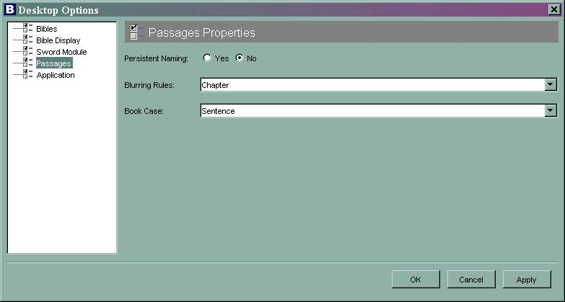

The Persistent Naming option ….

The Blurring Rules option determines how blurring (adding context verses to passages) should be applied. The available options are None (no blurring), Book (blur across book boundaries), and Chapter (blur across chapter boundaries).

The Book Case option determines what case is used to display references. The available selections are lower, Sentence, UPPER, and mIXeD.

        - Options - Application
The Desktop Options dialog with the Application option category selected is shown below.

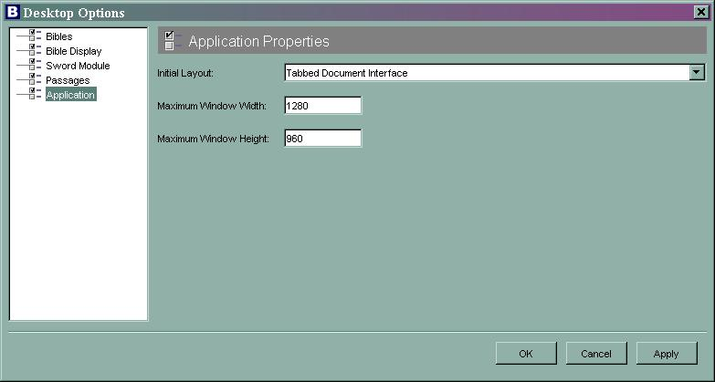

The Initial Layout option determines whether the Main Window is displayed using a tabbed interface (Tabbed Document Interface) or a sub-window interface (Multiple Document Interface) at startup. The remaining option fields determine the maximum size of the Bible Desktop Window in pixels.

    - Help
The Help menu presents the following options:

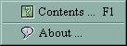

      - Contents
The Contents option presents the built-in help, as available and directs the user to on-line help sources.

      - About
This option displays the About Dialog. The About Dialog presents the current software version.

  - Toolbar

    - New Bible View
This button is a shortcut for the File>>New Bible View menu selection (see ).

    - Open
This button is a shortcut for the File>>Open menu selection (see ).

    - Save
This button is a shortcut for the File>>Save menu selection (see ).

    - Copy
This button is a shortcut for the Edit>>Copy menu selection (see ).

    - Help Contents
This button is a shortcut for the Help>>Contents menu selection (see ).

    - About
This button is a shortcut for the Help>>About menu selection (see ).

- Conclusion/Feedback
If you have comments about Bible Desktop, are interested in helping with its development, or just want to follow its progress, please consider joining one or more of the JSword mailing lists (http://www.crosswire.org/jsword/maillists.html).

