Bible Desktop User Manual

- Introduction
Bible Desktop is a java-based Bible study program. Bible Desktop is part of the JSword project (http://www.crosswire.org/jsword/). It has been developed as an ‘open-source’ project, meaning that it is freely redistributable; however, some modules may not be. See the project home page for details.

- Installation
Installation of Bible Desktop requires the Sun Java Plug-in, version 1.4.2 or later (see http://java.sun.com if you do not have the plug-in). Bible Desktop uses the Webstart feature of the Java Plug-in to install the program on your machine.

- Startup Screen
The splash screen below is displayed as Bible Desktop initializes. An initialization status bar is present at the bottom of the splash.

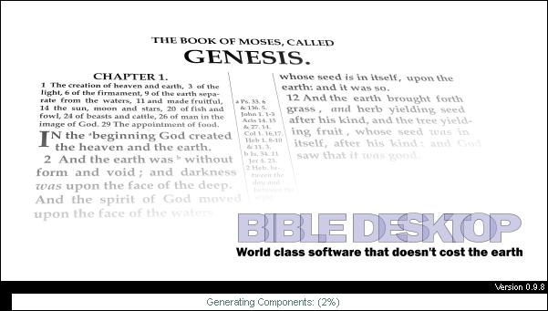

- Main Window
Upon initialization, the main window is displayed. The controls and display areas of the window are described in the following sections.
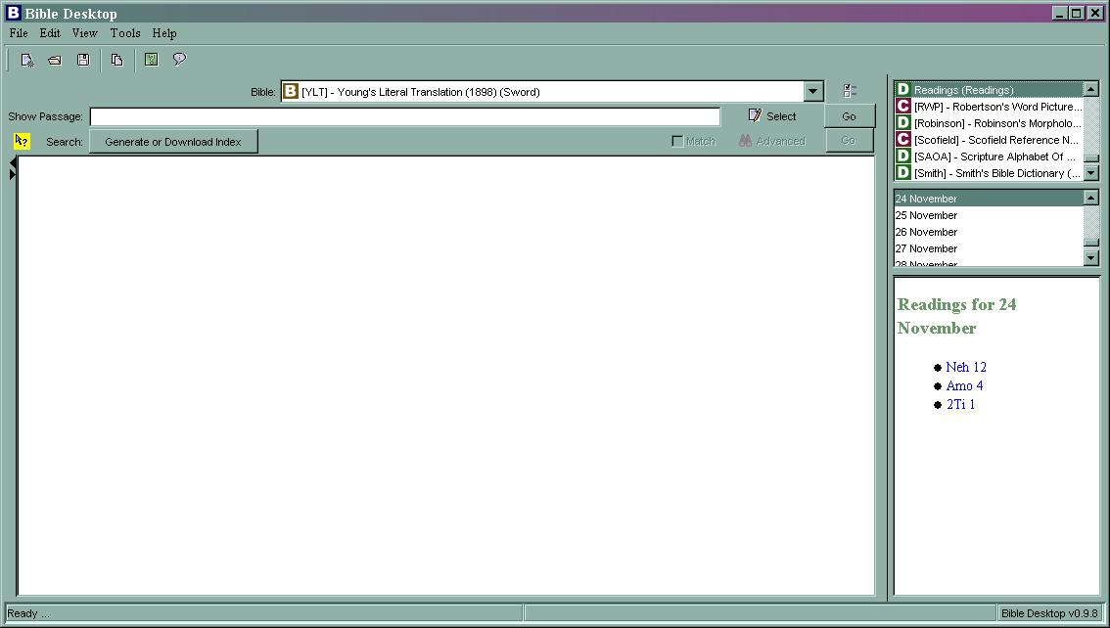

  - Bible Display Area
The Bible Display Area consists of a Bible selection menu, a passage selection area, a search area, a search sidebar, and a Bible text display. It is available in two formats—tabbed and sub-window (see View Menu, 4.4.3).

The figure below shows the Bible Display Area in Tabbed Mode. This format is helpful for examining a large number of passages, if you do not need to view them simultaneously. Each tab contains all of the text selection and display controls.

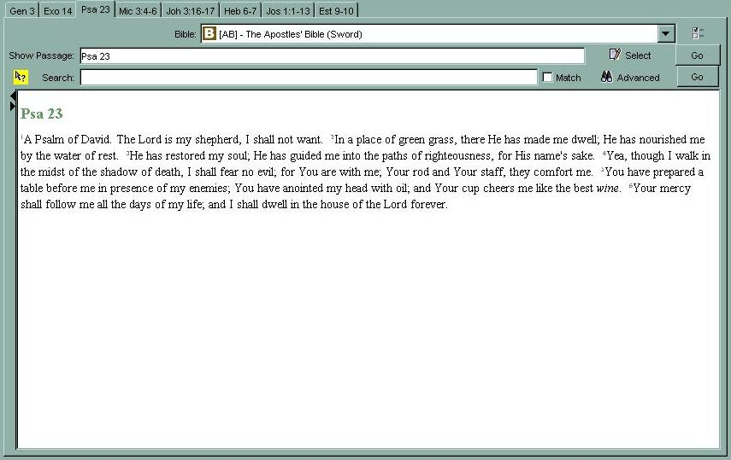

The figure below shows the Bible Display Area in Sub-window Mode. This format is helpful for multiple passages simultaneously (e.g. when comparing a passage in two or more translations).

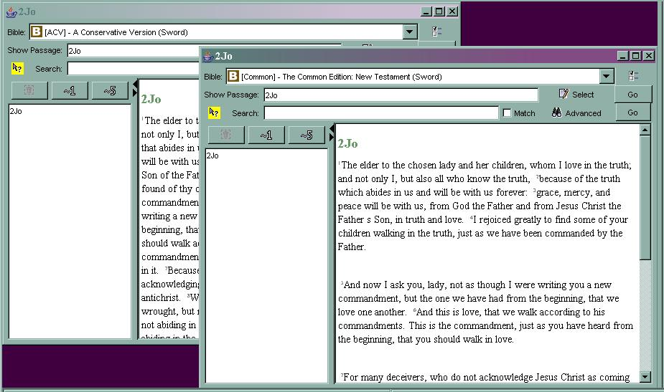

    - Bible Selection Menu
This pull-down menu lists the available Bible translations. The selected translation is used for all verses displayed in the Bible text display for the tab/sub-window.

    - Passage Selection Area
The text field labeled “Show Passage” allows the user to enter the passage(s) to display in the Bible Text Display. The user enters the desired verse(s) and clicks the button labeled ‘Go’ to the right of the text field. Alternatively, the user can choose passages using the Select Passage Dialog, below.

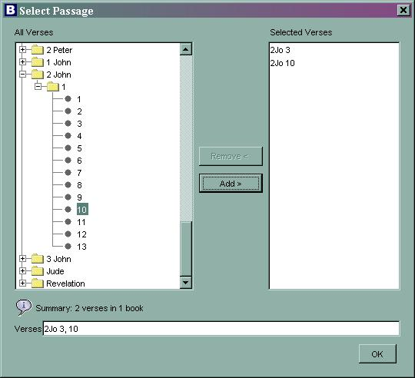

To use this dialog, the user clicks the ‘Select’ icon adjacent to the text field. The Select Passage dialog presents the user with a collapsible tree view of the Bible in the left column of the dialog. When collapsed, each book is represented by a file folder icon with a ‘+’ next to it. Clicking on the ‘+’ expands the tree to show each chapter as another file folder, indented under the book’s folder icon. Clicking on a ‘+’ next to a chapter’s folder icon expands the tree to show the numbers of each verse in the chapter, indented under the chapter’s icon. Note: For 1-chapter books, the chapter folder automatically expands. When the user clicks on a ‘+’, it turns to a ‘-‘. Clicking on a ‘-‘ collapses the contents of the associated folder. The user can select verses to add to the display. The user adds verses by selecting one or more verse numbers, then clicking the ‘Add >’ button. The user can select multiple verses for addition by using the CTRL or SHIFT key in the typical fashion. The right column displays the currently selected verses. The verses are also shown in the text field at the bottom of the dialog. Verses can be removed by clicking on an entry in the right column, then clicking on the ‘Remove <’ button. When the desired verses are listed in the ‘Selected’ column, the user clicks ‘OK’ to dismiss the dialog and loads the values into the ‘Show Passage’ field of the Passage Selection Area. Clicking on the ‘GO’ button to the right of the text field loads the verse text into the text display area.

    - Search Area
The Search Area allows the user to search Bible texts for words or phrases. It is located directly below the Passage Selection Area on the main window. This section describes the components that make up the Search Area.

      - Quick Search Help
The Quick Search Help Icon (located to the left of the ‘Search:’ label) presents the following explanation of the Quick Search Syntax. The syntax allows users to create complex searches.

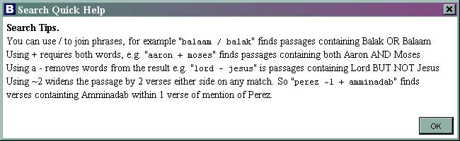

      - Index Button
To make searches faster and more effective Bible Desktop uses a search index for each Bible translation. Including an index for all translations greatly increases the download size (hence, time) for the program. Therefore, a button labeled “Generate or Download Index” is located to the right of the ‘Search:’ label whenever an index is not present for a translation. When the user clicks the button, they are given the option of generating an index locally or downloading it over the Internet.

      - Entry Area
When a search index is present for the translation, the Index Button is replaced with a text entry field.

      - Match Option
The Match Checkbox…. (Match – find verses like….)

      - Advanced Search Options
The Advanced Search Icon brings up the Advanced Search Dialog, below.
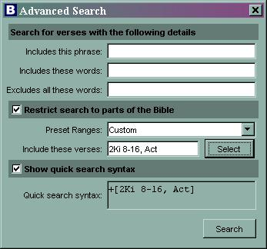

The upper portion of the dialog allows the user to define the search target(s). The user can enter a target phrase in the first text area. The second text area allows entry of additional words for inclusion in the search. The third text area allows the user to enter words that must not appear in the search results.

The middle portion of the dialog is optional and allows the operator to restrict the range of the search to a limited portion of the Bible. The user can restrict the search range by selecting a preset value from the pull-down menu. The following preset ranges are available:

- The Whole Bible
- All Prophecy (Deu 28, Isa-Mal, Rev)
- Old Testament (Gen-Mal)
- New Testament (Mat-Rev)
- The Pentateuch (Gen-Deu)
- History (Josh-Est)
- Poetry (Job-Song)
- Major Prophets (Isa-Dan)
- Minor Prophets (Hos-Mal)
- Gospel and Acts (Mal-Act)
- Letters to People (Rom-Heb)
- Letters from People (Jam-Jude)

The user can also select a custom range. The custom range is defined in one of two ways. The user can enter the verses for inclusion in the search in the text field. The user can also use the ‘Select’ button to open a Select Passage dialog, which functions in a similar fashion to the dialog used for the Passage Selection Area (see 4.1.2).
The selection made within the dialog is displayed in the text area adjacent to the ‘Select’ button.

The lower portion of the dialog is optional and allows the user to display the Quick Search Syntax used in the search. The syntax that the program will use to perform search (based on the user entries) is displayed in the text field. Upon clicking the ‘Search’ button, the contents of this field is loaded into the ‘Search:’ text field on the main window.

    - Passage Sidebar
The Passage Sidebar allows the user to modify the amount of text displayed in the Bible Text Display. The Passage Sidebar is opened/closed using the arrows to the left of the Bible Text Display. The figure below shows the Main Display Window with the Passage Sidebar displayed.

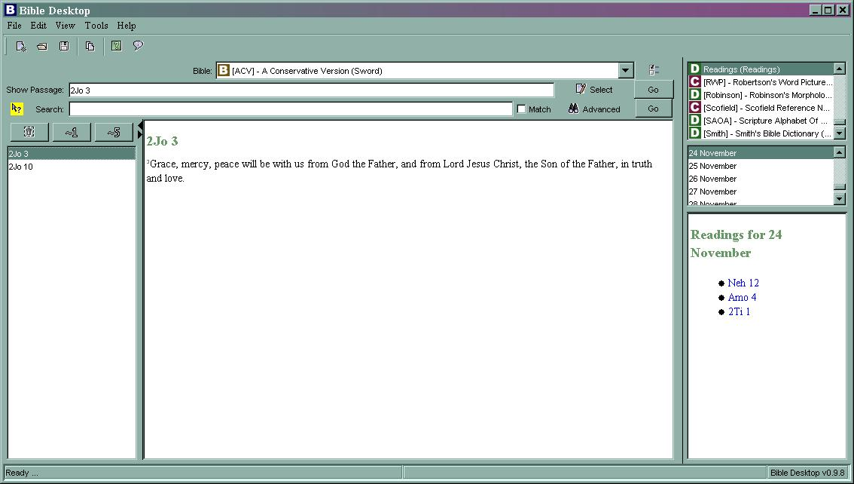

The sidebar contains a list of all passages currently displayed. It also contains three buttons above the list. The leftmost button allows the operator to highlight a passage in the list and delete it from the list. The remaining buttons are ‘blur’ buttons. The first blur button (‘~1’) adds one verse of context on either side of the passage. The second blur button (‘~5’) adds five verses of context on either side of the selected passage.

  - Dictionary/Commentary Area
The Dictionary/Commentary Area allows the user to access Bible study tools such as dictionaries, commentaries, and handbooks. This area is located on the right side of the Main Display Window. It is divided into three sections, described below.

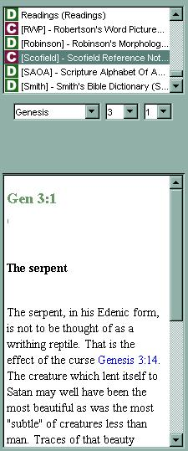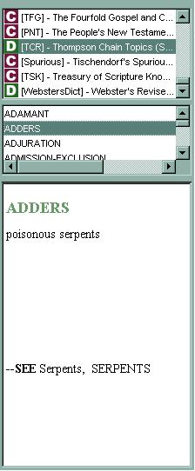
Book Selector

Item Selector

Book Text Display

    - Book Selector
The scrolled list at the top of the Dictionary/Commentary Area contains the currently loaded dictionaries and commentaries. Dictionaries are denoted by a ‘D’ to the left of the book title. Commentaries are denoted by a ‘C’ to the left of the book title.

    - Item Selector
The middle section of the Dictionary/Commentary Area controls which portions of the selected book are displayed. As shown in the figures above, the selector changes with the book chosen by the user. The selector may be a series of pull-down menus (e.g. Book/Chapter/Verse) or a scrolled list (e.g. Dictionary entries, Strong’s numbers, etc.).

    - Book Text Display
Bible Desktop presents the text requested by the user (via the Book and Item Selectors) in this display area.

  - Status Area
The Status Area appears at the bottom of the Main Display Window. It is shown in the figure below.

    - Status/Hint Display
The leftmost portion of the Status Area displays current program status as well as hints that expand on the program Tool Tip text.

    - Version Number Display
The rightmost portion of the Status Area displays the software version number of Bible Desktop.

  - Menus
The Bible Desktop menus provide the user control over the performance of the program. Many of the menu items have keyboard shortcuts listed next to the menu item title. These shortcuts work in an identical fashion to the menu items themselves.

    - File

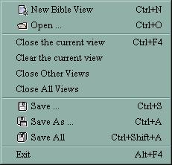

      - New Bible View
This option adds another tab (or sub-window) to the Bible Display Area.

      - Open
This option opens a previously saved verse list (.lst) file. The verses contained in the file are loaded in the currently selected tab/sub-window.

      - Close the Current View
This option removes the currently selected tab (or sub-window) from the Bible Display Area.

      - Clear the Current View
This option clears the passages from the currently selected tab (or sub-window) in the Bible Display Area.

      - Close Other Views
This option removes all but the currently selected tab (or sub-window) from the Bible Display Area.

      - Close All Views
This option removes all tabs (or sub-windows) from the Bible Display Area.

      - Save
This option allows the user to save the set of verses in the currently selected tab/sub-window as a verse list (.lst) file. If a file has not been created, a ‘Save As’ dialog is displayed, allowing the user to select the location for the file. This file can later be loaded using the ‘Open’ option, above.

      - Save As
This option allows the user to save the set of verses in the currently selected tab/sub-window as a verse list (.lst) file. A ‘Save As’ dialog is displayed, allowing the user to select the location for the file. This file can later be loaded using the ‘Open’ option, above.

      - Save All
This option allows the user to save the set of verses in each tab/sub-window as a verse list (.lst) file. A ‘Save As’ dialog is displayed, allowing the user to select the locations for the files. These filed can later be loaded using the ‘Open’ option, above.

      - Exit
This option terminates Bible Desktop.

    - Edit
The only entry under the Edit Menu is Copy. This option allows the user to copy highlighted text from either the Bible Text Display (see 4.1) or the Book Text Display (see 4.2.3).

    - View
The View Menu controls the display options for the Main Window. The figure below shows the View Menu. The options are discussed in the following sections.

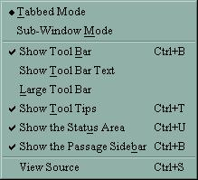

      - Tabbed Mode
This option changes the Bible Display Area so it displays each view as a separate tab (see 4.1). A circle next to the option indicates that it is selected. This option is mutually exclusive from the Sub-Window Mode option, below.

      - Sub-Window Mode
This option changes the Bible Display Area so it displays each view as a separate sub-window (see 4.1). A circle next to the option indicates that it is selected. This option is mutually exclusive from the Tabbed Mode option, above.

      - Show Tool Bar
Toggling this option allows the user to determine whether or not the Tool Bar shortcut buttons are displayed below the menus (see 4.5). A check mark next to the option indicates that it is selected.

      - Show Tool Bar Text
Toggling this option allows the user to determine whether or not the Tool Bar shortcut buttons have descriptive text displayed below them. A check mark next to the option indicates that it is selected.

      - Large Tool Bar
Toggling this option allows the user to determine whether the Tool Bar shortcuts are displayed using large or small buttons. A check mark next to the option indicates that it is selected.

      - Show Tool Tips
Toggling this option allows the user to determine whether the Tool Tips are displayed. Tool Tips are small, informational notes that appear when the user places a cursor over a menu item or button. A check mark next to the option indicates that it is selected.

      - Show the Status Area
Toggling this option allows the user to determine whether the Status Area is displayed (see 4.3). A check mark next to the option indicates that it is selected.

      - Show the Passage Sidebar
Toggling this option allows the user to determine whether the Passage Sidebar is available for display (see 4.1.4). A check mark next to the option indicates that it is selected.

      - View Source
Selecting this option displays the Source Viewer, as shown in the figure below. This window allows the user to view the raw Bible text in one of three formats, each in its own tab. The Source Viewer has a Copy Button that allows the user to copy selected text to the clipboard.

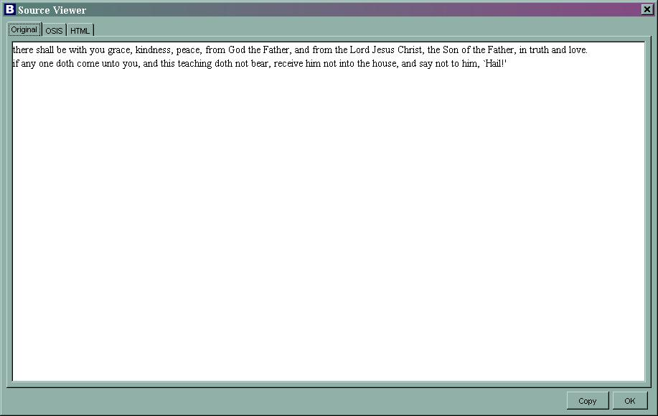

    - Tools
The Tools Menu give the user more advanced configuration options. The menu is shown in the figure below and the menu items are discussed in the following sections.

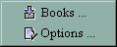

      - Books
Selecting the Books item displays the Available Books dialog, shown below.
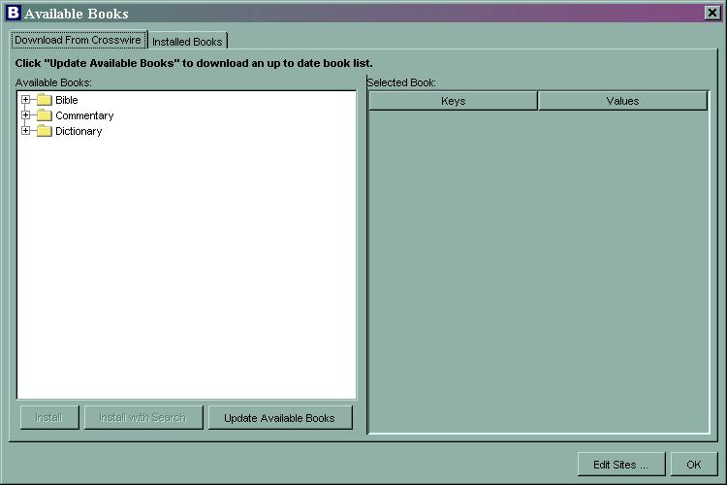

The dialog contains two tabs—one that allows the user to download more books from Crosswire, and one that shows the currently installed books. The ‘Edit Sites…’ button presents the Edit Update Sites dialog (shown below), allowing the operator to specify new download sites.

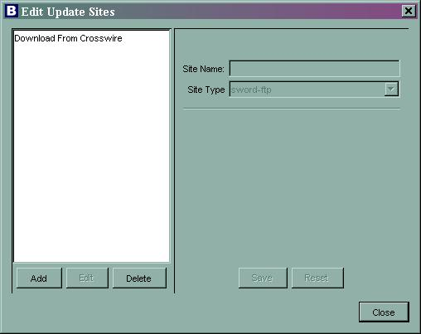

      - Options
Selecting the Options menu item displays the Desktop Options dialog. The figure below shows the dialog. There are five categories of options (Bibles, Bible Display, Sword Module, Passages, Application) displayed in the dialog. The option category is selected by clicking on the title in the left hand portion of the dialog.

        - Options – Bibles
The Bibles option category is shown below. This category presents three pull-down menus. The first selection determines what Bible translation is the default used for new views. The second and third selections determine the default dictionary and commentary used in the Dictionary/Commentary Area (see 4.2).

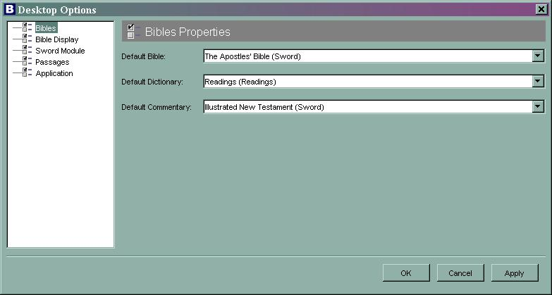

        - Options – Bible Display
The Desktop Options dialog with the Bible Display option category selected is shown below.

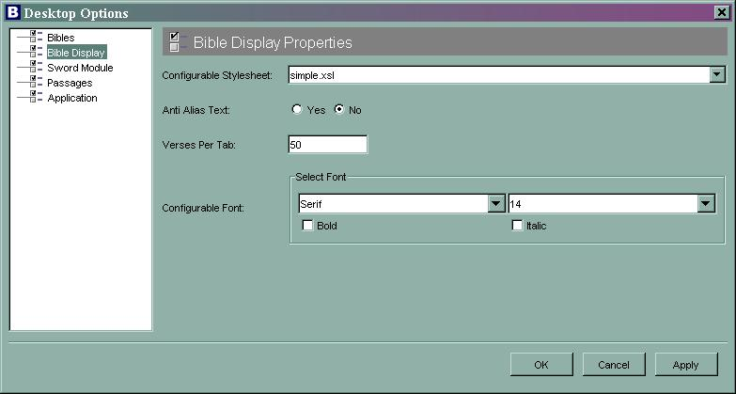

The first selection (“Configurable Stylesheet:”) determines the style applied to books when using the configurable styler. The available stylesheets are simple.xsl, cutandpaste.xsl, and cutandpaste2.xsl). The second selection determines whether anti-alias text is used when displaying Bible text. The third selection establishes the verse limit for each tab/sub-window. The final selection area allows the user to select the font type and size as well as bold and italic options.

        - Options – Sword Module
The Desktop Options dialog with the Sword Module option category selected is shown below.

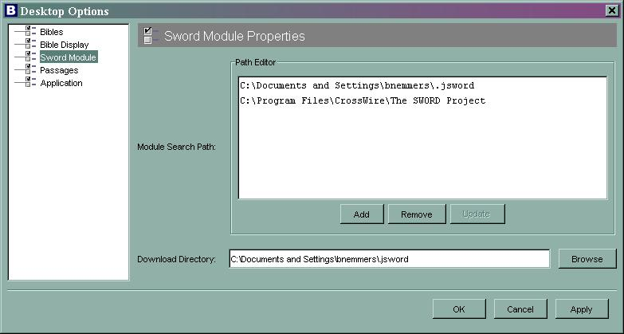

This option category allows the user to specify the Sword Module search path and the location of the book download directory.

        - Options - Passages
The Desktop Options dialog with the Passages option category selected is shown below.

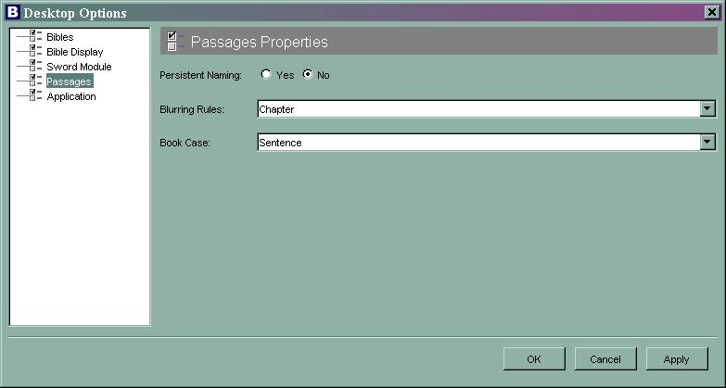

The Persistent Naming option ….

The Blurring Rules option determines how blurring (adding context verses to passages) should be applied. The available options are None (no blurring), Book (blur across book boundaries), and Chapter (blur across chapter boundaries).

The Book Case option determines what case is used to display references. The available selections are lower, Sentence, UPPER, and mIXeD.

        - Options - Application
The Desktop Options dialog with the Application option category selected is shown below.

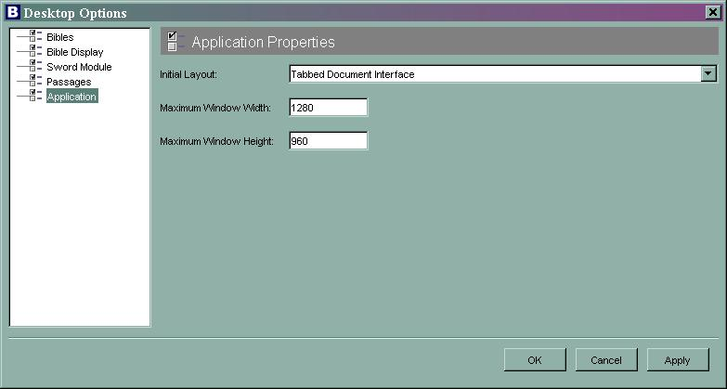

The Initial Layout option determines whether the Main Window is displayed using a tabbed interface (Tabbed Document Interface) or a sub-window interface (Multiple Document Interface) at startup. The remaining option fields determine the maximum size of the Bible Desktop Window in pixels.

    - Help
The Help menu presents the following options:

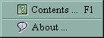

      - Contents
The Contents option presents the built-in help, as available and directs the user to on-line help sources.

      - About
This option displays the About Dialog. The About Dialog presents the current software version.

  - Toolbar

    - New Bible View
This button is a shortcut for the File>>New Bible View menu selection (see 4.4.1).

    - Open
This button is a shortcut for the File>>Open menu selection (see 4.4.1).

    - Save
This button is a shortcut for the File>>Save menu selection (see 4.4.1).

    - Copy
This button is a shortcut for the Edit>>Copy menu selection (see 4.4.2).

    - Help Contents
This button is a shortcut for the Help>>Contents menu selection (see 4.4.5.1).

    - About
This button is a shortcut for the Help>>About menu selection (see 4.4.5.2).

- Conclusion/Feedback
If you have comments about Bible Desktop, are interested in helping with its development, or just want to follow its progress, please consider joining one or more of the JSword mailing lists (http://www.crosswire.org/jsword/maillists.html).

