°Doctor of Philosophy Yet to be decided
=10000 =50pt
todo[2]
#2, #1
grayrgb0.4,0.4,0.4 darkbluergb0.0,0.0,0.6 cyanrgb0.0,0.6,0.6
basicstyle=, columns=fullflexible, showstringspaces=false, commentstyle=
XML basicstyle=, morestring=[b]", morestring=[s]><, morecomment=[s]<? ? >, stringstyle=, identifierstyle=, keywordstyle=, morekeywords=xmlns,version,type
[Sorry. Ignored \begin{abstractseparate} ... \end{abstractseparate}]

Scalable Software Defined Networking
17/04/2014
[Sorry. Ignored \begin{dedication} ... \end{dedication}]
[Sorry. Ignored \begin{acknowledgements} ... \end{acknowledgements}]
[Sorry. Ignored \begin{abstracts} ... \end{abstracts}]
Contents

Todo list 9
List of Publications 10
Introduction 11
1 Motivation 11
1.1 Computer Network Evolution 11
1.2 The Lernaean Hydra of Network Performance 11
1.3 Performance Limitations 12
2 Contributions 12
3 Outline 12
Background 13
1 Forwarding Devices 13
2 Forwarding Control in Production Networks 13
2.1 Data-Link Layer Control 13
2.2 Network Layer Control 13
3 Programmable Network Control 14
3.1 Active Networks 14
3.2 Devolved Control of ATM Networks 14
3.3 SDN 14
4 SDN applications 17
4.1 Network Virtualisation Applications 18
4.2 Security and Access Control Applications 18
4.3 Load Balancing Applications 18
4.4 Inter-domain and Intra-domain Routing 18
4.5 Network Management Applications 18
4.6 Energy Control Applications 18
4.7 Network Debugging and Measurement Applications 18
4.8 Resource Control Applications 18
4.9 Mobility Applications 18
4.10 Network Simulation 18
5 Conclusions 19
SDN Control Plane Scalability 20
1 Network Control Micro-Benchmark 20
2 OFLOPSDesign 20
3 Measurement Setup 21
4 Switch Evaluation 21
4.1 Packet Modifications 22
4.2 Traffic Interception and Injection 23
4.3 Flow Table Update Rate 23
4.4 Flow Monitoring 24
4.5 OpenFlowCommand Interaction 24
5 Network Control Macro-experimentation 24
6 Network experimentation 25
6.1 Mirage Library OS 25
6.2 SDNSIMArchitecture 25
7 SDNSIMevaluation 26
7.1 MirageController Emulation 26
7.2 MirageSwitch 27
7.3 ns-3 performance 27
8 Hierarchical Distributed Control 28
9 Summary 29
Secure and Scalable Internet-scale Connectivity 31
1 Personal Clouds 31
1.1 Approaches 31
1.2 Design Goals 31
2 Finding your way with Signpost 32
3 SignpostArchitecture 32
3.1 Network Tactic 32
3.2 Forwarding 39
3.3 Connection Manager 39
3.4 Effectful Naming 39
3.5 Security and Key Management 40
4 Evaluation 40
4.1 Signpostimplementation 40
4.2 Tunnel Evaluation 41
4.3 Application compatibility 41
5 Summary 41
Conclusions and Future Work 43
1 Summary 43
2 Summary of Contributions 43
3 Future Work 43
3.1 Distributed network control 43
3.2 User-centric networking 43
4 Conclusion 43
List of Figures

11
12
13
14
15
16
16
17
18
20
21
21
21
23
23
23
23
24
24
24
25
26
26
27
27
27
27
28
28
28
29
32
32
39
39
40
40
41
41
41
List of Tables

11
12
13
14
15
16
16
17
18
20
21
21
21
23
23
23
23
24
24
24
25
26
26
27
27
27
27
28
28
28
29
32
32
39
39
40
40
41
41
41

Todo list
starttoctdo
Chapter

List of Publications
As part of my PhD, I have published the following work:
• C. Rotsos, J. Van Gael, A. W. Moore, and Z. Ghahramani. Probabilistic graphical models for semi-supervised traffic classification. In Proceedings of the 6th International Wireless Communications and Mobile Computing Conference (IWCMC 2010).
• R. Mortier, B. Bedwell, K. Glover, T. Lodge, T. Rodden, C. Rotsos, et al. DEMO: Supporting novel home network management interfaces with OpenFlow and NOX. Presented at the SIGCOMM 2011: Proceedings of the ACM SIGCOMM 2011 conference.
• R. Mortier, T. Rodden, T. Lodge, D. McAuley, C. Rotsos, A. W. Moore, A. Koliousis, J. Sventek, Control and understanding: Owning your home network. In Proceedings of the Fourth International Conference on Communication Systems and Networks (COMSNETS), 2012.
• C. Rotsos, N. Sarrar, S. Uhlig, R. Sherwood, and A. W. Moore. OFLOPS: an open framework for OpenFlow switch evaluation. In Proceedings of the 13th international conference on Passive and Active Measurement (PAM 2012).
• A. Chaudhry, A. Madhavapeddy, C. Rotsos, R. Mortier, A. Aucinas, J. Crowcroft, et al. DEMO: Signposts: end-to-end networking in a world of middleboxes. Presented at the SIGCOMM 2012: Proceedings of the ACM SIGCOMM 2012 conference on applications, technologies, architectures, and protocols for computer communication.
• C. Rotsos, R. Mortier, A. Madhavapeddy, B. Singh, & A. W. Moore. Cost, performance & flexibility in OpenFlow: Pick three. Presented at the Communications (ICC), 2012 IEEE International Conference.
• A. Madhavapeddy, R. Mortier, C. Rotsos, D. Scott, B. Singh, T. Gazagnaire, S. Smith, S. Hand, and J. Crowcroft. Unikernels: library operating systems for the cloud. SIGPLAN Not. 48, 4 (March 2013).
Chapter 1

Introduction
Computer networks have become the predominant communications media of the digital era. Nonetheless, the widening adoption of network technologies has highlighted several scalability problems in network functionality. These primarily derive from the design of network protocols and architectures. Addressing these limitations through protocol redesign is a challenging process, which requires significant time and effort for deployment. Network systems require novel backwards-compatible mechanisms that provide scalable performance.
This dissertation is concerned with performance scalability problems in modern networks. The thesis of this dissertation is that control plane redesign can mitigate network bottlenecks introduced by protocol design, while ensuring backwards compatibility and high performance. We argue that existing control plane mechanisms remain inflexible and that their “single abstraction fits all” approach fails to fulfil the unique requirements of a set of novel deployment environments, e.g. data centres and home networks. We advocate that networks require control redesign, tailored to the requirement and opportunities of the environment. The recent rebirth of SDN in network devices provides a sufficient and readily-available enabler for the proposed approach.
For the remainder of this chapter, we discuss the motivations of our work (§ Error: Reference source not found), followed by the explicit definition of our contributions (§ Error: Reference source not found) and the outline of this thesis (§ Error: Reference source not found).

1 Motivation
This section presents the motivations for our thesis. Specifically, motivated by the radical evolution of current network technologies (§ Error: Reference source not found), we discuss the resulting network performance complexity (§ Error: Reference source not found) and exemplify some of the limitation incurred by the design of Internet protocols (§ Error: Reference source not found).

1.1 Computer Network Evolution
One of the key mechanisms that formed the objective conditions for the digital revolution of our era was the concept of packet-switched computer networking. Computer networks provide a generic data-exchange mechanism between 2 computers over a physical medium. The most successful attempt to define and implement a heterogeneous computer network of significant size was ARPANET (Beranek, 1981). ARPANET improved the resilience and performance of available circuit-switched networks, and its simple design allowed easy adoption by existing computing systems. It was adopted by a small number of US education and research institutes and allowed, for the first time in computing history, for the interconnection of multiple mainframes using a packet-switched network. The ARPANET community standardized a small set of data-exchange protocols, namely: e-mail(Bhushan et al., 1973); FTP (Bhushan, 1972); and voice (Cohen, 1977). ARPANET was later replaced by the NSFNET (Mills and Braun, 1987), which eventually evolved in today’s Internet. As part of this transition, the research community developed the standards for the Internet protocol suite (Clark, 1988; Postel, 1981b; Braden, 1989; Postel, 1981a; Hornig, 1984); the lower and middle layers of the network stack.
Computer networks, conceived only 20 years after the implementation of a programmable computer, have gained a significant position in our society since the ARPANET years, co-evolving with the digital revolution. Their communication abstraction replaces a number of traditional communication systems, while providing support for a wide range of applications and deployment environments (e.g. telephone networks). As a result, in 2011 a third of the global population is Internet-connected through a wide range of network technologies (ITU, 2011). The average user is Internet-connected in parallel through multiple devices (e.g. laptop, smartphone, home entertainment system) and a large portion of daily activities rely on network technologies (e.g. e-banking, e-gov, online social networking). The importance of computer networks is further reflected in its importance to the global economy. Internet resources are estimated to generate 3.4% of global GDP (du Rausas et al., 2011), while increasing availability of broadband connectivity in developing economies exhibits a positive correlation with GDP growth (10% increase in the number of people connected to broadband improves GDP by approximately 1% (Katz, 2011)). The growth in network adoption introduces novel performance requirements for network technologies and protocols.

1.2 The Lernaean Hydra of Network Performance
Traditional computer network theory textbooks (such as Peterson and Davie, 2011) define network performance using elementary metrics, like latency, bandwidth, jitter and packet loss. Nevertheless, the increased adoption of network technologies creates an equal augmentation in network use-cases, and the definition of performance must preclude the end-user and application perspective. Consequently, the definition of network performance becomes complex and is domain and application-specific, considering additional subjective aspects like usability. We elaborate on the complexity and multidimensionality of performance by discussing two example aspects: application resource requirements and network heterogeneity.

Application | Throughput (Mbps) | Latency (sec) | Jitter (sec) | Flow Number (median)
Web (JupiterResearch and Akamai, 2006; Butkiewicz et al., 2011) | - | 4 | - | 10
Video (Finamore et al., 2011) | 0.3 - 5 | - | - | 1
Peer-to-peer (Rasti and Rejaie, 2007; Pouwelse et al., 2004) | - | - | - | 30
VoIP | 0.1 - 1.5 | 0.5 | 0.1 | 1
Gaming (Armitage et al., 2006) | 0.1 | 0.1 | 0.05 | 1

Table 1: Network performance requirements for a set of popular traffic classes.
The availability of network abstraction in multiple devices and contexts motivates the development of a wide range of network applications, with global audiences and diverse performance requirements. As an example, Table Error: Reference source not found presents the network requirements in terms of bandwidth, latency, jitter and number of concurrent flows for web, video streaming, peer-to-peer, VoIP and gaming application classes. Based on the table, it is evident that current network applications have contradicting requirements. For example, peer-to-peer applications do not have any performance requirements but try aggressively to maximize network throughput, affecting applications with strict latency requirements, like VoIP. As a result, applications face difficulties in sharing network resources during times of congestion. Network operators overcome the sharing problem by over-provisioning bandwidth resources, but physical limitations reduce the effectiveness of the approach.

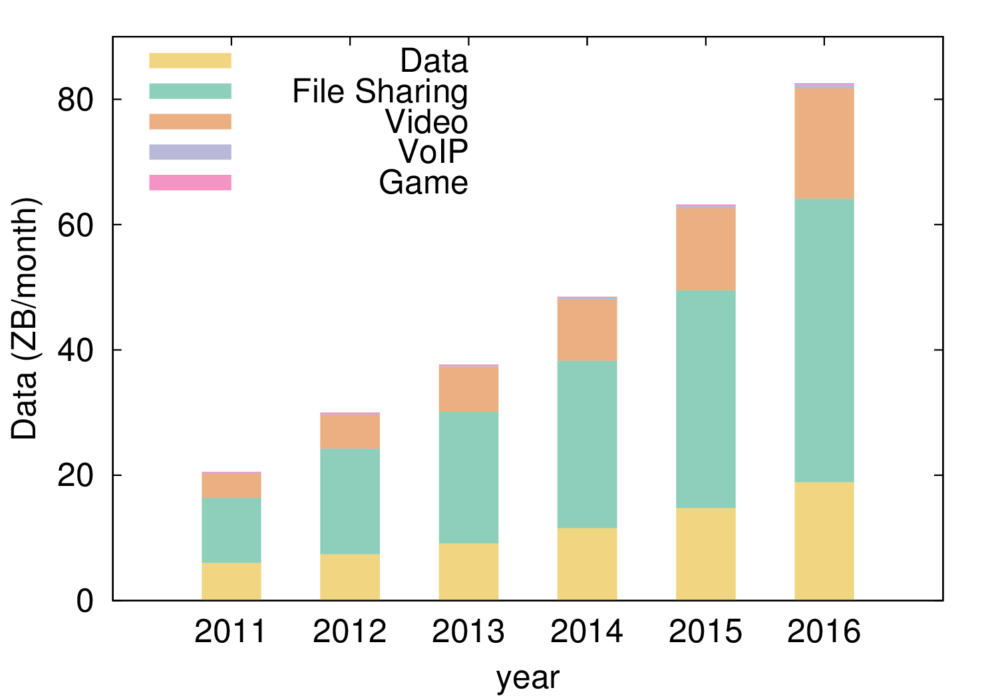
(a) Fixed Internet
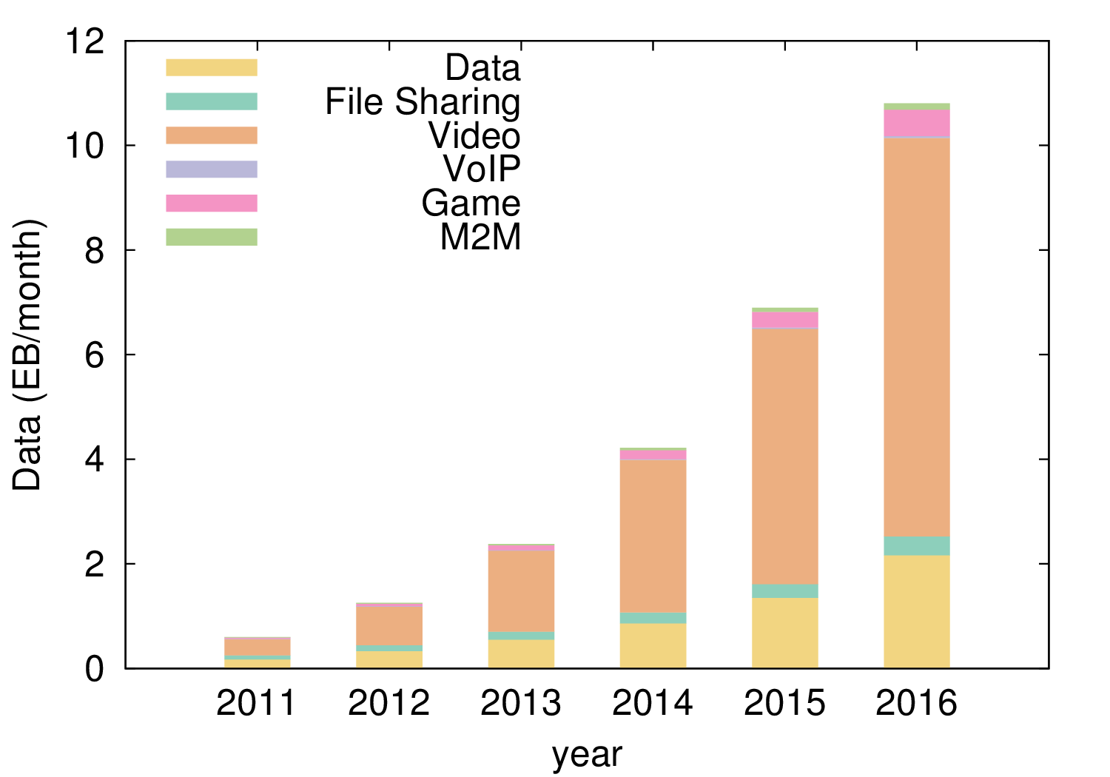
(b) Mobile Internet
Figure 1: Cisco Visual Network Index report on global traffic trends for fixed (Figure Error: Reference source not found) and mobile Internet (Figure Error: Reference source not found).Error: Reference source not foundError: Reference source not found
Application performance exhibits similar complexity at a macroscopic level. Figure Error: Reference source not found presents estimated traffic volumes for six popular network application classes between the years 2011 and 2016 for mobile and fixed Internet, using data from the Cisco visualization index (Mobile, 2012; Cisco, 2012e). Aggregate network traffic volumes exhibit an exponential augmentation and is expected to increase by an order of magnitude for mobile Internet, and by four times for fixed Internet between the years 2011 and 2016. Traffic volume increase is primarily driven by video delivery applications, which are increasing in popularity over file-sharing applications. The popularity churn reflects the availability of predominant file-sharing video content by high-availability CDN services like YouTube. Even so, the two classes exhibit different characteristics with respect to bandwidth requirements, and network providers are obliged to reflect these trends in their network architecture and configuration. Furthermore, application traffic volumes commonly exhibit long-term popularity fluctuation, but a minimum traffic volume will always exist in the network and shape ISP policies and architectures.
A significant evolution also exists in the lower layers of the network. Ethernet has been the predominant Internet link layer protocol since the 80’s, mainly due to its low cost and complexity. The network community has defined standards to implement the Ethernet abstraction over a wide range of medium types, like copper, fibre, off-licence radio frequencies, satellite links and GSM networks, encapsulating significant heterogeneity. This approach hides a number of medium properties (e.g. link layer ARQ, link rate), which reflect significant performance characteristics of the link layer. At the same time, applications, network layer protocols and users remain unaware of these factors, and require homogeneous performance semantics.

1.3 Performance Limitations
Current network protocols have a number of design limitations, primarily due to the inability to predict the radical adoption of the technology during their development. The early adopters of the NSFNET, the incubator of Internet protocol standards, were universities and research facilities, and the resulting system aimed to support asynchronous communication, low data-rates, open service connectivity and best-effort guarantees. These initial assumptions have been radically revised in the Internet over the years, but the protocol designs have not managed to keep up with their evolution. The mismatch between protocol capabilities and current requirements grows in proportion to the increase of link speeds.
In parallel, the evolution of network technologies, and especially of their control plane, has highlighted that the adopters dictate that abstraction simplicity as a primary design goal. The Internet protocol definition process followed a Darwinian selection approach between available solutions during the early days of NSFNET. Along with the TCP/IP protocol suite, OSI and ITU proposed equivalent protocol stacks (ISO/IEC, 2001, 1997), while the ATM Forum also defined similar higher-layer protocols (Siu and Jain, 1995). These protocol design efforts defined detailed abstractions which addressed some current functional limitations. For example, ATM provided strong resource guarantees, motivated by the fixed cell size and circuit-based forwarding approach. Nonetheless, their high complexity faces performance scalability problems with respect to available computational resources, and the protocols became obsolete in favour of the TCP/IP protocol suite. For the rest of the section we will discuss in detail some examples of network bottlenecks, which have arisen as a consequence of the design of current network protocols.

Network management scalability
Policy and configuration interfaces in current networks introduce a significant performance bottleneck. Mahajan et al. (2002) pinpoint a significant portion of global BGP routing errors to protocol misconfigurations, prompted to a great extent by the counter-intuitive configuration interface. Kim et al. (2011) study the configuration evolution of two medium-sized campus networks and highlight the limitations of current configuration interfaces. Device configuration files exhibit a continual size increase, containing frequently stale rules that are pruned only during policy conflicts or major policy revisions. Interfaces remain low-level and inexpressive. As a result, network policy updates translate into multiple device reconfigurations, while forwarding and security policies are merged by the device interface. The configuration bottleneck is equally important in environments with non-expert administrators, like the home network. Grinter and Edwards (2005) conclude that the human understanding of network abstraction is limited, and the complexity of control abstraction leads to under-optimized network configurations, especially in terms of security and performance.
Currently, network configuration relies to a great extent on the network administrator, who is responsible for manually transforming the network policy into specialised configurations for each network device and network layer. For example, the policy must be translated both into VLAN tagging configurations in the data-link layer, and routing and firewall configurations for the network layer. Section Error: Reference source not found provides an extensive presentation of current network control mechanisms and available control abstractions. The rapid development of network technologies has limited effect on device interfaces, which remain low-level and counter-intuitive to administrators. As a result, network configuration still remains a process requiring and relying on the experience of the network administrator. Effectively, network management interfaces introduce a bottleneck on the “mechanism” translating the network policy into distributed device configurations: the network administrator.
Network management requires a technological “revolution”, similar to the introduction of high-level programming languages in the 70’s. In order to scale network management performance, we require new, user-friendly control abstractions, which can automate the process of policy translation, unify the control domain across the network, and customize the control plane functionality to the deployment environment.

Resource allocation
As discussed in Section Error: Reference source not found, modern network functionality requires dynamic, fine grain and rapid resource control in order to fulfil the diverse application requirements. Network engineers commonly address this problem through resource over-provision (Teitelbaum and Shalunov, 2002) which, however, produces reduced effectiveness at high link-rates. High access speeds increase application responsiveness and similarly shape end-user expectations. Although, during high link utilisation incidents, network responsiveness and user experience degrade severely, in the vicinity of queueing delays and packet losses. A number of mechanisms have been proposed to improve resource control, in various layers of the network stack (e.g. ECN (Kuzmanovic et al., 2009), DiffServ (Blake et al., 1998), RSVP over MPLS-TE (Awduche et al., 2001)). These mechanisms however, for different reasons, fail to provide a generic solution to the problem.
The ideal mechanism for effective resource control requires a priori knowledge of resource requirements from end-hosts in order to define optimal resource allocations. Currently, networks follow a distributed approximation using a feedback mechanism between two systems: the end-to-end congestion control; and the network forwarding policy. End-to-end congestion control infers the available bandwidth of the network path using flow properties, like packet loss and RTT variance, and adjusts the traffic rate accordingly. The network forwarding policy defines, statically or dynamically, network paths between hosts, as well as prioritisation and buffer size for specific network flows. Forwarding policy decisions can modify flow properties, affect end-to-end congestion control and enforce resource control policies effectively. Nonetheless, because the two mechanisms are weakly integrated, policy enforcement is effective in long timescales. Resource management in current networks requires smarter control planes, which augment the inputs to the decision algorithm and provide faster responses.

Connectivity scalability
A popular approach to address network scalability problems uses middleboxes; transparent network devices which redefine the behaviour of data plane protocols, like NAT boxes, WAN optimizers and firewalls. Middleboxes have, to a great extent, redefined overall protocol functionality, as they commonly introduce new assumptions into the protocol functionality and violate the “Robustness principle” of networks. In addition, their functionality and behaviour varies significantly between vendors, and remains inflexible and isolated from the control plane of the operating network. Honda et al. (2011) present an Internet-wide robustness measurement study and report that obscure but semantically correct protocol behaviours are unsupported by a number of edge networks, primarily due to the functionality of such devices. Similarly, Hatonen, Seppo and Nyrhinen, Aki and Eggert, Lars and Strowes, Stephen and Sarolahti, Pasi and Kojo, Markku (2010) study the operational semantics of a series of home network routers and highlight significant differences between commercial NAT implementations.
A significant side-effect of middlebox functionality is the redefinition of elementary network properties, like the bi-directionality of network connectivity. For example, NAT boxes improve address scalability, but reduce host reachability. All hosts behind a NAT are able to access any Internet service using a single IP address, but require network reconfiguration to expose an Internet-wide service. A series of protocols has been proposed to enable end-host's middlebox control (Carpenter and Brim, 2002), but their generality is limited and context-specific.

2 Contributions
This dissertation contends that existing network architectures cause a significant performance bottleneck in network functionality and provide limited support to the constantly evolving network requirements of end-users. Modern networks require flexible and specialized control approaches that address complex functional requirements, and unify network control across all devices of the network. Our study employs the SDN control approach and the OpenFlow protocol extensively. Nonetheless, the applicability of our contributions are not limited and can easily adapt to alternative programmable control frameworks. In detail, we claim the following specific contributions:
• Control Plane Scalability: We provide an in-depth study of SDN control scalability. In this context, we present two measurement and evaluation platforms for SDN control: OFLOPS; and SDNSIM. OFLOPS is a high precision switch evaluation platform, providing a range of testing modules for elementary OpenFlow. SDNSIM is a network experimentation platform, specialised for OpenFlow architectures, which allows a user to easily describe and either simulate or emulate an experimental setup. These two platforms establish a generic toolbox, providing a flexible evaluation of SDN control applications. Using these tools, we provide an in-depth analysis of control plane performance and limitations for a wide range of off-the-self OpenFlow implementations. Additionally, using as an input the OFLOPS performance models, we explore the impact of a hierarchical control scheme on the architecture of a small-scale data centre.
• Network Management Scalability: We present a control application which addresses the problem of network management and resource control. We consider the multiple and varied domain of the home network. Motivated by recent ethnographic and measurement studies for home networks, we identify user requirements for accurate network state information and intuitive control primitives. We address these requirement through the home router, by redesigning the control plane functionality. While maintaining full compatibility with existing network applications, our design provides a user intuitive control abstraction, which incorporates the user's social input into the forwarding decision, and improves both access control and QoS.
• Naming And Connectivity Scalability: We revisit the problem of connectivity scalability in the Internet. Our exploration is motivated by the requirement of end-users to interconnect devices across the Internet in an ad hoc manner, thus forming Personal Clouds. Currently, this requirement is fulfilled through data offloading to third party cloud services, raising concerns regarding performance, efficiency and security. We propose Signpost, a distributed control plane architecture for end-hosts, which provides inter-device connectivity and controllable performance and security across the network. In addition, simple augmentation of end-host forwarding logic, allows Signpost to integrate seamlessly with a wide range of existing resource sharing applications.

3 Outline
The rest of this dissertation is organised as follows. Chapter Error: Reference source not found provides background information related to our thesis. Motivated by the architecture of current network devices and the physical and design limitation of network control, we revisit control plane mechanisms and related research efforts into control plane scalability.
In Chapter Error: Reference source not found we study the control scalability of the SDN paradigm. We present two control plane benchmarking platforms, OFLOPS and SDNSIM, designed to provide a high precision evaluation of the scalability of OpenFlow and architectures, respectively. Using these tools, we conduct a measurement study to characterise the performance of baseline OpenFlow operation by SDN-enabled devices and the impact of distributed control architectures in the data plane performance. In Chapter Error: Reference source not found, we study the problem of control plane management performance, focusing on the home network setting. Using existing user studies, we draw out the user network management requirements and redesign the control plane architecture of the home router. Our architecture provides a simpler, user-friendly control abstraction which fulfils the user requirements for control and information from their network. In addition, we provide an extensive evaluation of the architecture, providing evidence on scalability and backwards compatibility. In Chapter Error: Reference source not found we investigate the application of the SDN paradigm in naming and connectivity scalability to create a federated network between a user's devices. We present Signpost, a novel user-centric control plane architecture, providing Internet-wide device connectivity with user-controlled performance and security. We also present the architecture of the framework, its integration with existing connectivity-enabling mechanisms and we evaluate the performance and applicability of the framework. Finally, in Chapter Error: Reference source not found we draw conclusions from our study and discuss areas for further stdy.
Chapter 2

Background
This chapter provides an extensive discussion on network control in packet-switched networks. We motivate the discussion on network control, describing the architecture of network devices and their inherent physical limitations (Section Error: Reference source not found) and elaborate on existing network control mechanisms for production networks (Section Error: Reference source not found). Furthermore, we present three significant efforts in flexible network control, namely Active Networks, Devolved Control of ATM Networks (DCAN) and Software Defined Networking (SDN), proposed by the research community to address limitations in network control schemes (Section Error: Reference source not found). Finally, we focus on the SDN paradigm and present some of its applications in a series of current network problems (Section Error: Reference source not found).

1 Forwarding Devices
In this section we focus on Ethernet networks and provide a high-level design overview of a common forwarding device, the switch. Using this model we highlight the physical limits of network control and motivate a discussion on effective control.

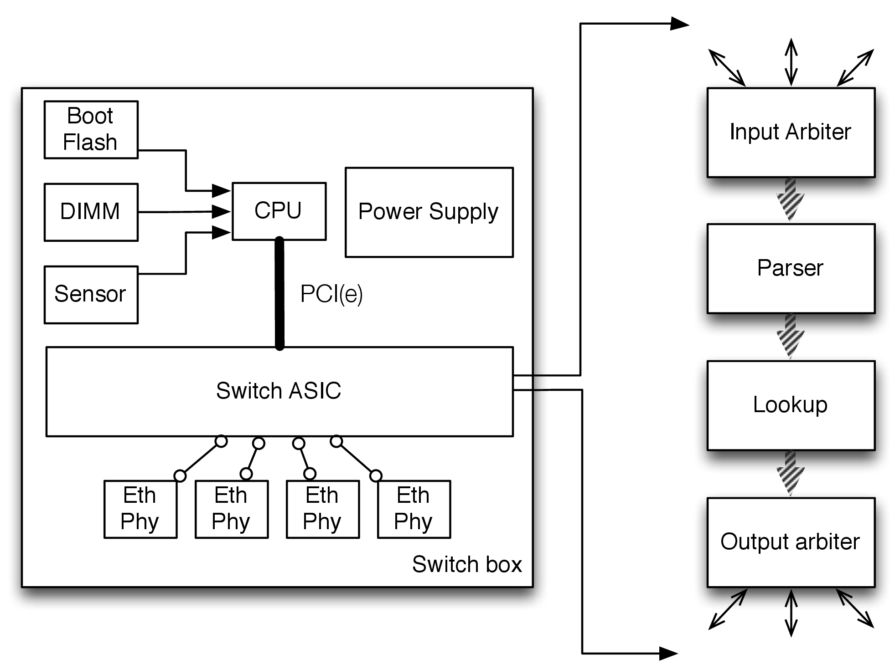
Figure 1: A generic switch design model.
Ethernet switches multiplex Ethernet broadcast domains and provides collision-free connectivity between network segments. Network vendors provide a wide range of switch types with variable functional capabilities (e.g. VLAN support, multilayer switches). For example, an unmanaged switch provides elementary non-configurable functionality with low 1 GbE port density, while a distribution switch provides high 10 or 40 GbE port density and a range of traffic management applications. We use the Top-of-Rack (ToR) switch type to elaborate on the architecture of modern hardware switches. ToR switches are used in data centre and enterprise networks to multiplex traffic between the edge and distribution network layers. Forwarding functionality is implemented using Application-Specific Integrated Circuit (ASIC) silicon, providing multi-GbE line-rate non-blocking traffic forwarding. Figure Error: Reference source not found presents the ToR architecture which consists of the following components:
• Co-processor/management CPU: Switch devices use a programmable CPU to fulfil control plane computation requirements. The CPU hosts a minimal operating system, responsible for translating the device configuration into appropriate ASIC manipulations at run-time. Vendors usually employ low-power CPUs, like SoC PowerPC and ARM processors. The CPU is equipped with runtime (Boot Flash and RAM) and persistent (e.g. SD cards) memory modules. In general, switch CPUs provide sufficient computation resources to run the switch control-plane functionality, but they cannot accommodate intensive processing tasks. The OS provides elementary remote control services, like telnet and SSH, command line/web interfaces and SNMP access to the switch state.
• Switch ASIC: The switch ASIC (HP, 2012; Broadcom, 2013; Intel, ) implements in hardware the data plane functionality. The capabilities of an ASIC are variable, depending on the vendor and the cost, and define the data plane performance limits of the device. ASICs have an expensive development cycle, consisting of long design and testing periods, and require significant human labour and material resource requirements. As a result, innovation has a high latency before reaching production, and the design details remain undisclosed.
The ASIC packet processing pipeline commonly contains four modules. The input arbiter module multiplexes and synchronizes packets from the Ethernet ports to the main processing pipeline of the silicon. The arbiter ensures non pre-emptive packet processing, by bridging the mismatch between the silicon processing clock rate and the link rate. The pipeline also contains a protocol parsing module and a memory lookup module. The protocol parser extracts significant packet fields from network packets, used by the memory lookup module to define packet processing and forwarding. The lookup module uses a memory module, integrated or external to the ASIC, which contains the forwarding policy. Memory modules have a trade-off between cost and access speed and between memory cost and memory management complexity. Finally, the output arbiter module is responsible for applying modifications to the packet and forwarding it to the appropriate output queue. The processing pipeline may contain additional modules which extend functionality, providing access control list (ACL) virtual network queues and flow statistics monitoring.
• ASIC-CPU interconnection: The management CPU is connected to the ASIC over a PCI or PCI-express channel. The interconnection provides an elementary bi-directional channel allowing the CPU to program the ASIC through its register API, and the ASIC to propagate exceptional packets to the CPU. The channel provides sufficient bandwidth for basic control plane communication, but it is not designed to handle high rate information. For example, current Broadcom Trident chipsets use a PCIe 4x or 8x bus, achieving 2 to 4 Gbps capacity.
• Memory: Apart from in-ASIC memory modules, switches also use multiple memory types to support the run-time requirements of the firmware. A switch is usually equipped with CPU Boot Flash, to boot the OS/firmware, DIMM RAM and multiple memory slots, for control plane logging and configuration persistence.
• Ethernet ports: The receipt and transmission of Ethernet packets is implemented by a separate hardware module, implementing the physical and MAC layers of the protocol. The port module connects with the ASIC through a Media Independent Interface (MII) and contains small packet buffers to reduce packet loss.
In terms of data plane performance, the forwarding capabilities of an ASIC are upper-bound by the transistor density and size, as in general purpose CPU silicones. A ToR switch uses a single ASIC, supporting up to 100 Gbps of processing capacity. In terms of control plane performance, the primary limitations are the capacity of the communication bus between the coprocessor and the ASIC, the design of the interface between the two entities, and the processing capabilities of the switch CPU. For a ToR switch, the vendors usually provide a PCIe communication bus, supporting capacities on the order of a few Gigabytes, while CPUs are usually constrained (Section Error: Reference source not found provides details on some off-the-self ToR switches).
ToR switches are simple switch devices and provide low to medium forwarding capacity. Vendors provide network devices that support higher link capacities and enhanced functionalities that have more complex architectures. Multi-chassis switches and routers, used in the core of large networks, cannot fit their processing pipeline requirements in a single ASIC. Packet processing is distributed between multiple silicons, interconnected using complex CLOS crossbar fabrics with non-blocking Terabit backplane capacities (Juniper, 2012). Network control in such devices exhibits similar high complexity, and uses distributed forwarding tables and cache coherent protocols to ensure state consistency (Cisco, 2005). In such devices, ASIC control is complex, inflexible and slow.

2 Forwarding Control in Production Networks
Current network architectures and technologies set dynamic control as a fundamental design goal. Existing standardized approaches provide distributed, autonomous and resilient control, influenced extensively by the end-to-end Internet principle. The administrator is responsible for defining the local policy of a device, and at run-time distributed protocols reconstruct the global network state. Using the global network state, the forwarding logic determines an optimal forwarding policy which optimizes specific aspects of network performance. For the rest of this section we present the control plane functionality in the data-link and network layers of the network stack.

2.1 Data-Link Layer Control
Data-link layer control protocols provide loop-detection, VLAN and QoS configuration automation. Loop detection is used to avoid packet loops in networks with redundant connectivity, asEthernet specification doesn’t support packet timeout functionality. The Spanning Tree Protocol (STP) was a first attempt to address this problem, standardised by IEEE in 802.1D-1998 (IEEE, 1998). The protocol implements the distributed spanning tree construction algorithm, presented in Perlman (1985. The algorithm uses broadcast messages to discover a spanning tree over the network graph, with respect to a common root switch. For each port, the switch maintains a state machine, which disables packet forwarding when the respective link is not part of the spanning tree. Because the initial definition of the protocol faced significant convergence delay after a network change, IEEE introduced the Rapid Spanning Tree Protocol (RSTP), an evolved version of STP (IEEE, 2004). In addition, IEEE Multiple Spanning Tree Protocol (MSTP) (IEEE, 2005) developed a modified version of the protocol, optimized for VLAN-based networks. MSTP constructs spanning trees for each VLAN, which effectively reduces unnecessary port blocking. Cisco has developed a series of proprietary protocols to address the problem in a similar manner (Cisco, 2012c, 2012d). Finally, IEEE recently defined an STP protocol to detect and use redundant paths in the IEEE 802.1aq standard (IEEE, 2006).
In terms of configuration automation, network vendors and standardization bodies have developed a number of protocols to disseminate device status between neighbouring nodes. This functionality differs significantly between vendors. In this class of protocols we consider Link Layer Discovery Protocol (LLDP) (IEEE, 2009), Cisco Discovery Protocol (CDP) (Cisco, 2012a), Extreme Discovery Protocol (EDP) and Nortel Discovery Protocol (NDP). Finally Cisco has developed the VLAN Trunking Protocol (VTP), a protocol which reduces the VLAN configuration burden in inter-switch trunk links.
In the class of data-link layer protocols, we also consider the MPLS protocol (Rosen et al., 2001). MPLS is a circuit-based technology and uses labels to forward packets, effectively reducing forwarding table sizes. MPLS circuit creation is automated through the Label Distribution Protocol (LDP) (Andersson et al., 2007), which uses an underlying routing protocol to compute and setup labels across the network. The IETF defines an RSVP resource allocation mechanism over MPLS (Awduche et al., 2001) and Autobandwidth (Osborne and Simha, 2002), an automatic mechanism to enforce such resource allocation. Because resource policing in not supported by MPLS, autobandwidth monitors the bandwidth requirements for each circuit and reconfigures circuits in order to fulfil measured requirements. Pathak et al. (2011) analyse an autobandwidth deployment on the MSN network, and highlight significant latency effects as a result of the autobandwidth functionality.

2.2 Network Layer Control
Control in the network layer is responsible for collectively constructing an optimal forwarding table between the routers of a network. Routing protocols are generally categorized into three classes: Link State; Distance Vector; and Path Vector. Link state protocols theory build on-top of the Djikstra algorithm (Dijkstra, 1959). Routers disseminate their local forwarding configuration to the rest of the network. Using this global state exchange, each router is able to construct the global connection graph. Each router can use the graph to calculate the minimum spanning tree of the network, using Djikstra’s algorithm. Currently there is a plethora of Link State protocol specification in the network community. IETF has developed the OSPF protocol (Moy, 1998), an IPv4 specific routing protocol, while the Open Systems Interconnection (OSI) organisation has defined the IS-IS protocol (Oran, 1990), a network layer agnostic routing protocol. Link State routing protocols provide high flexibility in defining the optimisation function of the routing system. Each router has a view over the complete graph of the network, and routers can propagate multiple link performance indexes (e.g. link load, link speed ). Nonetheless, the optimization function must be homogeneous across the network, in order to avoid routing loops.
Distance Vector protocols follow a different routing approach, based on Belman-Ford (Bellman, 1956). The routing table is constructed using information from adjacent routers. Network changes are slowly propagated across the network, through point-to-point information exchanges, until all routers converge. IETF developed the RIP protocol (Malkin, 1998) to implement Distance Vector routing, while Cisco has developed the proprietary IGMP protocol (Rutgers, 1991). Distance Vector protocols are less extensible in comparison to Link State protocols, but exhibit lower computational and memory requirements.
Finally, Path Vector protocols evolve Distance Vector protocols to support inter-domain routing. Path Vector routing discloses minimal information in terms of the forwarding policy of an AS, advertising only supported network paths, As a result, Path Vector protocols do not define a routing algorithm. The BGP protocol (Rekhter, 1991) is currently the predominant Path Vector routing implementation. As Internet increases in size, BGP deployment has experienced significant scalability problems and motivated some of the network control frameworks presented in Section Error: Reference source not found. A significant scalability problem in BGP is the impact of path updates in the functionality of routers in large ASs. Path updates are handed by the iBGP protocol using a full-mess dissemination approach, which incurs significant router load and memory usage. A widely used approach in addressing this problem uses Route Reflectors (RR) (Bates et al., 2006) hosts, which form a hierarchical update dissemination mechanism and reduce forwarding information on each router. A further improvement on iBGP scalability was developed by (Caesar et al., 2005) as part of the Routing Control Platform (RCP), proposing control centralisation similar to the SDN paradigm. RCP basically proposed the centralisation of the BGP routing table calculation within an AS.
Due to their distributed nature, routing protocols provide long-term routing resilience, while their mathematical foundations are provably correct. Nonetheless, the control abstraction of these protocols is not a good fit for an administrator to exercise dynamic control over the network. For example, the ability of a network manager to estimate the impact of a significant forwarding policy update is reduced as the network size get bigger. In 2008, the global Internet was severely affected by a BGP misconfiguration in the Pakistani national ISP in an effort to control traffic from the YouTube service (Brown, 2008). In addition, routing inconsistencies during routing changes can significantly impact network performance. Watson et al. (2003) evaluate that OSPF functionality in a regional ISP exhibits high routing churn, even during periods with low control plane activity, while the latency in convergence after a network change is, on average, on the order of seconds. Similar results have been observed in BGP. Kushman etal. (2007) highlight a strong correlation of BGP instability and VoIP performance. Modern high speed networks require higher flexibility and responsiveness in the control abstraction.

3 Programmable Network Control
The limitations of current standardized network control frameworks have motivated the research community to reconsider their design. The rest of this section presents three significant efforts, namely Active Networks, Devolved Control of ATM Networks (DCAN) and Software Defined Networking (SDN).

3.1 Active Networks
The network research community has highlighted the inevolvability of network functionality, often termed protocol ossification, since the early 90’s. (O’Malley and Peterson, 1992) challenged the generality of the OSI network model and suggested synthesizable protocol parsers, which can incorporate variable numbers of layers in forwarding devices. Motivated by these observations, DARPA funded the Active Networks project (DARPA, 1997) to develop next generation network devices supporting seamless network upgradability.
Active networks evolve the packet processing pipeline. Specifically, they introduce the notion of capsules; network packets carrying data and processing code. On each hop, the default packet processing logic is extended with the capsule code. Active Networks provide user-driven protocol upgrades without any device or driver modification.
Research in active networks defined two primary aspects of Active Network design: the capsule API and format and the switch architecture. In terms of capsule format, the active network community defined the Active Network Encapsulation Protocol (ANEP) (Alexander et al., 1997a), adopted by the ANTS and Sprocket capsule programming frameworks. Sprocket (Schwartz et al., 2000) was developed by BBN technologies and defined a capsule programming language, based on the C programming language. Sprocket removed all insecure C structures, like pointers, and provided native support for SNMP browsing. Its compiler produced MIPS assembly code and the capsule code was executed using a MIPS VM on each network device. Sprocket did not persist any state on the switch, but allowed in capsule code modification of packet data. ANTS (Wetherall et al., 1998) was an attempt by the MIT Active Network group to develop a JAVA-based capsule programming environment. ANTS used a restricted version of the Java language, and switch and capsule integration was modelled using Java interfaces. Capsule code could persist state on switches and modify packet content. An interesting functionality of the ANTS framework was the code dissemination mechanism. An end-node would deploy its protocol functionality solely to the local Internet gateway, and the code would be forwarded along the network towards the destination, hop-by-hop. Finally, the University of Pennsylvania's active networks group developed PLAN (Hicks et al., 1998), an OCaml-based approach to capsule programming. PLAN did not follow the ANEP packet format. A PLAN capsule contained code and data, with the capsule code replacing the network header information. In order to secure switch infrastructure, the language disallowed packet data modification or switch state persistence. Ultimately, the language provided a framework for programmable control plane.
In terms of active network platform architecture, the community developed a number of architectures, addressing many efficiency aspects in capsule processing. The University of Pennsylvania developed the SwitchWare Execution Environment (EE) (Alexander et al., 1998a). The architecture developed an OCaml capsule processing framework providing enhanced security for the switch and capsule execution environment. SwitchWare used SANE (Alexander et al., 1998b), a trustworthy operating system, to secure the functionality of the switch, and build on top of its primitives to provide higher level of security. The platform addressed issues regarding secure execution and authentication as well as capsule code verification. PLANet (Hicks et al., 1999) and Active Bridge (Alexander et al., 1997b) used the SwitchWare framework to implement novel functionality in active networks.
The active networks group in the University of Arizona presented a switch architecture which optimized multi-layer packet processing using the communication-oriented Scout OS (Montz et al., 1995). On top of Scout, the group developed the Liquid Software API (Hartman et al., 1999), providing a tight integration between the OS and the JVM, and improved capsule processing using the JIT JAVA compiler.
The CANEs project (Chae and Zegura, 2002) from the Georgia Tech Active Network group proposed a switch architecture, which improved flexibility in multi-protocol packet processing. Specifically, it defined a number of abstractions, which allowed multiple protocol stacking on the forwarding path. CANE's project build on top of the Bowman Switch OS (Merugu et al., 1999) and established a simple and efficient abstraction over switch resources. Researchers from Columbia University developed the NetScript switch programming language (da Silva et al., 2001), designed for flexible protocol processing definition and composition. The language provided seamless extensibility in protocol implementation logic, providing three types of protocol composition: layered composition; composition through protocol bridging; and end-to-end composition.
Finally, a joint effort between ETH and the University of St. Louis, developed a high performance capsule-enabled switch design. The High Performance Active Network Node (ANN) switch architecture (Decasper et al., 1999) used an FPGA-based CPU on each ATM interface to handle capsule execution. The CPU could run the ANTS EE and provided an IPv4 and IPv6 protocol processor supporting Gigabit rates.
Active networks addressed a number of interesting problems in control plane functionality, especially issues like controllability and evolvability, and motivated recent efforts in the field. Nonetheless, proposed architectures followed a complex and clean-slate approach, and thus reduced their applicability in production environments. In addition, active network functionality benefited highly from the relatively low link rates of the time, which were manageable by the CPU chipsets. The exponential increase in link capacities, supporting up to Gigabit rates, restricts our ability to support the rich programmability of active networks. Finally, the flexibility provided by active networks raised significant concerns on network security and resource controllability.

3.2 Devolved Control of ATM Networks

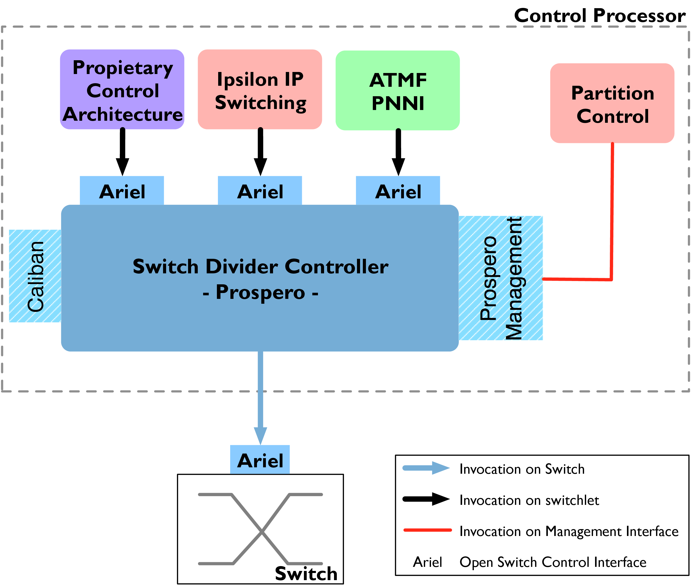
Figure 2: Tempest switch architecture (van der Merwe, 1998)
Active networks focused extensively on Ethernet technologies and strived to develop protocol evolvability. A similar approach was developed in the University of Cambridge for the DCAN (2000), focusing primarily on control evolvability and network virtualisation in ATM networks. DCAN tried primarily to simplify the control plane of ATM devices, in order to support network multi-functionality. Similar efforts were developed by IETF through the General Switch Management Protocol (GSMP) (Doria et al., 2002).
(Rooney et al., 1998) presented Tempest, a novel ATM switch architecture, which enabled clean separation of the control and forwarding plane of an ATM switch. Similar to the SDN approach, the control plane was centralised in a single programmable entity, which could implement intelligent and dynamic forwarding. The implementation of Tempest was logically divided between three subsystems, depicted in Figure Error: Reference source not found. The figure presents how a single switch is able to function in parallel as an IP router, an ATM switch and a Hollowman controller (Rooney, 1997), a devolved ATM control framework.

3.2.0.1 Prospero Switch Divider
The Prospero abstraction provides a mechanism for virtualising ATM switch resources into multiple virtual switches, called switchlets, through a resource control interface. A switchlet controls a subset of switch ports, VCI and VPI mappings, packet buffers and bandwidth. Prospero used the ATM QoS principles to implement packet buffer and bandwidth virtualisation. Fundamentally, Prospero is responsible for mapping the control interface, exposed to controllers, to the underlying switch functionality.

3.2.0.2 Ariel Switch Independent Control Interface
Switchlets exposed forwarding control through the Ariel Interface. The Ariel Interface organises network control through six control objects: Configuration, Port, Context, Connections, Statistics and Alarms. The Configuration object provides details for the switch configuration; the Port object provides primitive controllability of ports (e.g. state, loopback functionality); the Context object enables QoS policy control; the Connection object exposes control of VPI/VCI mappings; the Statistics object exposes packet and byte counters; and the Alarms object pushes state change notifications to the controller. Tempest switches executes an Ariel server and translates Ariel requests to Prospero control requests. Ariel was fundamentally an abstraction layer between the switch silicon and the Prospero control interface.

3.2.0.3 Caliban Switch Management Interface
In addition to network control, Tempest also supports evolved network management through the Caliban interface. The interface functionality is similar to the SNMP protocol. Caliban provides fine level SNMP-style information, as well as higher level aggregation operations over the switch state.
In addition to the redefinition of the network control abstraction, Tempest also proposed a relaxed network resource management scheme. Specifically, the architecture proposed a measurement-based admission control mechanism for circuit establishment (Lewis et al., 1998). The measurement scheme redefined the static resource allocation scheme in an ATM network, and used effective bandwidth measurement techniques to estimate available resources and provide higher utilisation of network resources, with minimum relaxation of the QoS guarantees.
Tempest defined a highly efficient network control abstraction, which motivated modern network control approaches, like the SDN, to reimplement it over Ethernet devices. The simplicity of the control abstraction permitted integration of the technology with existing forwarding devices, and enabled line rate forwarding and efficient resource control. Nonetheless, its strong reliance on the ATM technology made the approach less relevant for the modern Ethernet-dominated networks (Crosby et al., 2002).

3.3 SDN
SDN (Foundations, 2012), the most recent network control paradigm, provides a pragmatic approach for controlling evolvability. SDN employs a clean separation between the control and forwarding plane of a network device. The control logic is removed from the network device and implemented by a separate service. A well defined protocol establishes the integration between the two entities.
The SDN paradigm is motivated by relevant earlier attempts in network programmability (active networks and DCAN), but follows an evolutionary approach. The paradigm is motivated by two key observations. Firstly, the evolution of computer networks has collapsed the layers of the OSI and TCP/IP model. Production networks use network devices (e.g. firewall, NAT, layer-5 switches) which operate on multiple layers of the network and engage extensively in layer violation. The SDN paradigm provides a unifying cross-layer control model which fits such functionality under a single interface. Secondly, although network complexity has increased, network devices still expose stand-alone, decentralised and inflexible configuration mechanisms (e.g. remote logic, CLI interfaces), and employ proprietary control protocols, which reduce device interoperability within the network. The SDN architecture establishes centralised and unified management, supporting high control reactivity. The OpenFlow protocol is currently the pre-dominant implementation of the SDN paradigm.

OpenFlowprotocol

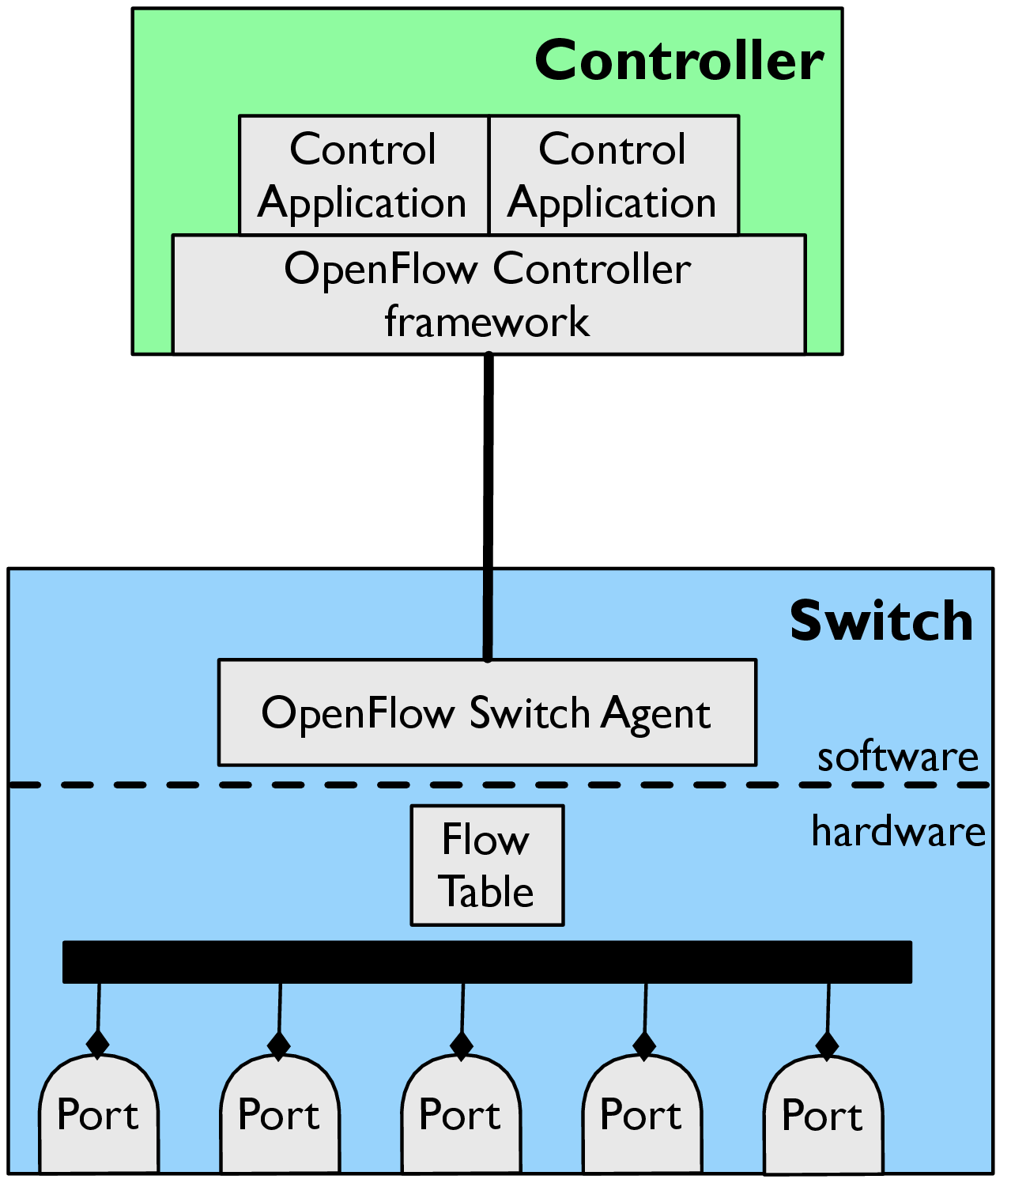
Figure 3: A schematic representation of a basic OpenFlow

Field | OpenFlow Version
src & dst MAC addr. | 1.0
input port | 1.0
VLAN ID | 1.0
VLAN PCP | 1.0
MPLS label | 1.1
MPLS class | 1.1
IPv4 src/dst addr. | 1.0
IPv4 proto | 1.0
ARP opcode | 1.0
ARP src/dst IPv4 address | 1.0
ARP src/dst MAC address | 1.2

Field | OpenFlow Version
IPv4 ToS | 1.0
ICMPv4 Type & Code | 1.0
TCP/UDP/SCTP src/dst port | 1.0
Metadata | 1.1
IPv6 src/dst addr. | 1.2
IPv6 flow label | 1.2
ICMPv6 type & code | 1.2
ICMPv6 Network Discovery target address | 1.2
ICMPv6 Network Discovery src/dst MAC address | 1.2

Table 1: OpenFlowfields
Field | Operation | OpenFlow Version
OUTPUT | output packet to a port | 1.0
SET_QUEUE | output packet to a port queue | 1.0
SET_VLAN_VID | modify VLAN id | 1.0
SET_VLAN_PCP | modify VLAN PCP | 1.0
SET_DL_SRC SET_DL_DST | modify src/dst mac addr. | 1.0
SET_NW_(SRC,DST) | modify IPv4 src/dst addr. | 1.0
SET_NW_TOS | modify IPv4 ToS | 1.0
SET_NW_ECN | modify IPv4 ECN bits | 1.1
SET_TP_(SRC,DST) | modify TCP/UDP/SCTP src/dst port | 1.0
COPY_TTL_(OUT,IN) | copy TTL value for IPv4 tunnels | 1.1
SET_MPLS_LABEL | modify MPLS label | 1.1
SET_MPLS_TC | modify MPLS traffic class | 1.1
(SET,DEC)_MPLS_TTL | modify/decrement MPLS TTL | 1.1
(PUSH,POP)_VLAN | Add/remove a VLAN header | 1.1
(PUSH,POP)_MPLS | add/remove MPLS tag | 1.1
(SET,DEC)_NW_TTL | modify/decrement IPv4 TTL value | 1.1
(PUSH,POP)_PBB | remove/add a PBB service tag | 1.3

Table 2: OpenFlow packet actions
OpenFlow was originally defined an organisation of academic institutes, also named OpenFlow, but currently the protocol development is steered by the ONF, a standards definition committee comprised of academic institutions, service providers and network vendors. OpenFlow has been a highly successful approach to network control. It is readily available in a series of production devices as well as in large enterprise networks (Google, 2013; Kobayashi et al., 2012).
Figure Error: Reference source not found presents an elementary OpenFlow, consisting of two entities: the controller and the switch. The two entities communicate over a TCP control channel. The OpenFlow executes the network control logic and disseminates it to switches over the control channel. The controller is usually divided into two layers. A controller framework encapsulates the low level OpenFlow logic and exposes a higher level abstraction to the developer. Table Error: Reference source not found presents a complete list of available OpenFlow frameworks. The network control is implemented in modules running over the controller framework.
The OpenFlow, also called datapath, abstracts the control of a forwarding device. It consists of a set of flow tables and a set of ports. The flow table is a memory module containing flow entries which encode the active network policy. The data of a flow entry can be decomposed into three structures: the flow tuple; the flow statistics; and the flow action list. The tuple defines packet matches using header fields to group packets into flows. The fields of the tuple have evolved over the years and Table Error: Reference source not found presents the match tuple fields in each protocol version. Each tuple is associated with a field mask and permits wildcard matching. Flow statistics stores packet and byte counters for each flow. The action list contains the list of actions applied to each matched packet. We present in Table Error: Reference source not found the packet processing actions defined by the OpenFlow. The protocol defines a simple packet processing algorithm. For each packet, the datapath extracts a set of header fields and matches them against the entries of the flow tables. If a matching flow is found, then the flow statistics are updated and the action list is applied on the packet. If there is no matching entry in the flow table, then the packet is sent to the controller. The implementation of the OpenFlow abstraction in production switches is usually split between the hardware and software plane of the device. An OpenFlow runs on the switch co-processor, translating OpenFlow into an ASIC configuration.
The protocol defines a number of message types for controlling datapath resources. OpenFlow can be grouped into two categories: forwarding control and switch configuration. The rest of the section presents further details on available OpenFlow, and discusses the evolution of the protocol. We focus our protocol presentation on version 1.0 of the protocol. ONF has released three revisions of the protocol, versions 1.1, 1.2 and 1.3, which significantly change the protocol specification. Nonetheless, the majority of production systems support version 1.0.

3.3.0.4 Forwarding control
OpenFlow has two main control modes: reactive and proactive control. In reactive control, the switch forwards every unmatched packet to the controller, which is then responsible for responding with an appropriate modification in the flow table. The protocol defines the pkt_in message to encapsulate the header of a data plane packet when forwarded to the controller, and the flow_mod message to manipulate the flow table. The reactive control approach provides fine control over the traffic dynamics, but introduces significant load on the control plane. In proactive control, the controller is responsible for pre-installing all required flows in the flow table and avoiding any packet handling exceptions. The OpenFlow provides the flow_stats_req/flow_stats_resp, port_stats_req/port_stats_resp and aggr_stats_req/aggr_stats_resp controller messages to poll for flow and port statistics and infer network resource allocation. In order to ensure operational atomicity, the protocol provides the barrier_req/barrier_reply message to synchronise message execution between the controller and the switch. A barrier_reply is send by a switch as a response to a barrier_req from the controller, when all previous operations are processed. Finally, the OpenFlow provides two additional message types to enhance control capabilities: the pkt_out and the flow_removed. The pkt_out message enables the controller to inject traffic in the data plane and the flow_removed message can notify the controller when a flow entry is removed from the flow table.

3.3.0.5 Switch configuration
Apart from the control of the flow table, the OpenFlow provides switch configuration capabilities. A controller can use the switch_config_req/switch_config_resp message types, to discover the switch operational support of OpenFlow. In addition, the protocol provides capabilities for controlling port states with the port_mod message type. The switch is also able to notify the controller when a port changes its state (e.g. link is detected to be inactive in the physical layer) with the port_status message. In recent revisions of the protocol, the steering committee has introduced the capability for controlling per port traffic shaping queues.

3.3.0.6 Protocol evolution
Since the specification of the version 1.0 of the protocol, the OpenFlow committee has produced 3 non-backwardly compatible protocol revisions. This protocol evolution is driven both by the osmosis between the hardware and software community and the introduction of new deployment use-cases.
Version 1.1 modifies the main protocol processing pipeline and exposes a switch abstraction which better matches the design of an ASIC. Specifically, the packet lookup process searches sequentially, instead of in parallel, between the switch flow tables. The packet must match an entry in each of the tables, otherwise a pkt_in message is generated. In addition, in order to persist partial results between tables, the protocol defines a 64-bit per-packet metadata field and the action list is augmented with operations over the metadata field and over the table search process (e.g. terminate lookup, skip table). Secondly, the protocol introduces a primitive to express multipath support using a new forwarding table, i.e. the group table. Group table entries consists of group entries containing flow actions and an assigned output port. A flow table entry can forward a matching packet to a group entry. The group selection action can forward a packet to all the buckets of the entry (ALL) or to a random bucket, similar to Equal Cost Multiple Path routing (ECMP) (Hopps, 2000) functionality, (SELECT); or select a specific bucket (INDIRECT); or to the first group entry with a non-blocked output port (FAST_FAILOVER). Thirdly, the protocol introduces MPLS support.
Version 1.2 of the protocol extends data plane protocol support. This revision introduces support for IPv6 and Provider Bridge Network (PBB - Mac-in-Mac) traffic. In addition, the protocol uses a flexible type-length-format (TLV) for flow tuple definitions. Finally, the protocol defines a model for efficient multi-controller switch connectivity, in an effort to improve control channel resilience.
Version 1.3 introduces protocol support of QoS control. The protocol defines a new table abstraction, the metering table, which contains queue definitions. In addition, this protocol defines a control plane improvement using multiple parallel control channels to the controller, in order to parallelise pkt_in transmission, and defines a mechanism to support message fragmentation.
Because the protocol complexity has increased significantly in recent versions of the protocol, the vision for future OpenFlow is to differentiate support between devices, and only optimize a subset of the functionality. For example, a firewall device can support only network and transport layer field match to improve flow table capacity.

4 SDN applications
Language | Controller
Python | NOX (Gude et al., 2008b), POX (Pox, 2012), Pyretic (Monsanto et al., 2013)
C++ | NOX (Gude et al., 2008b)
JAVA | Maestro (Cai et al., 2011), Floodlight (Switch, 2013)
Haskell | Nettle (Voellmy et al., 2010)
C | Mul (Saikia, 2013)
Javascript | Nodeflow (Berger, 2012)
Ruby | Trema (Trema, 2011)

Table 3: List of OpenFlow, organised by programming language
Vendor | Model | OpenFlow
HP | 8200zl, 6600, 6200zl, 5400zl, and 3500/3500yl | v1.0
Brocade | NetIron CES 2000 Series | v1.0
IBM | RackSwitch G8264 | v1.0
NEC | PF5240, PF5820 | v1.0
Pronto | 3290, 3780 | v1.0
Juniper | Junos MX-Series | v1.0
Pica8 | P-3290, P-3295, P-3780 and P-3920 | v1.2

Table 4: List of hardware switches with OpenFlow
The SDN paradigm has proven extremely effective, both for the network community and the industry. A number of vendors provide production-level hardware SDN support (Table Error: Reference source not found), while the SDN community provides OpenFlow support for the majority of programming languages (Table Error: Reference source not found). In this section we iterate a series of network problem classes and present the design of a series of effective SDN applications which address these problems.

4.1 Network Virtualisation Applications
The introduction of OS virtualisation, and the subsequent rise of the cloud computing paradigm, has created new opportunities for ICT to reduce infrastructure costs and provide a high level of resilience to applications. Although OS virtualisation platforms, like Xen, provide high precision resource allocation and performance isolation, there is still a significant mismatch in the network abstraction. The introduction of the SDN abstraction in the data centre provides novel opportunities to extend the virtualisation abstraction in network resources.
(Sherwood et al., 2010a) presented FlowVisor, an early network virtualisation approach based on OpenFlow. FlowVisor is an OpenFlow between switches and controllers, and manages to transform control over a set of switches into a single big virtual switch abstraction. FlowVisor is a simple network topology discovery and resource control mechanism, while appropriate message processing allows to translate the view between the two abstractions. The administrator can partition the OpenFlow, delegate network control to different controllers and, effectively, allow multiple tenants to exercise network control for their own network subnet over the same network infrastructure. FlowVisor quickly transformed into a network product by BigSwitch. Furthermore, Corin et al. (2012) developed a topology virtualisation extension for FlowVisor. FlowN (Drutskoy et al., 2013) follows a different approach and integrates virtualisation into the programming framework. The framework uses VLAN tags to multiplex data plane traffic and synchronizes controller states through an SQL database. Finally, Nicira provides the Nicira Network Virtualization Platform (NVP), a production level network virtualisation and control isolation framework. However, it is proprietary and it's implementation details are undisclosed.

4.2 Security and Access Control Applications
SDN provides fast prototyping for secure network applications and unprecedented control reactivity to threat detection frameworks. Ethane (Casado et al., 2007), an early attempt to define the SDN abstraction, established a policy expression language to control interactions between user identities and network services. Ballard et al. (2010) focus on the problem of effective network monitoring and present OpenSAFE, a policy expression language for efficient traffic interception and inspection. Finally, Porras et al. (2012) present FortNOX, an security extension for network virtualisation applications. FortNOX enables users to assign priorities and roles to control applications and automatically resolve policy inconsistencies.

4.3 Load Balancing Applications
The high popularity of network services with a global scope has introduced a requirement for novel indirection mechanisms, with high responsiveness and resilience. Current approaches employ proprietary load balancing devices, which dynamically distribute user requests between servers. SDN can integrate the indirection functionality in the network fabric. Wang et al. (2011) present an in-network proactive load balancing framework which uses the range of the OpenFlow wildcard matching to distribute client load between servers. Handigol et al. (2009b, 2010) follow a reactive approach to the problem. For each new client, their Plug-and-Serve controller chooses on-the-fly a destination server, based on an allocation algorithm and the overall system load.

4.4 Inter-domain and Intra-domain Routing
The SDN community has developed a series of applications to improve the performance of existing control plane protocols. Rothenberg et al. (2012) present an integration of the Quagga routing framework with the OpenFlow, in an effort to revisit Route Reflectors in BGP routing (Bates et al., 2006). Similarly, Kotronis et al. (2012) revisits the problem of BGP routing instabilities and proposes a framework for OpenFlow-based BGP calculation offloading to third parties.
The SDN has also motivated explorations on forwarding state compressibility. Sarrar et al. (2012) present a library which exposes an OpenFlow-based FIB abstraction for routing applications. The library at run-time analyses the FIB table and traffic pattern, and calculates the minimum set of flow entries which can server a specific subset of the traffic on the fast-path of the network. Yu et al. (2010) present DIFANE, a valiant routing framework achieving significant FIB table compressibility. The proposed mechanism uses the OpenFlow to partition effectively the network IP space and aggregate subsets of the FIB on each network device.

4.5 Network Management Applications
SDN control primitives can support the development of innovative network management frameworks. One of the first efforts was the Onix management framework (Koponen et al., 2010). Onix provides a centralised control abstraction through its development API, which at run time was transparently distributed across the network.
The SDN paradigm has found significant applications in the formalisation of the network management. Foster et al. (2011) present Frenetic, a declarative programming language for network control policies, providing inherent support for significant network control programming requirements, like race conditions. Monsanto et al. (2012) developed NetCore, a policy expression language providing dynamic policy adaptation to traffic and topology changes and automatic optimization of the forwarding state. Guha et al. (2013) introduced verifiability to the NetCore language, while Monsanto et al. (2013) proposed an extension which provides seamless integration between control applications. Such control abstraction has also been discussed in the context of network upgradability. Reitblatt et al. (2012) present a verifiable framework which ensured network operability during updates. Finally, Voellmy et al. (2012) present a declarative policy language exposing a functional reactive programming model and providing flexible development.

4.6 Energy Control Applications
In recent years, energy consumption has become an important measure of the efficiency of a system's architecture. Currently the network is estimated to contribute approximately 20% of the total power consumption of a data centre. Unlike CPUs, which can reduce power consumption when idle, network cards exhibit a constant high power consumption, due to continuous physical layer frame synchronisation. As a result the most efficient mechanism to reduce network power consumption is to shutdown the interfaces. Heller et al. (2010) present a power-aware control plane architecture, built on top of the OpenFlow. The application takes advantage of link redundancy and turns off interfaces when network utilisation is low.

4.7 Network Debugging and Measurement Applications
The SDN paradigm, as well as the OpenFlow, provide novel mechanisms for network troubleshooting and debugging. Wundsam et al. (2011) present OFRewind, a mechanism for intercepting and recording network policy inconsistencies for debugging purposes. Handigol et al. (2012b) present NDB, a control plane debugger which replicates the GDB abstraction for OpenFlow. NDB enables developers to register data plane breakpoint conditions and receive rich state information when these conditions are met. Finally, a number of applications have been proposed to enable control plane monitoring in order to detect potential network misconfigurations. Khurshid et al. (2012) present an OpenFlow service which detects flow modifications that create forwarding policy inconsistencies. Canini et al. (2012) present a model-checking mechanism which uses symbolic execution to detect flow modifications that create significant inconsistencies in data plane forwarding. Recent efforts in remote network debugging have introduced OpenFlow-based solutions for home networks. Calvert et al. (2010) propose a network controller providing precise home network logging, in an effort to enable ISPs to troubleshoot connectivity problems.

4.8 Resource Control Applications
SDN reactivity enables fine-level resource control, and a number of applications have been developed for data centre environments. Al-Fares et al. (2010) presented Hedera, a novel data centre control architecture, providing better network utilisation in comparison to the ECMP (Hopps, 2000) network load-balancing mechanism. Hedera uses the OpenFlow statistics to discover progressively network-limited flows and reroute them over underutilised network paths. Benson et al. (2011) presented a network load distribution mechanism designed to exhibit fairness towards short-lived flows. Even et al. (2012) employ OpenFlow as a network embedding mechanism for data centre job assignments and to provide strong resource guarantees.
Resource control has also been proposed in the context of home networks. Yiakoumis et al. (2011) propose home network virtualisation in an effort to improve resource allocation on the edges, and enable core infrastructure sharing between ISPs. Furthermore, Yiakoumis et al. (2012) evolve this idea and introduce a simple user interface which can translate user resource requirement into ISP-wide network policies.

4.9 Mobility Applications
The SDN paradigm provides novel control capabilities in mobile networks. Huang et al. (2010) present PhoneNet, a mobile application development framework which provides the ability for dynamic multicast groups setup. Yap et al. (2009, 2010) present OpenRoads, a network control plane for wireless networks, enabling seamless Access Point (AP) hand-overs and network virtualisation. Finally, Li et al. (2012) discuss SDN applicability for cellular networks.

4.10 Network Simulation
Currently, a number of large-scale shared experimentation infrastructures provide OpenFlow. The GENI testbed (Global Environment for Network Innovations, 2013) funded by the NSF, and the Ofelia testbed (2013) funded by the EU, FP7 framework provide network and computing resources for running large-scale experiments for free. Erickson et al. (2011) present Virtue, a large-scale Xen-based emulation framework which uses the OpenFlow protocol to enable scalable user experimentation with network topologies, and VM placements in a multi-tenant data centre environment. Similarly, Mininet (Lantz et al., 2010; Handigol et al., 2012a) provides a scalable platform for OpenFlow experimentation and reproducibility. Mininet uses the LXC (2013) Linux user-space virtualisation framework and network namespaces to run large scale topologies in a single host and experiment with network functionality. Mininet has been used in the Stanford Computer Science department to introduce students to recent research efforts (McKeown et al., 2012).

5 Conclusions
In this section we provided an in-depth analysis of available network control mechanisms. We started the discussion by presenting a generic architectural model for network devices, and highlighted the inherent limitations of network control. Furthermore, we presented the current production control mechanisms and, motivated by their limitations, we presented three experimental network control frameworks, i.e. Active Networks, Devolved Control for ATM Network and Software Defined Networking. Finally, we provided an extensive presentation of recent efforts to improve modern network functionality through control plane redesign. In the next chapter we present an extensive study on the scalability of the SDN paradigm.
Chapter 3

SDN Control Plane Scalability
This thesis contends that control plane applications can scale aspects of computer network functionality. In our exploration we extensively employ the SDN design paradigm and the OpenFlow abstraction, primarily due to two core functional properties. Firstly, the clean separation of the network control and data plane is inherently backwards-compatible with existing network applications and interoperable with existing network devices. The evolution of the control plane of a network does not affect data plane protocol support and allows progressive deployment in production networks. Secondly, the OpenFlow abstraction is sufficiently generic to support various control approaches. The protocol supports reactive and proactive control schemes, while the flow definition granularity can be dynamically controlled to match the environment requirements. The following chapters of this thesis employs the OpenFlow to address two diverse network scalability problems.
This chapter presents an extensive scalability analysis of available SDN technologies. Our exploration provides an in-depth analysis of the limitations of existing implementation efforts and their impact on data plane performance. The work focuses on implementations of version 1.0 of the OpenFlow, the predominant production-level protocol SDN instantiation. We present two measurement platforms: OFLOPS and SDNSIM. OFLOPS is a high precision OpenFlow switch micro-benchmark platform. Using OFLOPS, we implement a set of benchmark tests and characterise the performance of elementary protocol interactions. SDNSIM is a macro-benchmark OpenFlow, which extends the Mirage framework (Madhavapeddy et al., 2013) to support large scale OpenFlow-based network simulations and emulations. Using SDNSIM, developers are able to import OFLOPS profiles into their experiment and test the performance of their SDN design.
In this Chapter, we present the motivations (Section Error: Reference source not found) and the design overview of OFLOPS (Section Error: Reference source not found). We select a number of off-the-self OpenFlow (Section Error: Reference source not found) and assess the elementary protocol interaction performance (Section Error: Reference source not found). Furthermore, we discuss some of limitations in network experimentation and present SDNSIM (Section Error: Reference source not found) and its architecture (Section Error: Reference source not found). Finally, we assess the performance of the SDNSIM, along with a measurement study of control scalability over the fat-tree topology (Section Error: Reference source not found), and conclude our work (Section Error: Reference source not found).

1 Network Control Micro-Benchmark
Despite the recent introduction of the SDN paradigm, the research community has already proposed a wide range of novel control architectures, presented extensively in Section Error: Reference source not found. These architectures address significant problems of modern networking, but their deployment in production environments is not straightforward. Computer networks have become a vital asset for modern enterprises. High availability and performance are critical and any control plane modification must ensure these requirements, requiring extensive testing and performance characterisation. Weissmann and Seetharaman (2011) present the deployment experience of the first OpenFlow network in the Computer Science department of Stanford University, and report significant performance and reliability problems. The performance limitations were significantly influenced by the inability of the hardware switching platform to process OpenFlow interactions at high rates. Fundamentally, the SDN development toolchain lacked generic tools to assess OpenFlow. Traditional switch performance models use metrics like packet latencies and MAC table size. The control decoupling of the SDN paradigm expands the interaction freedom between a controller and a switch device, and effectively increases the complexity of characterising switch performance.
In order to fulfil the requirement for OpenFlow performance evaluation, we developed OFLOPS, a measurement framework enabling rapid development of performance tests for hardware and software OpenFlow implementations. To better understand the behaviour of the tested OpenFlow, OFLOPS measurements from the OpenFlow channel with data-plane measurements. To ensure sub-millisecond-level accuracy of the measurements, we bundled the OFLOPS software with specialized hardware in the form of the NetFPGA platform. Note that if the tests do not require millisecond-level accuracy, commodity hardware can be used instead of the NetFPGA (Arlos and Fiedler, 2007).

2 OFLOPSDesign

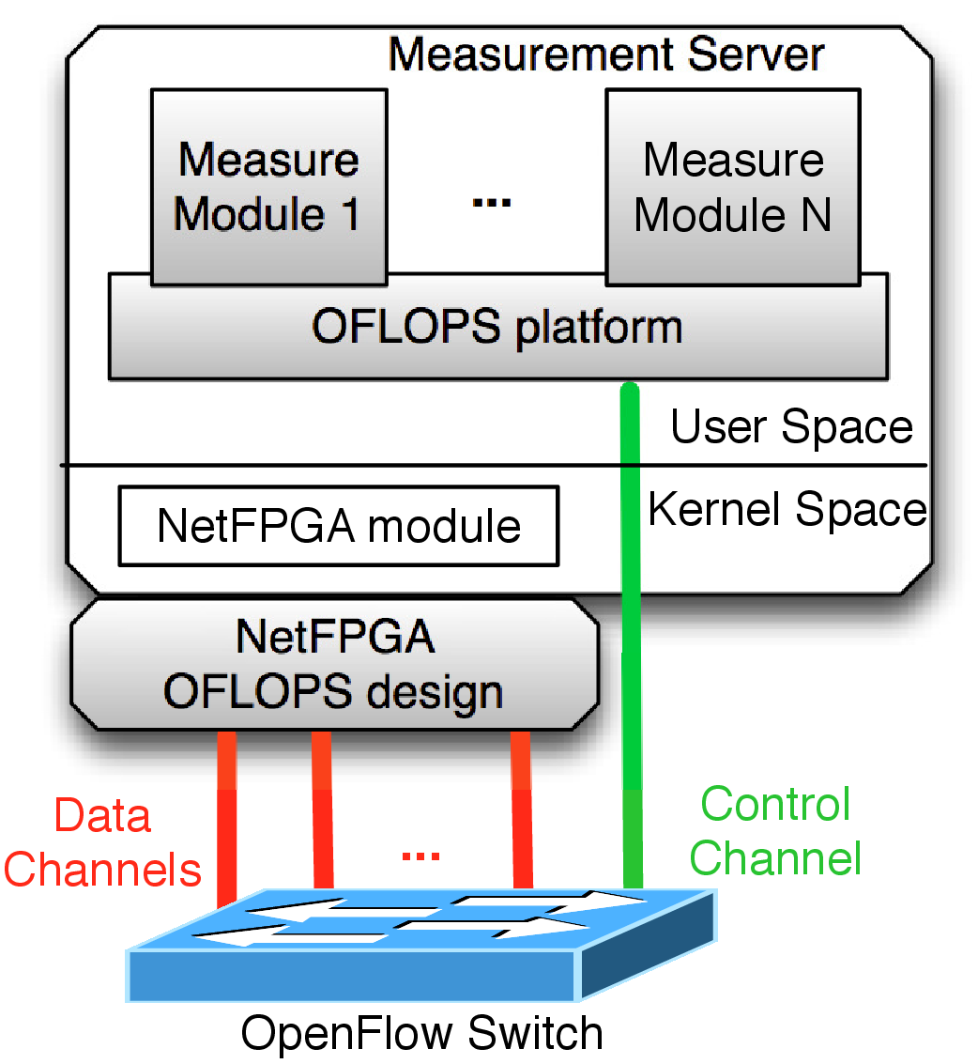
(a) NetFPGA packet
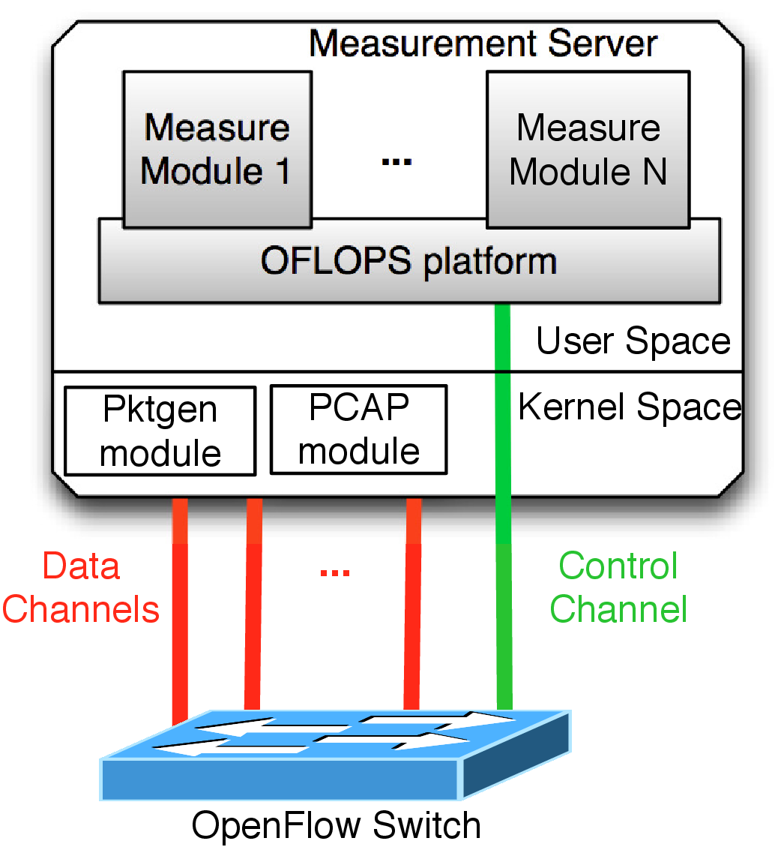
(b) Kernel-space
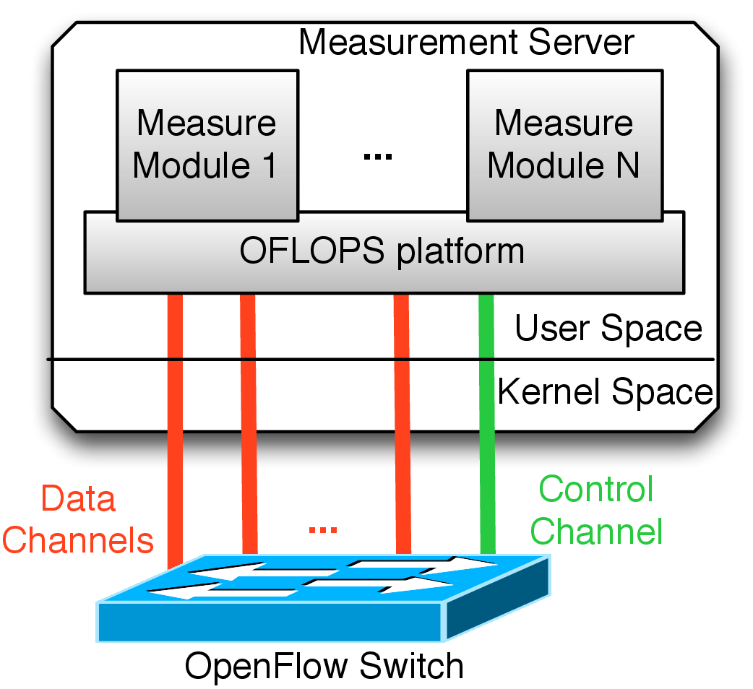
(c) User-space
Figure 1: OFLOPS enables the development of custom multi-channel measurement experiments and supports: 1) the high accuracy NetFPGA packet generator hardware design (Figure Error: Reference source not found), 2) the kernel space pktgen traffic generation module and the PCAP packet capturing module (Figure Error: Reference source not found), 3) a userspace packet capture and generation library (Figure Error: Reference source not found)Error: Reference source not foundError: Reference source not foundError: Reference source not found
Measuring OpenFlow implementations is a challenging task in terms of the characterization of accuracy, noise suppression and precision. Performance characterization is non-trivial, as most OpenFlow-enabled devices provide rich functionality but do not disclose implementation details. In order to understand the performance impact of an experiment, multiple input measurement channels must be monitored concurrently, such as data and control channels. Furthermore, current controller frameworks, like Gude et al. (2008a) and Switch (2013), are designed for production networks and incur significant measurement noise. Such controllers employ asynchronous processing libraries and multi-thread execution models, to maximize the aggregate control channel processing throughput, and provide high-level programming interfaces that require multiple data structure allocation and modification during packet processing. The processing time for a specific OpenFlow, especially at high rates, is subject to multiple aspects, like thread scheduling policy and asynchronous library execution logic (Jarschel et al., 2012). Measurement noise suppression in the control plane is required from the controller framework to minimize message processing and delegate processing control to the measurement module. Finally, sub-millisecond precision in software is subject to unobserved parameters, like OS scheduling and clock drift. The result of these challenges is that meaningful, controlled, repeatable performance tests are non-trivial in an OpenFlow.
OFLOPS has a low overhead abstraction, enabling interaction with an OpenFlow-enabled device over multiple data channels. The platform provides a programming API, allowing control of multiple information sources: data and control channels, and SNMP. OFLOPS is an event-driven architecture. Interactions over each channel are transformed into semantically meaningful events and the developer can register callbacks to handle them programatically. OFLOPS is implemented in C, and experiments are compiled as shared libraries, loaded at run-time using a simple configuration interface. A schematic of the platform is presented in Figure Error: Reference source not found. OFLOPS (2011) provides further details regarding the OFLOPS model.
The platform is implemented as a multi-threaded application and takes advantage of modern multicore environments. To reduce latency, our design avoids concurrent access controls: we leave any concurrency-control complexity to individual module implementations. OFLOPS processing occurs in the following five threads:
1. Data Packet Generation: control of data plane traffic generators.
2. Data Packet Capture: data plane traffic interception.
3. Control Channel: controller events dispatcher.
4. SNMP Channel: SNMP event dispatcher.
5. Time Manager: time events dispatcher.
OFLOPS run on heterogeneous platforms and integrates support support for multiple packet generation and capturing mechanisms. Packet generation functionality is supported through three mechanisms: userspace (Figure Error: Reference source not found); kernel-space using the pktgen kernel module module (Olsson, 2005b) (Figure Error: Reference source not found); and hardware-accelerated through a modified version of the NetFPGA Stanford Packet Generator (Covington et al., 2009) (Figure Error: Reference source not found). OFLOPS uses both the PCAP library and the modified NetFPGA design for packet capturing and timestamping. Each mechanism provides different precision guarantees.

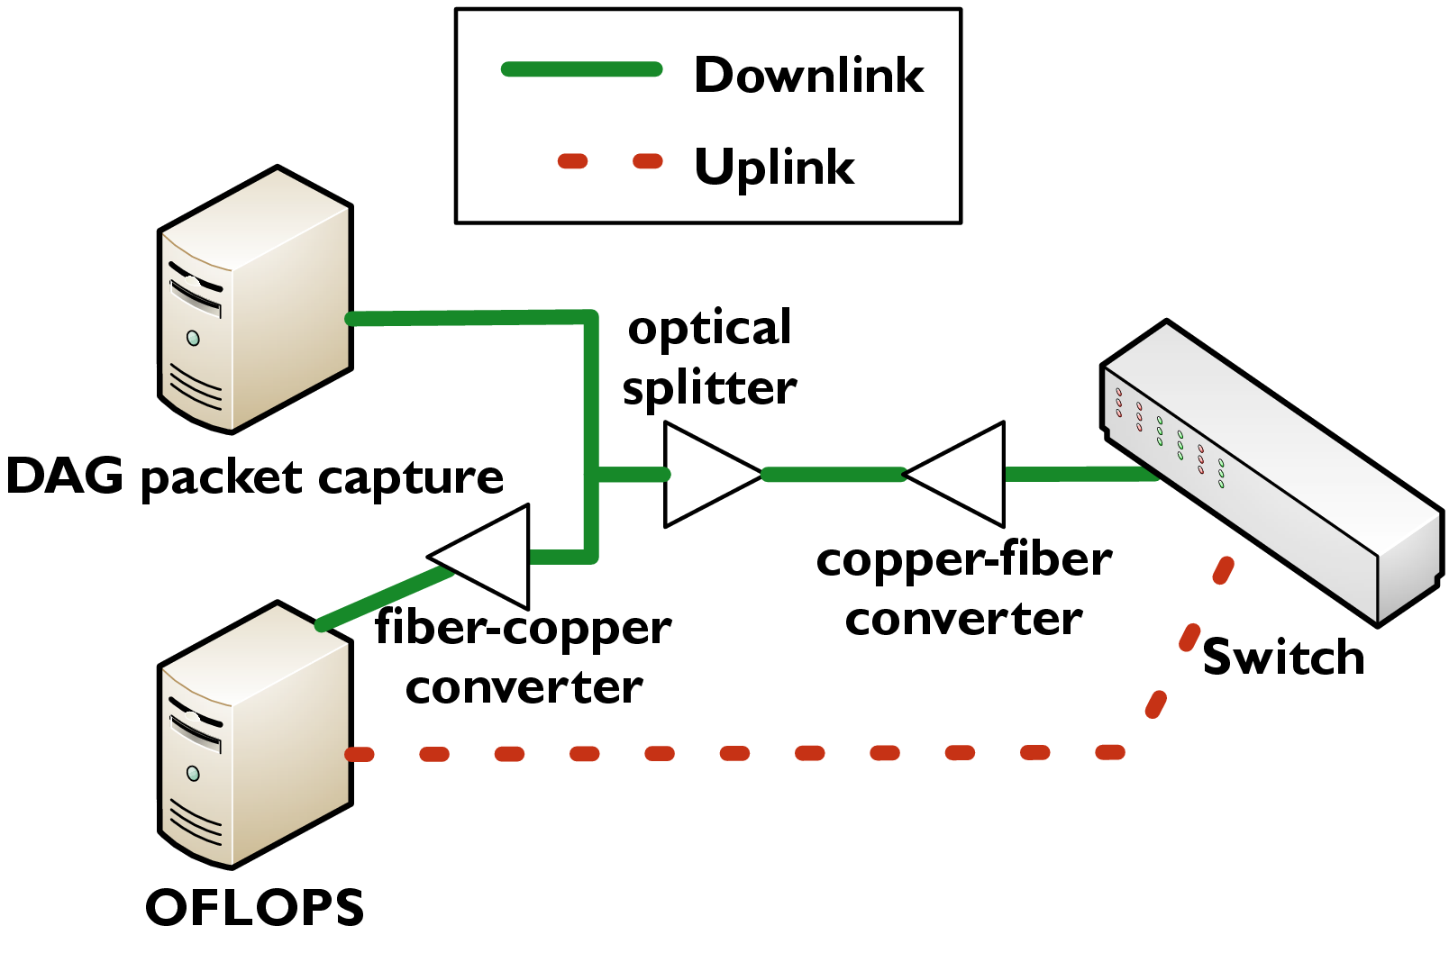
Figure 2: Measurement topology to evaluate capturing mechanism precision.
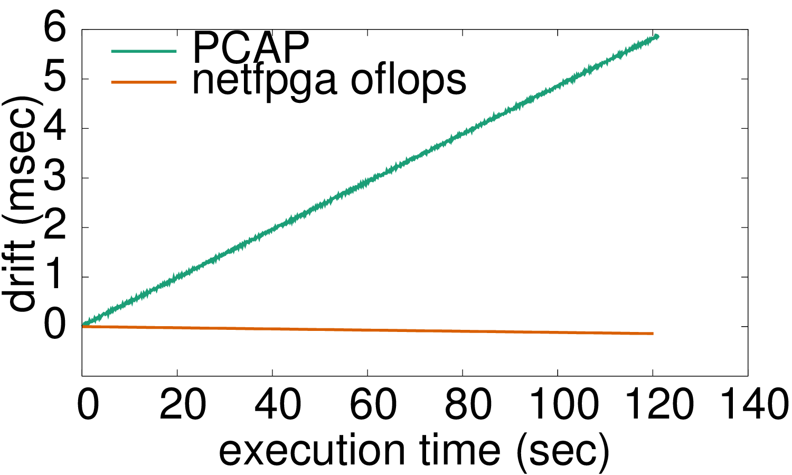
Figure : Timestamping precision evaluation using a DAG card. PCAP timestamps exhibit a significant drift in the order of microseconds, in comparison to the NetFPGA hardware design
Figure Error: Reference source not found presents a simple evaluation setup for the accuracy of the OFLOPS mechanism, in comparison to a DAG card (Endace, 2012). For the measurement, we use a 100 Mbps CBR probe of small packets for a two minute period. The probe is duplicated, using an optical wiretap with negligible delay, and sent simultaneously to OFLOPS to a DAG card. In Figure Error: Reference source not found, we plot per-packet drift between each OFLOPS timestamping mechanism and the DAG card. From the figure, we note that the PCAP timestamps drift by 6 milliseconds after 2 minutes, while the NetFPGA timestamping mechanism exhibits lower drift on the order of microseconds.

3 Measurement Setup
At the end of 2009, the OpenFlow specification was released in its first stable version, 1.0 (OpenFlow Consortium, 2009b), the first recommended version implemented by vendors for production systems. Our analysis was conducted in collaboration with T-labs in Spring of 2011. During that period, the introduction of OpenFlow in commodity switches was limited, and only a small number of devices provided production-level support for the protocol. Using OFLOPS, we evaluated OpenFlow-enabled switches from three different switch vendors. Vendor 1 provided production-ready OpenFlow, whereas vendors 2 and 3 during that period provided experimental OpenFlow. The set of selected switches provided a representative but not exhaustive sample of available OpenFlow-enabled ToR-type switching hardware, during that time. Finally, we also include in our measurement a more recent fourth OpenFlow which provides production support up to version 1.1 of the OpenFlow, and the firmware that was released in December 2014. Switch4 uses the Open vSwitch to implement its OpenFlow. Table Error: Reference source not found provides details regarding the CPU and the size of the flow table for each switch. In addition, the switching fabric in the vendor hardware specification reports similar non-blocking capacity and packet processing rates.
OpenFlow is not limited to hardware. The protocol reference implementation is the software switch, Open vSwitch (Pettit et al., 2010), is an important implementation for production environments. Firstly, Open vSwitch is a replacement for the poor-performing Linux bridge (Bianco et al., 2010), a crucial functionality for virtualised operating systems. Currently, the Xen platform uses Open vSwitch forward traffic between VMs in the Dum0, a configuration which is inherited by major Cloud providers, like Amazon and Rackspace. Secondly, several hardware switch vendors use the Open vSwitch codebase for the development of their own OpenFlow-enabled firmware. The Open vSwitch team has standardised a clean abstraction for the control of packet forwarding elements (similar to Linux HAL), which allows code reuse by any forwarding entity. Thus, the mature software implementation of the OpenFlow is ported to commercial hardware, making certain implementation bugs less likely to (re)appear. We study Open vSwitch in our performance and scalability study of hardware switches. Finally, in our comparison we include the OpenFlow design for the NetFPGA platform (Naous et al., 2008). This implementation is based on the original OpenFlow implementation (OpenFlow Consortium, 2009a), extending it with a hardware forwarding design.

Switch | CPU | Flow table size
Switch1 | PowerPC 500MHz | 3072 mixed flows
Switch2 | PowerPC 666MHz | 1500 mixed flows
Switch3 | PowerPC 828MHz | 2048 mixed flows
Switch3 | MIPS 1.1 SoC | 2048 mixed flows
Open vSwitch | Xeon 3.6GHz | 1M mixed flows
NetFPGA | DualCore 2.4GHz | 32K exact & 100 wildcard

Table 1: OpenFlow switch details.
In order to conduct our measurements, we setup OFLOPS on a dual-core 2.4GHz Xeon server equipped with a NetFPGA card. For all of the experiments we utilized the NetFPGA-based packet generating and capturing mechanism. 1 Gbps control and data channels are connected directly to the tested switches. We measured the processing delay incurred by the NetFPGA-based hardware design to be a near-constant 900 nsec.

4 Switch Evaluation
As for most networking standards, there are different ways to implement a given protocol based on a paper specification. OpenFlow is no different in this regard. The current OpenFlow implementation is Open vSwitch (Pettit et al., 2010). However, different software and hardware implementations may not implement all features defined in the Open vSwitch, or they may behave in an unexpected way. In order to understand the behaviour of an OpenFlow implementation, we developed a suite of measurement experiments to benchmark the functionality of the elementary protocol interactions. These tests target:
1. The OpenFlow processing actions (Section Error: Reference source not found)
2. The packet interception and packet injection functionality of the protocol (Section Error: Reference source not found)
3. The update rate of the OpenFlow table, along with its impact on the data plane (Section Error: Reference source not found)
4. The monitoring capabilities provided by OpenFlow (Section Error: Reference source not found)
5. The impact of interactions between different OpenFlow operations (Section Error: Reference source not found).

4.1 Packet Modifications
The OpenFlow 1.0 specification (OpenFlow Consortium, 2009b) defines 10 packet modification actions which can be applied on incoming packets. Available actions include modification of source and destination MAC and IP addresses, VLAN tag and PCP fields and TCP and UDP source and destination port numbers. The action list of a flow definition can contain any combination of them. The left column of Table Error: Reference source not found lists the packet fields that can be modified by an OpenFlow-enabled switch. These actions are used by network devices such as IP routers (e.g. rewriting of source and destination MAC addresses) and NAT (rewriting of IP addresses and ports). Existing network equipment is tailored to perform a subset of these operations, usually in hardware to sustain line rate.
To measure the time taken by an OpenFlow to modify a packet field header, we generated from the NetFPGA card UDP packets of 100 bytes, at a constant rate of 100 Mbps (approximately 125 Kpps). This rate is high enough to give statistically significant results in a short period of time, without introducing packet queuing in software-based switches. The flow table is initialized with a flow that applies a specific action on all probe packets and the processing delay is calculated as the difference between the transmission and receipt timestamps provided by the NetFPGA card. We report in Table Error: Reference source not found the median processing delay for each action, along with its standard deviation, and the percent of lost packets of the measurement probe.

Mod. type | Switch1 |  |  |  |  |  | Switch2 |  |  |  |  |  |  | Switch3
 | med |  | sd |  | loss% |  | med |  | sd |  |  | loss% |  | med |  |  |  | sd |  | loss%
Forward | 4 |  | 0 |  | 0 |  | 6 |  | 0 |  |  | 0 |  | 5 |  |  |  | 0 |  | 0
MAC addr. | 4 |  | 0 |  | 0 |  | 302 |  | 727 |  |  | 88 |  | - |  |  |  | - |  | 100
IP addr. | 3 |  | 0 |  | 0 |  | 302 |  | 615 |  |  | 88 |  | - |  |  |  | - |  | 100
IP ToS | 3 |  | 0 |  | 0 |  | 6 |  | 0 |  |  | 0 |  | - |  |  |  | - |  | 100
L4 port | 3 |  | 0 |  | 0 |  | 302 |  | 611 |  |  | 88 |  | - |  |  |  | - |  | 100
VLAN pcp | 3 |  | 0 |  | 0 |  | 6 |  | 0 |  |  | 0 |  | 5 |  |  |  | 0 |  | 0
VLAN id | 4 |  | 0 |  | 0 |  | 301 |  | 610 |  |  | 88 |  | 5 |  |  |  | 0 |  | 0
VLAN rem. | 4 |  | 0 |  | 0 |  | 335 |  | 626 |  |  | 88 |  | 5 |  |  |  | 0 |  | 0
Mod. type |  | Switch4 |  |  |  |  |  | Open vSwitch |  |  |  |  | NetFPGA
 |  | med |  | sd |  | loss% |  | med |  | sd | loss% |  | med |  |  |  | sd |  | loss%
Forward |  | 2 |  | 0 |  | 0 |  | 35 |  | 13 | 0 |  | 3 |  |  |  | 0 |  | 0
MAC addr. |  | 2 |  | 0 |  | 0 |  | 35 |  | 13 | 0 |  | 3 |  |  |  | 0 |  | 0
IP addr. |  | 2 |  | 0 |  | 0 |  | 36 |  | 13 | 0 |  | 3 |  |  |  | 0 |  | 0
IP ToS |  | 2 |  | 0 |  | 0 |  | 36 |  | 16 | 0 |  | 3 |  |  |  | 0 |  | 0
L4 port |  | 2 |  | 0 |  | 0 |  | 35 |  | 15 | 0 |  | 3 |  |  |  | 0 |  | 0
VLAN pcp |  | 2 |  | 0 |  | 0 |  | 36 |  | 20 | 0 |  | 3 |  |  |  | 0 |  | 0
VLAN id |  | 2 |  | 0 |  | 0 |  | 35 |  | 17 | 0 |  | 3 |  |  |  | 0 |  | 0
VLAN rem. |  | 2 |  | 0 |  | 0 |  | 35 |  | 15 | 0 |  | 3 |  |  |  | 0 |  | 0

Table 2: Time in μs to perform individual packet modifications and packet loss. Processing delay indicates whether the operation is implemented in hardware (<10μs) or performed by the CPU (>10μs).
We observe significant differences in the performance of the hardware switches due in part to the way their firmware implements packet modifications. Switch1 and Switch2, with their production-grade implementations, handle all modifications in hardware; this explains their low packet processing delay of between 2 and 4 microseconds. On the other hand, Switch2 and Switch3 each run experimental firmware that provided, at the time, only partial hardware support for OpenFlow. Switch2 uses the switch CPU to perform some of the available field modifications, resulting in packet processing delay and variance two orders of magnitude higher. Switch3 follows a different approach; all packets of flows with actions not supported in hardware are silently discarded. The performance of the Open vSwitch implementation lies between Switch1 and the other hardware switches. Open vSwitch implements all OpenFlow. However, hardware switches outperform Open vSwitch as the flow actions are supported in hardware. Finally, the NetFPGA design provides support for all actions in hardware and allows line rate support with low and constant processing latency.
We conducted a further series of experiments with variable numbers of packet modifications in the flow action list. We observed, that the combined processing time of a set of packet modifications is equal to the highest processing time across all individual actions in the set (e.g. Switch2 requires approximately 300 ms per packet to modify both IP source addresses and IP ToS field). Furthermore, we notice that for Switch1, Switch4 and Open vSwitch has a limit of 7 actions, which exposes limits enclosed in the implementation.

4.2 Traffic Interception and Injection

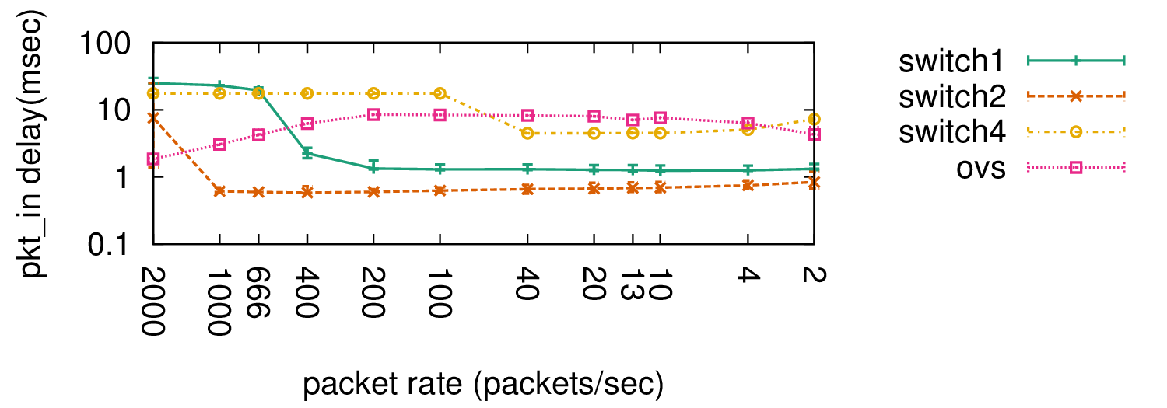
(a) pkt_in processing latency
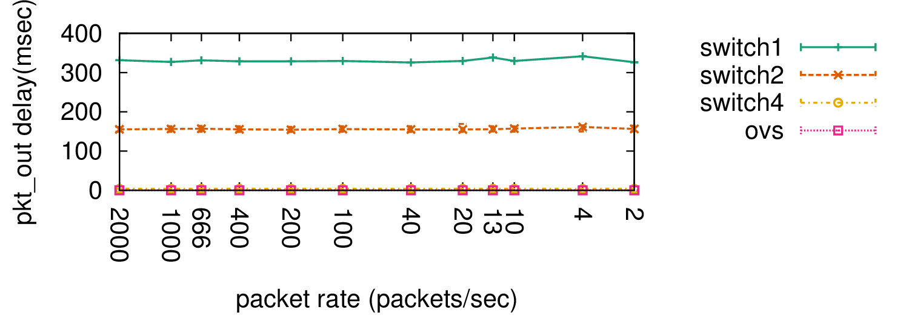
(b) pkt_out processing latency
Figure 4: Latency to intercept (Figure Error: Reference source not found) and inject (Figure Error: Reference source not found) data plane packets using the OpenFlow.Error: Reference source not foundError: Reference source not found
OpenFlow permits a controller to intercept or inject traffic through the control plane. Packet interception is fundamental for reactive control, while packet injection enables applications to interact with data plane end-hosts and devices, e.g. topology discovery using the LLDP protocol. In order to characterise the performance of these functionalities, we conducted two experiments. The first experiment invalidates all flow table entries and uses a data plane probe of small packets (100 bytes) on a data channel, and measures the per-packet delay between the packet transmission and its reception on the control plane, as a pkt_in message. The second experiment generates a control plane probe using pkt_out messages and measures the delay in receiving each packet on a data channel.
Figure Error: Reference source not found presents the quantiles and median per-packet processing latency for varying probe rates. We omitted Switch3 in this experiment, because these functionalities incurred significant co-processor load, resulting in control plane unresponsiveness. In terms of packet injection, hardware switches exhibit high latency (150 ms for Switch2 and 350 ms for Switch1), in comparison to Open vSwitchSwitch4 (approximately 0.1 ms). For hardware switches at high packet rates, we noticed that packet transmissions were rate-limited using the advertised window of the control plane TCP connection. In terms of traffic interception, we observed diverse behaviours between hardware switches at high packet rates. For Switch1, latency becomes note-worthy beyond 400 packets/sec, resulting in a median latency of 1 ms, while the switch can process up to 500 packets/sec, with median latency of 10 ms. For Switch2, latency is significantly lower, with a median value of 800 μs and reaches 10 seconds only when the probe rate is 2,000 packets/sec. Switch4 exhibits a constant delay, between 9 and 17 ms, but the packet rate is limited to 50 packets/sec. Open vSwitch, has a high but stable latency, between 1 and 10 ms, for any tested data rate.

4.3 Flow Table Update Rate
The flow table is a central component of an OpenFlow and is the equivalent of a Forwarding Information Base (FIB) on routers. Given the importance of FIB updates on commercial routers, e.g. to reduce the impact of control plane dynamics on the data plane, the FIB update processing time of commercial routers provides useful reference points and lower bounds for the time to update a flow entry on an OpenFlow. The time to install a new entry on commercial routers has been reported in the range of a few hundreds of microseconds (Shaikh and Greenberg, 2001).
OpenFlow has a mechanism for defining barriers between sets of commands: the barrier command. According to the OpenFlow specification (OpenFlow Consortium, 2009b), the barrier command is a way of being notified that a set of OpenFlow has been completed. Furthermore, the switch has to complete the set of operations issued prior to the barrier before executing any further operation. If the OpenFlow comply with the specification, we expect to receive a barrier notification for a flow modification once the flow table of the switch has been updated, implying that the change can be seen from the data plane.
We checked the behaviours of the tested OpenFlows, finding variation among them. For Open vSwitch, Switch1, Figure Error: Reference source not found shows the time to install a set of entries in the flow table. Switch2 and Switch3 are not reported, as this type of OpenFlow is not supported by the firmware. For this experiment, OFLOPS worked on a stream of packets of 100 bytes at a constant rate of 100 Kpackets/sec (10Mbps) that targeted the newly installed flows in a round-robin manner. The probe achieved sufficiently low inter-packet periods in order to accurately measure the flow insertion time.

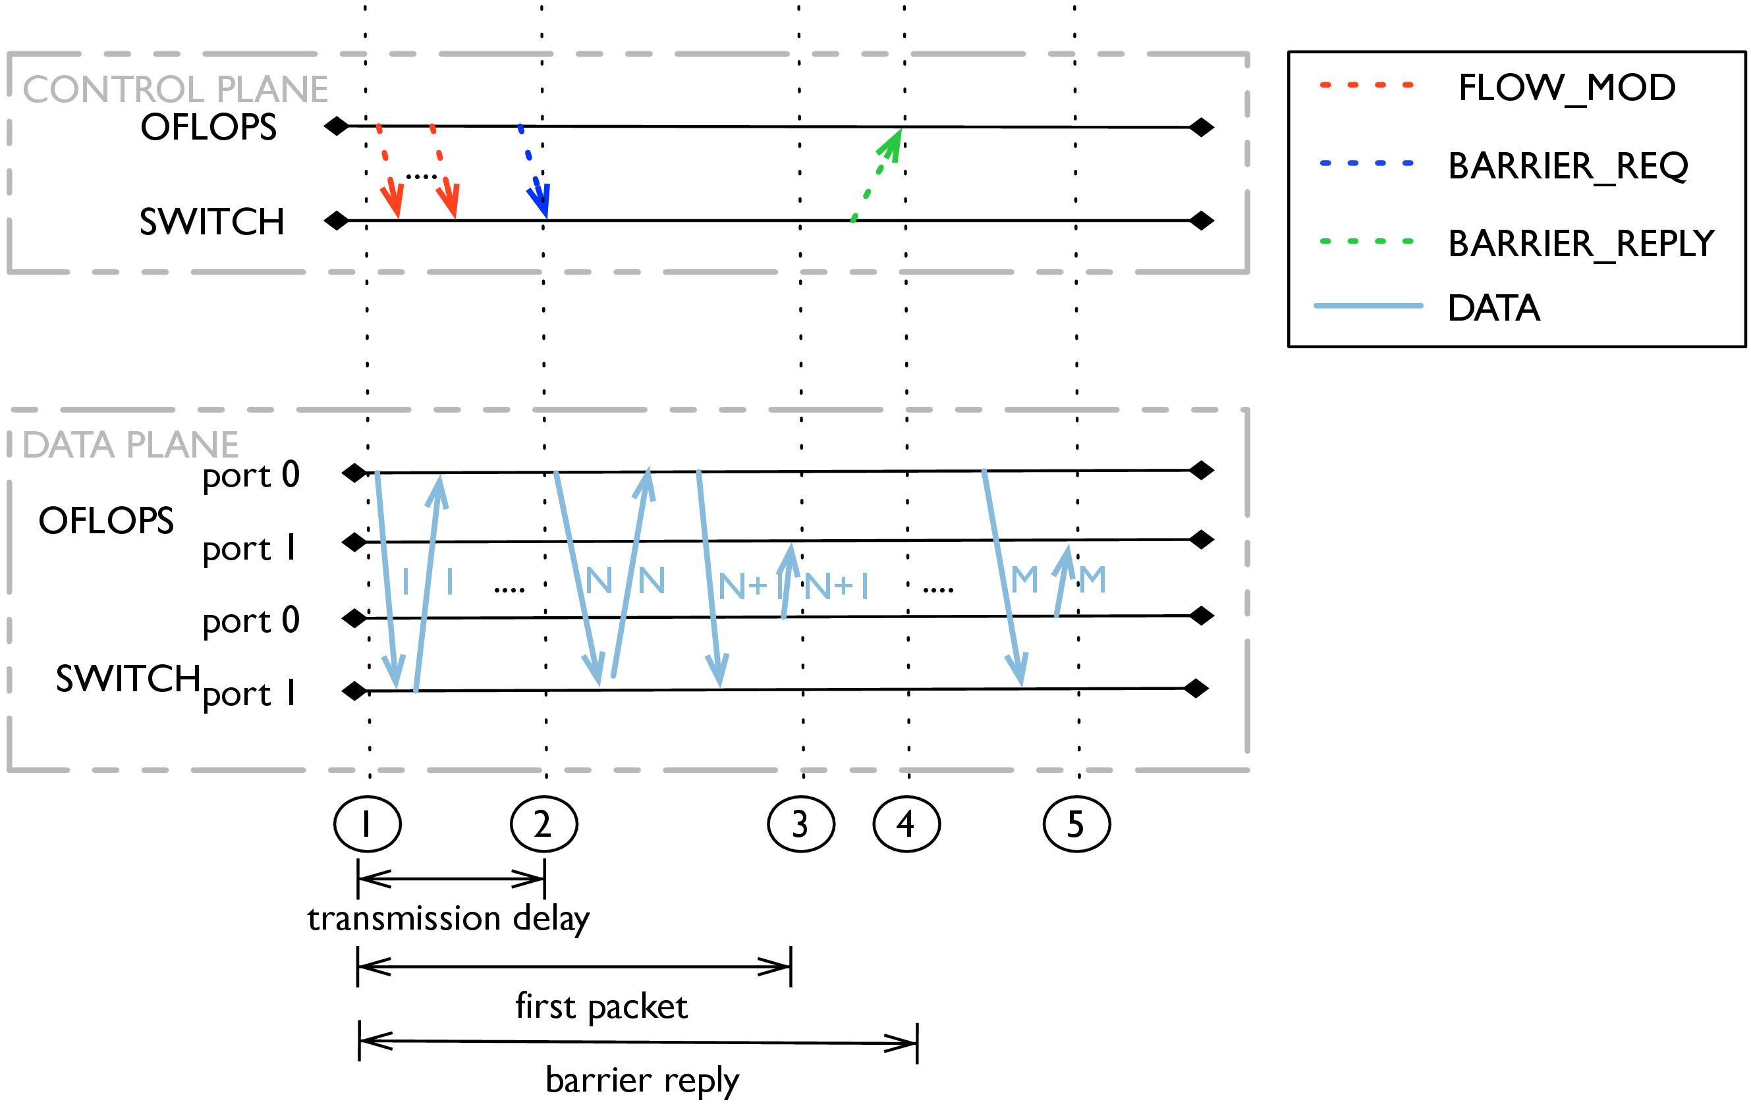
Figure 5: Flow insertion and flow modification measurement scenario. The experiment uses multiple information channels to estimate the delay in modifying entries in the flow table.

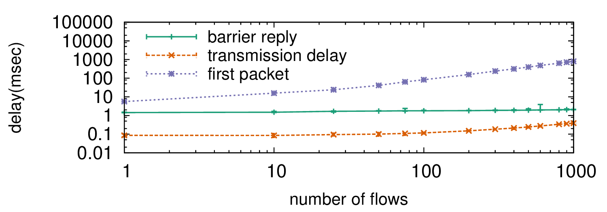
(a) Open vSwitch (log-log scale)
(b) Switch1 (log-log scale)
Figure 6: Flow entry insertion delay: as reported using the barrier notification and observed at the data plane.
Figure Error: Reference source not found presents the measurement scenario, while Error: Reference source not found presents three different measured latencies. The first, barrier notification, is derived by measuring the time elapsed between when the first insertion command is sent by the OFLOPS controller and the time the barrier notification is received by the PC. The second, transmission delay, is the time elapsed between when the first and last flow insertion commands are sent out from the PC running OFLOPS. The third, first packet, is the time elapsed between when the first insertion command is issued and when a packet has been observed for the last of the (newly) inserted rules. For each configuration, we ran the experiment 100 times and Figure Error: Reference source not found shows the median result as well as the and percentiles, although the variations are small and cannot be easily viewed.
From Figure Error: Reference source not found, we observe that even though the transmission delay in sending flow insertion commands increases proportionally to the flow number, this time is negligible when compared with data plane measurements (first packet). Notably, the barrier notification measurements are almost constant, increasing only as the transmission delay increases (difficult to discern on the log-log plot) and, critically, this operation returns before any first packet measurement. This implies that the way the barrier notification is implemented does not reflect the time when the hardware flow-table has been updated.
These results demonstrate how OFLOPS computes per-flow overheads. We observed that the flow insertion time for Switch1 starts at 1.8 ms for a single entry, but converges toward an approximate overhead of 1 ms per inserted entry as the number of insertions grows.

Flow insertion types

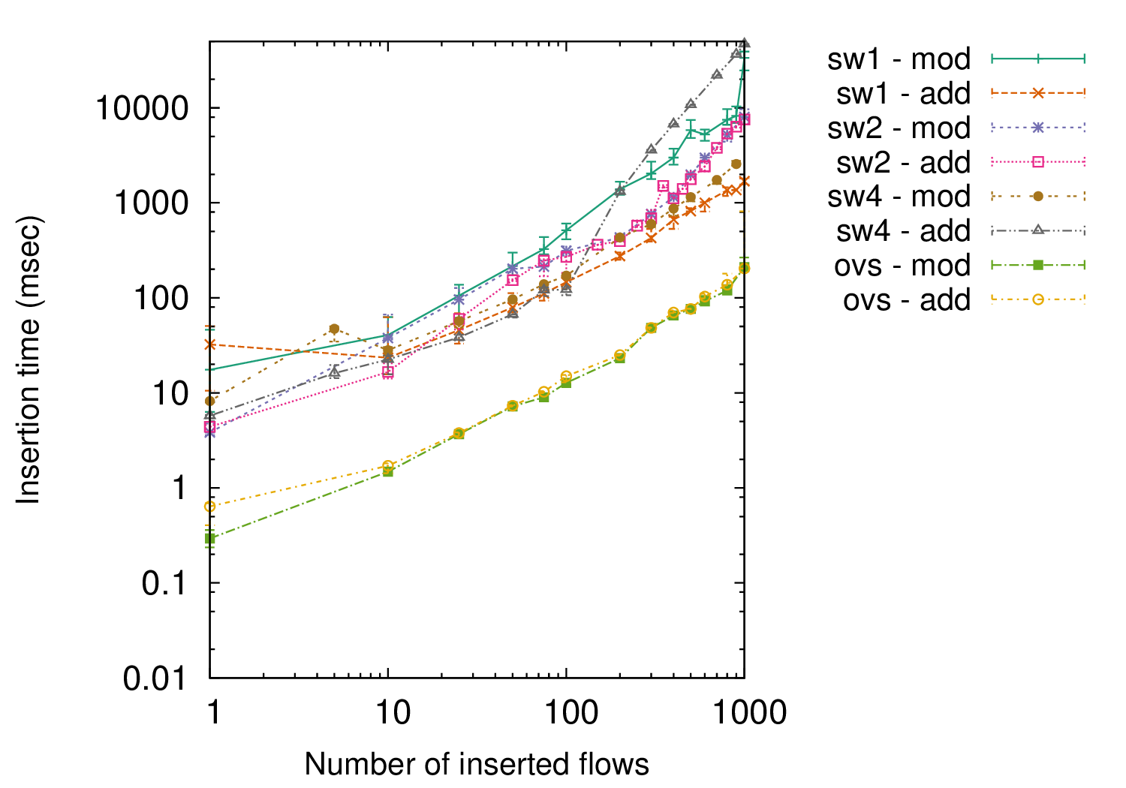
Figure 7: Delay of flow insertion and flow modification, as observed from the data plane (log-log scale).
We now distinguishing between flow insertions and the modification of existing flows. With OpenFlow, a flow rule may perform exact packet matches or use wildcards to match a range of values. Figure Error: Reference source not found measures the flow insertion delay as a function of the number of inserted entries. This is done for the insertion of new entries and for the modification of existing entries.
These results show that for software switches that keep all entries in memory, the type of entry or insertion does not make a difference in the flow insertion time. Surprisingly, both Switch1 and Switch2 take more time to modify existing flow entries compared to adding new flow entries. For Switch1, this occurs for more than 10 new entries, while for Switch2 this occurs after a few tens of new entries. After discussing this issue with the vendor of Switch2, we came to the following conclusion: as the number of TCAM entries increases, updates become more complex as they typically require re-ordering of existing entries. In Gupta and McKeown (2001), the authors characterise the update complexity of a TCAM as linear.
Clearly, the results depend both on the entry type and implementation. For example, exact match entries may be handled through a hardware or software hash table. Whereas wild-carded entries, requiring support for variable length lookup, must be handled by specialized memory modules, such as a TCAM. With such possible choices and a range of different experiments, the flow insertion times reported in Figure Error: Reference source not found are not generalizable, but rather depend on the type of insertion entry and implementation.

4.4 Flow Monitoring
The use of OpenFlow as a monitoring platform has already been suggested for the applications of traffic matrix computation (Tootoonchian et al., 2010; Balestra et al., 2010) and identifying large traffic aggregates (Jose et al., 2011). To obtain direct information about the state of the traffic received by an OpenFlow switch, the OpenFlow protocol provides a mechanism to query traffic statistics, either on a per-flow basis or across aggregates matching multiple flows and supports packet and byte counters.
We now test the performance implications of the traffic statistics reporting mechanism of OpenFlow. Using OFLOPS, we installed flow entries that match packets sent on the data path. Simultaneously, we started sending flow statistics requests to the switch. Throughout the experiment we recorded the delay in getting a reply for each query, the amount of packets that the switch sends for each reply, and the departure and arrival timestamps of the probe packets.
Figure Error: Reference source not found reports the time taken to receive a flow statistics reply for each switch as a function of the request rate. Despite the rate of statistics requests being modest, quite high CPU utilization is recorded for even a few queries per second being sent. Figure Error: Reference source not found reports the switch-CPU utilization as a function of the flow statistics inter-request time. Statistics are retrieved using SNMP. Switch3 is excluded for lack of SNMP support.

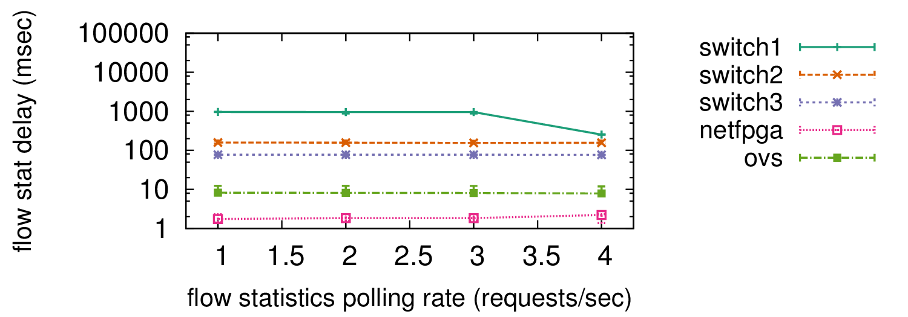
(a) Reply time.
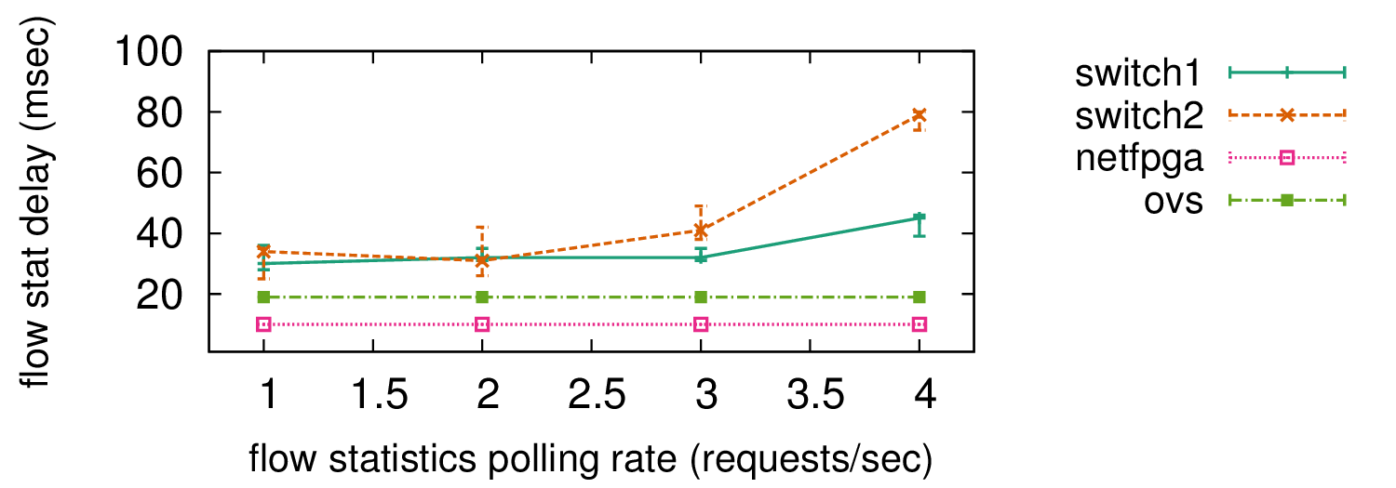
(b) CPU utilization.
Figure 8: Time to receive a flow statistic (median) and corresponding CPU utilization.
From the flow statistics reply times, we observe that all switches have (near) constant response delays; the delay itself relates to the type of switch. As expected, software switches have faster response times than hardware switches, reflecting the availability of the information in memory without the need to poll multiple hardware counters. These consistent response times also hide the behaviour of the exclusively hardware switches, whose CPU time increases proportionally with the rate of requests. We observe two types of behaviour from the hardware switches: the switch has a high CPU utilization, answering flow statistic requests as fast as possible (Switch2); or the switch delays responses, avoiding over-loading its CPU (Switch1). Furthermore, for Switch1, we noticed that the switch is applying a pacing mechanism on its replies. Specifically, at low polling rates the switch splits its answer across multiple TCP segments, each segment containing statistics for a single flow. As the probing rate increases, the switch will aggregate multiple flows into a single segment. This suggests that independent queuing mechanisms are used for handling flow statistics requests. Finally, neither software nor NetFPGA switches see an impact of the flow statistics rate on their CPU, thanks to their significantly more powerful PC CPUs (Table Error: Reference source not found).

4.5 OpenFlow Command Interaction
An advanced feature of the OpenFlow is its ability to provide network control applications with, for example, flow arrival notifications from the network, while simultaneously providing fine-grain control of the forwarding process. This permits applications to adapt in real time to the requirements and load of the network (Handigol et al., 2009a; Yap et al., 2009). Using OFLOPS measurement instrumentation, we developed a test scenario of dynamic network control, in order to understand the behaviour of the switch control and data plane. In this scenario, we emulated the simultaneous querying of traffic statistics and modification of the flow table. More specifically, we extended Section Error: Reference source not found by showing how the mechanisms of traffic statistics extraction and table manipulation interact. Specifically, we initialized the flow table with 1,024 exact match flows and measured the delay to update a subset of 100 flows. Simultaneously, the measurement module polls the switch for full table statistics at a constant rate. The experiment uses a constant rate 10 Mbps packet probe to monitor the data path, and polls every 10 seconds for SNMP CPU values.

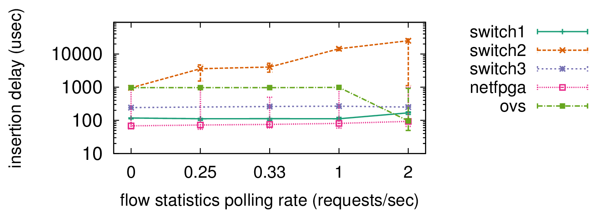
Figure 9: Delay when updating flow table while the controller polls for statistics.
In this experiment, we controlled the probing rate for the flow statistics extraction mechanism, and we plotted the time necessary before the modified flows become active in the flow table. For each probing rate, we repeated the experiment 50 times, plotting the median, and percentile. In Figure Error: Reference source not found we can see that, for lower polling rates, implementations have a near-constant insertion delay comparable to the results of Section Error: Reference source not found. For higher probing rates on the other hand, Switch1 and Switch3 do not differ much in their behaviour. In contrast, Switch2 exhibits a noteworthy increase in the insertion delay. This is explained by the CPU utilization increase incurred by the flow statistics polling (Figure Error: Reference source not found). Finally, Open vSwitch has a marginal decrease in the median insertion delay, and at the same time an increase in its variance. We believe that this behaviour is caused by interactions with the OS scheduling mechanism: the constant polling causes frequent interrupts for the user-space daemon of the switch, which leads to a batched handling of requests.

5 Network Control Macro-experimentation
OFLOPS Cbench (2010) provides a sufficient toolbox for profiling the building blocks of OpenFlow, the switch and the controller. Nonetheless, in order to understand the impact of a control architecture, we require mechanisms that transform OpenFlow models into network-wide measurements under specific traffic patterns and network topologies. A popular approach to examine performance and correctness uses experimental setups which reproduce specific network-wide functionalities. Network experimentation uses two primary approaches: emulation and simulation.
Network emulation scales network system behaviour replication by replacing portions of network functionality with simpler models. Vahdat etal. (2002) present Modelnet, an early network emulation framework attempt, which used highly optimized in-kernel resource control primitives to simulate large Internet-scale systems. Recent efforts employ lightweight virtualisation to scale large-scale network experiments (Handigol et al., 2012b; Puljiz and Mikuc, 2006; Gupta et al., 2011). Network emulation approaches provide an effective solution to network experimentation, but the experimental fidelity is bound by the computational resources of the execution environment.
A notable approach to network emulation employs real testbeds to reproduce in full detail an experiment, and achieve maximum fidelity. Real testbeds incur significant resource and configuration overhead, which scale sub-linearly with respect to the size of the experiment. In an effort to improve resource scalability, the research community builds and maintains a series of shared testbeds, which multiplex experimental deployments in shared infrastructure using virtualisation (PlanetLab, 2007; Ofelia, 2013). Shared testbeds fulfil the requirements for a wide range of experiments, but the resource sharing techniques limit measurement precision, as they introduce noise which is not always detectable and removable.
Network simulation replaces network functionality with simplified models (Varga and Hornig, 2008; Issariyakul, 2012). Simulation platforms set out to provide good resource scalability, but ultimately the accuracy and scalability is influenced by the assumptions of the network models and implementation. In addition, the programming abstractions in simulation platforms remain extensively incompatible with real system programming abstractions and, as a result, require a significant effort to transfer functionality between the two domains. For example, POSIX socket-based applications must modify their connection abstraction to match the API of the simulation platform, while forwarding plane traffic patterns may have to transform into stochastic models.
Network simulation and emulation follow two philosophically distinct approaches to scale experiments, each providing different trade-offs. In the section, we present SDNSIM, a network experimentation framework which bridges the two aforementioned approaches. The framework is written in OCaml, a high performance functional language, and extends the functionality of the Mirage library OS. Developers can describe network functionality over the Miragesystems API, and, during compilation, transform the experimental definition into a concrete experiment realisation. SDNSIM provides two experimentation options: Simulation, transforms the experiment definition into an ns-3 (Henderson et al., 2006) simulation, and Emulation, emulates the experiment definition using the Xen virtualization platform (Barham et al., 2003).

6 Network experimentation
This section presents the design of the SDNSIM platform. We present the MirageOS (Section Error: Reference source not found), a core building block for the functionality of experimentation nodes, and elaborate on the functionality of the SDNSIM and its integration with the ns-3 and Xen platforms (Section Error: Reference source not found).

6.1 Mirage Library OS

Appliance | Binary size (MB)
DNS | 0.184
Web Server | 0.172
OpenFlow switch | 0.164
OpenFlow controller | 0.168

Table 3: Sizes of Mirage application images. Configuration and data are compiled directly into the image.
Mirage (Madhavapeddy et al., 2013) is a development framework for cloud services, supporting the transformation of applications in single purpose appliances, compile-time specialised into stand-alone Xen-compliant kernels. SDNSIM exposes the Mirage abstraction to develop host functionality for two core reasons: the low memory footprint of Mirage applications; and its clean and simplified design. Mirage revisits the idea of a library OS; functionality is separated into logical modules and linked to an appliance only if the code expresses an explicit dependency. As a result, Mirage by design results in compact OS images with very low memory requirements. Table Error: Reference source not found presents the compiled image size for a set of Mirage applications.
Mirage OS exposes a simple systems programming API, implemented by two core modules: Net and OS. The OS module provides thread scheduling, device management and IO functionality, while the Net module provides a network stack supporting ICMP, IP, TCP, UDP and DHCP protocols. The interface of the core Mirage API is sufficiently generic to enable development of complex distributed services, while the OS architecture is sufficiently simple and portable over a wide range of platforms. Specifically, a Mirage application can compile into a Xen image, a Linux application or a NodeJS executable. Currently, the platform is being ported to the FreeBSD kernel and the BareMetal OS (Return Infinity, 2013), a high performance assembly-code OS.

6.2 SDNSIMArchitecture
language=XML, numberstyle=, basicstyle=, captionpos=b,
[Sorry. Ignored \begin{lstlisting} ... \end{lstlisting}]
From the developer perspective, SDNSIM is an alternative build system for Mirage. Developers implement host functionality as Mirage applications and describe network topology using an XML-based configuration file. SDNSIM is responsible for compiling the Mirage applications and deploying the experiment, according to the configuration file.
Listing Error: Reference source not found presents an SDNSIM file for a client (host1) - server (host2) architecture. A minimal experimental configuration consists of the name of the main OCaml module containing the host code (topology@module), the target experimentation environment (topology@backend) and the experiment duration (topology@duration). Optionally, the emulation backend supports a slowdown parameter (topology@slowdown) which controls a time dilation mechanism, presented in detail in Section Error: Reference source not found. Hosts are defined using a host XML entity, containing a host name (node@name), its main function (node@main) and a variable number of children param entities (node/param) for host initialisation. Network link definitions use a link XML entity, containing the name of the interconnected hosts (link@src, link@dst), the device queue size (link@queue_size), the link propagation properties (link@rate, link@delay) and logging (link@pcap). Finally, experiments can import external network interfaces, allowing interaction with external applications. Links with external hosts are defined using a link_ext XML entity, which has the same parameters as the link entity, except from the src and dst attributes. These attributes are replaced by the host (link_ext@host) and dev (link_ext@dev) attributes, which map a host device to a TUN/TAP network device. In addition, the optional IP (link_ext@ip) attribute defines the address and netmask of the TUN/TAP device.

Subsystem | Implemented Protocols
Network | Ethernet, ARP, DHCP, IPv4, ICMP, UDP, TCP, OpenFlow
Storage | Simple key-value, FAT-32, Append B-Tree, Memcache
Application | DNS, SSH, HTTP, XMPP, SMTP
Formats | JSON, XML, CSS, S-Expressions

Table 4: System facilities provided as Mirage libraries.

(a) ns-3

(b) Xen
Figure 10: SDNSIMinternal architecture: ns-3 simulation (Figure Error: Reference source not found) and Xen real-time emulation (Figure Error: Reference source not found).Error: Reference source not foundError: Reference source not found
Figure Error: Reference source not found presents the host architecture in SDNSIM. Host functionality is separated in three layers. The top layer contains the application logic of the host. This layer is defined by the developer, and encodes the end-host network functionality of the experiment. SDNSIM uses all application libraries of the Mirage, enumerated in Table Error: Reference source not found, and thus provides high traffic realism. Furthermore, we extended the ocaml-openflow library to incorporate switch and controller performance models and implement the pttcp (Pratt, 2002) traffic generator functionality in OCaml, to support stochastic traffic models. The middle layer of the host architecture contains the core Mirage libraries and provides OS functionality to the application layer. Finally, the lower layer of the host architecture, provides integration between the Mirage OS and the execution backend. Currently, SDNSIM has two execution backends: the ns-3 simulation platform and the Xen virtualisation platform. These two execution environments are highly heterogeneous and employ different execution models. For the rest of this section, we present the integration details between Mirage and each backend. SDNSIM's goal is network accuracy and the presentation focuses on the network and time subsystems.

6.2.1 Xen backend
SDNSIM uses the Xen virtualisation platform to emulate experimental definitions. Hosts are represented as Mirage VMs, while network links are realised using virtual interfaces (VIF) bridged in Dom0. SDNSIM network link properties using the resource control primitive (e.g. throughput) of the XEN VIF implementation.
Experiment setup uses the Xen Management API (XAPI) (Xen Project, 2013). XAPI provides an API to control programmatically the creation of VM instances and VIFs. Specifically, the execution pipeline for an emulated experiment is the following: host definitions are compiled in VM images, equivalent VM configuration are created on Xen and network links are translated into equivalent VIF and bridge setups. Once all configurations are completed, created VMs are booted and executed for the duration of the experiment.
As discussed in the previous section, a core limitation of experimental emulation is computation resource scalability. In order to address this problem, SDNSIM uses the Mirage core libraries and develops time dilation functionality. Specifically, when the resources of the execution host are insufficient, the experimenter can use a time dilation factor (TDF) to trade time for resource scalability. For example, a TDF value of 2 means that 1 second of emulation time requires 2 seconds of real time to execute, doubling effectively the experimental perceived CPU and network resources. Similar approaches have been proposed in the domain of experimental emulation, in an effort to scale the complexity of large topologies. (Gupta et al., 2011) present a series of modifications in the Xen hypervisor, providing time virtualisation.
The clean design of the Mirage provides easy modification of the time subsystem. Mirage functionality relies on OCaml Lwt language extension, an event-driven asynchronous programming library. Lwt threads are cooperative and non pre-emptive, either executing code or idling waiting for an IO event or a synchronisation primitive (e.g. a semaphore) or a timer event. The main thread scheduler logic works as follows: Execute any resumable sleeping threads, calculate the time left until the next timer event and poll the IO event channel until that time expires. SDNSIM virtualisation functionality requires only a multiplication of the time events and time sources with the TDF value. Guest hosts access time information through a shared page with the hypervisor containing a shared_info structure containing CPU time information. Mirage encapsulates access to the shared_info page through a single time function, which was modified with the TDF parameter. Similarly, we modify the time event registration method to use the TDF parameter. Finally, time virtualisation is enforced on network resources by dividing link throughput values and multiplying link latency values with the TDF parameter.

6.2.2 ns-3 backend
SDNSIM ns-3 (Henderson et al., 2006), is a discrete-time packet-driven network simulator, used to simulate experimental definitions. The core of the system consists of a time simulation engine, while the code base provides multiple libraries modelling functionalities like network applications, routing protocols, data-link layer protocols and link propagation models. ns-3 is fundamentally an extensive refactor of the ns-2 code base, providing a stabler development environment.
The ns-3 backend has a significant difference from the Xen backend; the execution model is discrete and non-reentrant. ns-3 applications register their interest for specific time and network events, event handling is atomic and the progress of the simulation is centrally controlled by the simulation engine. In order to port Mirage to the ns-3 simulation engine, we transformed thread blocking calls into equivalent ns-3 events. More specifically, the Mirage OS clock abstraction is bridged with the ns-3 simulation clock and all sleep calls are scheduled as ns-3 time events. A thread is resumed from a sleep call when the simulator executes the respective time event. Network blocking calls are integrated with the network device abstraction of ns-3. The packet reading thread registers a packet handler on the network device, while the packet writing thread checks the device queue occupancy and blocks it when the queue is full. Finally, in order to avoid scheduling deadlocks, the OS schedules idle time events to resume any yielded threads. Using these transformations we are able to provide a semantically accurate integration of Mirage with the ns-3 engine. Furthermore, network links between hosts are simulated using the PointToPoint link model. This model simulates a PPP link over a lossless medium, a valid approximation of the full duplex non-shared medium of current wired Ethernet technologies.
SDNSIM's backend used a distributed simulation engine for ns-3 which conservative event execution parallelization. The simulation engine spawns a different process for each host of the simulation and an MPI-based synchronisation algorithm establishes conservative clock synchronisation and distributed event execution (Pelkey and Riley, 2011).

7 SDNSIM Evaluation
In this section, We evaluate the SDNSIM performance and precision using small scale micro-benchmarks that target the OpenFlow functionality and the ns-3 backend scalability. Madhavapeddy et al. (2013) presents an exhaustive performance analysis of the Mirage, providing evidence on the scalability of the Xen backend. This section presents in detail a performance comparison of the Mirage with other controllers (Section Error: Reference source not found) and the Mirage (Section Error: Reference source not found) with the Open vSwitch switch, and an evaluation the time scalability of the distributed ns-3 backend (Section Error: Reference source not found).

7.1 Mirage Controller Emulation
We benchmark our controller library’s performance through a simple baseline comparison against two existing OpenFlow, NOX and Maestro. NOX (Gude et al., 2008b) is one of the first and most mature open-source OpenFlow; in its original form it provides programmability through a set of C++ and Python modules. In our evaluation we compared it against both the master branch and the destiny-fast branch, an optimised version that sacrifices Python integration for better performance. Maestro (Cai et al., 2011) is a Java-based controller designed to provide service fairness between multiple OpenFlow channels. We compared these controllers against our Xen-based Mirage controller application.
Our benchmark setup uses the Cbench (2010) measurement tool. Cbench emulates multiple switches which simultaneously generates pkt_in messages. The program measures the processing throughput of each controller. It provides two modes of operation, both measured in terms of pkt_in requests processed per second: latency, where only a single pkt_in message is allowed in flight from each switch; and throughput, where each emulated switch maintains a full 64 kB buffer of outgoing messages. The first measures the throughput of the controller when serving connected switches fairly, while the second measures absolute throughput when servicing requests from switches.
We emulated 16 switches concurrently connected to the controller, each serving 100 distinct MAC addresses. We ran our experiments on a 16-core AMD server running Debian Wheezy with 40 GB of RAM and with each controller configured to use a single thread of execution. We restricted our analysis to the single-threaded case as the Mirage execution environment, at time of testing, does not support multi-threading. For each controller we ran the experiment for 120 seconds and measured the per-second rate of successful interactions. Table Error: Reference source not found reports the average and standard deviation of requests serviced per second.
Unsurprisingly, due to mature, highly optimised code, NOX fast shows the highest performance for both experiments. However, the controller exhibits extreme short-term unfairness in the throughput test. NOX provides greater fairness in the throughput test, at the cost of significantly reduced performance. Maestro performs as well as NOX for throughput but significantly worse for latency, probably due to the overheads of the Java VM. Finally, Mirage is somewhat reduced from NOX fast, but substantially better than both NOX and Maestro. In addition, the Mirage achieves the best product of performance and fairness among all tested controllers in the throughput test. Comparing latency, Mirage is much better than Maestro, but suffers somewhat in comparison to NOX. From the comparison results, we conclude that the Mirage performance is comparable to the performance of existing controlling platforms and our emulation environment can reproduce controller deployments realistically. The SDNSIM dilation mechanism can improve further the throughput of the system in the emulated time domain.

2*Controller | Throughput (kreq/sec) |  |  |  | Latency (kreq/sec)
 | avg |  | std. dev. |  | avg |  |  | std. dev.
NOX fast | 122 | 6 | 44 | 8 | 27 |  | 4 | 1 |  | 4
NOX | 13 | 6 | 1 | 2 | 26 |  | 9 | 5 |  | 6
Maestro | 13 | 9 | 2 | 8 | 9 |  | 8 | 2 |  | 4
Mirage Xen | 98 | 5 | 4 | 4 | 24 |  | 5 | 0 |  | 0

Table 5: OpenFlow controller performance.

7.2 Mirage Switch
We benchmarked our Mirage implementation through a baseline comparison with the Open vSwitch implementation. We developed, using the OFLOPS, a simple forwarding test and measured the switching latency incurred by each implementation. For this experiment we used two virtual machines, one running the OFLOPS, the other running the OpenFlow configured with three interfaces bridged separately in Dom0. One interface was used by the OpenFlow channel, while the other two interfaces were used as switch ports. Using OFLOPS, we generated packets on one of the data channels and received traffic on the other, having bootstrapped appropriate the switch flow table. We ran the test for 30 seconds, a sufficient measurement period to detect statistically significant results. We used small packets (100 bytes) and varied the data rate.

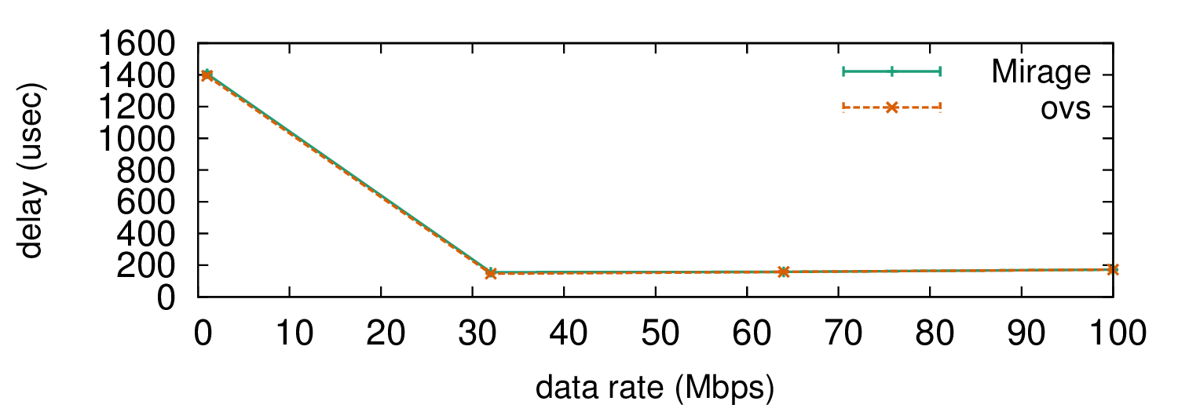
Figure 11: Min/max/median delay switching 100 byte packets when running the Mirage switch and Open vSwitch module as DomU virtual machines.
Figure Error: Reference source not found plots as error boxes the minimum, median and maximum of the median processing latency of ten test runs of the experiment. We can see that the Mirage’s forwarding performance is very close to that of the Open vSwitch, even mirroring the high per-packet processing latency with a probe rate of 1 Mb/s; we believe this is due to a performance artefact of the underlying Dom0 network stack. We omitted packet loss data, but can report that both implementations suffered similar levels of packet loss. From the comparison results of the Mirage, we can conclude that our OpenFlow can emulate accurately software switch functionality. Nonetheless, the minimum latency of our switch emulation (approximately 100 ms) is 2 orders of magnitude higher than a hardware switch (approximately 0.5-1 μs). This performance difference can easily be addressed using the time functionality by using TDF=100.
Using the results from OFLOPS, we configured our switch model to replicate Switch4, and evaluated its accuracy. We set-up a simple topology with two hosts, a data-sink and data generation host interconnected through an OpenFlow. The data-sink hosts generates flow requests to the data generator host following an exponential distribution with λ=0.02 and a constant request size of 1 MB resulting in an average 400 Mbps traffic rate. We ran our experiment for 120 s, ensuring that the resulting number of flow is below the flow table limits. For all experiments we used a learning switch application to control the switch.

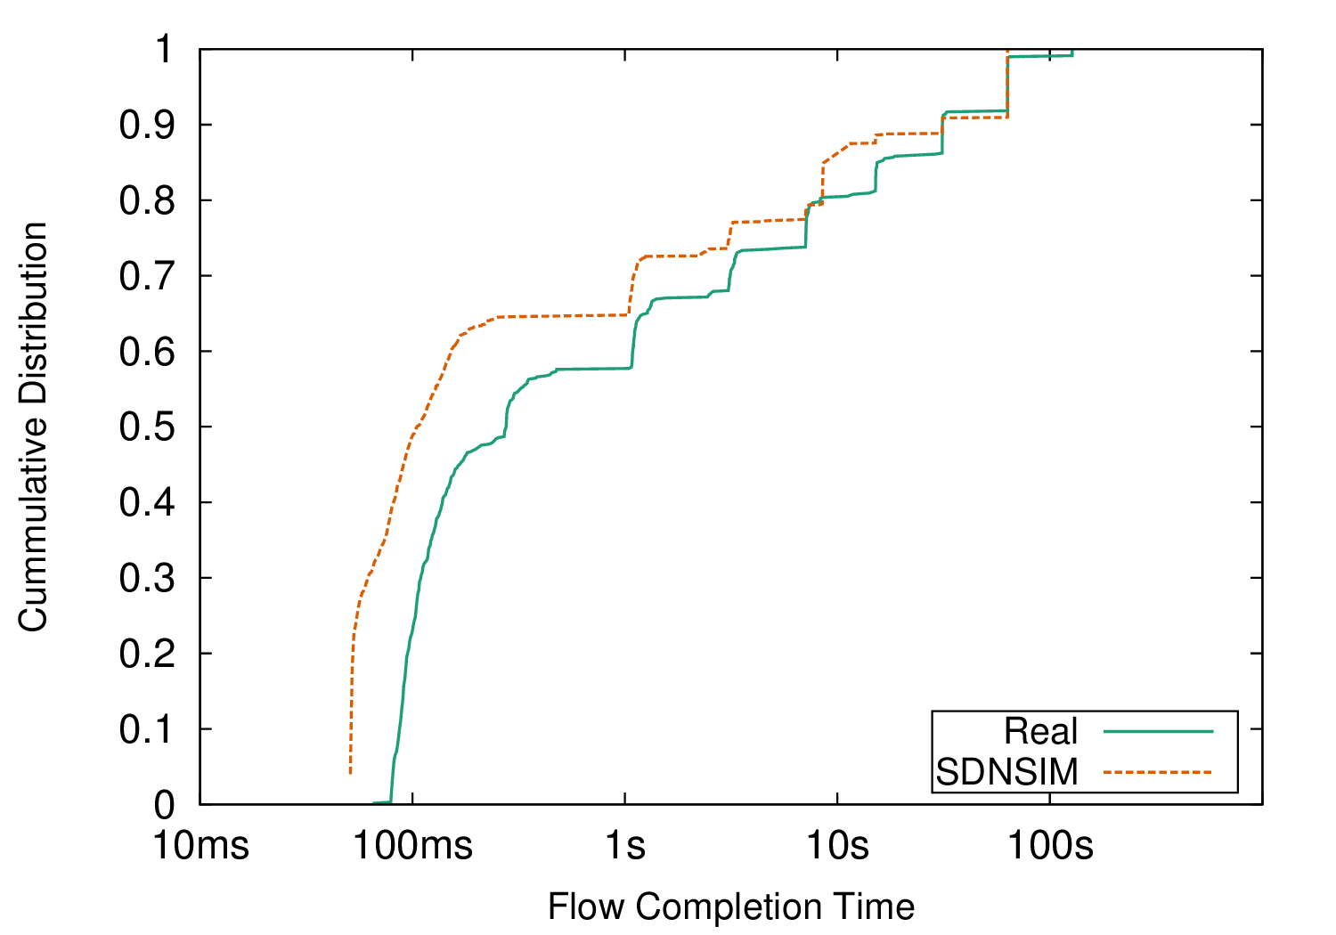
Figure 12: Comparing flow completion times between a real system based on Switch4 and an SDNSIM model.
In Figure Error: Reference source not found we present the cumulative distribution of flow completion times for the real and our model-based experiment. The performance observed with the real switch highlights the impact of the switch control plane design on network performance. In the real experiment, 20% of flows have higher completions time than 10 s. The predominant cause of this effect is the rate-limiting behaviour of the switch in pkt_in messages transmissions. This introduces TCP SYN and SYNACK packet drop during “bursty” periods. The completion time distribution exhibits a stepping behaviour, aligned with the back-off delay mechanism of TCP in the SYN_SENT SYN_RCVD states. Our model is able to capture the macroscopic behaviour of the switch. Nonetheless, our switch model exhibits a minor over-estimation of completion times. We attribute this behaviour to the high load that the reactive control scheme introduces to the communication channel between the co-processor of the switch and the ASIC, which skews the initial model.

7.3 ns-3 performance

(a) centralised topology

(b) distributed topology
Figure 13: Network topology to test the scalability of ns-3-based simulation. We simulated two topologies: a centralised topology (Figure Error: Reference source not found) and a distributed topology (Figure Error: Reference source not found)Error: Reference source not foundError: Reference source not found

 | Centralised topology |  |  | Distributed topology
Number of hosts | 4 | 8 | 12 | 4 |  | 8 | 12
Wall-clock delay (in min) | 13 | 35 | 75 | 8 |  | 25 | 42
Slowdown factor | 26 | 70 | 150 | 16 |  | 50 | 84

Table 6: Wall-clock delay to run a 30 second simulation time of the topology presented in Figure Error: Reference source not found, for a variable number of network hosts. SDNSIM of a network experiment using the ns-3 backend scales linearly as the traffic is localised. Error: Reference source not found
We evaluated the SDNSIM scalability using a simple network topology, depicted in Figure Error: Reference source not found. The topology consisted of a number of switches and host pairs, connected through 1 GbE links. Each pair of hosts generated steady state TCP traffic at line rate. We used two variations of the topology: a centralised topology using a single switch to connect all hosts (Figure Error: Reference source not found), and a distributed topology, with pairs of hosts distributed between two switches (Figure Error: Reference source not found). Each switch is connected to a controller running a learning switch application.
We executed 30 seconds of simulation time on a 24-core AMD server with 128 GB of RAM and Table Error: Reference source not found presents the wall-clock execution time and the slowdown factor of each simulation. From the results we noted the real time to execute a simulation in SDNSIM on the number of network events; as we increase the number of host and, consequently, the number of packets, the execution time increases. Additionally, from the comparison between the centralised and distributed topology, we noted that the performance of the simulation improves when network events are localized, as the simulation can be parallelized. In the distributed topology, network events are distributed between the two switches and executed independently, achieving near-linear scaling. The scaling properties of the SDNSIM backend matched data centre traffic experimentation, where applications run independently and networks employ multipath topologies (Kandula et al., 2009).

8 Hierarchical Distributed Control

Parameter | value
packet_in processing delay | 10 μsec
flow_mod insertion delay | 120 μsec
link propagation delay | 0.5 μsec
switch processing delay | 10 μsec
link capacity | 100 MbE
Request arrival rate (per host) | 62 retrievals/sec

Table 7: Hierarchical control simulation parameters.

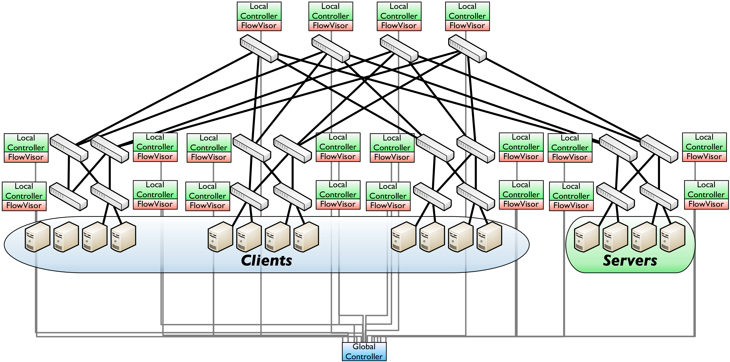
Figure 14: Hierarchical control experimental topology.
As we have discussed earlier in Section Error: Reference source not found, the OpenFlow abstraction can be used both for reactive and proactive control. The two approaches represent the two extremes of the control spectrum: proactive control pre-computes forwarding policy and thus reduces control plane latency; while reactive control enables unprecedented fine levels of network control at the cost of latency and scalability. In this section we present a use case for SDNSIM, evaluating the impact of distributed reactive control in network performance.
The experimental design revisits the hierarchical design pattern and implements an application for network control. Specifically, a global controller was connected to all network devices and maintains a global view of the network, while local controllers were connected to a subset of the devices and were able to exercise local forwarding policy in order to improve control responsiveness when necessary. FlowVisor on each network device multiplex switch control channels between local and global controllers, and can dynamically switch between the two controllers. During periods with high control plane load, the architecture can switch control to the local controllers in order to improve latency. Our experiment simulates the control architecture and evaluates the impact of multi-level control schemes on the performance of the data plane.
The experiment, presented in Figure Error: Reference source not found, uses a FatTree (Al-Fares et al., 2008) Clos topology with 4 pods and replicates the network behaviour of a database application. Specifically, the hosts in the first three pods act as clients, while the hosts of the fourth pod act as database servers. Each client selects at random a server and generates a 10 byte request, which is fulfilled by the server. The request size is selected at random from the values of 4 KB, 8 KB, 16 KB, 32 KB and 64 KB, while request arrivals follow a Poisson model. The control architecture of the network replicates the control logic presented by (Al-Fares et al., 2008). Every second the controller polls for flow-level statistics, calculates link loads, and redistributes flows between redundant network paths. In addition, the controller distributes new flow between redundant paths, with probabilities proportional to the path load ratio. Furthermore, in the simulation we encoded the parameters presented in Table Error: Reference source not found.
Using the previous experimental setup, we evaluated local and global control. Local control uses only local controllers and defines the forwarding policy using states from a single switch. In this setup we assume that the local controller has minimum latency to access the switch and minimizes the control channel latency and load. Global control uses only the global controller and setups flows across the
In order to evaluate the effect of each control scheme, we used the flow completion delay, a popular network performance metric (Dukkipati and McKeown, 2006). Figure Error: Reference source not found presents the median, 10th and 90th quantile of completion for each flow size. From the results we noted that the centralised policy provides higher performance in comparison to the local control scheme. Regardless of the low delay of the control channel in the local approach, the suboptimal forwarding policy of the system results in significant latency in the completion time of a flow, especially for long-lived TCP connections. The increased delay is due to packet queueing delays and recovery from packet losses. Interestingly, the latency increase is proportional to size of the flow. The suboptimal policy is expected to affect more packets as the duration of the flow increases.

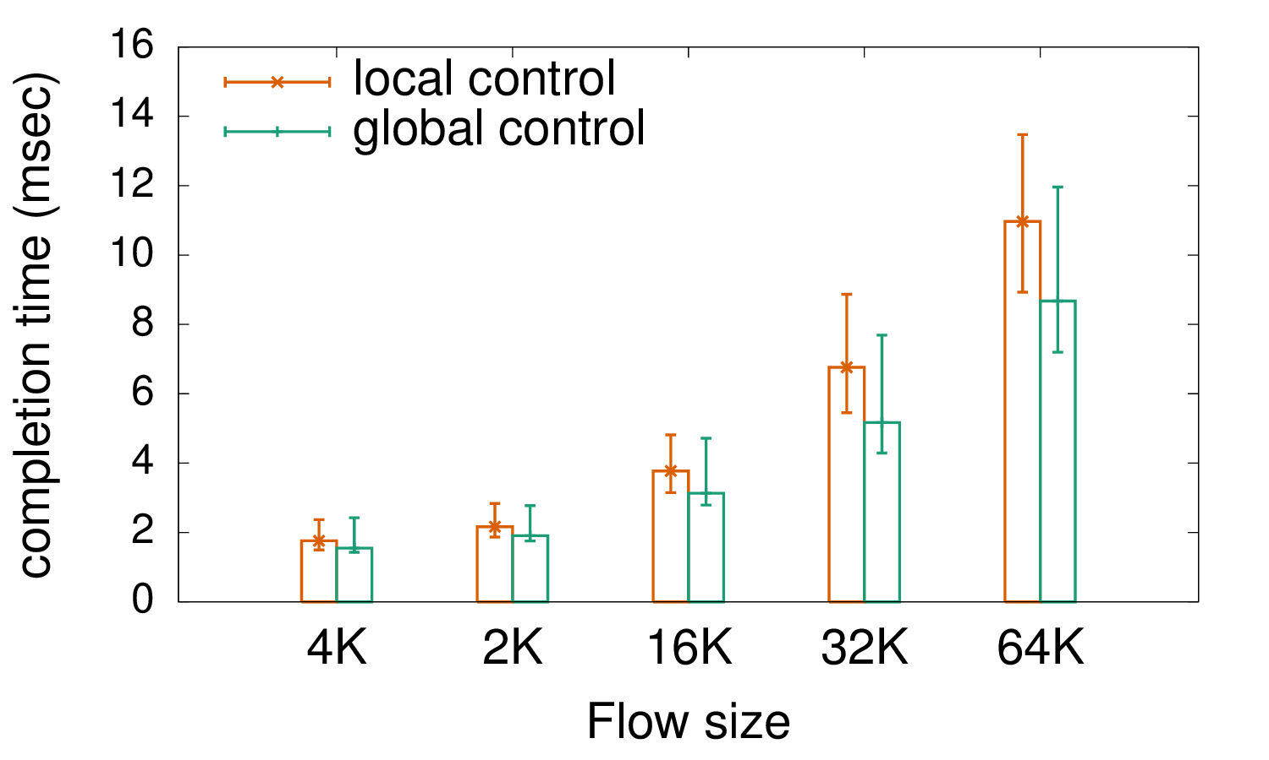
Figure 15: Comparison of TCP flow completion time for various flow sizes between a centralised and decentralised control architecture in a Fat Tree network topology.

9 Summary
This chapter discussed the scalability capabilities of the predominant SDN implementation, the OpenFlow. We presented OFLOPS, a tool that tests the capabilities and performance of OpenFlow-enabled software and hardware switches. OFLOPS has advanced hardware instrumentation, for accuracy and performance, and provides an extensible software framework. We used OFLOPS to evaluate five different OpenFlow implementations, in terms of OpenFlow protocol support as well as performance. In our performance evaluation, we benchmarked the packet processing, traffic interception and injection, flow table modification and traffic statistics export functionalities of the switches. We identified considerable variation among the tested OpenFlow. We took advantage of the ability of OFLOPS data plane measurements to quantify accurately how fast switches process and apply OpenFlow. For example, we found that the barrier reply message is not correctly implemented, making it difficult to predict when flow operations will be seen by the data plane. Finally, we found that the monitoring capabilities of existing hardware switches have limitations in their ability to sustain high rates of requests. Furthermore, at high rates, monitoring operations impact other OpenFlow commands.
In addition, in this chapter we presented the SDNSIM, an experimentation framework for large-scale high-precision experimentation with control plane architectures. SDNSIM used the Mirage abstraction layer to enable developers to program the functionality of their network. An SDNSIM definition can seamlessly translate at compile into a simulation over the ns-3 simulation platform, or a high precision emulation over the Xen virtualisation framework. We conducted a number of micro-benchmarks and evaluated that the software provided emulation performance comparable to software OpenFlow and switching platforms, while SDNSIM provided good scaling properties. Furthermore, we used SDNSIM to investigate the impact of hierarchical distributed control architectures on the performance of the data plane of the network. In the next chapter, we explore applications of the SDN paradigm to scale network management.

Chapter 5

Secure and Scalable Internet-scale Connectivity
In this chapter we explore applications of the SDN technology in connectivity and naming scalability. The work is motivated by the user requirement to create a network federation between the network's devices. We call this functionality a Personal Cloud. Currently, Personal Clouds use third-party Cloud services as information caches, to bridge the inter-device communication requirements. Device federation is currently limited due to the connectivity and naming limitations of the Internet architecture. This architecture is a consequence of the connectivity scalability limitations of the Internet, as discussed in Section Error: Reference source not found. Nonetheless, as users offload personal information to third-party services, they become subject to privacy threats and performance degradation.
We argue that end-devices require an adaptable network control architecture, in order to overcome connectivity limitations and control their data and resources. The network community provides an abundance of free and open mechanisms, which can be reused dynamically to provide inter-device connectivity. We introduce Signpost, a network control plane for end-devices, capable of delivering continuous and secure connectivity between user devices. Signpost uses existing network testing approaches to detect network environment conditions and configures existing software packages to establish end-to-end connectivity between devices.
In order to understand the feasibility and performance of the proposed architecture, we present a strawman implementation of the core control logic and its integration with a number of network connection and notification services. Currently, Signpost SSH (Levin and Even, 2005), OpenVPN , TOR (Dingledine and Mathewson, 2006), NAT-punch and Privoxy (2013) mechanisms, while it can also propagate Multicast-DNS notifications across devices.
For the rest of this chapter, we present a preliminary categorisation of Personal Cloud platforms and, motivated by some key observations, we define the key design requirements for our platform (Section Error: Reference source not found). Furthermore, we present the Signpost (Section Error: Reference source not found) and architecture (Section Error: Reference source not found), followed by an elaborate description of a strawman Signpost and an evaluation of its functionality (Section Error: Reference source not found). Finally, we conclude with our observations (Section Error: Reference source not found).

1 Personal Clouds
The digital revolution of our era has mirrored a large part of our life in the digital domain. For example, human labour is commonly stored in PDF and word processing files, while social interactions are partially captured in digital photo collections. Effectively, our physical presence has an increasing digital counterpart, accessible through computing devices. Nonetheless, the increase in the adoption of personal computers introduces challenges in the management of our digital footprint. Complimentary to personal computers, users own and use tablets, smartphones and other purpose-built computing units (e.g. home entertainment systems and gaming consoles), while the IoT paradigm (Atzori et al., 2010) will extend further. From a user perspective, each device fulfils a specific role in managing digital resources, thus requiring access only to a subset of the user's digital presence, but these roles are fluid and intercept. For example, a smartphone is primarily a communication device, but end-users may use it as a media player. In the latter case, the smartphone and the home entertainment system provide similar functionality to the user and require access to the same subset of his digital presence. As a result, the transition from a single PC to a multi-device paradigm requires global and homogeneous access and control mechanisms of digital information and resources. We define this abstraction as the user's Personal Cloud.
This section presents existing Personal Cloud mechanisms, discusses their functional limitations (Section Error: Reference source not found), and defines the core Signpost goals (Section Error: Reference source not found).

1.1 Approaches
Personal Cloud functionality is readily available in a number of applications, providing a wide range of abstractions. This section provides a simple taxonomy, based on their architecture.

Decentralised Personal Cloud
The Decentralised Personal Cloud application class contains standalone connectivity mechanisms, managed by end-users. Computer networks by design provide the middleware to enable information and resource sharing between computers. As a result, the network community provides an extensive collection of applications and protocols that support Personal Cloud functionality, such as remote desktop access (e.g. Remote Frame Buffer protocol (Richardson and Levine, 2011)), file sharing (e.g. NFS (Nowicki, 1989); SAMBA file service (Leach and Naik, 1997)), remote login (e.g. SSH (Ylonen and Lonvick, 2006)), remote printing (e.g. IPP (Hastings et al., 2000)). Such systems employ a client-server architecture and extend the computer abstraction to include inter-device connectivity. A user can set-up and manage sharing services on his personal devices and enhance his computing experience. Furthermore, the setup complexity of some services has motivated the development of automation mechanisms like Multicast-DNS, UPnP and ZeroConf, which allow a user to seamlessly browse and access available services.
Decentralised Personal Cloud applications provide extensive control over personal data and strong privacy guarantees. Decentralised approaches are a popular mechanism for sharing data within the local network, like the home network, Nonetheless, Internet-scale deployment of such mechanism faces significant scalability problems, primarily due to the following three issues:
• Connectivity: Decentralised Personal Cloud effectiveness is defined by Internet connectivity limitations. The current Internet architecture does not guarantee global and homogeneous service accessibility, as we have discussed in Section Error: Reference source not found, limiting the applicability of client-server models. End-users commonly connect to the Internet through edge networks optimised for outgoing connectivity, while ubiquitous middleboxes limit service accessibility. For example, NATed networks restrict by default incoming Internet connectivity, while mobile and enterprise networks enforce network policies, using firewalls, which limit device connectivity for security reasons.
• Authentication: In the context of security, there are two primary authentication architectural paradigms: out-of-band communication; and pre-deployed information (Touch et al., 2008). The majority of decentralised applications use pre-deployed authentication mechanisms, based either on password or public key schemes. Although the approach is effective, it exhibits limited flexibility in supporting management automation and responsiveness to user credential compromises. Out-of-band authentication mechanisms effectively address the aforementioned problems, but existing applications often lack support, while enabling such a mechanism requires significant management effort.
• Usability: Decentralised Personal Cloud applications introduce significant usability challenges to inexperienced users. Configuration interfaces of relevant software vary significantly, while in some cases effective configuration requires a deep understanding of the system (e.g. the SSH client in Linux has 26 command line parameters and 70 configuration options). In addition, due to the previously discussed connectivity limitations, users must resort to a “trial and error” approach in order to evaluate the effectiveness of an application configuration in a specific environment, and potentially use multiple mechanisms to achieve connectivity, like tunnelling software. Effectively, the configuration of decentralised Personal Cloud applications is complex, time-consuming, and highly disengaging for inexperienced users, as discussed in Section Error: Reference source not found.
As an example, we will describe the required steps to access files from a remote device using the SSH service, following the decentralised approach. Initially, the user must configure the SSH service on the server host, both in terms of access control and service functionality, and any firewall and NAT device deployed in the local network. Additionally, the user must dynamically configure a naming service if the public IP of the server is dynamic, e.g. DynDNS. SSH connectivity is subject to the ability of the user in the remote network to use the SSH protocol on the preconfigured port. In cases where this is not possible, the user has to try a different connection establishing mechanism.

Centralised Personal Cloud
A popular alternative to decentralised Personal Cloud services uses third-party services to share information and resources between devices. In this class of applications we consider applications like the Google service suite, the Dropbox file sharing service, the LogMeIn Remote Desktop service, and other similar services. These applications provide a simple, intuitive and ubiquitous mechanism for sharing data and resources between a user's devices, or even with the user's social circle. Centralised Personal Cloud applications rely on resilient, high availability and responsive services. Although this approach provides an effective solution, some of its properties are ambivalent and demotivate user engagement.
• Identity: Cloud applications provide an effective control framework to disseminate information between devices and users. Each user has an online identity, verifiable by the service provider. Users can define information access policies using these identities and guarantee secure delivery. Nonetheless, such identities are susceptible to privacy attacks. Krishnamurthy and Wills (2009) present a privacy attack using online identities from online social networks. Specifically, the service provider exposed identification breadcrumbs to advertising services, thus allowing user monitoring. Facebook has openly verified the existence of such services (Juan Carlos Perez, 2007).
• Performance: The elasticity of cloud computing infrastructures, commonly used to host centralised Personal Cloud applications, provides high performance scalability. Nonetheless, such applications commonly underutilize the wealth of computational and network resources available in edge networks and devices. Two devices connected to the same subnet will experience bloated RTT when they connect using a centralised service, while the cost and latencies of cloud storage are orders of magnitude higher in comparison to local storage. Wittie et al. (2010) report that Internet path latency and packet losses extensively affect the 95th quantile of cloud service network performance, while Dean and Barroso (2013) present a wide range of parameters which influence user-perceived performance, spanning from the CPU scheduler to hardware design in the cloud infrastructure.
• Cost: The majority of relevant services provide weak user service level agreements (SLAs) and minimum guarantees to users and their data. As a result, if the service is compromised and sensitive information is leaked, the SLAs minimize the legal obligations of the provider towards affected users (Declan McCullagh, 2011). In addition, recent allegations (Greenwald and MacAskill, 2013) claim intentional data access rights being granted to unauthorized entities. Although a significant number of such services provide cost-free access, the cost of personal information leaks can be significant and unobserved by the user Liu et al. (2011).
• Availability: Cloud services run on well connected data centres, managed by highly-skilled engineers, ensuring performance, functionality and security. However, centralised architectures have by design a single point of failure. For example, two devices, belonging to different users and connected to the same local network, cannot exchange a file over Dropbox if the Dropbox service is inaccessible.

1.2 Design Goals
In the previous section, we present the capabilities and limitations of existing Personal Cloud approaches. Decentralized Personal Cloud applications lack user-friendliness and their functionality is subject to the network policy. Centralised Personal Cloud applications introduce privacy vulnerabilities and are a performance bottleneck. The security and performance trade-offs are a direct consequence of the scalability limitations in current Internet architecture.
We believe that an efficient and secure Personal Cloud framework should employ a hybrid approach to scale connectivity, security and usability. User information must remain on user devices and the system must provide user-controlled privacy. The wealth of available decentralized Personal Cloud applications cannot support global connectivity, and thus functionality, and require that cloud support establishes a control channel between hosts. Nonetheless, cloud mediation is not always required in order to provide inter-device connectivity, as the host can evaluate the network policy and negotiate the use of a connection establishing software, like tunnelling software. We have set the following high-level goals for our system architecture:
• Naming: A sufficient architecture requires a high availability naming mechanism translating global names into accessible network end-points.
• Connectivity: Personal Cloud architecture must provide connectivity, and thus functionality, in all network environments. The system should be able to recover when exogenous factors disrupt connectivity.
• Control: A Personal Cloud system should exhibit a user-friendly access control abstraction. Access policies should operate on the level of devices or users and rely on strong authentication and encryption mechanisms. Additionally, the control should be sufficiently dynamic to respond to security changes, e.g. propagate trust revocation for a compromised device. The control abstraction should also incorporate diverse security aspects and allow the user to control the trade-offs between performance and security.
• Backward Compatibility: The framework should provide support to existing decentralised applications without any code modification.
• Usability: The system should expose a simple control abstraction to end-users in order to orchestrate the connection establishment process. All low-level network interactions should be managed by the system and remain hidden by the end-user. Ultimately, the abstraction of the system should be compatible with the existing functionality of decentralised Personal Cloud.

2 Finding your way with Signpost
Signpost is a decentralised naming and connectivity framework with user-controlled security. The system provides an Internet-wide overlay network between the devices of a user, enabling device federation. Signpost uses a cloud-based inter-device control channel to coordinate end-to-end network path establishment between devices by using existing connection-establishing software and protocols. In order to ensure functionality under any circumstance, the Signpost channel is integrated with the Internet naming service, a high availability and resilient service.
At the core of Signpost, we define a generic testing and configuration model, which automates connection establishment using a wide range of relevant software. Section Error: Reference source not found presents in detail the proposed model and Section Error: Reference source not found presents the integration with a representative set of connection establishing software. Signpost offers backwards-compatibility with existing applications on the network layer. The applications can use Signpost by routing traffic to Signpost, while the control API for inter-device connection establishment is integrated with the gethostbyname() OS method. Each device is exposed to the users as a domain name, and a name lookup for a device triggers the establishment of a Signpost.

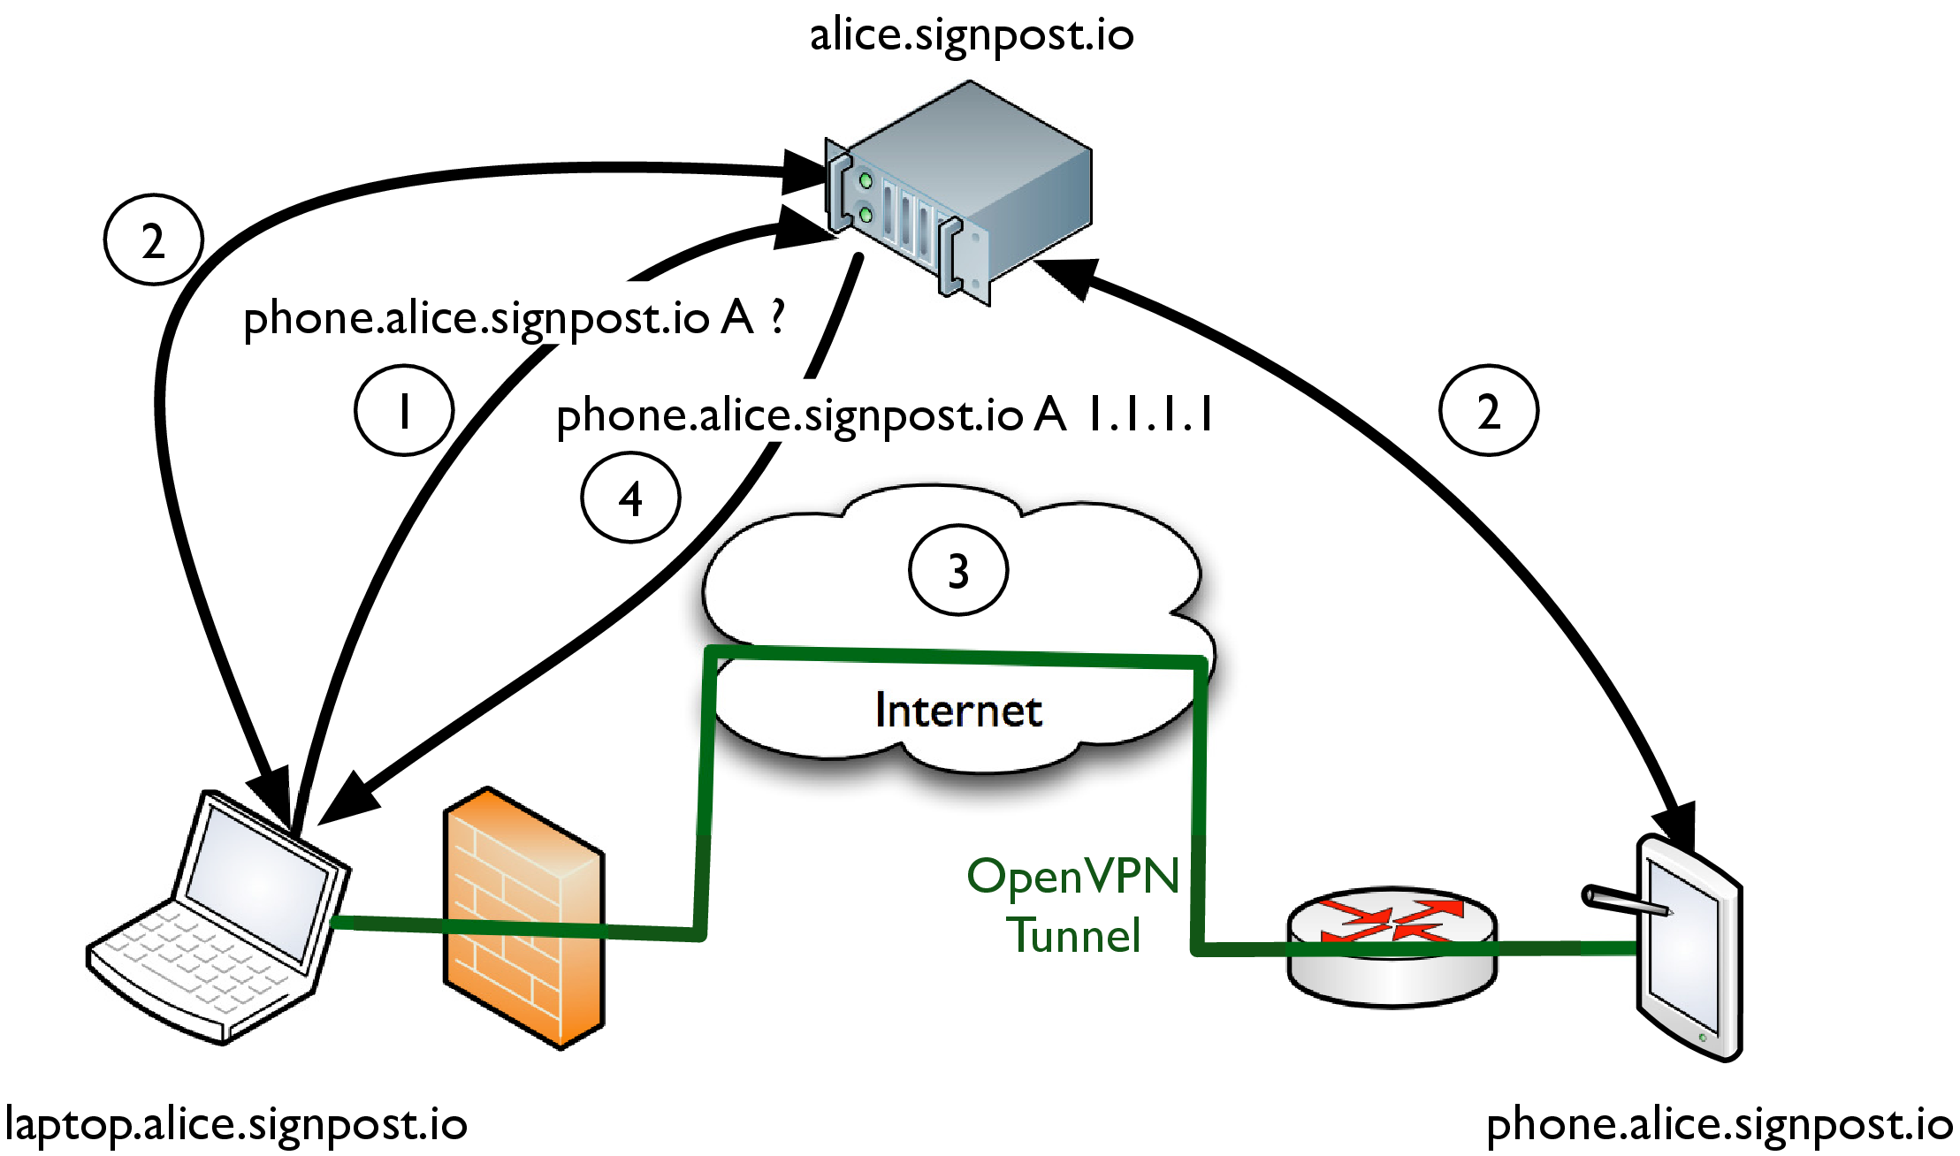
Figure 1: An example use-case of the Signpost abstraction. Alice establishes a direct communication channel between her smartphone and her home PC over the Internet.
In order to introduce the reader to Signpost, Figure Error: Reference source not found depicts a simple use case example. In this scenario, Alice, while at work, wishes to access files from her laptop, situated behind a home router, through her smartphone. In order to express her interest in connecting to her laptop, Alice performs a name lookup for the domain name laptop.bob.signpost.io to her local Signpost (step 192). The name request propagates through the public DNS infrastructure to her Signpost cloud service, which we call Signpost. A verified name request to Signpost initiates the connection establishment logic of the system, which triggers the two devices to try multiple connection establishment mechanisms and setup an end-to-end path (step 193). Once an initial path is available (step 194), the controller replies to the initial name request with a local Signpost-specific IP address. Traffic to this address is routed by the device network stack to the established inter-device network path (step 195). In parallel, Signpost will evaluate different connection mechanisms, aiming to discover paths with higher performance, and monitors path availability, thus recovering automatically from disconnections.

3 Signpost Architecture

Figure 2: Signpost operates over three different perspectives: The user device, the Internet and the naming hierarchy.
Figure Error: Reference source not found presents the architecture of Signpost from three different viewpoints. In the lower section of the figure, we present the design of Signpost and its integration with existing applications. Signpost is contained in a single executable, and requires the guest OS to expose a flow control abstraction, like OpenFlow, and to redirect DNS queries to the embedded DNS resolver. The software consists of three subsystems: The Connection Engine (Section Error: Reference source not found), responsible for setting up and managing Network Tactics (Section Error: Reference source not found) in order to establish end-to-end paths, the local DNS resolver, and the OpenFlow-based Signpost router (Section Error: Reference source not found), which enhances the normal OS routing functionality with Signpost control logic. The middle section of Figure Error: Reference source not found, presents the inter-device connectivity architecture of Signpost. The system sets up an Internet-wide inter-device control channel, enabling capability and parameter negotiation between devices. The architecture uses a special Signpost, which we call Signpost, to run on a well-connected host and bridge the device control channel across the Internet, effectively orchestrating connection negotiation and establishment. The upper section of Figure Error: Reference source not found presents the naming organisation of the Signpost. The system reuses the naming abstraction of the DNS service. Each device has a global domain name, while the domain hierarchy and name aliasing expresses the control relationship between devices and users. We extend the normal name resolution functionality of the DNS protocol and introduce an effectful name resolution functionality for Signpost-enabled domains; a name resolution expresses user interest in connecting to another device, and triggers the test and setup of a network path (Section Error: Reference source not found). In the rest of this section we present in detail the architecture of Signpost, using a bottom-up narrative.

3.1 Network Tactic

Tactic name | Purpose | Layer | Transport | Authenticate | Encrypt | Anonymize | Signpost Support
Avahi | Discover | 7 | UDP | No | No | No | Yes
Samba | Discover | 7 | UDP | No | No | No | No
Bonjour | Discover | 7 | UDP | No | No | No | Yes
Universal PnP | Discover | 7 | UDP | No | No | No | Yes
dns2tcp | Tunnel | 7 | UDP | No | No | No | No
DNScat | Tunnel | 7 | UDP | Yes | No | No | No
HTTP-Tunnel | Tunnel | 7 | TCP | No | No | No | No
iodine | Tunnel | 7 | UDP | Yes | No | No | Yes
NSTX | Tunnel | 7 | UDP | No? | No | No | No
Proxytunnel | Tunnel | 7 | TCP | Can be | Can be | No | No
ptunnel | Tunnel | 4 | ICMP | Yes | No | No | No
tuns | Tunnel | 7 | UDP | Yes | No | No | No
SSH | Tunnel/Encrypt | 7 | TCP | Yes | Yes | No | Yes
IPSec | Tunnel/Encrypt | 3 (4*) | IP | Yes | Yes | No | No
OpenVPN | Tunnel/Encrypt | 7 | UDP/TCP | Yes | Yes | No | Yes
libjingle | Nat punch | 7 | UDP/TCP | Yes | Yes | No | No
privoxy | Anonymize | 7 | TCP | No | No | Yes | Yes
tor | Anonymize | 7 | TCP | No | Yes | Yes | Yes
stunnel | Encrypt | 7 | TCP | Yes | Yes | No | No
TCPCrypt | Encrypt | 4 | TCP | No | Yes | No | No

Table 1: List of available connection establishing mechanisms. The table presents for each mechanism, its primary functionality, the layer providing connectivity and the protocol used to establish connectivity and the support of the mechanism for Authentication, Encryption, Anonymisation and Signpost.
In order to provide end-to-end connectivity, Signpost uses available functionality from the wide range of free and open source connection establishing mechanisms. Table Error: Reference source not found, presents a survey of such mechanisms along with their network requirements and security properties, highlighting the significant diversity available between mechanisms. For example, some mechanisms provide connectivity, bypassing strict network policies, other mechanisms enhance security and privacy in end-to-end Internet paths, while a third class enables connection automation. Furthermore, available mechanisms vary significantly on the operating network layer and the exposed connection abstraction. Connection mechanisms expose connectivity over a specific transport layer port or through a network layer device. In terms of protocols, the majority use UDP or TCP sockets, but some mechanisms use other network protocols, like ICMP. Finally, authentication exhibits significant diversity, spanning from user-based authentication, using either passwords or certificates, to simple pre-shared passphrases, while some mechanisms lack support entirely.

Figure 3: Signpost lifecycle.
In order to accommodate the variances between available connection establishing mechanisms, Signpost uses a Network Tactic abstraction; a generic model encapsulating testing and control requirements and automating the end-to-end path setup process for a connection mechanism. A Network Tactic is modelled as a 4 state automaton for each pair of devices, presented in Figure Error: Reference source not found. A Tactic is initialized in the Idle state. A test method invocation transfers the Tactic to the Test state and triggers Tactic-specific connectivity tests to discover the network policy and configuration requirements. If testing is successful, the Tactic can progress to the Connected state through an invocation of the connect method, responsible for configuring the underlying Tactic in order to provide an end-to-end path. Once the end-to-end path is established, the Tactic can progress to the Enabled state and forward traffic between the two devices over the path. Finally, the Tactic abstraction provides methods to backtrack from each state, tearing down any established path.
Furthermore, because Signpost requires inter-device synchronisation and state distribution, its functionality is distributed between the Signpost controller and Signpost, and split logically into two layers: the Southbound layer implements low-level Tactic operations and runs on Signpost; and the Northbound layer, implements the state transitions of the Tactic automata, translating them into low-level operations, and runs on Signpost.
The two layers of a Tactic employ the control channel between the devices and Signpost to communicate using a JSON-RPC service (Group et al., 2012). The control channel is exposed as a TCP service on port 5353. Signpost uses a control channel with high availability to ensure Tactic parameter negotiation, even in heavily policed networks. If direct connectivity fails, the system uses as a fallback mechanism an Iodine (iod, 2014) DNS tunnel. Iodine uses the DNS protocol to transmit data between two hosts on UDP port 53, by encapsulating tunnel traffic in well-formed DNS packets which can travel through recursive DNS resolvers. Iodine can provide connectivity as long as the naming service, an important service for Internet connectivity, is not blocked by the network. The choice of Iodine provides sufficient capacity and latency to support the Signpost channel, while better integration of control messages with the DNS packet format can improve the channel performance.
In order to present the separation between the two layers, we present the implementation details of the OpenVPN test method. For the specific functionality, the Southbound layer of the Tactic provides two operations: the init operation, initializing an OpenVPN; and the test operation, testing client connectivity to an OpenVPN. The Northbound test method uses Southbound operations to evaluate connectivity between two devices. During connection testing between two devices, the test method will execute in parallel on both devices; initially, the init operation and then the test operation towards the other device. The first device returning a successful test result becomes the client of the OpenVPN. If the test times-out or both devices return a negative result, then the controller will initialise a local OpenVPN and execute the test operation on both devices towards the controller.

3.2 Forwarding
Signpost connectivity on the network layer of the host, thus achieving backwards compatibility with existing decentralized applications. A Signpost cloud is abstracted as a local subnet and each device is assigned a persistent local IP. An ARP proxy, integrated with Signpost, replies with the MAC address fe:ff:ff:ff:ff:ff to all Signpost-local IP addresses, thus reducing broadcast traffic and focusing forwarding decisions on the network layer. Signpost on programmable network control mechanisms, like OpenFlow, to dynamically define forwarding policy and detect connection problems.
The majority of the Signpost logic is defined by Network Tactics. Non-Signpost is forwarded based on the routing configuration of the host. For Signpost, control is delegated to Tactics, which are responsible for installing appropriate forwarding rules. Tactics can inject and intercept traffic and exercise control proactively or reactively. Section Error: Reference source not found presents the integration details between Signpost and connection establishing mechanisms and elaborates on different network control approaches.

3.3 Connection Manager
Signpost management is implemented by the Connection Manager module. The module runs on the Signpost, controlling path establishment, selecting optimal paths between device pairs and ensuring connectivity. Path establishment uses the Tactic abstraction to isolate low-level connection details. In terms of path selection, Signpost establishes multiple end-to-end paths between two devices, but multipath connectivity is not supported by popular transport protocols, while newer multipath-enabled protocols, like SCTP (Ong and Yoakum, 2002) and multipath TCP (Ford et al., 2013), are not yet available in production systems. As a result, Signpost uses only a single end-to-end path between each pair of devices. Path search is initiated by the connect method of the Connection Manager module, using as parameters the device names and a list of security properties. Path selection takes under consideration two aspects: performance and security properties.
Path performance in Signpost the resource availability in a path. The current implementation of Signpost uses a set of simple and static heuristics to predict path performance, based on the properties of the underlying Tactics. More specifically, Tactics using Signpost as a path relay exhibit lower performance in comparison to direct paths, while Tactics using connectionless protocols, like UDP, are considered more efficient than Tactics using connection-oriented protocols, like TCP. These simple rules provide an approximation of the Tactic performance. Path performance characterisation can also incorporate active network measurements to improve flexibility and estimate accuracy.
In terms of security properties, Signpost uses three elementary functions for each Tactic: encryption, authentication and anonymity. An encrypted Tactic applies strong cryptography on both directions of the path, while an authenticated Tactic uses strong authentication during the establishment of the path. Finally, an anonymising Tactic provides built-in user identity obfuscation on the path. Each Tactic provides a subset of these functionalities, based on the capabilities of the underlying connection mechanism (Table Error: Reference source not found), and there is no single Tactic that supports all security properties, and ensures connectivity under any network environment. In order to address this limitation, Signpost uses a Tactic synthesis operation; a path that can be constructed by layering multiple connectivity mechanisms and effectively create a path providing the aggregate security properties. For example, an anonymised and authenticated path can be established using an SSH tunnel over a TOR circuit between the two devices. It is important to point out at this point that Signpost uses existing frameworks to enhance security for an end-to-end path and does not develop a security framework from scratch. The security properties of a path are a side effect of the used Tactics. End-users can use security properties to define security policies towards specific devices. The policy is expressed through a configuration file, and users specify security requirements on a per domain basis
Path selection is modelled as a dynamic optimization problem with security requirements modelled as constraints and path performance modelled as the objective function. Path performance is represented by a positive integer weight, with higher values reflecting lower performance of the path. The weight of a path is equal to the sum of the individual weights of the Tactics synthesizing the path. Path selection uses a breadth-first search mechanism over the complete space of all possible Tactic combinations. During a connection request the system spawns a thread for each Tactic, testing end-to-end connectivity. If the test is successful, the Tactic will try to connect the two hosts. If the connection is also successful, and there is either no other Tactic enabled or the enabled Tactic has a higher performance value, then the Manager will progress the state machine of the Tactic to the Enabled state, and disable any existing enabled Tactics. If the Tactic doesn’t fulfil the security policy, the Manager will recursively try to layer more Tactics over the established path and find a Tactic synthesis with sufficient security properties. The Manager returns a successful result when the algorithm finds a path configuration fulfilling the security policy, but the search will continue to search for better paths. The search will terminate when all remaining Tactic combinations have a higher performance weight or they are synthesized by more than three Tactics. Effectively, the search algorithm rapidly establishes a first path between two devices, and progressively optimizes path performance while the devices remain interconnected.
Finally, the connection manager module is additionally responsible for monitoring enabled paths and detecting disconnections. The module uses flow_stats OpenFlow to identify packet transmissions during a monitoring period, and thus infer path liveness. If the path is idle during that period, the module uses a UDP heartbeat service to verify path connectivity. During a heartbeat timeout, the connection manager tears down the path and repeats the path search process. A Tactic can employ application-specific connectivity evaluation mechanisms, e.g. OpenVPN to a keep a mechanism alive.

3.4 Effectful Naming
The majority of Internet-connected devices are essentially anonymous from a network perspective, being assigned transient names (e.g. via DHCP). The IPv6 protocol (Deering and Hinden, 1995) addresses a number of such limitations, but the protocol deployment on the edges of the Internet has been slow and limited. A fundamental goal for Signpost is to support stable and secure resolution of device names to concrete end-to-end paths. Signpost uses the DNS protocol (Mockapetris, 1987) to support its naming functionality for two reasons. Firstly, DNS is an effective solution to the naming problem. It is an Internet-wide service, supported by all network applications and never blocked in a network. The introduction of the DNSSEC extensions provides additional bi-directional authentication. Secondly, the DNS service inherently supports delay-tolerant service indirection, used extensively across the Internet. Many services employ user-friendly domain names to represent virtual service end-points which are refined during name resolution, directing users to the best service mirror based on the end-host location and the service load (Barbir et al., 2003). Effectively, a domain name resolution represents the interest of a user in connecting to a service, which the service provider can direct to a concrete end-point based on the network context.
The Internet naming service provides good scaling properties, using a hierarchical architecture. Every domain name consists of a sequence of name tokens organised in a hierarchical tree structure with a single root: the empty string. Every node on the tree can be coupled with a number of DNS Resource Records (RRs) and provides rich information on the domain name, like its network addresses and name aliases. In order to scale the performance of the naming service across the Internet, the design of the system allows service delegation for a zone to other servers using the NS RR type. In addition, the DNS service defines a record caching mechanism, in order to improve lookup performance and service load.
A DNS packet (queries and responses) contains a standard header and four sections: the question, containing the name being looked up; the answer, containing RRs answering the question; the authority, pointing to an authoritative server for the question; and the additional records, containing any additional information pertaining to the question. Name resolution then follows one of two paths. A recursive resolution occurs when the server does not have the answer and so it acts as a resolver itself, pursuing the answer on behalf of the client. In contrast, an iterative resolution occurs when the server does not have the answer and responds by referring the client to a server “closer” to the answer.
Signpost uses the DNS naming service abstraction and extends its functionality, introducing the idea of effectful name resolution. Effectful name resolutions have as a side-effect the creation of an end-to-end path towards the requested destination. Effectively, Signpost uses name resolutions as an intention to connect to the requested device and translate the name resolution in an explicit connection request to the Connection Manager module. This extension to DNS functionality is similar to the indirection functionality of the protocol. In addition to pointing the requester to an appropriate network address, Signpost a path towards that address.

3.4.0.4 Secure Names For All Internet Users

Figure 4: Example DNSSEC files for the signpost.io and bob.signpost.io domains. The signpost.io nameserver zone file contains a DS RR with the hash of the bob.io. DNSKEY RR and a RRSIG RR signature of the DS RR signed with the DNSKEY of the signpost.io domain. bob.signpost.io uses its DNSKEY to sign an A RR for desktop.bob.signpost.io
The initial definition of the Internet naming service provided weak security guarantees and was vulnerable to man-in-the-middle and cache poisoning (emergency response team, 2008) attacks. In order to enhance the security primitives, the IETF standardised a number of DNS protocol extensions, described as DNSSEC. DNSSEC has three RR types (Arends et al., 2005), enabling response authentication as presented in Figure Error: Reference source not found. In DNSSEC, each zone owns one or more cryptographic keys to sign authoritative DNS responses. DNSSEC defines four new DNS RR types to accommodate the authentication functionality. The RRSIG RR type can carry RR signatures, while the NSEC RR type reflects the lack of specific RRs for a domain to a resolver. The DNSKEY RR type disseminates public keys of a domain to resolvers, which in turn can use them to authenticate response signatures. Finally, the DS RR type expresses the trust of a domain to a signing key of another domain. With respect to Figure Error: Reference source not found, the domain bob.signpost.io signs an A record for the host desktop.bob.signpost.io through an RRSIG RR using Bob’s DNSKEY. Bob’s key is registered with the signpost.io domain through a DS RR, containing the hash of the key and signed using an signpost.io public key. Effectively, the DNSSEC extensions form a chain of trust as part of the naming service and ensure query response and key authenticity. The resolver requires, as in the X509 certificate architecture, only a list of authenticated anchors, configured out-of-band and injected into the authentication chain.
Signpost uses the DNSSEC types to establish an authenticated control channel between the devices of the user. Each Signpost must have authoritative control of a domain zone, serviced by Signpost, and register a signing key to the DNSSEC of trust. Each device has a domain name under the domain of the user. With respect to Figure Error: Reference source not found, Bob is granted control of the zone bob.signpost.io where he registers his laptop under the domain name laptop.bob.signpost.io. As a result, each Signpost has a globally accessible authenticated public identity for each device via a public-private key-pair. Using this key-pair, a user can sign and authenticate messages, bootstrap public key cryptography mechanisms and run key-exchange mechanisms, such as Diffie-Hellman-Merkle (Rescorla, 1999), and derive new shared private keys between any two devices over unsecure channels.
The base DNSSECtypes provide a mechanism for authenticating responses from a nameserver to a DNS resolver. In terms of Signpost, we are additionally interested in authenticating DNS requests. Authenticated requests enable the server to present a different view over the resource mappings, depending on the querying entity. Signpost uses the SIG(0) RR type, defined in 3rd (2000), to sign DNS requests using the key of the device.

3.4.0.5 Signpost With DNSSEC
Signpost uses the Signpost and controller DNS functionality. Specifically, the controller runs a programmable DNS service, which is authoritative for the user domain. The server is authoritative for the user domain, signs responses on-the-fly, verifies SIG(0) signed queries, and translates them into Connection Manager requests. A request for an A RR for domain name laptop.alice.signpost.io, signed with a SIG(0) record with a key from host desktop.alice.signpost.io, will be translated into a connection request between Alice’s laptop and desktop devices. In the client side of Signpost, we use a local Signpost-aware DNS resolver. DNS queries for non-Signpost trigger a recursive search of the DNS name tree, in order to retrieve the requested RRs. For Signpost requests, the resolver signs the query with a SIG(0) record using the private key of the device.
The DNS functionality is also available offline in a local network. Specifically we use DNS-based service discovery (DNS-SD) (Cheshire and Krochmal, 2013b), an RR organisation specification, which enables service advertisement and browsing in a local network. DNS-SD uses the Multicast-DNS (Cheshire and Krochmal, 2013a) service and provides an efficient local service discovery mechanism. The combination of DNS-SD and multicast-DNS is currently a popular service discovery mechanism in local networks, supported by most operating systems. Signpost advertises, using the DNS-SD mechanism, a Signpost record with name \_sp.\_tcp.local along with an RRSIG RR and the DNSKEY RR of the device, signed with the private key of the user domain. Another Signpost can verify a destination Signpost, using a locally cached copy of the Signpost public key, and establish a control channel. In offline mode, a query receiver functions as a Signpost, responsible for the server RR request for its domain name only.

3.5 Security and Key Management
Signpost uses the DNSSEC architecture to develop a public key distribution mechanism. Firstly, DNSSEC uses better trust chain integrity in comparison to SSL, which has a large set of root certificate providers, and supports incomplete trust chains via look aside validation (Weiler, 2007). Secondly, a domain in DNSSEC uses a single, well-defined owner, registered under a top-level domain, whereas URL-based identity schemes, like OpenID (Recordon and Reed, 2006), is subject to the trust to the domain owner.
Signpost hierarchy extends the DNSSEC hierarchy and introduces an additional layer of device keys in each user domain. DNSSEC specifications dictate the use of at least two RR signing keys (Kolkman and Gieben, 2006): A Zone Signing Key (ZSK) and a Key Signing Key (KSK). ZSK signs the KSK, and its hash is stored as a DS RR in the top-level zone. KSK is used by the controller to sign authoritative RRs. The use of two keys by the authentication mechanism provides a persistent anchor in the DNSSEC hierarchy for each domain and enhances flexibility in key revocation; KSK rollover requires only a few record modification in the zone file. Signpost uses an additional layer of Device Signing Keys (DSK), which are signed using the KSK and used by the devices to bootstrap authentication. In order to join a Personal Cloud, a device must generate a DSK and add it in the zone file of the Signpost using a DNSKEY RR and a signed RRSIG RR. Any device with an anchor in the global DNSSEC infrastructure can verify any Signpost request, by following the key chain in the DNSSEC.

4 Evaluation
In this section we evaluate Signpost and its compatibility with distributed Personal Cloud applications. Specifically: we present a strawman Signpost and its integration with a set of Tactics (Section Error: Reference source not found); we measure the performance of the available Signpost in a realistic testbed (Section Error: Reference source not found); and we discuss the experience in the integration of Signpost into a set of popular applications (Section Error: Reference source not found).

4.1 Signpost Implementation
Signpost is implemented predominantly in OCaml, a type-safe functional language providing enhanced security and fast prototyping. The implementation uses existing protocol libraries to integrate DNS and OpenFlow protocol support to the core daemon of the system. Our strawman implementation is fully functional under Linux and Android, using the Open vSwitch implementation, and MacOSX, using a userspace switch implementation from the ocaml-openflow library. Our Signpost supports the following connection establishing mechanisms:
• Direct: The Direct Tactic evaluates the ability of two devices to connect directly without any tunnelling mechanism. The Tactic test method evaluates if direct bi-directional connectivity is possible between the two devices on a set of well-known service ports (e.g. TCP and UDP connectivity on ports 53, 80, 443 and 8080). If the tests are successful, the Tactic inserts OpenFlow rules on both devices to translate Signpost into network addresses.
• OpenVPN: OpenVPN integrates the respective tunnelling mechanism with Signpost. The Tactic test method evaluates inter-device and device-Signpost connectivity on UDP port 1194. The Tactic connect method uses Signpost to bootstrap the OpenVPN mechanism. Because of some limitations in OpenSSL certificate chain evaluation, for each path the Tactic generates transient private keys, signed by the user private key, and injects in the trusted certificate configuration of the OpenVPN software a certificate for the destination device key signed by its private key. The Tactic configures the OpenVPN to expose connectivity through an Ethernet TAP interface (Krasnyansky et al., 2002), which is added to the local switch datapath. Each TAP device is assigned an IP in the 10.0.0.0/16 subnet and appropriate ARP announcement packets are broadcast, to bootstrap state in the internal OpenVPN cache. Finally, The Tactic enable method inserts OpenFlowto forward packets over the OpenVPN and translate source and destination addresses, similarly to the direct Tactic.
• SSH: The SSH Tactic provides inter-device connectivity using the SSH protocol. The Tactic configures and runs an SSH server on every Signpost device on port 10000, configured exclusively to provide tunnelling functionality using key-based authentication. We spawned a separate SSH daemon on each device, to enable tighter service configuration. Tactic testing evaluates direct TCP connectivity between the devices or through the Signpost. The connect method of the SSH Tactic appends the public key of the destination device in the authorized_key and the known_host SSH configuration files and uses the device private key to authenticate the client and server during connection. The SSH Tactic associates the SSH tunnel with a local TAP Ethernet interface on each device and the Tactic inserts appropriate OpenFlow to forward traffic to the TAP interface.
• Privoxy: The Privoxy Tactic enables HTTP request anonymisation using the Privoxy (2013) HTTP proxy. The Tactic provides a mechanism for purging HTTP requests and responses from user identification elements, but does not ensures connectivity. The Tactic test method configures a Privoxy HTTP proxy server on each device, configured with a strict anonymisation policy, and succeeds only when the Tactic is used in a synthesised path and the Tactic is tested over an existing connection establishing Tactic (e.g. direct, OpenVPN, etc.). The Privoxy connect method handles TCP flows in a proactive manner. For each SYN packet, the Tactic installs bi-directional flows, forwarding data from the application to the local listening port of the Privoxy daemon.

Figure 5: TOR Tactic connection establishment diagram. The Tactic translates each TCP connection request to the destination device to a SOCKS request to the TOR proxy.
• TOR: The TOR Tactic enables connectivity between devices over the TOR anonymised network (Dingledine and Mathewson, 2006). The Tactic configures a TOR client on each device, exposing a SOCKS proxy and uses the TOR hidden service functionality to support inter-device connectivity. The Tactic generates for each host an anonymised domain name under the .onion domain and employs the embedded name lookup capability of the SOCKS protocol to provide host discoverability over end-to-end TOR circuits. The TOR test method initializes the TOR client, propagates the domain name of the device to Signpost and tests the effectiveness of the Tactic in the network environment.
The TOR Tactic uses a reactive control scheme. For each SYN packet to a Signpost, the Tactic injects packets to initiate a TCP connection with the local SOCKS proxy and sends a SOCKS request to establish a TOR circuit to the destination device. On TCP connection establishment with the local SOCKS proxy, the Tactic responds to the initial SYN request with a SYNACK packet with sequence and ACK numbers which accommodate the additional bytes of the SOCKS request, and a zero receive window, to suppress any further data transmissions from the application. Once a positive SOCKS response is received, the Tactic sends to the initiating TCP flow an ACK packet with a non-zero window and insert appropriate OpenFlow to translate the fast path IP addresses and port numbers. On negative SOCKS response, the Tactic injects TCP RST packets in order to tear-down all flows. Figure Error: Reference source not found presents a sequence diagram of the Tactic interactions. In order to replicate a similar abstraction for UDP and ICMP traffic, we setup a VTUN (2012) tunnel over TOR, thus enabling IP-level connectivity. We avoided using the tunnel for TCP connections in order to reduce header capacity losses of the tunnelling mechanism.
• DNS-SD: The DNS-SD Tactic enables service advertisement between Signpost. DNS-SD (Cheshire and Krochmal, 2013b) is a common OS service enabling hosts to advertise services in the local network. The Tactic aids existing decentralised Personal Cloud applications to discover available services running on other Signpost. Similarly to Privoxy, the Tactic does not provide connectivity and thus can only be used in synthesized paths. The Tactic connect method intercepts DNS-SD packets from the network stack of the device and propagates them over the control channel to the other devices of the user. Signpost injects equivalent DNS-SD multicast packets through the OpenFlow to the network loopback device and thus provides service discovery.

Figure 6: NAT-punch Tactic connection establishment sequence diagram. The device Signpost injects crafted packets to create appropriate state in the local NAT, while the controller detects the applied port mapping for both hosts of the Signpost.
• NAT-punch: The Tactic implements a packet injection technique which allows TCP and UDP flows to bypass NAT boxes. The Tactic supports only Full-cone NAT, Address-restricted NAT and Port-restricted NAT Rosenberg et al. (2003). The NAT-punching Tactic uses the Signpostto infer the port mappings configuration of the local NAT. We present a sequence diagram between two devices and Signpost to establish a TCP connection using the NAT-punch Tactic Error: Reference source not found. Specifically, for a new TCP connection, the daemon intercepts the SYN packet (Step 192), propagates important header fields (Port number, initial sequence number and TCP options) over the control channel to the remote device and sends a SYN packet from the device to the Signpost, in order to infer the port mapping policy and create the appropriate state in the NAT (Step 193). When Signpost receives the SYN, it extracts the source port mapping applied by the NAT and forwards it, along with the TCP initial sequence number, to the destination device (Step 194). Once the destination device receives the control message from the Signpost, it will generate a SYN packet, using the header fields of the initial SYN packet, and send both to the listening service and Signpost (Step 195). In the destination device, Signpost intercepts the SYNACK response of the listening service and propagates the TCP header fields over the control channel to the connection initiating device (Step 196). Once the exact port-mapping is inferred by the Controller, the information is propagated to the initiating device (Step 197), which will inject a SYNACK packet to the local stack to progress the TCP-handshake (Step 198). Finally, once the two devices know the NAT port-mapping and have created the appropriate state in the NAT flow table, the Tactic inserts OpenFlow to translate appropriately incoming and outgoing traffic of the flow (Step 199).
For UDP traffic, the Tactic controller will intercept the initial UDP packet of the flow and propagate it over the control channel to the remote device, as well as transmit a similar packet to Signpost in order to generate the appropriate state in the intermediate NAT services. The remote device sends a similar UDP packet to Signpost. Once the controller has received both UDP packets, it will notify both devices to appropriately transform flow IP address and port numbers, using OpenFlow.

4.2 Tunnel Evaluation

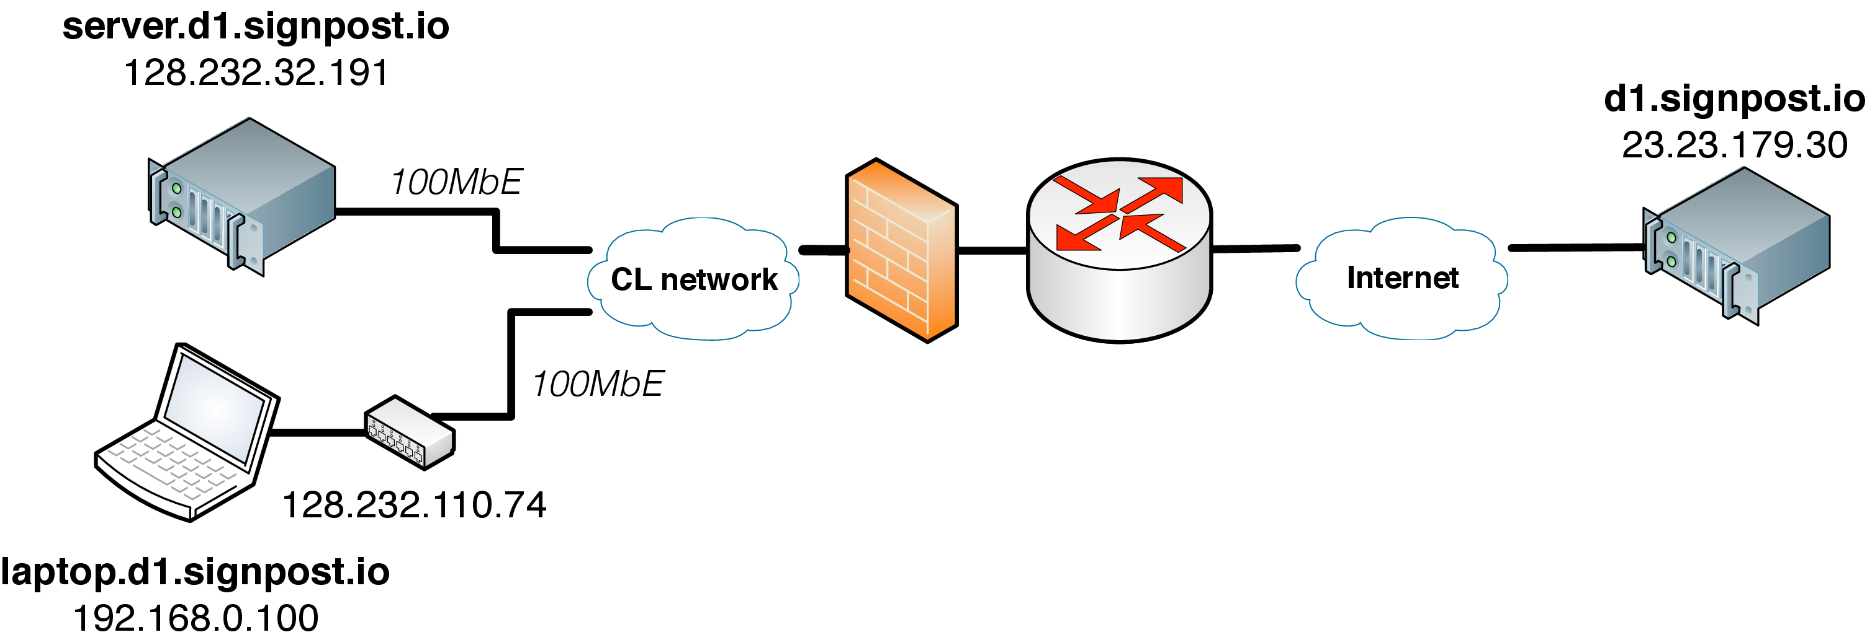
Figure 7: Signpost evaluation topology. server and laptop hosts are connected on different subnets of the CL network. The laptop is connected to the network through a NATed home router and a stateful firewall enforces network policy between the two subnets. The Signpost controller is hosted on an Amazon EC2 micro instance (Amazon, ).

2*Tactic name | Direct connectivity |  |  | cloud-assisted connectivity
 | setup (sec) | throughput (Mbps) | RTT (msec) | setup (sec) |  | throughput (Mbps) | RTT (msec)
Direct | 1.0 | 94.1 | 1.5 | - |  | - | -
OpenVPN | 13.3 | 66.0 | 1.23 | 20.0 |  | 1.9 | 172.0
SSH | 6.8 | 86.5 | 2.73 | 8.8 |  | 1.7 | 829.0
TOR | 60.2 | 2.4 | 912.0 | - |  | - | -
NAT-punch | 1.2 | 94.1 | 1.5 | - |  | - | -

Table 2: Signpost performance evaluation results in terms of latency to setup a path, throughput and RTT delay. Direct cloud-assisted paths exhibit two orders of magnitude higher performance and lower throughput.
In order to evaluate the performance of our strawman implementation, we conducted a series of measurements for each Tactic. Our testbed consists of three hosts, two Signposts and a Signpost, presented in Figure Error: Reference source not found. The Signpost clients (laptop.d1.signpost.io, server.d1.signpost.io) are connected to the production network of the Computer Laboratory on different subnets through 100 MbE links. The network enforces a security policy between both devices and towards the Internet using a stateful firewall. Additionally, the host laptop is connected to the network through a home router with NAT functionality. The Signpost controller of our experiment runs on an Amazon EC2 micro instance (Amazon, ). Using Signpost, we establish all possible end-to-end Tactics and measure the path setup delay, the achievable throughput, and the round trip delay for each Tactic. More specifically, in each experiment we initialize Signpost on each device, and establish connectivity using a specific Tactic. For each established path we measure the delay in completing a Signpost name resolution and initialize a Signpost, the path throughput, using a steady-state TCP measurement probe, and the average path RTT, using a 1 Mbps UDP measure probe. We conducted our measurements ten times for each possible configuration and present the medians value in Table Error: Reference source not found.
From the results of our experiment, we note the difference in capacity and latency when a path uses Signpost. Edge network connectivity provides two to three orders of magnitude higher performance in comparison to cloud-assisted paths. In addition, we highlight the trade-off between security and performance between Tactics. For example, the TOR anonymisation functionality significantly degrades performance and latency, deeming it inadequate for responsive applications. The performance degradation is primarily due to the onion routing scheme used to obfuscate the source and destination addresses of the flow, and the sharing nature of the system. Signpost a clear control abstraction of the trade-off between performance and security.
An important aspect of Tactic performance is the path setup latency. This delay is important because the DNS protocol employs time-outs in name resolutions to detect unresolvable domain names. Linux and OSX have a maximum delay of 15 seconds (3 retries with 5 seconds time-out per request), while for Windows the delay varies between 12 to 15 seconds depending on the OS version. Bootstrapping a Signpost incurs noteworthy setup latencies, but the DNS naming service is designed to handle such latencies. Based on Table Error: Reference source not found results, the majority of the Tactics exhibits setup latencies within the resolver time-out limit, except the TOR Tactic. TOR setup latency is dominated by the circuit establishment latency of the onion overlay. The current implementation exposes the setup latency to applications and thus may experience DNS name lookup time-outs for the first flow of a path. An optimistic approach can mitigate potential resolver time-outs (e.g. use of DNS aliases to delay the response). It is important at this point to clarify that the measured setup latencies occur only for the first flow of a path, and subsequent flows will experience name resolution delays equal to the round-trip time to Signpost.
Finally, using the aforementioned topology we also measured the performance of Tactics synthesis. The results of the experiments report that the throughput and RTT of such paths is equal to the minimum value between the Tactics forming the network path, while the setup latency is equal to the sum of the individual Tactics.

4.3 Application compatibility
In this section we evaluate the compatibility of Signpost applications providing resource and information sharing. Our evaluation focuses on the effectiveness of Signpost with such applications. We used the topology in Figure Error: Reference source not found and considered two primary classes of applications: File Sharing and Resource sharing. In terms of file sharing, we tested three popular applications, namely the Linux NFS implementation (Shepler et al., 2010), git-annex (git, 2013) over rsync and SSH Secure Copy. In terms of resource sharing we tested the functionality of CUPS remote printing, DAAP media sharing, VNC remote desktop and SSH remote access.
We report that all applications functioned correctly from a network perspective over all Tactic configurations. Nonetheless, user-perceived performance is proportional to the underlying Tactic performance (Table Error: Reference source not found). Some Tactics incur significant RTT delays and impact the user-experience in reactive applications. For example, the SSH software exhibited significant responsiveness problem when routed over TOR. In addition, through the integration testing we identified limitations in the openness of our architecture and modified accordingly our implementation. For example, we observed that the Linux SSH client and server use different values for the ToS bits, depending on the payload of the packet, and require the respective OpenFlow to wildcard the ToS field value in the NAT-punch and TOR Tactics. Our design choice to integrate Signpost existing network applications in the network layer of the OS is effective and enables seamless integration with existing network applications.

5 Summary
This chapter focused on the problem of Internet-scale inter-device connectivity. Our work is motivated by the end-user requirement for resource and information sharing services using network device federation between its personal devices; a generic abstraction which we termed Personal Cloud. We elaborated on the available mechanisms and highlighted trade-offs between available solutions. We identified a significant connectivity and naming problem in the current Internet architecture. We argued that the abundance of connection establishing mechanisms provides a sufficient toolset to connect devices across the Internet, but requires a distributed control framework to orchestrate the automatic establishment of end-to-end paths using these mechanisms. We presented Signpost, a distributed naming and connectivity framework which enables global device naming, automates the testing and configuration of end-to-end paths and provides secure and backwards-compatible connectivity to existing network applications.
Signpost used two aspects of user device control plane. Firstly, the control plane is extended to accommodate Network Tactic functionality; mechanisms enabling ad-hoc end-to-end connectivity, like tunnelling software and NAT punching techniques. The architecture develops a generic model coupled with a secure and high-availability Internet-wide control channel, enabling inter-device Tactic testing and configuration orchestration. In addition, the rich security properties provided by existing network Tactics, allow the system to expose a security control abstraction, providing trade-off control between performance and security. Secondly, the architecture integrates the control plane logic with the naming service. Signpost Internet-wide persistent device names and a global and secure key distribution mechanism, building on top of the DNSSEC.
We presented our strawman Signpost and its integration with network connectivity applications, and evaluated the performance of Signpost paths and its compatibility with existing network applications. We elaborated on the integration details of Signpost direct, OpenVPN, TOR, SSH, Privoxy, DNS-SD and NAT-punch software and connection techniques, supporting the generality of the Signpost model. Additionally, we measured the performance of integrated Tactics in a typical deployment scenario and verified the backwards-compatibility of the system with a number of popular decentralised network applications. In the next chapter, we conclude the results of our research and discuss future work directions.
Chapter 6

Conclusions and Future Work
This chapter concludes the dissertation by summarising the work it described, and noting areas in which further work is required.

1 Summary
This dissertation has addressed issues of control plane performance scalability using the SDN paradigm. Chapter Error: Reference source not found began by motivating the requirement to scale the functionality of existing network protocols and technologies in order to support the design limitation which are highlighted by the increased adoption by networks. We argued that control plane performance is multi-dimensional (e.g. resource control, management, connectivity), which has variable importance for applications, and depends highly on the deployment environment. We claimed that specialized control plane architectures can mitigate network bottlenecks introduced by protocol design, while ensuring backwards compatibility and high performance by addressing the requirements and opportunities of the deployed environment.
Chapter Error: Reference source not found then considered background and related work to the problem of network control. We provided a bottom-up design discussion on available network control mechanisms. We elaborated on the architecture of current network devices and presented a generic design model of the integration between the control and data plane in a single device in order to highlight the physical limitations in network performance. Furthermore, we reviewed the current production-level network control protocols and mechanisms for the data link and network layers and it was argued that their ability for responsive flexible and user friendly control is reduced. Furthermore, we surveyed a series of experimental approaches which address network control limitations and provide flexible, distributed and evolvable control. Namely we present Active Network, Devolved Control of ATM Networks and Software Defined Networking. In order to highlight the opportunities provided by these mechanisms, we concluded this chapter with an extensive presentation of novel control applications build on top of the SDN paradigm.
The bulk of the experimental contribution of this dissertation was reported in the following three chapters. Chapter Error: Reference source not found analysed the elementary scalability of the SDN paradigm. In this chapter, we presented two measurement platforms, enabling network experimenters to evaluate the performance of SDN architectures. OFLOPS is a high-precision hardware-accelerated OpenFlow measurement platform which enables experimenters to understand the performance behaviour of OpenFlow-enabled devices, and SDNSIM, a lightweight high-precision network simulation and emulation framework. Using OFLOPS, we developed and ran a series of tests characterising the elementary functionalities of OpenFlow and detected significant variance between switch protocol implementations. SDNSIM is a high precision experimentation environment, which allows users to implement their control logic and traffic models and evaluate the performance of an SDN architecture. The platform provides the ability to simulate, using the ns-3 platform, or emulate, using the Xen virtualisation platform, a experimental definition. The platform provides enhanced realism on the performance characteristics of the network control plane, while through our evaluation we highlighted the scalability of experimentation. Using SDNSIM, we replicated the functionality of a small-scale data centre network and highlighted the effectiveness of control centralisation.
Chapter Error: Reference source not found elaborated on the problem of management scalability in modern home networks. Using ethnographic and measurement studies of the home setting, we identified significant mismatches between the user-requirement and user-understanding of network functionality, and the existing technologies. Motivated by this observation, we redesigned the home router, implementing a series of control modifications which enhanced user control and bridged user perception with the underlying network functionality. The proposed architecture was extended with a collaborative resource control mechanism which integrated users' application-level requirements with the ISP policy, in an effort to develop a user-friendly control scheme for the last-mile bottleneck in residential broadband networks. We presented the development of a strawman implementation of our system and verified that: the architectures incurs minimal impact on network functionality; the protocol modifications remain backwards compatible with a number of popular devices, OSes and applications; and the resource control mechanism improves the support for latency and bandwidth sensitive applications in congested residential networks.
Chapter Error: Reference source not found discussed Internet-scale naming and connectivity scalability. Through the work of this chapter, we aimed to develop a decentralised and Internet-wide federated network between the devices of a user. We motivated our effort by presenting the limitations of existing approaches in terms of usability and privacy, and argued that an evolved control plane for end-hosts can address such limitations and support all required functionality. We proposed Signpost in providing secure, continuous and decentralised inter-device connectivity. Signpost uses existing connectivity mechanisms to provide ad hoc end-to-end paths between devices. The system provides a global naming structure and uses the DNS protocol to establish a global control channel through which Signpost distributes evaluation and configuration of connection establishing mechanisms. We presented a strawman implementation of Signpost and its integration with OpenVPN, TOR, SSH, Privoxy, NAT punching and DNS-SD mechanisms. Using the Signpost implementation, we characterised the low impact of the architecture to network functionality and its backwards compatibility with existing applications.

2 Summary of Contributions
The dissertation makes the following three contributions:

2.0.0.6 Control plane scalability
In this thesis we presented the first scalability characterisation of OpenFlow implementations. We highlighted the significant performance diversity between implementations which can affect the performance and the correctness of control architectures. Furthermore, we developed SDNSIM, an experimentation platform for SDN architectures, providing the ability to emulate and simulate network experiments. SDNSIM high fidelity on replicating the control channel of the network and provides intuitive control between fidelity and scalability. Using SDNSIM to evaluate the performance of a hierarchical control architecture in a small-scale data centre.

2.0.0.7 Management scalability
This thesis presented a novel control architecture establishing scalable management for home network. We presented a flow-based controller, which exploited the social conventions in the home to manage introduction of devices to the network, and their subsequent access to each other and Internet hosted services. Additionally, we proposed a modification in the control architecture of the ISP network, which enables users to express and enforce their resource requirements in a user-friendly manner. We provided strong evidence on the scalability, backwards compatibility and effectiveness of our solution.

2.0.0.8 Connectivity and naming scalability
This thesis analysed the significant limitation introduced by the current Internet architecture on the connectivity ability between the devices of users. In order to mitigate these limitations we presented Signpost, a decentralised control architecture providing global names for user devices and continuous connectivity between them. We presented the flexibility of Signpost in encapsulating a wide range of connection establishing mechanisms and provided strong evidence on its backwards compatibility with existing applications, and its performance scalability.

3 Future Work
The experimental results and the practical solutions presented in the thesis provide fruitful seeds to cultivate a wider research agenda on control plane evolvability.

3.1 Distributed Network Control
One of the first use cases of the SDN paradigm was the centralisation of control in order to improve policy effectiveness and ease network management. Nonetheless this vision has evolved and refocused on the development of distributed control architectures. Control distribution is motivated by two observations. Firstly, load and latency of the control channel increases proportionally to the size of the network, while reliability guarantees relax. Secondly, defining one global control policy which is able to encapsulate multiple policy aspects (e.g. security, performance, access control) exhibits significant complexity. Applications have shifted to a multi-controller paradigm using either centralised proxies (Sherwood et al. (2010b) or separating the network in domains and using distribute algorithms to synchronise state between controllers (Koponen et al., 2010).
The work presented in Chapter Error: Reference source not found provides a scalable control experimentation platform, a powerful tool to understand further the impact of distributed design patterns on the performance of a network. Hierarchical control, as presented through the evaluation experiment using the SDNSIM, has low impact on network performance, but a complete architectural design requires further evaluation of mechanisms with strong control plane responsiveness and reliability guarantees.

3.2 User-centric Networking
As we have discussed in Chapter Error: Reference source not found, current network technologies exhibit a significant mismatch with the user requirements. The outcomes from the previous two chapters have provided strong evidence on the ability of networks to reconsider control and augment it with meaningful user input. Rather than relegating users to an artefact of the application layer, accommodating users and their relationships at all layers of the system can improve user satisfaction and network functionality. We consider two main extensions on the work of the thesis towards this goal.
Firstly, a number of areas arise from the work in Chapter Error: Reference source not found. The presented control architecture provides novel opportunities to augment home network functionality and exploit the wider social context of the home setting. In the local network, home guests can inject their configuration into the local network policy and improve their experience. This approach is not limited in the local network and can expand to wider contexts. For example, neighbours can negotiate resource control by taking advantage of the social context in a neighbourhood. Users can coordinate socially to share un-utilized resources on the last mile of the residential connection, e.g. exchange high priority traffic for specific timeslots with neighbours.
Secondly, a number of pieces of work arise from Chapter Error: Reference source not found. Signpost at the moment is limited in its policy expressiveness, but is sufficient to address our motivations. Nonetheless, the authentication primitives can provide a scalable and global mechanism to develop novel network policy frameworks and address a series of problems stemming from the inability of the network layer to authenticate network end-points. Furthermore, the hierarchical structure of Signpost can be used to reflect higher level social relationship and increase the in-network flexibility. Bigraph theory provides a sufficient framework to model and scale the complexity of such control designs.

4 Conclusion
In summary, this dissertation has argued that network technologies exhibit significant limitation in scaling their functionality and support of the multiple aspects of network performance. We identified these limitations as due to the unforeseen functional requirements that occurred by the wide adoption of network technologies. In order to address these limitations, we contend that network control must be redesigned and specialized in order to fit the requirements and take advantage of the properties of the deployment environment. This dissertation has presented and evaluated mechanisms to control plane functionality, management and connectivity scalability.

? “In general, an implementation must be conservative in its sending behavior, and liberal in its receiving behavior. That is, it must be careful to send well-formed datagrams, but must accept any datagram that it can interpret (e.g., not object to technical errors where the meaning is still clear).” (Postel, 1981a)
? CAM/TCAM lookup: < 10 clock cycles, SRAM: 2-3 nsec, DRAM: 20-35 nsec, http://people.ee.duke.edu/~sorin/prior-courses/ece152-spring2009/lectures/6.2.2-memory.pdf
? SInce version 1.1 the protocol permits masked mac address matching
? OpenFlow1.0 defined a primitive to remove a VLAN header only
? OFLOPSunder the GPL licence and can be downloaded from http://www.openflow.org/wk/index.php/Oflops
? http://www.netfpga.org
? SDNSIM works under the GPL licence and can be downloaded from http://github.com/crotsos/sdnsim/
? http://openmirage.org
? We used a packet size slightly larger that the minimum packet size because we appended the payload packet generation information (e.g.packet ID, packet generation timestamps).
? In our experiments we are using a Linux host with kernel 3.11.0, which incorporates the Cheng et al. (2013).
? http://dyn.com/dns/
?Dropbox provides local network synchronization functionality between devices. However it is only used for performance reasons and requires service connectivity https://www.dropbox.com/help/137/en
?“DNS servers can play games. As long as they appear to deliver a syntactically correct response to every query, they can fiddle the semantics.”— RFC3234 (Carpenter and Brim, 2002)
? We excluded the privoxy and DNS-SD Tactics because they improve functionality on established paths only.
? http://linux.die.net/include/resolv.h
? http://blogs.technet.com/b/stdqry/archive/2011/12/15/dns-clients-and-timeouts-part-2.aspx

