


D_{atasheet}

11 GHz, 35 dBi airFiber® X Antenna

Model: AF-11G35


Powerful Performance for Long-Range Links
Robust Design and Construction for Outdoor Use
Seamless Integration with airFiber AF-11FX Radio

D_{atasheet}

Hardware Overview
Innovative, Weatherproof Design  - Secure Pole-Mounting Maintains the position of the dish during harsh outdoor conditions.  - Protective Shroud Protects the cables and connectors from the elements.  - Integrated Radome Shields the radio from the environment. | M  •  •  • | ount Designed for Safety, Easy Upgrade  Lanyard Loops Assist in safely hoisting the antenna up a tower and into place.  Azimuth Support Brackets Allow the antenna to be safely supported while the azimuth is adjusted.  Shared AF-5/AF-5U Mount Design Facilitates upgrade of full-duplex links from unlicensed 5 GHz to licensed 11 GHz.
Radome

Lanyard Loops

Protective Shroud

Mount Brackets

Azimuth Support Brackets



The AF-11G35 antenna is specially designed for the AF-11FX radio, so that installation requires no special tools. The AF-11G35 comes preconfigured with V/H polarization, and can be configured to support ± 45° slant polarization for improved noise immunity and Signal-to-Noise Ratio (SNR), dependent on regulatory region.
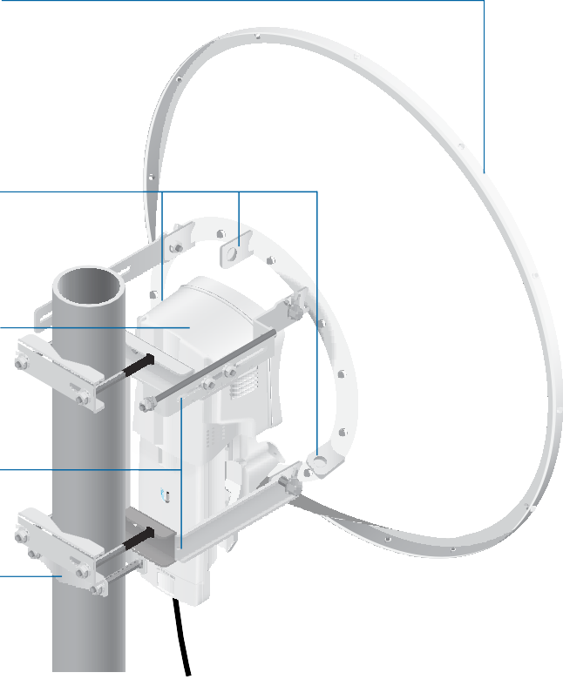

Model | Frequency | Gain | Radome
AF-11G35 | 10.3 - 11.7 GHz | 35 dBi | Integrated

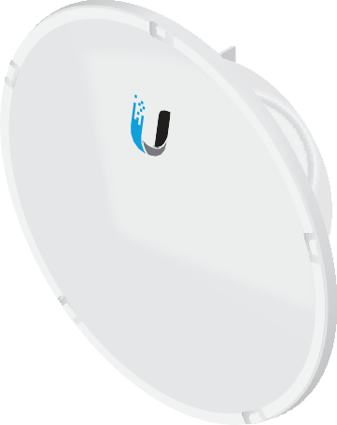

3

Specifications
D_{atasheet}

AF-11G35 Antenna Characteristics
Dimensions | ø 811 x 460 mm (ø 31.9 x 18.1")
Weight | Mount Not Included : 7.14 kg (15.74 lb) Mount Included : 11.85 kg (26.12 lb)
Frequency Range | 10.3 - 11.7 GHz
Gain | 35 dBi
HPOL Beamwidth | 2.5°
VPOL Beamwidth | 2.5°
Front-to-Back Ratio | 60 dB
Max. VSWR | 2:1
Wind Survivability | 200 km/h (125 mph)
Wind Loading | 1538 N @ 200 km/h (346 lbf @125 mph)
Polarization | Default: H/V After Rotating OMT: ± 45°
Cross-Pol Isolation | 35 dB
Mounting | Uses the AF-5/AF-5U Mounting System
Pattern Regulatory | ETSI 302 217-4-2, Class 3 and FCC Cat B
AF-11G35 Antenna Information

Return Loss | Azimuth, 11,000 MHz | Azimuth Specs
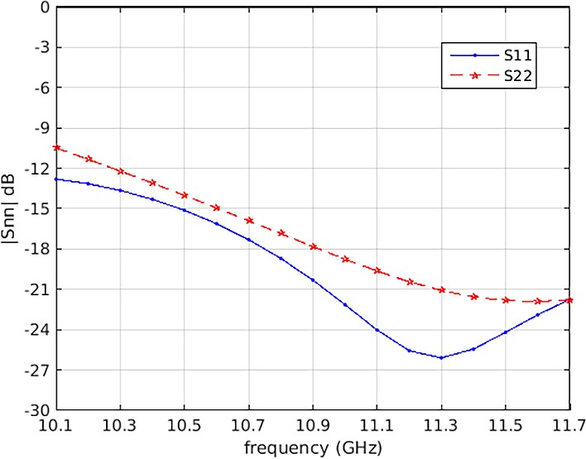 | 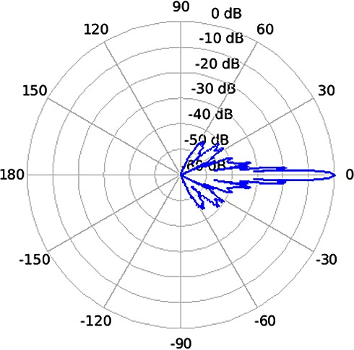 | 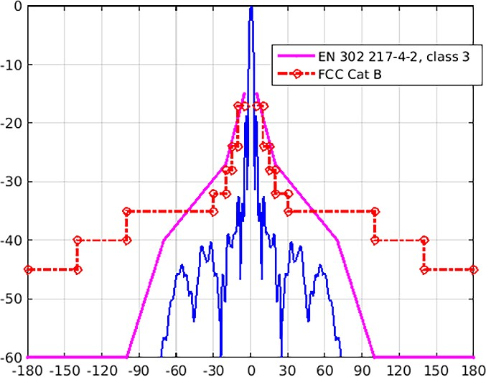
 | Elevation, 11,000 MHz | Elevation Specs
 | 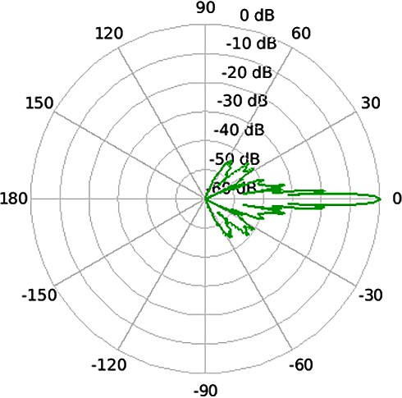 | 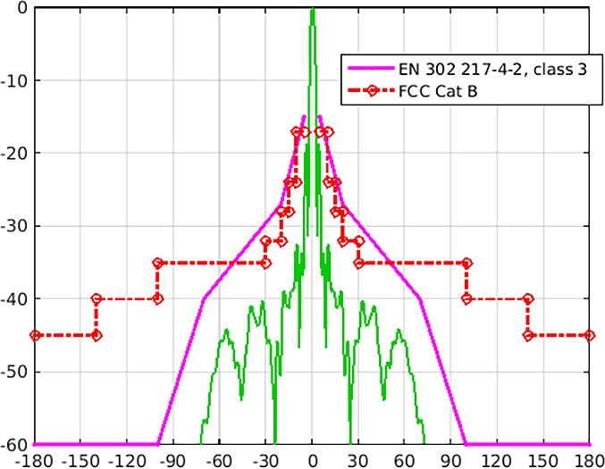




Specifications are subject to change. Ubiquiti products are sold with a limited warranty described at: www.ubnt.com/support/warranty
4
AI020817
© 2016-2017 Ubiquiti Networks, Inc. All rights reserved. Ubiquiti, Ubiquiti Networks, the Ubiquiti U logo, the Ubiquiti beam logo, airFiber, airMAX, airOS, and Rocket are trademarks or registered trademarks of Ubiquiti Networks, Inc. in the United States and in other countries. All other trademarks are the property of their respective owners.

www.ubnt.com

