**THE FUTURE OF BOOKS**

**HOW WE WILL EXPERIENCE READING IN THE 21ST CENTURY**

**ROLEMODEL**

**ENTERPRISES**

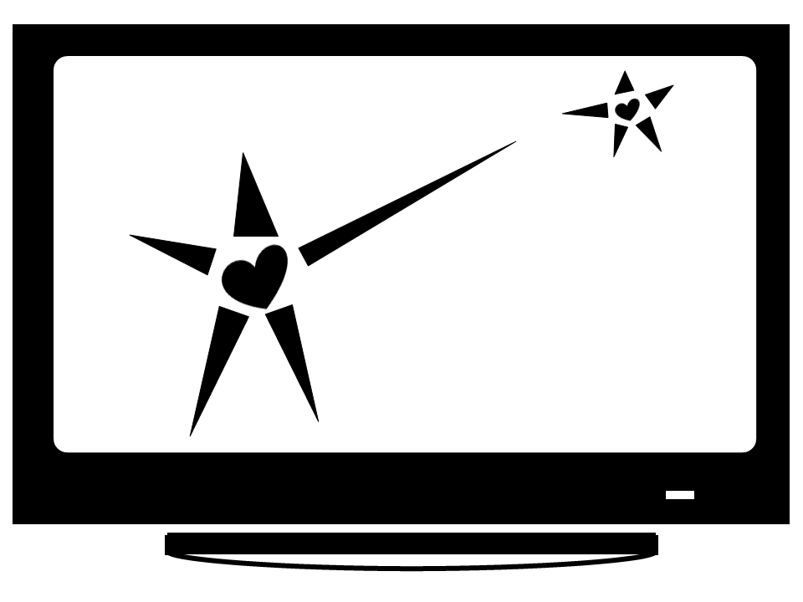

By Lisa Schaefer, Ph.D.

http://RoleModelEnterprises.com

THE MAKING OF ROLEMODEL ENTERPRISES. Copyright © 2012 by RoleModel Enterprises, LLC. All rights reserved. Printed in the United States of America. No part of this book may be used or reproduced in any manner whatsoever without written permission except in the case of brief quotations embodied in critical articles and reviews. For information contact RoleModel Enterprises, LLC, RoleModelEnterprises@gmail.com, http://RoleModelEnterprises.com

ABOUT THE AUTHOR: Lisa Schaefer is currently the president of RoleModel Enterprises and has over fifteen years of industry and teaching experience. Dr. Schaefer earned her B.S.E. and M.S. in civil engineering and Ph.D. in industrial engineering from Arizona State University. She is involved in a Fairfax County public access cable show and has taken several graduate-level screenwriting and video production courses.

**Table of Contents**

ROLE

HARDWARE 4

Mobile Devices 4

Screens 4

Input devices 4

SOFTWARE 5

Mobile Software: Apps 5

SOCIAL 5

Meetups 5

Multiplayer Games 6

Events Everywhere 6

What I’m Inventing 6

Interactive Television 6

I invented ereaders.

Kindle.

### HARDWARE

I.

### Mobile Devices

Events .

### Screens

MIT in glasses

Public domain pic?

### Input devices

MIT keyboard in one hand.

Evolution of voice recognition software

Google voice mail

### SOFTWARE

I.

### Mobile Software: Apps

Downloadable

On device

In cloud.

### SOCIAL

I.

### Meetups

Associations are dying. Meetups are king.

Social capital.

### Multiplayer Games

Second Life. The culture is porn.

### Events Everywhere

I.

In the future, we will be sitting in our living room, on a train, or on a mountaintop attending multiple events at once. We will interact with people over the internet who are in China, New York, and Antartica. These events will be about any topic – intellectual or otherwise.

Multitasking. We will attend simultaneous events. If we've had enough of one event, we'll go to the next. If we want to be at several events at the same time, we can skip back and forth between them. Admit it. You've always wanted to be in two places at once.

Location and transportation will not bound us. We'll be able to virtually teleport to online events. Our video will be seen by the other participants. We'll see others via their webcam. We won't have screens. We'll see everyone's video floating in front of us and be able to move their images into a circle or sort them into an audience. We'll see them via a device similar to google glass where the images float in our regular field of vision.

We'll 'go' to work like this. We can have meetings with coworkers all around the world. When we need to talk to them, we won't walk down the hall, we'll bring them up in our field of vision.

### What I’m Inventing

I.

### Interactive Television

I.