**THE FUTURE OF WORK**

**HOW WE WILL MAKE**

**GOOD THINGS HAPPEN**

**IN THE 21ST CENTURY**

**ROLEMODEL**

**ENTERPRISES**

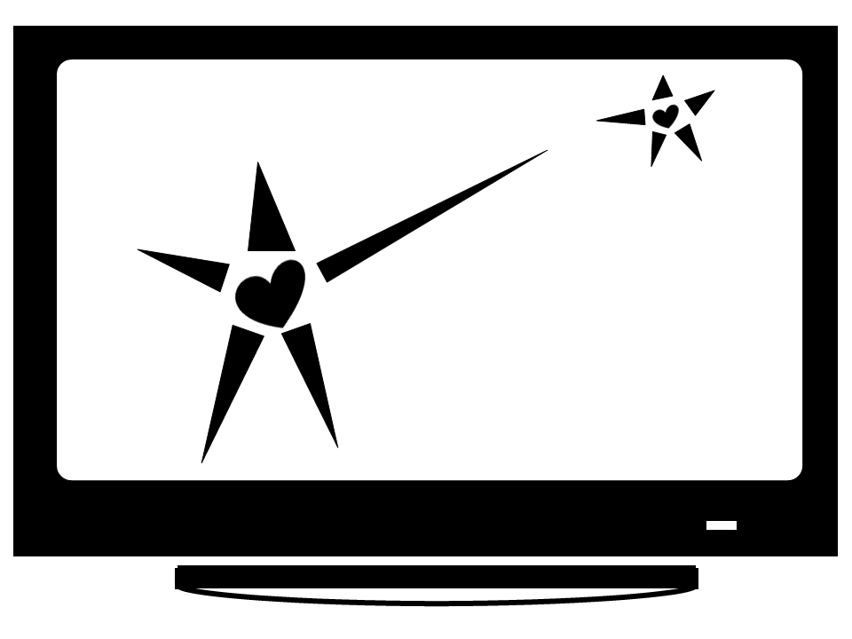

By Lisa Schaefer, Ph.D.

http://RoleModelEnterprises.com

THE MAKING OF ROLEMODEL ENTERPRISES. Copyright © 2012 by RoleModel Enterprises, LLC. All rights reserved. Printed in the United States of America. No part of this book may be used or reproduced in any manner whatsoever without written permission except in the case of brief quotations embodied in critical articles and reviews. For information contact RoleModel Enterprises, LLC, RoleModelEnterprises@gmail.com, http://RoleModelEnterprises.com

ABOUT THE AUTHOR: Lisa Schaefer is currently the president of RoleModel Enterprises and has over fifteen years of industry and teaching experience. Dr. Schaefer earned her B.S.E. and M.S. in civil engineering and Ph.D. in industrial engineering from Arizona State University. She is involved in a Fairfax County public access cable show and has taken several graduate-level screenwriting and video production courses.

**Table of Contents**

### ROLE

### The Past – The Man

When I was in college, the good engineers went to work for The Man.

### AD-HOC TEAMS

I.

### The Technology That Will Facilitate This

Hardware: WiFi everywhere

Software: Matchmaking sites

### The Social Structure

Where we live

What we do in free time: No kids. We don’t need them.

No spouse. My mom got married at age 19. My mom was a year late. Ever heard of a June wedding? Most of her friends got married as soon as they graduated from high school. I was 24, still in grad school. A few years ago, I went to the Mormon wedding factory the Friday of the last day of school at Brigham Young University. Every ten minutes a bride emerged.

### Building Long-term relationships

Long t

### FLYING SOLO

When you’ve established yourself with groups

High-risk ventures

Difficult to get venture money. You don’t want that unless you need it.

### Startups – When All the Cofounders Are ‘Wrong’

I’ve been to many events where cofounders are seeking others. But once the idea is owned, it doesn’t make sense to hand it to someone else for free.

Just like a life mate, There may be no Mr. or Ms. Right, but there are a lot of Mr. Wrongs.

### Write a Book

Position yourself. Articulate what you know. Learn while you write, clarify what you know.

Defining the topic

Writers Diarrhea

Critique groups

GuruTapas: Engage your fans.

### Videos

Simple editing software

### Making the Most of Time

Steal every second – carry an electronic device. The perfect device was created ten years ago, but is no longer compatible with my printer and never was compatible with my WiFi. iPad is not good for typing. Extra keyboard a nuisance.

Focus initial efforts on producing only the truly essential

Crowdsource: Post relevant comments in blogs

oDesk

Do the bare minimum - Lean Startup

### 21st CENTURY RESOURCES

Your life will be a combination of solo and team.

### Minimum Needed In Place

Web site. Wordpress.

Home office. Most county zoning laws allow this until you have more than one employee.

Network, marketing

### Web site resources

Paypal,

Wordpress,

Webs.com

Facebook

Speek

GuruTapas

Ebay

Storenvy

### Social and Professional Support

Professional associations used to be the go-to organizations

Meetups – DC Tech

Biz incubators

Coworking

Office sharing