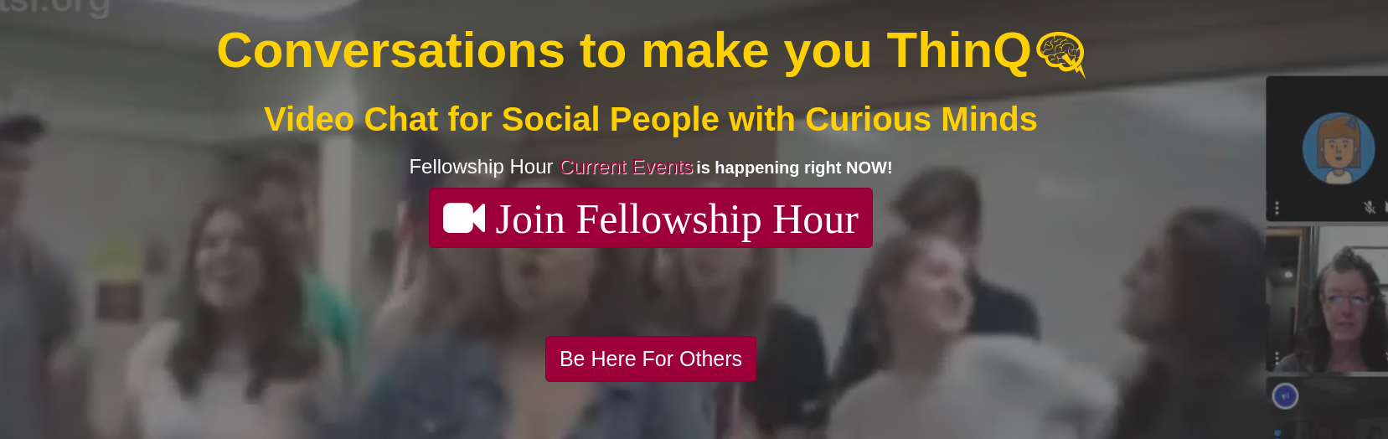


June 1, 2020

Dear Reagan Phung,

I am pleased to confirm your offer of an internship as Jr. Rails Developer for ThinQ.tv with RoleModel Enterprises, LLC. Your duties and assignments for this position are as follows:

- Post 10 hours per week when you will be at a computer with a browser window open to the ThinQ.tv live video viewer as your Coworking time
- Write tests to expand the current test suite for Test Driven Development
- Improve features based on user feedback

Your first day of work will be June 2, 2020. You will work 10 hours per week, totaling 160 hours before the end of summer.

Your supervisor will be ThinQ.tv founder, Lisa Schaefer. If you have any questions, please feel free to contact us. We are looking forward to a very exciting summer online at ThinQ.tv!

Sincerely,


Lisa Schaefer, Ph.D.
ThinQ.tv Founder

