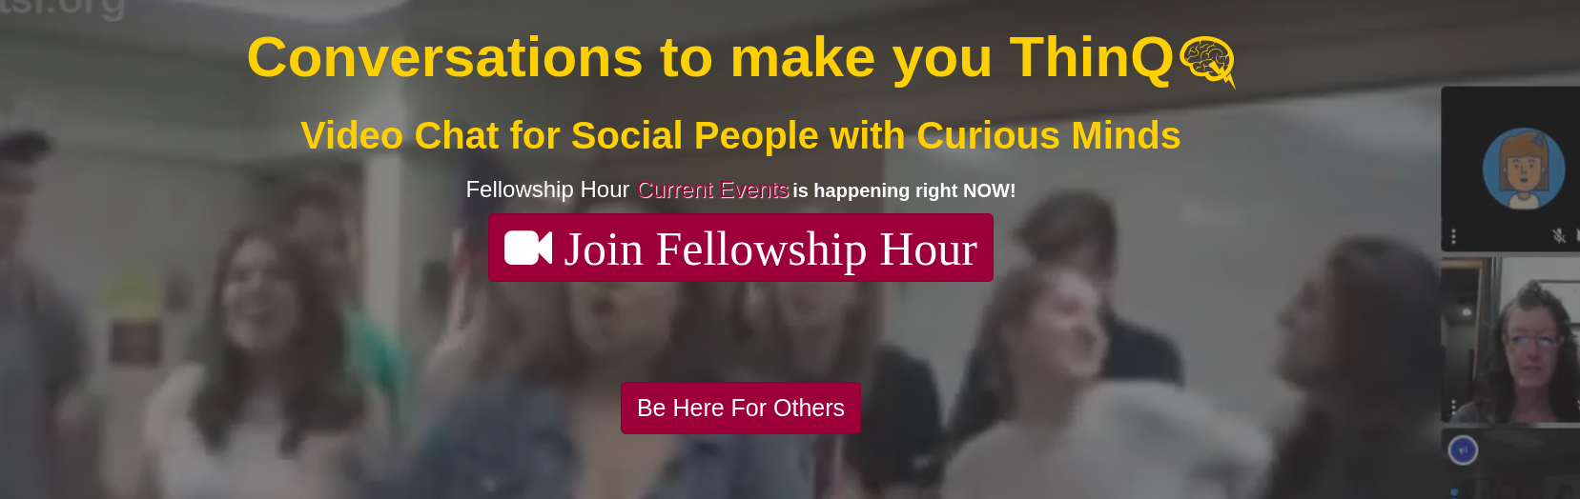


May 18, 2020

Dear Pamela Li,

I am pleased to confirm your offer of an internship as User Experience Designer Intern for ThinQ.tv with RoleModel Enterprises, LLC. Your duties and assignments for this position are as follows:

- Post 10 hours per week when you will be at a computer with a browser window open to the ThinQ.tv live video viewer as your Coworking time
-Recruit potential early adopters to ThinQ.tv to experience the site
- Greet users who drop in to ThinQ.tv and solicit feedback to understand their perceptions of the site
- Improve site usage and design based on user feedback

Your first day of work will be May 18, 2020. You will work 10 hours per week totaling 160 number of hours before the end of summer.

Your supervisor will be ThinQ.tv founder, Lisa Schaefer. If you have any questions, please feel free to contact us. We are looking forward to a very exciting summer online at ThinQ.tv!

Sincerely,


Lisa Schaefer, Ph.D.
ThinQ.tv Founder

