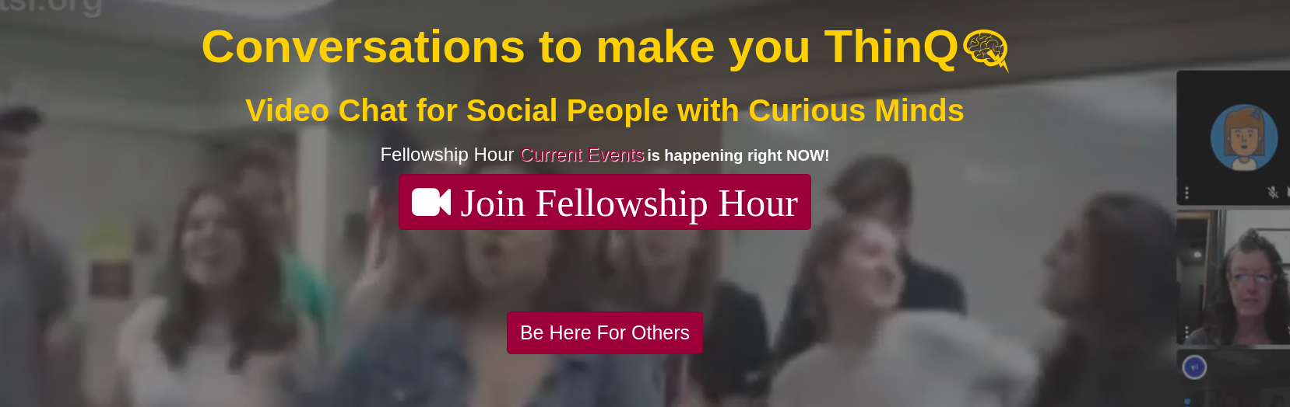


June 10, 2020

Dear Shahzaib Zaveri,

I am pleased to confirm your offer of an internship as User Interface Designer Intern for ThinQ.tv with
RoleModel Enterprises, LLC. Your duties and assignments for this position are as follows:

- Working with ruby on rails framework to work with backend development. Connect front end and backend functionality when needed.
- Working with databases, creating new tables in database, querying the database to retrieve information. Creating forms for user input, storing data in database
- Post 10 hours per week when you will be at a computer with a browser window
open to the ThinQ.tv live video viewer as your Coworking time
- Greet users who drop in to coworking hours and solicit feedback to understand
their perceptions of the site
- Improve site usage and design based on user feedback
- Organize CSS styles and files in the ThinQ.tv github repository

Your first day of work will be June 15, 2020. You will work minimum 10 hours per week. Your supervisor will be ThinQ.tv founder, Lisa Schaefer. If you have any questions, please feel free to
contact us. We are looking forward to a very exciting summer online at ThinQ.tv!

Sincerely,


Lisa Schaefer, Ph.D.
ThinQ.tv Founder

