Exercise:

Create Metadata About a Historical Object

(Custom Schema)

**Summary**

Creating structured data about historical objects can present special problems. Data about the object may be limited, incorrect, or even incomprehensible.

In this exercise, you’ll take unstructured data about a historical image and create custom metadata elements to represent the image. At this point, don’t worry about using controlled vocabularies, but try to keep in mind which elements have information that could be standardized using a controlled vocabulary. You will also find that some data doesn’t fit easily into your elements or you may not understand what some of the data means.

These images come from the University of Cincinnati Archives & Rare Books Library’s *Cincinnati* *Street Card File Collection.* These cards detail street name changes in the city of Cincinnati and were likely created by city survey workers in the early 1900s. If you were creating a database of the information on these cards, what kind of structured data could you take from them? What information would you omit?

**Image 1**

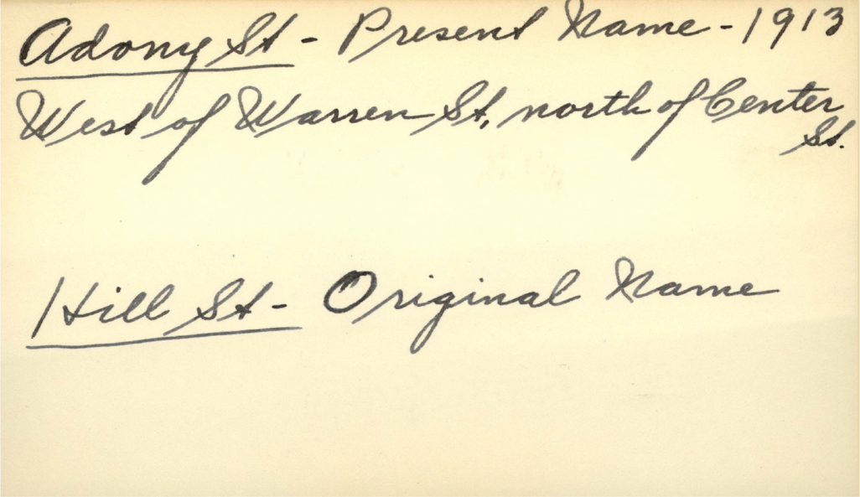

**Custom Schema\*\***

|  |  |
| --- | --- |
| **Element** | **Value** |
|  |  |
|  |  |
|  |  |
|  |  |
|  |  |

**Note: You can make your elements repeatable.

**Image 2** (A little less straight-forward)

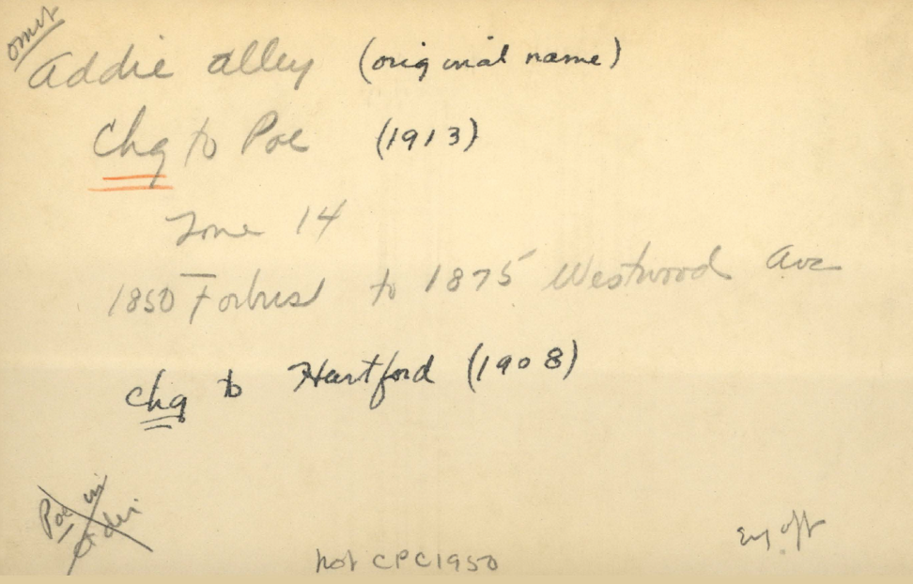

**Custom Schema**

|  |  |
| --- | --- |
| **Element** | **Value** |
|  |  |
|  |  |
|  |  |
|  |  |
|  |  |

**Discussion:**

* What kinds of problems did you run into?
* Was there information that you couldn’t understand or didn’t know how to represent in a structured form?
* Did you see any opportunities for standardization in the data values? For example, did you transcribe information exactly as you saw it on the original piece or did you write out abbreviations such as “St.”?
* How would you approach this task if dealing with 5,000 cards instead of 2? Do you think your schema would be more complicated or would you try to simplify it?