Exercise:

Create Dublin Core Metadata

**Summary**

Dublin Core (DC) is a non-hierarchical (flat) schema composed of 15 core elements. Information on the standard can be accessed at: <http://dublincore.org/documents/dces/>

In this exercise, you’ll take unstructured data about an image and create DC metadata to represent the image. At this point, don’t worry about using controlled vocabularies, but try to keep in mind which elements have information that could be standardized using a controlled vocabulary. You will also find that some data doesn’t fit easily into the DC elements.

**Image 1**

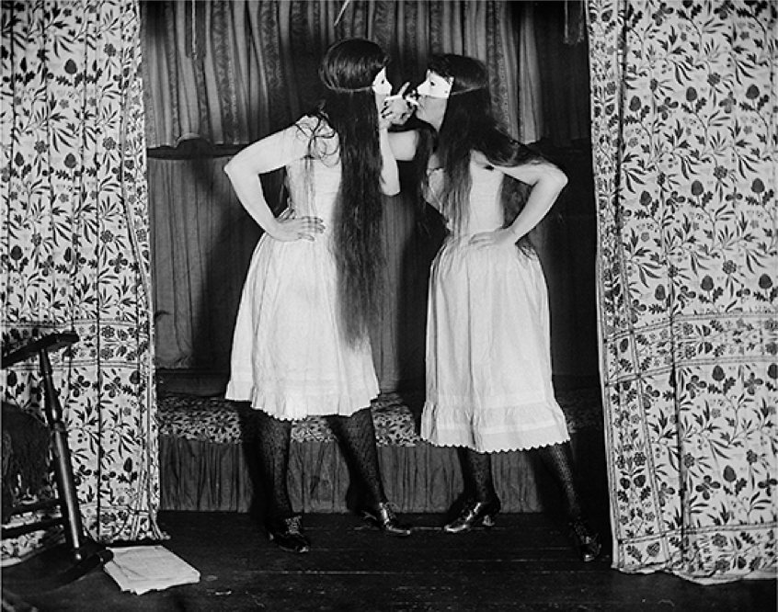

**Unstructured Data About the Image:**

* “Trude & I Masked” by Alice Austen. Taken August 6, 1891. Gelatin silver print.
* Part of the Alice Austen House Collection. Public Domain. Available at: <https://commons.wikimedia.org/wiki/File:Alice_Austen,_Trude_&_I_Masked.jpg>
* From Alice Austen House: “In an era when women were arrested for smoking in public, 25-year-old Alice and the Episcopalian minister’s daughter, Gertrude Eccleston, simulated sinfulness. The scene is Ms. Eccleston’s bedroom in the rectory. Alice Austen wrote on the negative sleeve: ‘Trude & I masked, short skirts. 11 p.m. Thursday Aug. 6th 1891. Gas on, flash. Stanley 35, Waterbury lense. 11 fit.”

|  |  |
| --- | --- |
| **DC Element\*\*** | **Value** |
| dc.creator |  |
| dc.contributor |  |
| dc.coverage |  |
| dc.date |  |
| dc.description |  |
| dc.format |  |
| dc.identifier |  |
| dc.language |  |
| dc.publisher |  |
| dc.relation |  |
| dc.rights |  |
| dc.source |  |
| dc.subject |  |
| dc.title |  |
| dc.type |  |

**Note: DC elements are repeatable.

**Discussion**

* What kinds of problems did you run into?
* Was there information that was difficult to fit into the DC elements?
* Did you lose information from the unstructured data by structuring it in DC?
* What fields would benefit from controlled vocabularies?
* Could qualifying any of the DC terms help?

**Image 2**

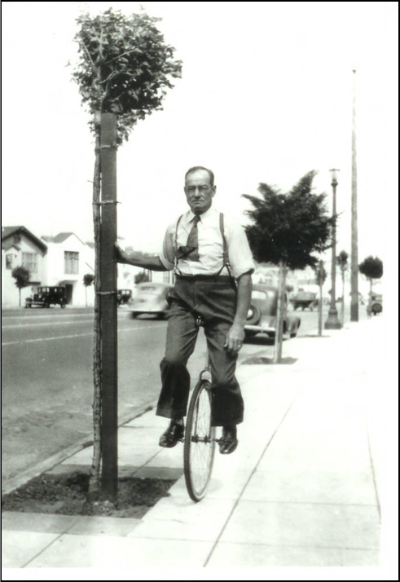

**Unstructured Data About the Image:**

* “William Palmer riding a unicycle in about 1939.” Taken circa 1939 in Sebastopol, California. Black and white photographic print. 5” x 7”.
* Part of the Western Sonoma County Historical Society Photographic Collection. No known copyright restrictions.
* Geolocation: 38.40174, -122.825254
* Local system identifier: 2931
* Still Image. Medium quality (200 dpi)

|  |  |
| --- | --- |
| **DC Element** | **Value** |
| dc.creator |  |
| dc.contributor |  |
| dc.coverage |  |
| dc.date |  |
| dc.description |  |
| dc.format |  |
| dc.identifier |  |
| dc.language |  |
| dc.publisher |  |
| dc.relation |  |
| dc.rights |  |
| dc.source |  |
| dc.subject |  |
| dc.title |  |
| dc.type |  |