Exercise:

Create VRA Core Metadata

**Summary**

The Visual Resources Association (VRA) Core Metadata Schema is a hierarchical schema composed of 19 core elements. Information on the standard can be accessed at: <https://www.loc.gov/standards/vracore/VRA_Core4_Element_Description.pdf>

In this exercise, you’ll take unstructured data about an image and create VRA metadata to represent the image. At this point, don’t worry about using controlled vocabularies, but try to keep in mind which elements have information that could be standardized using a controlled vocabulary. You will also find that some data doesn’t fit easily into the VRA elements.

**Image 1**

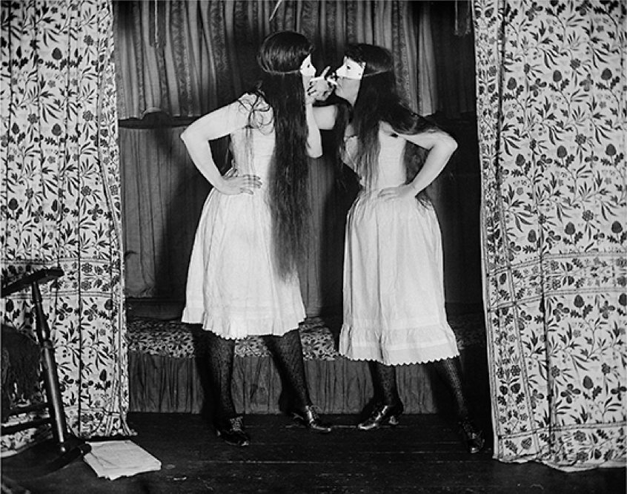

**Unstructured Data About the Image:**

* “Trude & I Masked” by Alice Austen. Taken August 6, 1891. Gelatin silver print.
* Part of the Alice Austen House Collection. Public Domain. Available at: <https://commons.wikimedia.org/wiki/File:Alice_Austen,_Trude_&_I_Masked.jpg>
* From Alice Austen House: “In an era when women were arrested for smoking in public, 25-year-old Alice and the Episcopalian minister’s daughter, Gertrude Eccleston, simulated sinfulness. The scene is Ms. Eccleston’s bedroom in the rectory. Alice Austen wrote on the negative sleeve: ‘Trude & I masked, short skirts. 11 p.m. Thursday Aug. 6th 1891. Gas on, flash. Stanley 35, Waterbury lense. 11 fit.”

|  |  |  |
| --- | --- | --- |
| **VRA Element** | **Refinement** | **Value** |
| work |  | work |
| agent | N/A** |  |
| attribution |  |
| culture |  |
| earliestDate (circa) |  |
| latestDate (circa) |  |
| name (type) |  |
| role |  |
| culturalContext |  |  |
| date | N/A |  |
| earliestDate (circa) |  |
| latestDate (circa) |  |
| description |  |  |
| inscription | N/A |  |
| author |  |
| position |  |
| text (type) |  |
| location | N/A |  |
| name (type) |  |
| refid (type) |  |
| material |  |  |
| measurements |  |  |
| relation |  |  |
| rights | N/A |  |
| rightsHolder |  |
| text |  |
| source | N/A |  |
| name (type) |  |
| refid (type) |  |
| stateEdition | N/A |  |
| description |  |
| name |  |
| stylePeriod |  |  |
| subject | N/A |  |
| term (type) |  |
| technique |  |  |
| textref | N/A |  |
| name (type) |  |
| refid (type) |  |
| title |  |  |
| worktype |  |  |

**Note: Some VRA elements can be further refined by sub-elements and attributes. However, you are not required to use the sub-elements or attributes.

**Discussion**

* What kinds of problems did you run into?
* Was there information that was difficult to fit into the VRA elements?
* Did you lose information from the unstructured data by structuring it in VRA?
* What fields would benefit from controlled vocabularies?
* Did you prefer using DC or VRA to describe this image?

**Image 2**

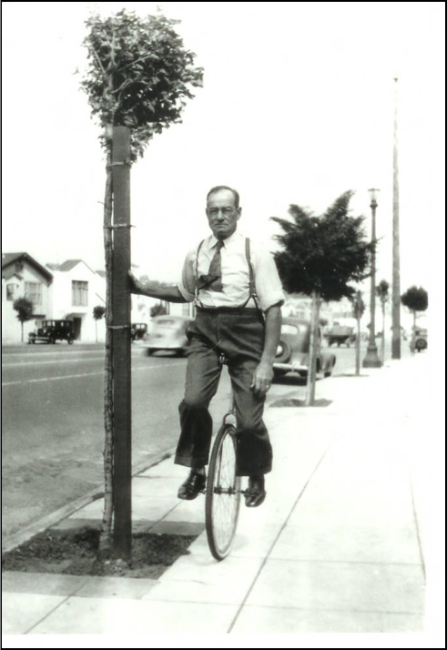

**Unstructured Data About the Image:**

* “William Palmer riding a unicycle in about 1939.” Taken circa 1939 in Sebastopol, California. Black and white photographic print. 5” x 7”.
* Part of the Western Sonoma County Historical Society Photographic Collection. No known copyright restrictions.
* Geolocation: 38.40174, -122.825254
* Local system identifier: 2931
* Still Image. Medium quality (200 dpi)

|  |  |  |
| --- | --- | --- |
| **VRA Element** | **Refinement** | **Value** |
| work |  | work |
| agent | N/A** |  |
| attribution |  |
| culture |  |
| earliestDate (circa) |  |
| latestDate (circa) |  |
| name (type) |  |
| role |  |
| culturalContext |  |  |
| date | N/A |  |
| earliestDate (circa) |  |
| latestDate (circa) |  |
| description |  |  |
| inscription | N/A |  |
| author |  |
| position |  |
| text (type) |  |
| location | N/A |  |
| name (type) |  |
| refid (type) |  |
| material |  |  |
| measurements |  |  |
| relation |  |  |
| rights | N/A |  |
| rightsHolder |  |
| text |  |
| source | N/A |  |
| name (type) |  |
| refid (type) |  |
| stateEdition | N/A |  |
| description |  |
| name |  |
| stylePeriod |  |  |
| subject | N/A |  |
| term (type) |  |
| technique |  |  |
| textref | N/A |  |
| name (type) |  |
| refid (type) |  |
| title |  |  |
| worktype |  |  |

**Note: Some VRA elements can be further refined by sub-elements and attributes. However, you are not required to use the sub-elements or attributes.