Selina Wang Genetic Picture Report : Oct. 27Th 2020.

Phenotype (Genotype) i.e store, s a Genotype class
| |
is a class with 'pheno' is itself a class that
contains a key member
as a member this itself is called 'gene' which is
an [x,y] co-ord pair that an array of Genes. This type
stores the terrain value is also a class containing their
as an integer. Own terrain values, (x,y) co-ords
and a kind displacement dx,dy type members.

Score routine :

I implemented this function by using some of the ideas outlined in your assignment report.
i.e I used the “realisticness” of the outputted bitmap at each iteration as what to score upon.
So when eg. Water – sea is surrounded by land – as this does not occur in reality I scored this down by 1 unit.

When land was surrounded immediately by water – this population's score was decremented .
In all of these sub cases I defined “near” [i.e water should not be surrounded near a land position (x,y)] as the immediate locations above, below , left and right of the location (x,y) in Q. These would thus be denoted as [x - 1, y] ,[x + 1, y], [x, y + 1], [x, y – 1] .

Also I coded the term “mostly surrounded by” as 3/4 s of these locations in a certain state (i.e water = 2 or 0). So if 3 out of 4 of these locations were in the state mentioned a scoring up or down would occur.

- land connected to mostly other land (say at least 75 % of horizonal & vert. cells) - score up by 1.

- A piece of land mostly (75%) surrounded by sea or fresh water. Using the 'phenoSum' – a sum of > 6 or < 2 would indicted this criterion.

- Water surrounded by land again is unrealistic and so it is scored down accordingly as with other criteria.

- Look at each cell If the cell is freshwater and more or less surrounded by Sea, score it down

- Look at each cell If the cell is Sea and more or less surrounded by freshwater, score it down
- Look at each cell If the cell is water and more or less surrounded by water, score it up

Code:

I built and ran the code in 'Visual Studio 2017”. This project was created/opened
as “generateLandnSea.proj”.

The code I wrote is shown here :

for (int x = 0; x < Params.dimX; x = x + every)
{
for (int y = 0; y < Params.dimY; y++){ // { pheno[x,y] = 0; } // initialise to
int z = 0;
if (x == Params.dimX- 1 || y == Params.dimY -1 || x == 0 || y == 0)
z = x;
// TODO : put in equivalents to below's logic here ! !!!!!!!!!!!!!!!!!!!!!!!!!!!!!!!!!!!!!!!!!!!!!!!!!!!!!!!!!!!!!!!!!!!!!!!!!!!!!!!!!!!!!!!!!!!!!!!!!!!!!!!!!!!!!!!!!!!!!!

else{
//create a summation for these'conecting' pixels which can be used in the checks ahead...
int phenoTerrainSum = this.pheno[x - 1, y] + this.pheno[x + 1, y] + this.pheno[x, y + 1] + this.pheno[x, y - 1];
// Just focus on the simpler horizontal and vertical connecting
/ /current is on land and one neighbour is water - score up
if (this.pheno[x, y] == 1 && (this.pheno[x - 1, y] != 1 | this.pheno[x + 1, y] != 1 | this.pheno[x, y + 1] != 1 | this.pheno[x, y - 1] != 1)){
this.score += 1;
score += 1;}

// land surrounded by water - score down
// these sums indicted > 6 or < 2 would correspond to a piece of land mostly (75%) surrounded by sea or fresh water.
if (this.pheno[x, y] == 1 && (phenoTerrainSum > 6 | phenoTerrainSum < 2))
{
this.score -= 1;
score -= 1;
}

//land connected to mostly other land (ay at least 75 % of horizonal & vert. cells) - score up
if (this.pheno[x, y] == 1 && ((this.pheno[x - 1, y] == 1 && this.pheno[x + 1, y] == 1 && this.pheno[x, y + 1] == 1 && this.pheno[x, y - 1] != 1)
| (this.pheno[x - 1, y] == 1 && this.pheno[x + 1, y] == 1 && this.pheno[x, y - 1] == 1 && this.pheno[x, y + 1] != 1)
| (this.pheno[x, y - 1] == 1 && this.pheno[x + 1, y] == 1 && this.pheno[x, y + 1] == 1 && this.pheno[x - 1, y] != 1)
| (this.pheno[x - 1, y] == 1 && this.pheno[x, y - 1] == 1 && this.pheno[x, y + 1] == 1 && this.pheno[x + 1, y] != 1)))
{
this.score += 1;
score += 1;
}

// Look at each cell If the cell is water and more or less surrounded by land, score it down
if (this.pheno[x, y] != 1 && ((this.pheno[x - 1, y] == 1 && this.pheno[x + 1, y] == 1 && this.pheno[x, y + 1] == 1 && this.pheno[x, y - 1] != 1)
| (this.pheno[x - 1, y] == 1 && this.pheno[x + 1, y] == 1 && this.pheno[x, y - 1] == 1 && this.pheno[x, y + 1] != 1)
| (this.pheno[x, y - 1] == 1 && this.pheno[x + 1, y] == 1 && this.pheno[x, y + 1] == 1 && this.pheno[x - 1, y] != 1)
| (this.pheno[x - 1, y] == 1 && this.pheno[x, y - 1] == 1 && this.pheno[x, y + 1] == 1 && this.pheno[x + 1, y] != 1)))
{
this.score -= 1;
score -= 1;
}

//Look at each cell If the cell is water and more or less surrounded by water, score it up
if (this.pheno[x, y] != 1 && ((this.pheno[x - 1, y] == 1 && this.pheno[x + 1, y] == 1 && this.pheno[x, y + 1] != 1 && this.pheno[x, y - 1] == 1)
| (this.pheno[x - 1, y] != 1 && this.pheno[x + 1, y] != 1 && this.pheno[x, y - 1] != 1 && this.pheno[x, y + 1] == 1)
| (this.pheno[x, y - 1] != 1 && this.pheno[x + 1, y] != 1 && this.pheno[x, y + 1] != 1 && this.pheno[x - 1, y] == 1)
| (this.pheno[x - 1, y] != 1 && this.pheno[x, y - 1] != 1 && this.pheno[x, y + 1] != 1 && this.pheno[x + 1, y] == 1)))
{
this.score += 1;
score += 1;
}

//Look at each cell If the cell is Sea and more or less surrounded by freshwater, score it down
if (this.pheno[x, y] == 2 && ((this.pheno[x - 1, y] == 0 && this.pheno[x + 1, y] == 0 && this.pheno[x, y + 1] == 0 && this.pheno[x, y - 1] != 0)
| (this.pheno[x - 1, y] == 0 && this.pheno[x + 1, y] == 0 && this.pheno[x, y - 1] == 0 && this.pheno[x, y + 1] != 0)
| (this.pheno[x, y - 1] == 0 && this.pheno[x + 1, y] == 0 && this.pheno[x, y + 1] == 0 && this.pheno[x - 1, y] != 0)
| (this.pheno[x - 1, y] == 0 && this.pheno[x, y - 1] == 0 && this.pheno[x, y + 1] == 0 && this.pheno[x + 1, y] != 0)))
{
this.score -= 1;
score -= 1;
}

//Look at each cell If the cell is freshwater and more or less surrounded by Sea, score it down
if (this.pheno[x, y] == 1 && ((this.pheno[x - 1, y] == 2 && this.pheno[x + 1, y] == 2 && this.pheno[x, y + 1] == 2 && this.pheno[x, y - 1] != 2)
| (this.pheno[x - 1, y] == 2 && this.pheno[x + 1, y] == 2 && this.pheno[x, y - 1] == 2 && this.pheno[x, y + 1] != 2)
| (this.pheno[x, y - 1] == 2 && this.pheno[x + 1, y] == 2 && this.pheno[x, y + 1] == 2 && this.pheno[x - 1, y] != 2)
| (this.pheno[x - 1, y] == 2 && this.pheno[x, y - 1] == 2 && this.pheno[x, y + 1] == 2 && this.pheno[x + 1, y] != 2)))
{
this.score -= 1;
score -= 1;
}

As you can see I used the this pointer to reference the phenotype in Question being scored – to make sure i am not writing to just a copy of said variable.
In Addition I took care of the boundaries of the bit map as they are a special cases.

Mutation routine :

For the mutation routine I used 5 different mutation types. For each (most) of these i madde a small change to some of a Gene's data members – x,y,repeatX/Y etc. I did this for 3 random indices (Genes) along a genotype, and the delta – which I either added or subrtracted (randomly each one 1/2 of the time) by a value of 5.

- add or subtract a small delta from 3 random indices' x value along the genotype
- add or subtract a small delta from 3 random indices' y value along the genotype
- add or subtract a small delta from 3 random indices' repeatX value along the genotype
- add or subtract a small delta from 3 random indices' repeatX value along the genotype
- Finally, I replaced the current Genotype with a randomly generated one. IN case 5.

I created a random number “mutateToggle” to evenly and ramdomly choose between these 5 strategies each time. Then I used a simple Switch flow control to do this – which suited it quite well.

The code :

public void mutate(Genotype g, Random r)
{

// generate a random no. in [1,6] to choose which mutation strategy to employ each time:
int toggleMutate = (int) (r.NextDouble() * 6);

//debugging print ...
//String togStr = toggleMutate.ToString();
//Console.WriteLine("toggleMutate = " + togStr);
switch (toggleMutate) {

case 1:

//mutate a couple (3 - fixed for now) random indices's repeatX along the genotype
for (int k=0; k < 3; k++) {

int mutate_index = (int)r.NextDouble() * Params.genotypeSize;

if (G.rnd.NextDouble() < 0.5)
g.genes[mutate_index].repeatX += (int)r.NextDouble() * 5; //int(1 / r);
else
g.genes[mutate_index].repeatX -= (int)r.NextDouble() * 5;

}
break;

case 2:

//mutate a couple (3 - fixed for now) random indices' x value along the genotype
for (int k = 0; k < 3; k++)
{

int mutate_index = (int)r.NextDouble() * Params.genotypeSize;

if (G.rnd.NextDouble() < 0.5)
g.genes[mutate_index].x -= (int)r.NextDouble() * 5; //int(1 / r);
else
g.genes[mutate_index].x += (int)r.NextDouble() * 5;

}
break;

case 3:

//mutate a couple (3 - fixed for now) random indices's repeatY value along the genotype
for (int k = 0; k < 3; k++)
{

int mutate_index = (int)r.NextDouble() * Params.genotypeSize;

if (G.rnd.NextDouble() < 0.5)
g.genes[mutate_index].repeatY += (int)r.NextDouble() * 5; //int(1 / r);
else
g.genes[mutate_index].repeatY -= (int)r.NextDouble() * 5;

}
break;

case 4:

//mutate a couple (3 - fixed for now) random indices' y value along the genotype
for (int k = 0; k < 3; k++)
{

int mutate_index = (int)r.NextDouble() * Params.genotypeSize;

if (G.rnd.NextDouble() < 0.5)
g.genes[mutate_index].y += (int)r.NextDouble() * 5; //int(1 / r);
else
g.genes[mutate_index].y -= (int)r.NextDouble() * 5;
}
break;

case 5:

//replace gene with a new randomly generated one:
g = new Genotype(r);
break;

case 6:

//grab another genotype and swap with g :

Genotype swap_genotype = getPhenotype((int)r.NextDouble() * numInPop).genotype;
Genotype temp = new Genotype(r);

//swap them using the temp as intermediary:
temp = g;
g = swap_genotype;
swap_genotype = temp;
break;

default:
break;
}
G.mutationCount++;
}

Experiments usong these strategies :

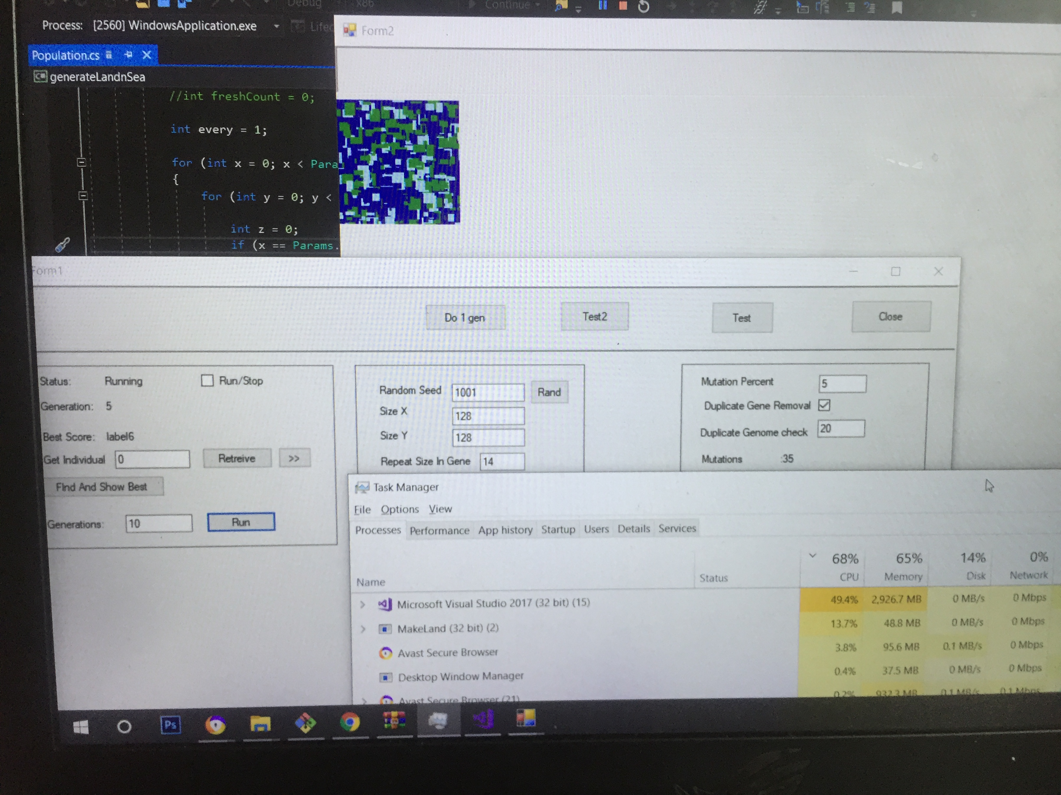

I just ran 10 iterations and reduced down the population size to and ? To ? as my system's memory seemed to be struggling. Anyway I overcame this memory issue and tried again but each time it was the case that the bitmap did not evolve from a very early iteration if at all beyond just one. You can see in the screenshot above that

Looking into the code for the reason for this I noticed (!!) that the actually optimization function itself – 'findBest()' was not even being called anywhere !! Clearly thius needs to be called in every or some iterations or there wil l be no evolution. So I figured this must be the case within the 'Breed' function. Hence I made one of the parents here be this best genotype before the crossover.

What I found Interesting or difficult / Challenging :

it was challenging to figure out why the bitmap was not evolving over many generation initially. So i had to ensure i had several different mutation and Scoring strategies written and also that they were well tested /debugged before I was confident this was the cause of the static image.

Initially when running this my laptop caused the running program to crash repeatedly, it seemed it could not handle the memory usage. So I had to ensure all other applications were not running and even some unneeded background ones via task-manager.

