EE 506 Optimization Theory

Homework #2
David Crowley
September 19, 2018

Traveling Salesman Problem

1a. The problem of the Traveling Salesman is difficult to solve because it is NP. The only way to know if you have the best solution is to try all of the solutions. The number of possible solutions is equal to (N-1)! where N is the number of cities. For a small number of cities this is feasible. For 7 cities the number of possible solutions is 720 of which 2 are equally best solutions where one best solution is in the opposite order of the other best solution.

1b. For the given sample problem, my program came up with the following best solution:

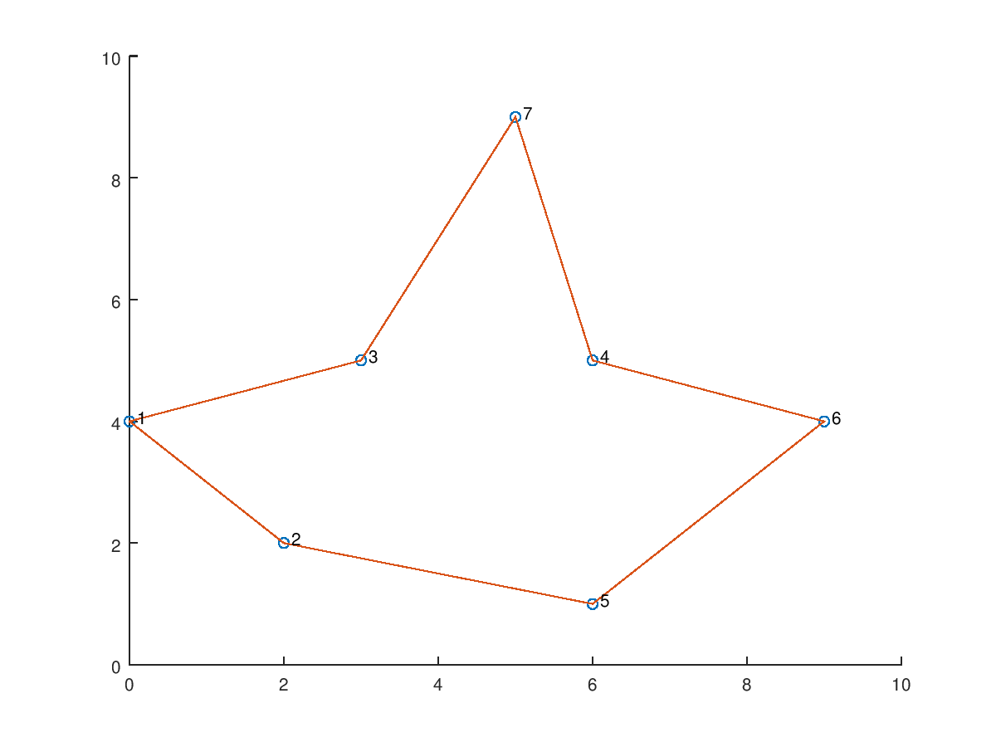

1c. For the simple 7 city problem, it is a little bit difficult to understand what changes to C do to the solution. But by looking at the equation for P and running the program solutions with more cities we are able to determine that lower values for C give us more movement. As C → 0, p → 1 so there is a high probability that if we are at a solution x we will move to another solution y which may not be quite as good as solution x.

1d. The value N determines the number of starting points we generate. As N increases, we have a better change of finding a really good solution. A larger N helps us better cover the entire solution space. For the 7 city problem, N=10 and C=1 worked adequate and my code found the best solution nearly every time.

1e. I ran my code for 50 cities. Values of C that are too low make cause the code to run for too long because it jumps so much. I found that for 50 cities, C=0.04, N=400 worked really well and often returned really good solutions. My criteria for a really good solution was one where the path never crossed itself, as seen below

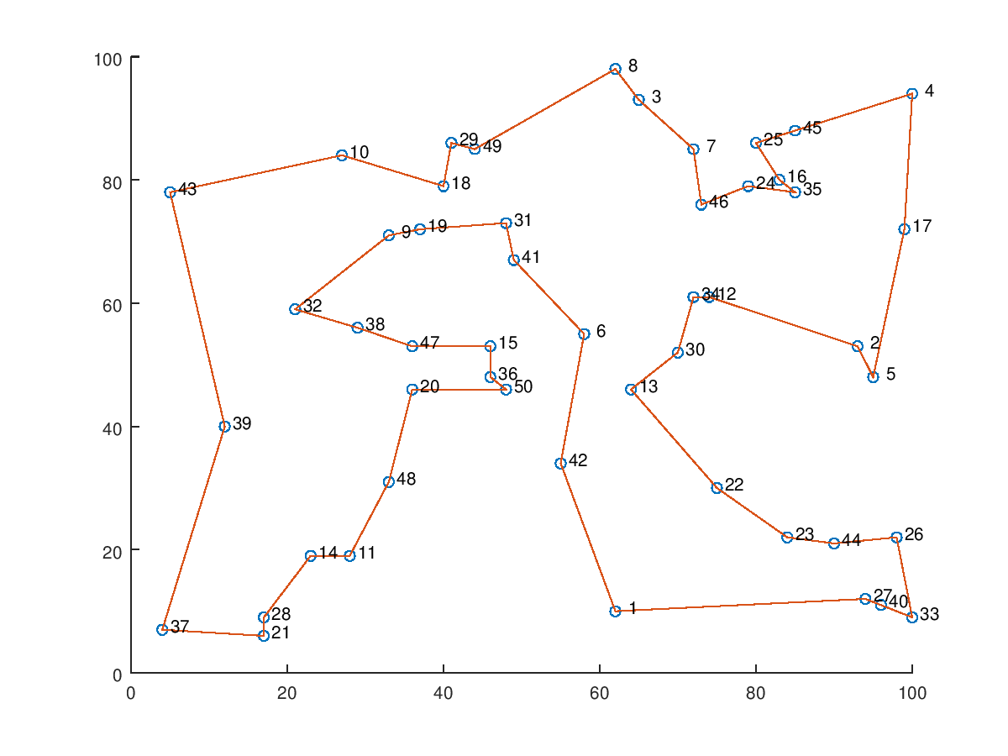
1f. The value M was the number of iterations the code was willing to run without finding a better solution. The break condition for the loop was to run until the number of iterations since the last better solution was equal to M. For 50 cities, a value that seemed to work well for M was 1000.

I wrote my code in C++ and I was able to make it multi-threaded using openmp. The resulting code was really fast! I can generate really good solutions to a 50 city problem in under 20 seconds. A sample run is shown below:
$ time ./tsp 50 400 0.04 1000 > tsp.txt

real 0m12.153s
user 0m49.010s
sys 0m28.928s
$ tail tsp.txt

matlab script to view solution:

cities=[97 55;38 48;46 63;10 25;32 36;71 11;52 9;93 64;82 35;69 2;40 1;48 90;44 52;95 100;56 15;89 50;53 34;27 99;99 20;25 67;68 99;53 2;17 6;76 74;8 49;74 63;52 27;74 4;11 21;4 60;46 47;47 12;74 8;3 89;61 13;80 16;83 7;24 28;89 68;87 30;30 94;12 47;86 31;3 5;95 66;17 70;50 11;18 98;41 85;60 68;];
best=[ 1 8 45 14 21 12 49 41 18 48 34 46 20 30 25 42 2 5 38 4 29 44 23 11 22 7 47 32 15 27 17 31 13 3 50 26 24 39 16 9 43 40 36 33 6 35 10 28 37 19 1 ];
scatter(cities(:,1),cities(:,2))
hold on
plot(cities(best,1),cities(best,2))
text(cities(:,1)+1,cities(:,2)+1,cellstr(num2str([1:length(cities)]')))
hold off

