**User Guide for EasyRead**

Table of Contents

1. Getting Started (Landing Page)

1.1. Signing up

1.2. Logging In

1.3 Resetting Password

2. Home Page

2.1. Categories

2.2. Latest Releases

2.3. Top Charts

2.4. Books Recommended

3. Search Feature

3.1. Search By Title

3.2. Search By Author

4. Bookmarks

4.1. Bookmarks Page

5. Profile

5.1. Edit Profile

5.1.1. Adding Profile Picture

5.2. Add Friends

5.2.1. View Another User’s Profile

5.3. Notifications

5.4. Log Out

1. Getting Started (Landing Page)

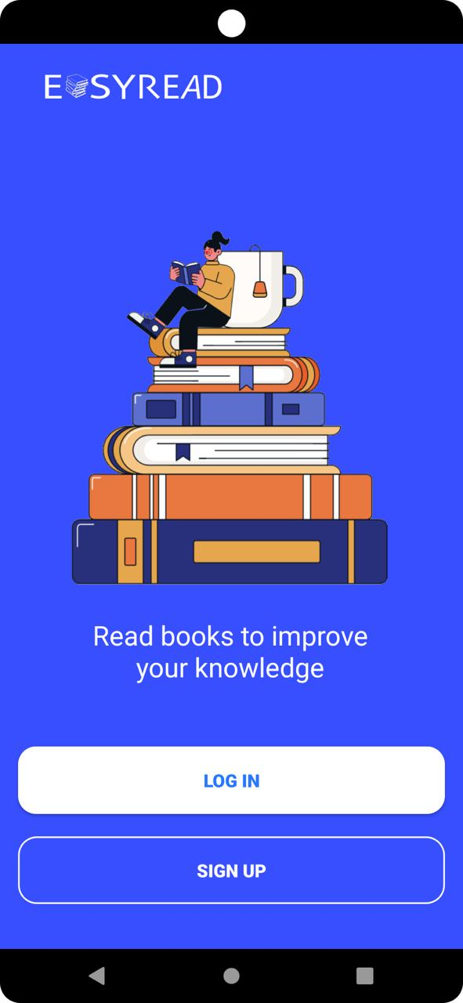

This is what you will see the first time you launch the app, now we will teach you how to sign up for an account.

Step 1: Click on “SIGN UP” to proceed to the sign up page.

1.1. Signing Up

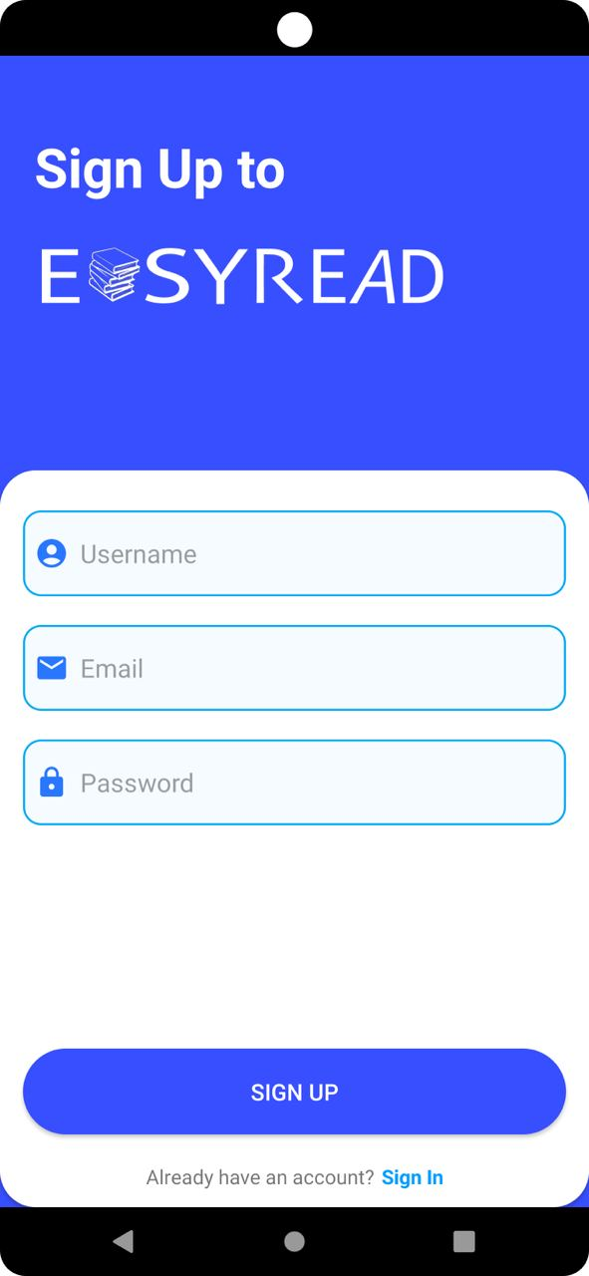

This is what you will see in the registration page.

Step 2: Fill in the necessary information “Username” , “Email”, and also “Password” to create an account in EasyRead !

1.2. Logging In

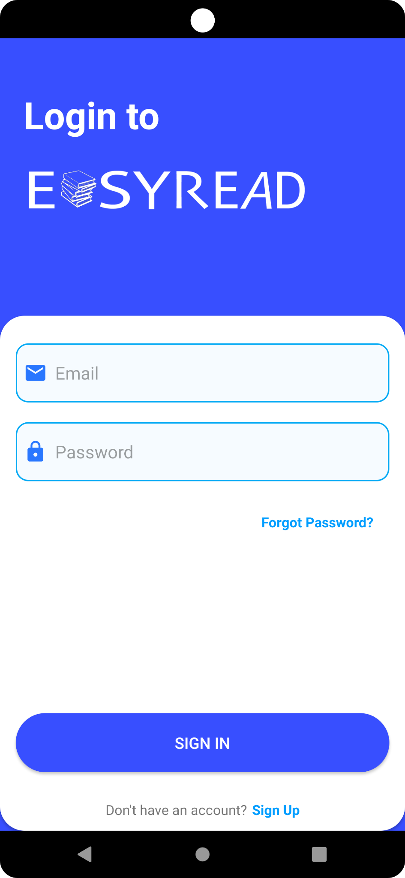

After you have successfully registered for an account, you can login to EasyRead.

Step 3: Enter “Email” and “Password” credentials followed by clicking the “SIGN IN” button to get started.

1.3. Resetting Password

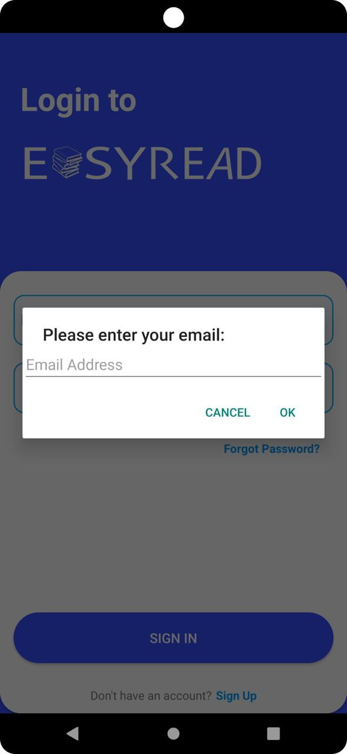

This is what you will see if you happen to forget the password for your account, EasyRead provides a password resetting feature where a new link to change your password will be sent via your email when you click “Forgot Password?”.

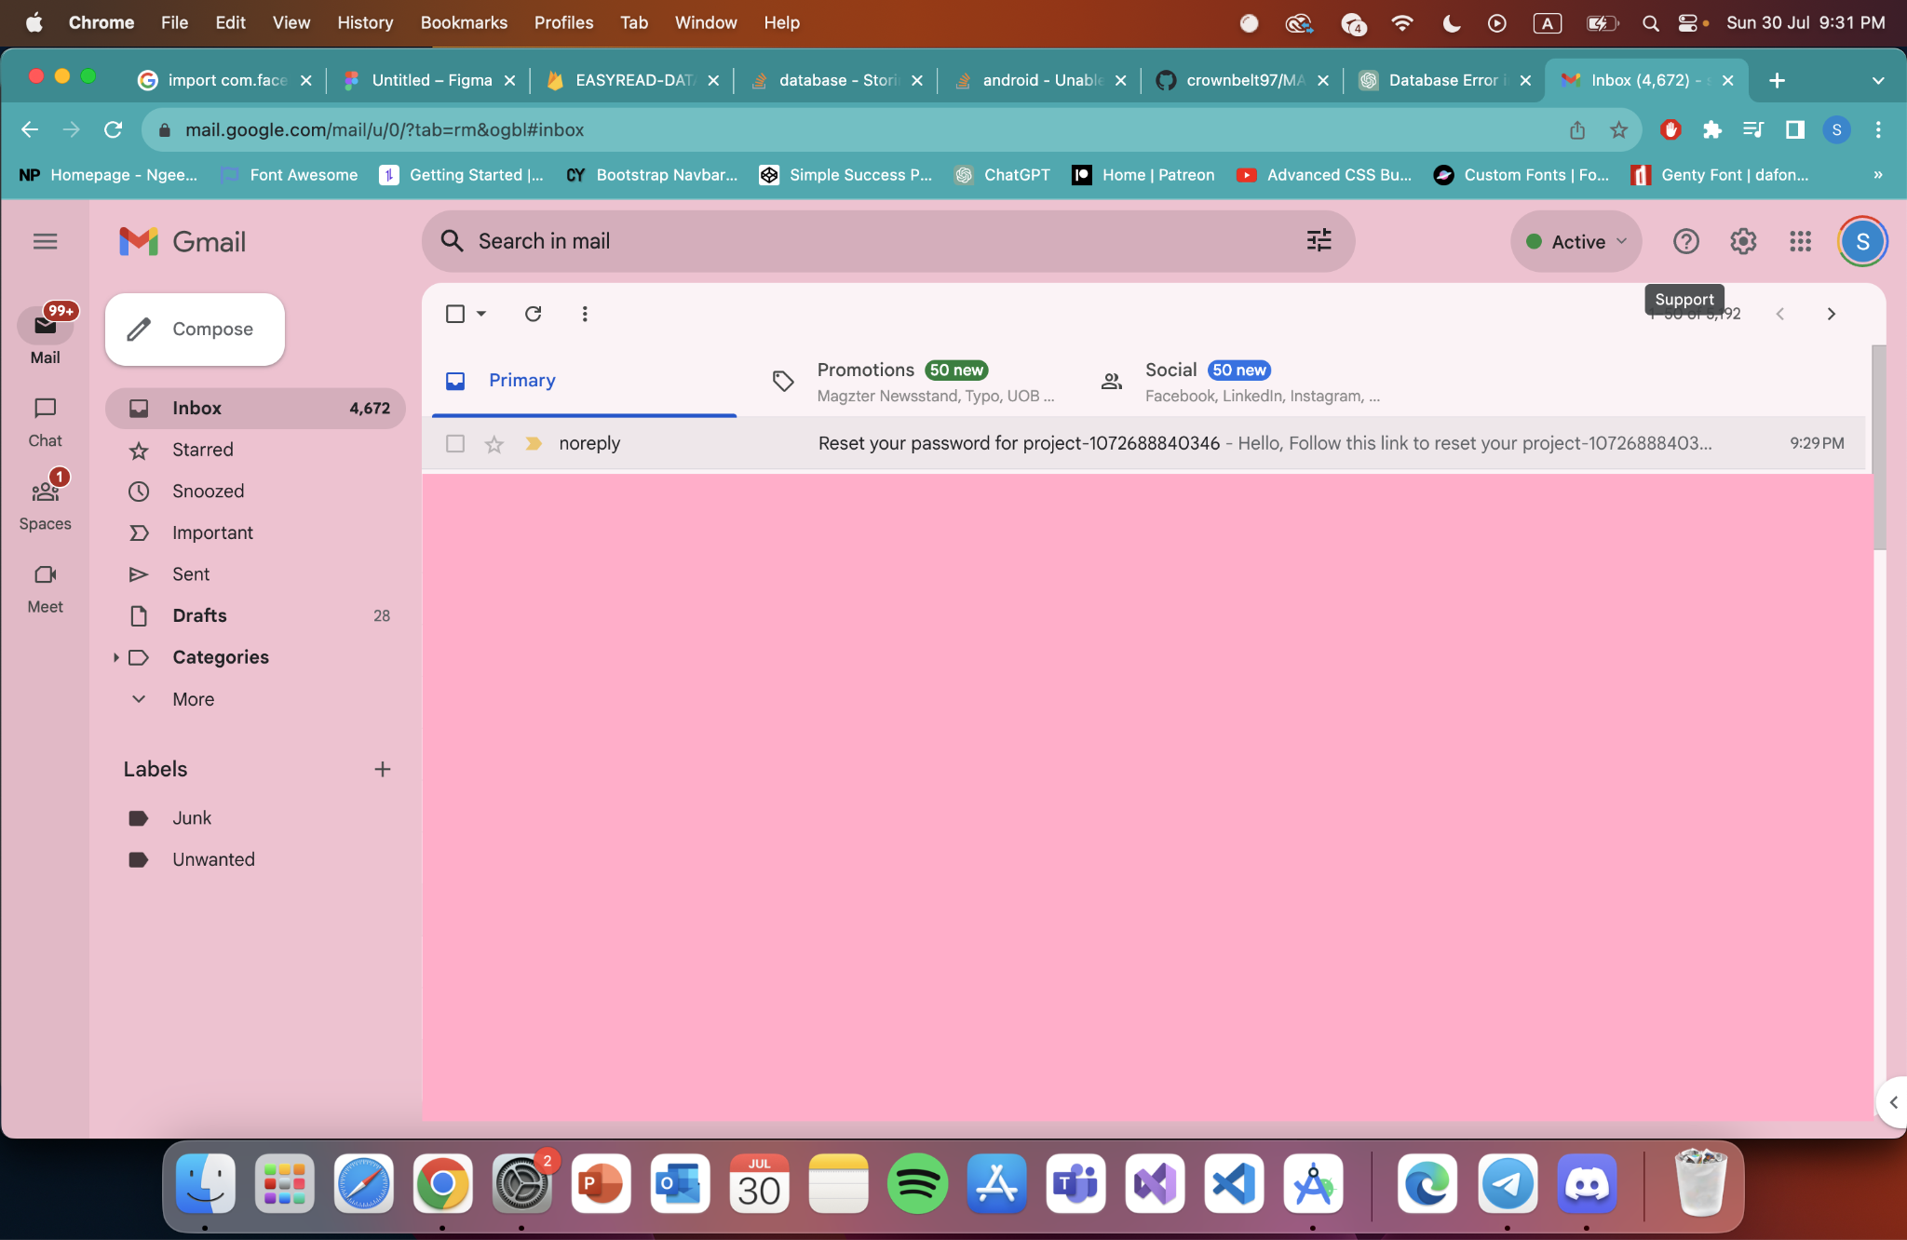

Step 1: Click on “Forgot Password?”

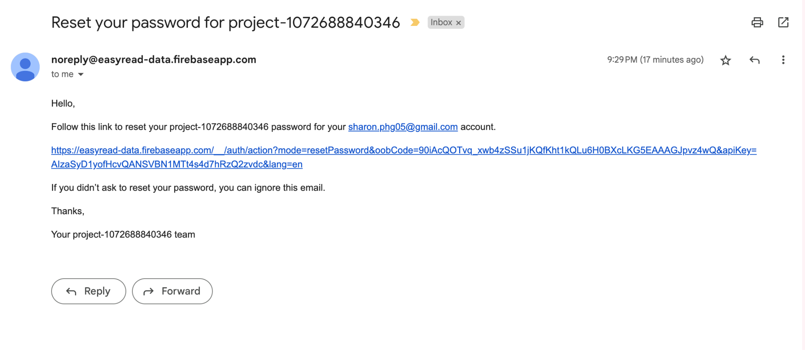

Step 2: Click on the link provided for you

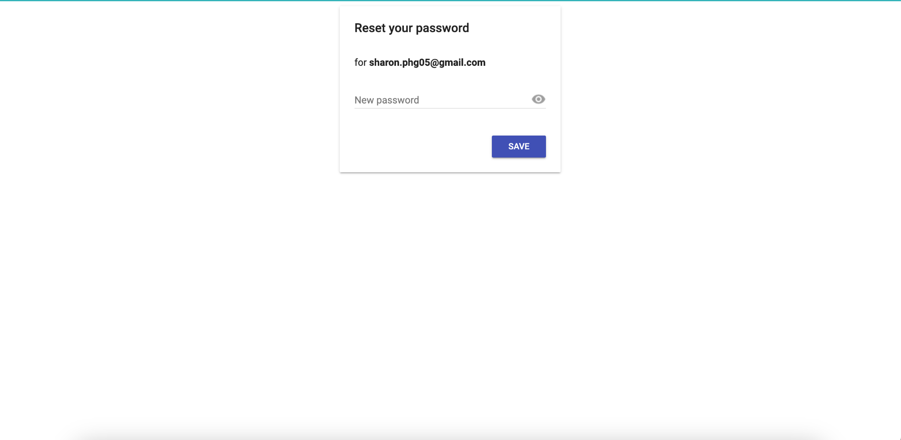

Step 3: provide your new password and click on “SAVE”.

2. Home Page

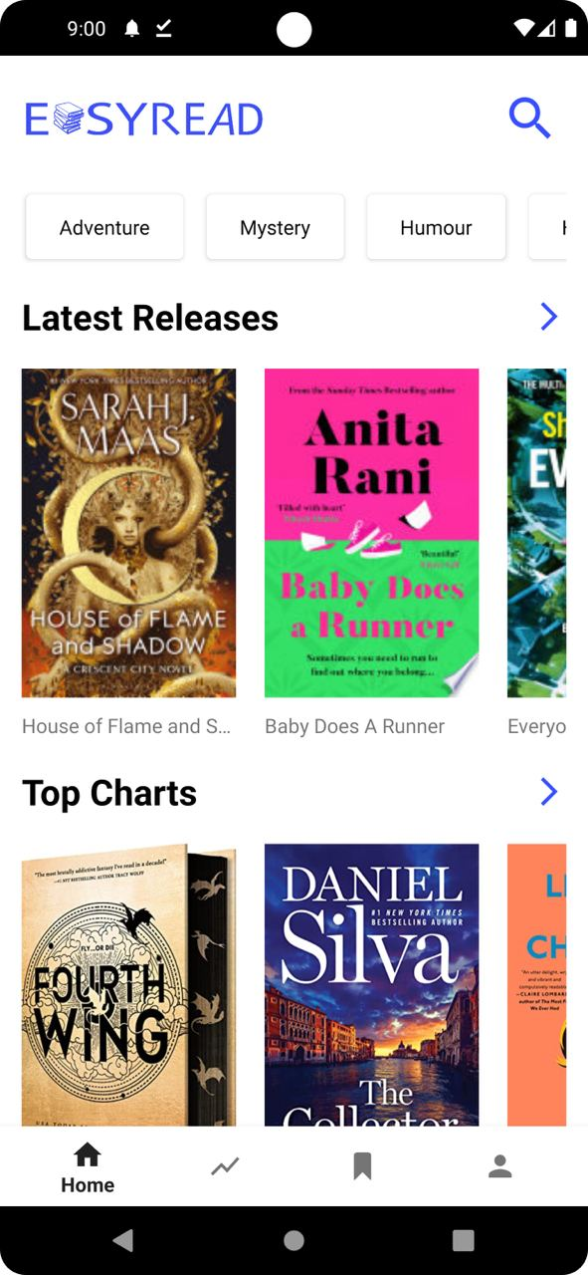

This is what you will see when you have successfully logged in using the credentials that you have registered previously.

2.1. Categories

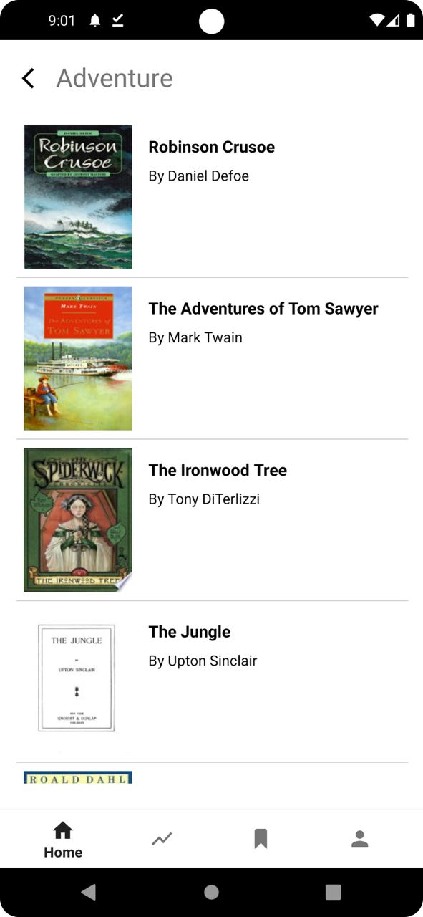

This is what the Categories Page looks like when you click on any of the categories button in the Home Page, here we are seeing the Adventure Category. You can click any of the books to get its details.

2.2. Latest Releases

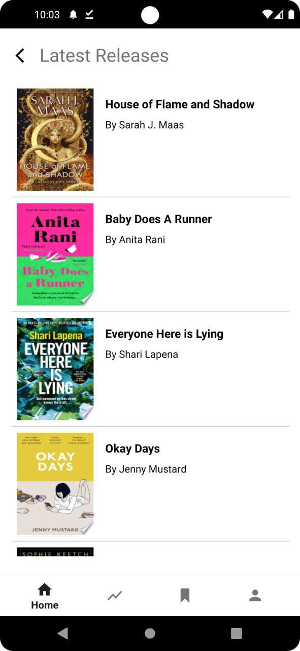

This is what the Latest Releases Page looks like when you press the blue arrow right beside “Latest Releases”. You can click any of the books to get its details.

2.3. Top Charts

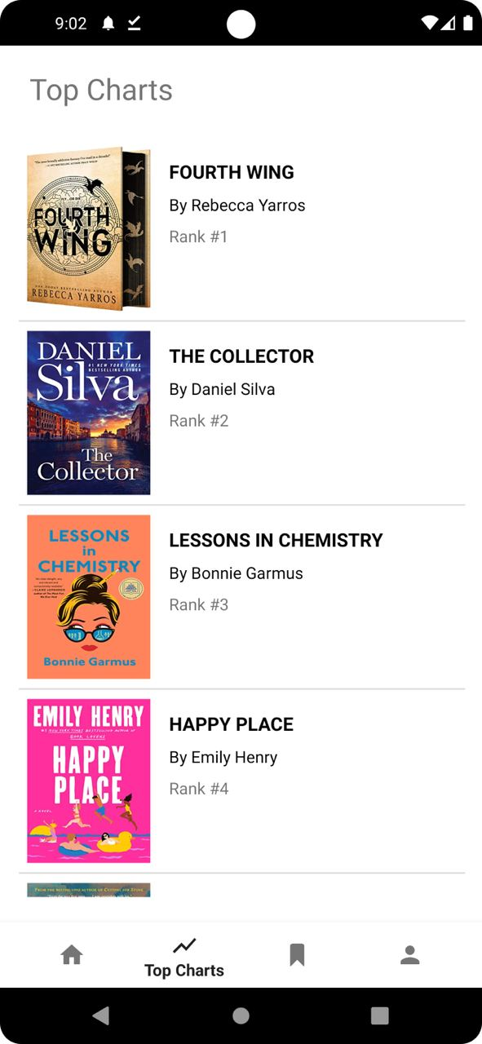

This is what the Top Charts Page looks like when you press the blue arrow right beside “Top Charts”. You can click any of the books to get its details.

2.4. Books Recommended

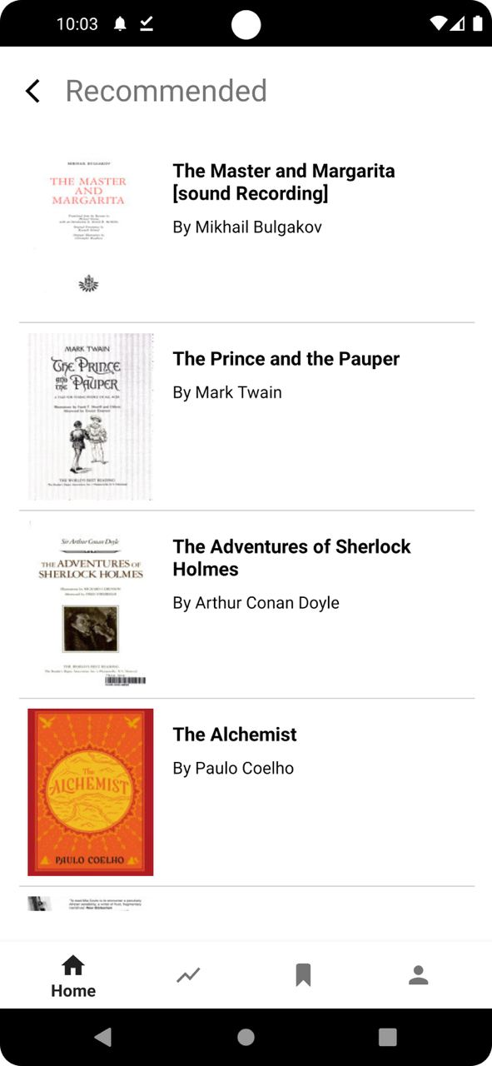

This is what the Top Charts Page looks like when you press the blue arrow right beside “Top Charts”. You can click any of the books to get its details.

3. Search Feature

3.1. Search By Title

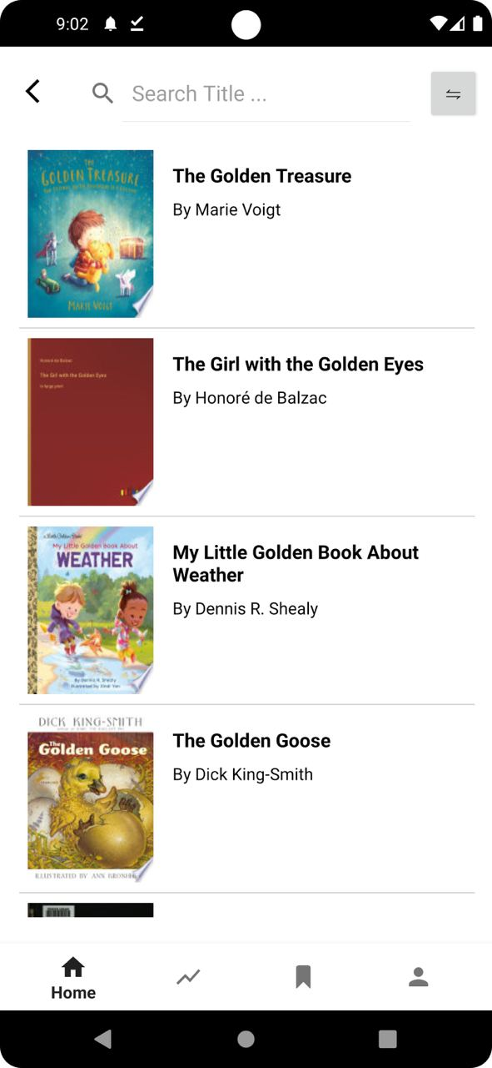

This is what you will see when you press on the magnifying glass icon located at the top right side of the Home Page.

Step 1: Type the desired book you wish to find online in the search bar “Search Title ..”

3.2. Search By Author

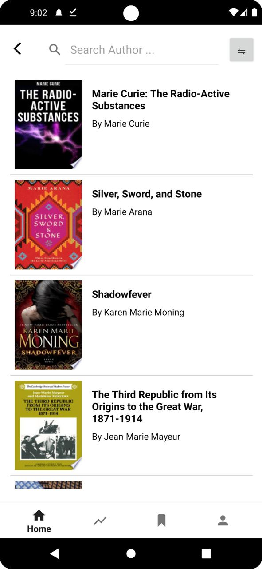

Step 2: Click the button to the right side of the search to switch to search by author. Type the desired Author you wish to find online in the search bar “Search Author ..”

4. Bookmarks

4.1. Bookmarks Page

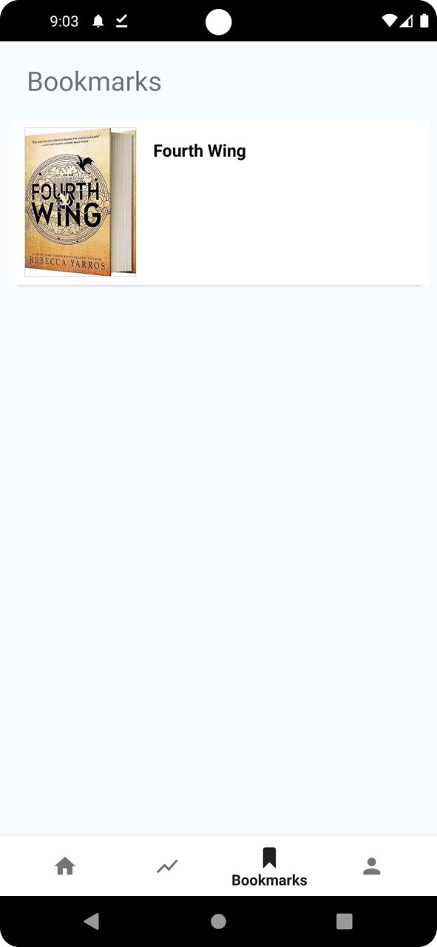

This page shows you all the books that you have bookmarked. Now you will be learning how to bookmark the books that you like.

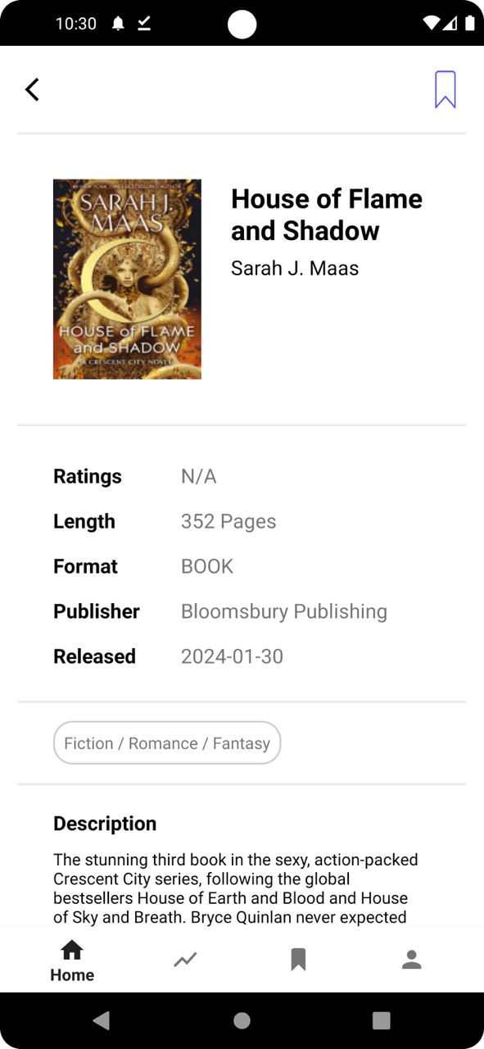

Step 1: From the book details page, you can click on the bookmark icon located at the top right side and you have successfully bookmarked a book !

5. Profile

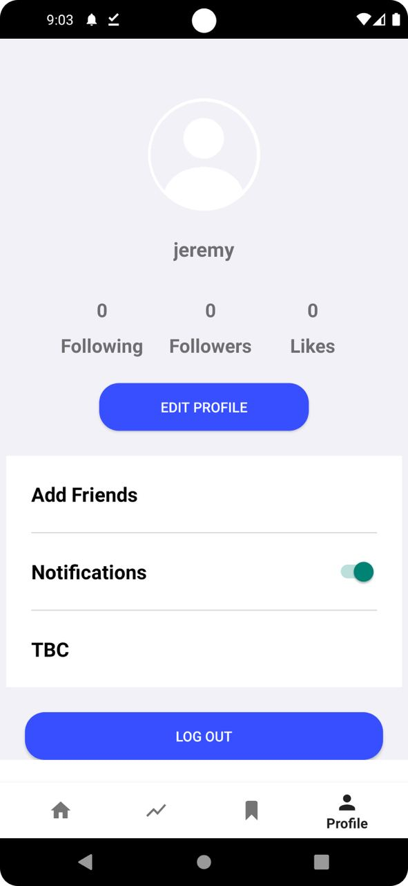

This is what the profile page looks like, in the profile page users can choose to edit their profile, add friends, notifications and also log out.

5.1. Edit Profile

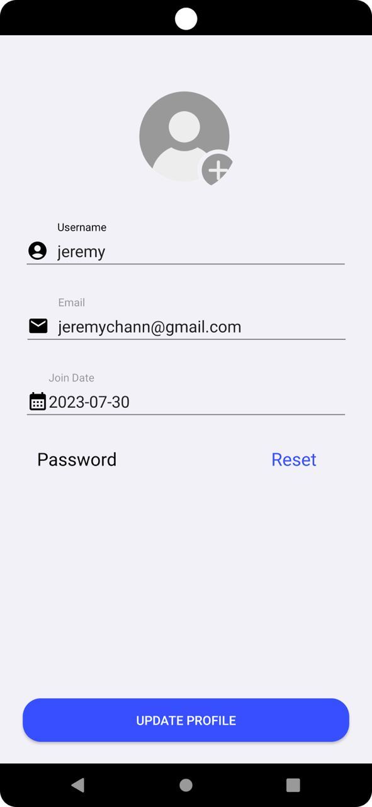

This is the edit profile page, here you can choose to edit your username, email, join date, password and even add a new profile picture. When you click on password reset, it will send an email to your current email address. It works the same way as the forgot password function.

5.1.1. Adding Profile Picture

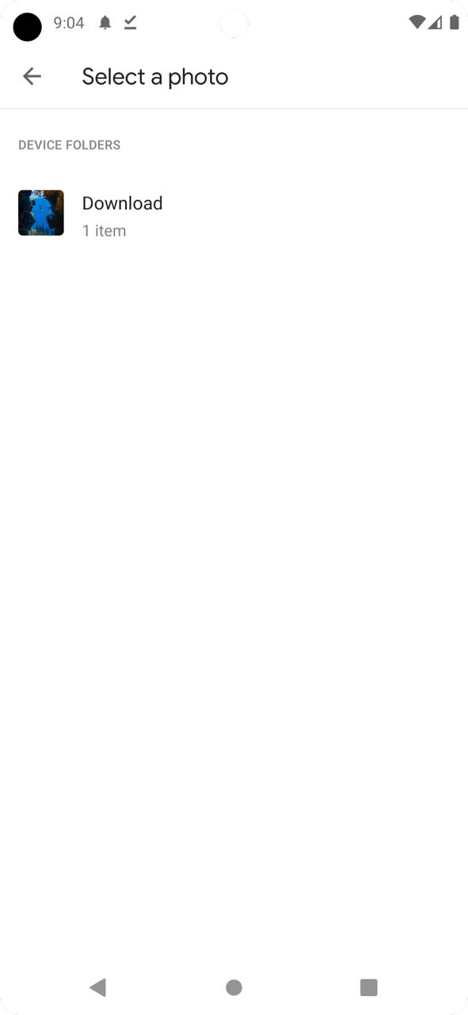

Step 1: Click on the default profile picture in the edit profile page.

Step 2: Choose any image you wish to change.

Step 3: Click on “Update Profile” to confirm changes.

5.2. Add Friends

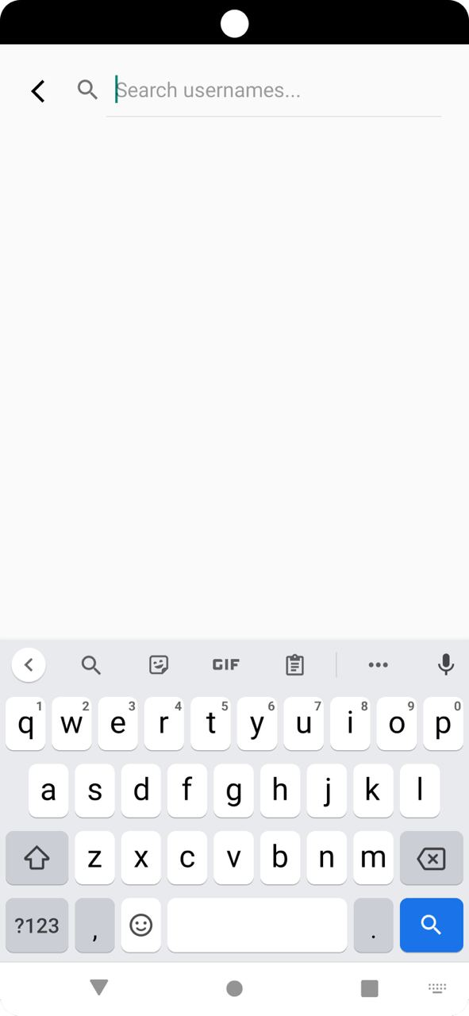

Step 1: Click on Add Friends located in the edit profile page.

Step 2: Type your friend’s username in “Search usernames..”.

Step 3: Click on the “FOLLOW” button to add and follow friends.

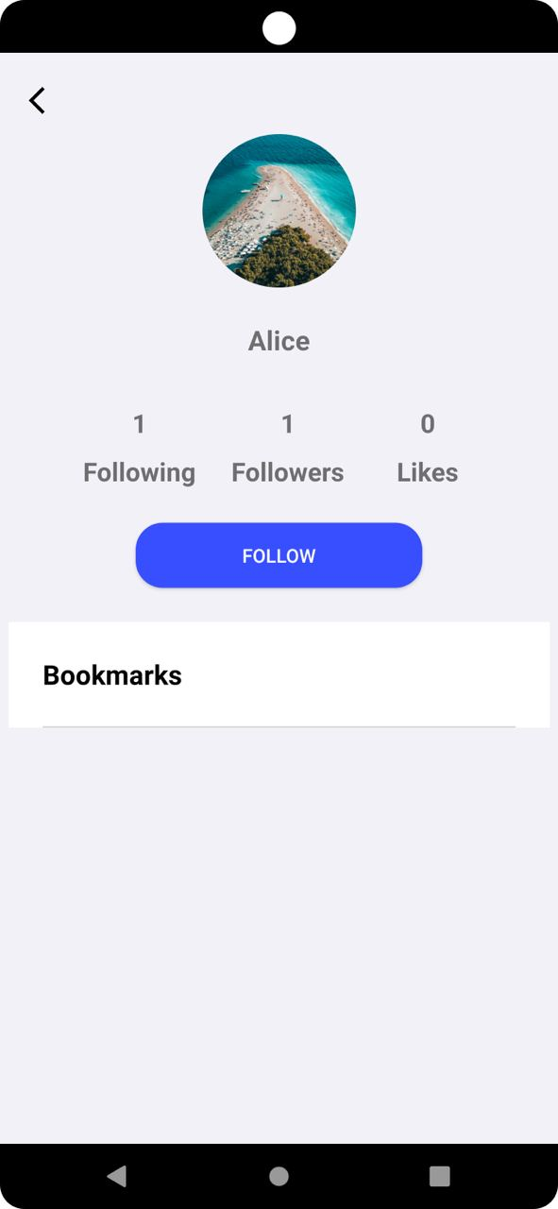

This is what another user’s profile page looks like. It shows their following, followers, likes and also bookmarks.

5.3. Notifications

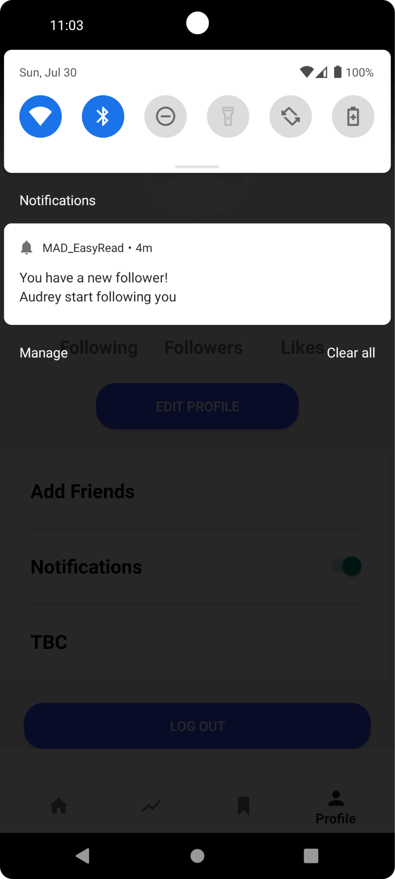

This is the notification of what you will see if someone has followed you on EasyRead.

5.4. Log Out



Upon clicking of “LOG OUT” button in the edit profile profile, you will be redirected back to the landing page.