

**MOMIN KHALID   
 VISA APPOINTMENT& BOOKING HEAD**

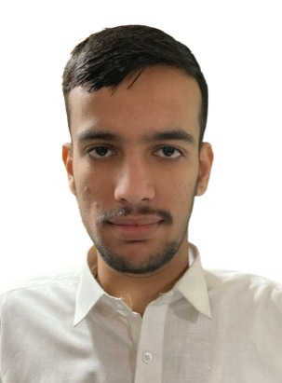

**JAWAD ALI**   
**VISA APPOINTMENT AND BOOKING ASSISTANT**

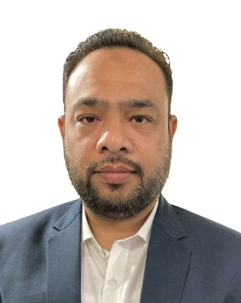

**ADNAN IQBAL   
SALES MANAGER**



**ABDDUL REHMAN   
 VISA APPOINTMENT AND BOOKING ASSISTANT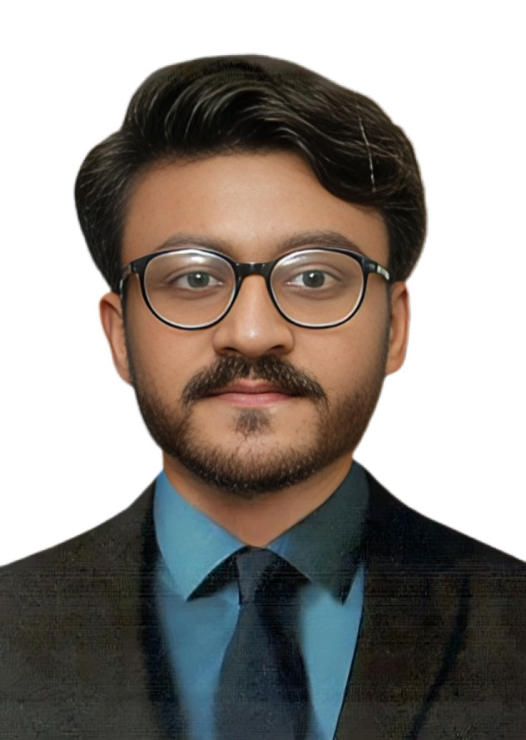 AHMED MIRAJ   
VISA PROCESSING HEAD**