Solution approach:

Server:

Keep a list of ClientHandler objects each one listens for any message from the client.

If a client handler j receives a message from a client then it loops through all of the client handlers and passes the j’s number (assigned by the server at connection time) and a message string to a method that sends a message to the owning client handler’s client.

Client:

User enters name.

Client connects to server and asks user to enter a message.

When a message is typed and enter is pressed the client sends the users chosen name and message to the server.

Create a thread that listens to the port that was used to connect to the server. When a message is received it prints it to the console window.

Images:

Server Connects:

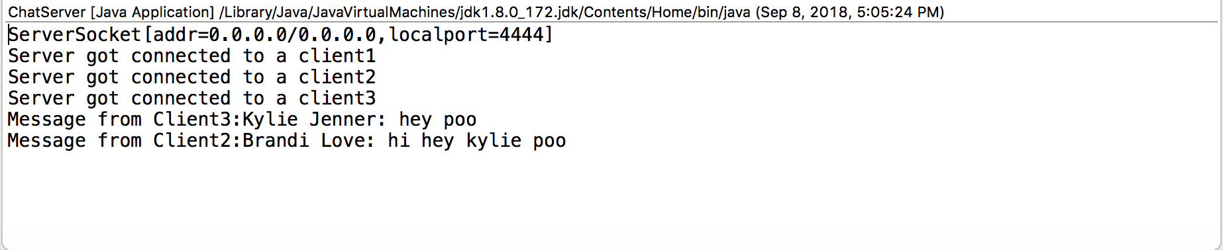

Client 1 Connects:

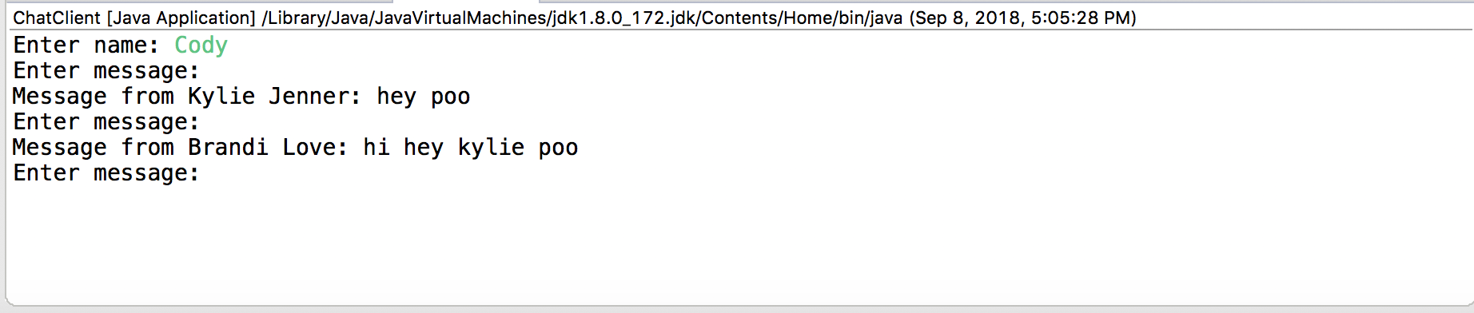

Client 2 Connects and sends message:

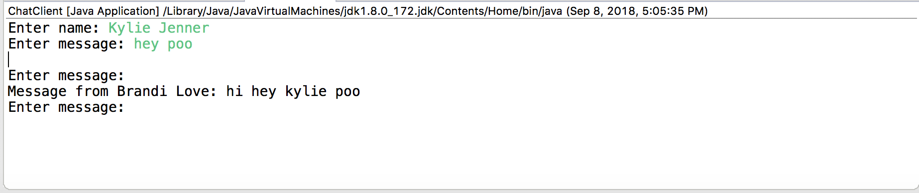

Client 3 Connects and sends message:

