Report

Cody Peter

Validation 1

* First and last name: check to make sure entry is not empty and if only alpha numeric numbers
* Gender make and state: make sure entry is not “—“.

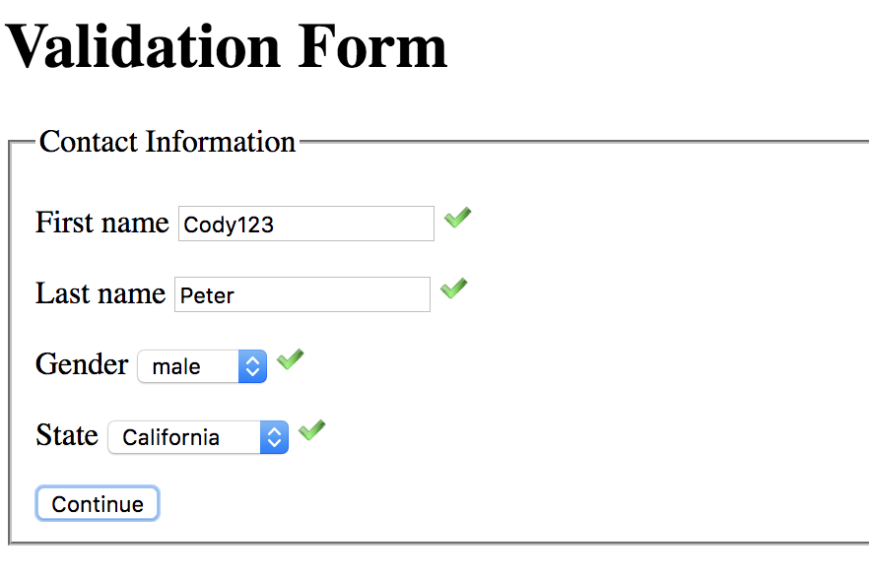

Validation 2

* Email: split string into part before @ and par after, split part after into before . and after make sure that the split up parts are alpha numeric chars.
* Number: check if either string is all numbers and 10 digits or split it between ‘-‘ and if it is three parts then check if parts 0 and 1 are length 3 and part 3 is length 4.
* Address: split into two parts before and after ‘&’ and make sure that the chars are alphabet or space.

