COM S/SE 319 : Software Construction and User Interfaces

Fall 2018

Individual Report for 2st Release

Group No. 9

Project Title: Chitchat.io

Name: Cody Peter

Individual Contribution

* Search for users and send Personal Messages.

Worked on Story Cards No. Login and Register page

* Search for users.
* Send personal messages to specific user.

UI Screenshots:

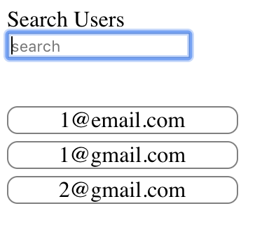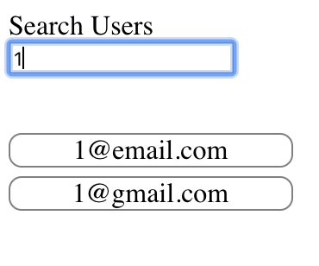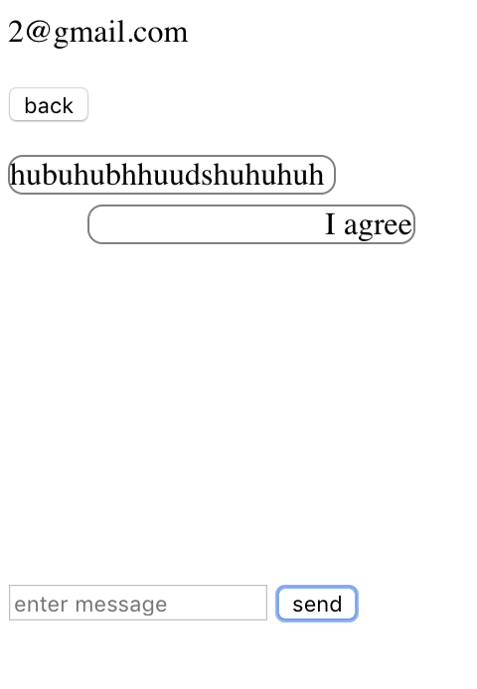

Use case Diagram:

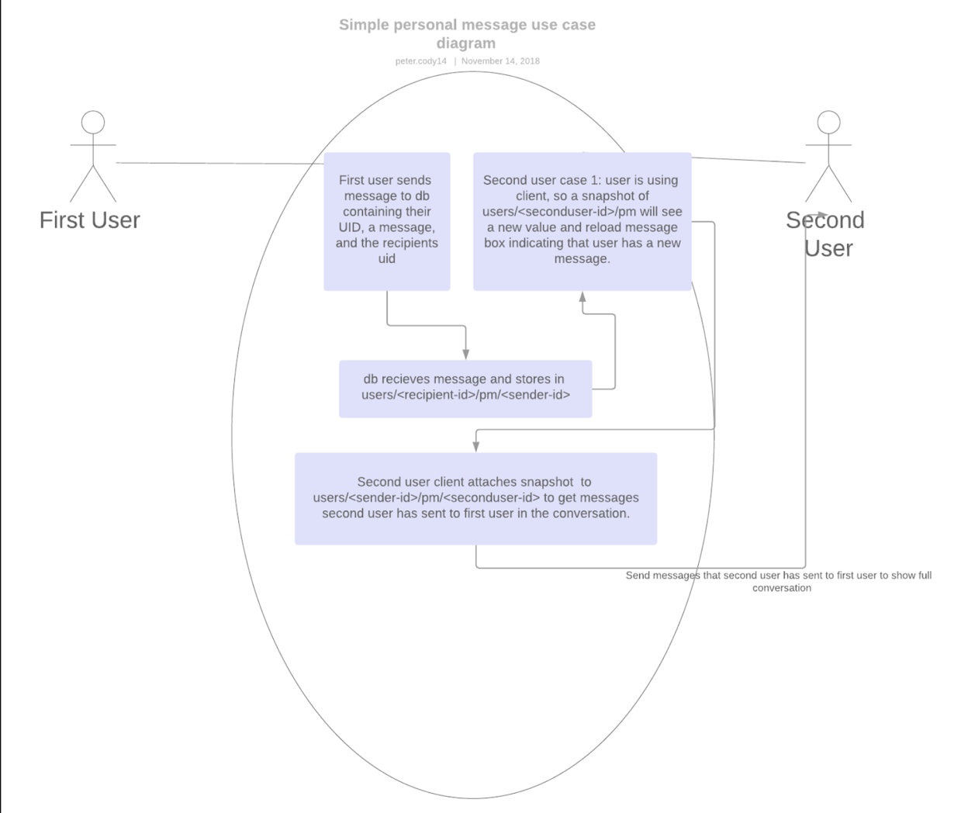

Git:

