COM S/SE 319 : Software Construction and User Interfaces

Fall 2018

Individual Report for Finalst Release

Group No. 9

Project Title: Chitchat.io

Name: Cody Peter

Individual Contribution

* Style personal messaging module to make presentable.
* Fixed a bug in messaging which printed incorrect info.
* Add personal messaging module onto front page.
* Add firebase functions to i) record timestamp of user created. ii) Cleanup messages and account information for a user when the user is deleted.

Worked on Story Cards No. Personal Messaging and Database Management

* **Personal Messaging:** Search for and send personal messages to specific user.
* **Database Management:** Clean up a users info after their account is deleted.

Outcomes

* The team successfully implemented all story cards.
* Communication and trello/git were kept updated throughout the process making it easy to identify what still required work.
* Overall the team successfully developed ChitChat.io.

UI Screenshots:

List of users:  
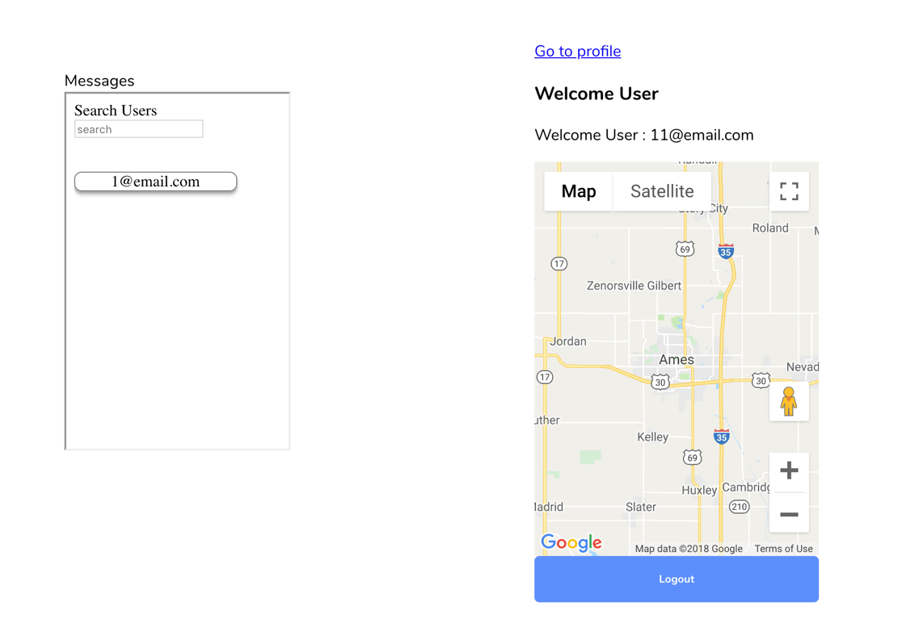

PM with 1@email.com:

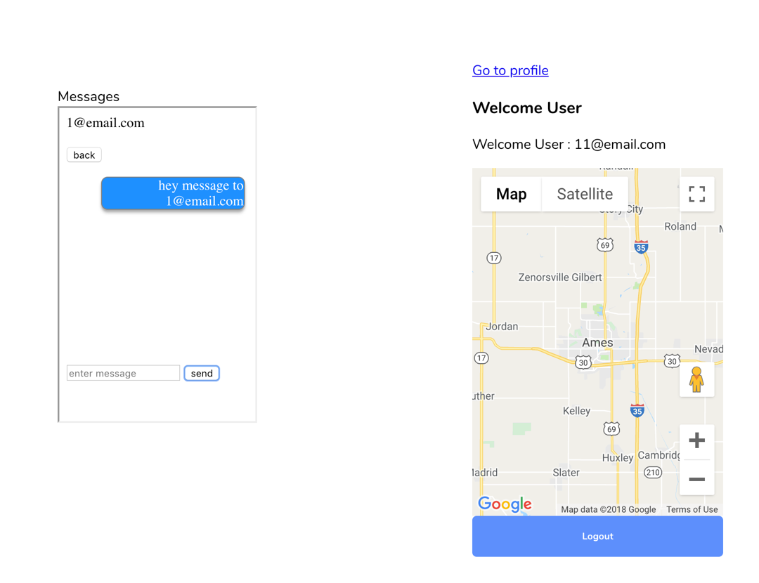

Git:

Total Commits: 13 (10 to branch Cody and 3 to branch message).



