Chris Pruett

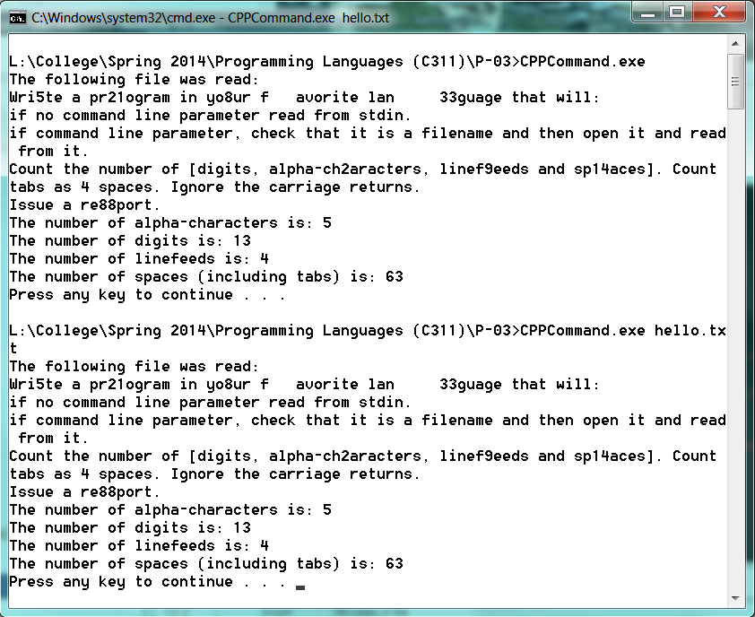

#include <iostream>

#include <fstream>

using namespace std;

int main (int argc, char* argv[]) {

string line;

fstream frigginfile;

if (argc != 2) {

frigginfile.open ("hello.txt", fstream::in);

} else {

frigginfile.open (argv[1], fstream::in);

}

if (!frigginfile.is_open()) {

cout << "Pointer does not reference a file!!";

cin.get();

return 0;

}

char ch;

int capnumchar = 0;

int spacecount = 0;

int linefeed = 0;

int digit = 0;

cout << "The following file was read: \n";

while (getline(frigginfile, line)) {

linefeed++;

}

frigginfile.clear();

frigginfile.seekg(0);

linefeed = linefeed - 1;

while (frigginfile >> noskipws >> ch) {

cout << ch;

if (isupper(ch)) {

capnumchar++;

} else if (isdigit(ch)) {

digit++;

} else if (isspace(ch)) {

if (ch == 9) {

spacecount = spacecount + 4;

} else {

spacecount++;

}

}

}

cout << "\n";

cout << "The number of alpha-characters is: " << capnumchar << endl;

cout << "The number of digits is: " << digit << endl;

cout << "The number of linefeeds is: " << linefeed << endl;

cout << "The number of spaces (including tabs) is: " << spacecount << endl;

frigginfile.close();

system("pause"); // or cin.get();

return 0;

}