Chris Pruett

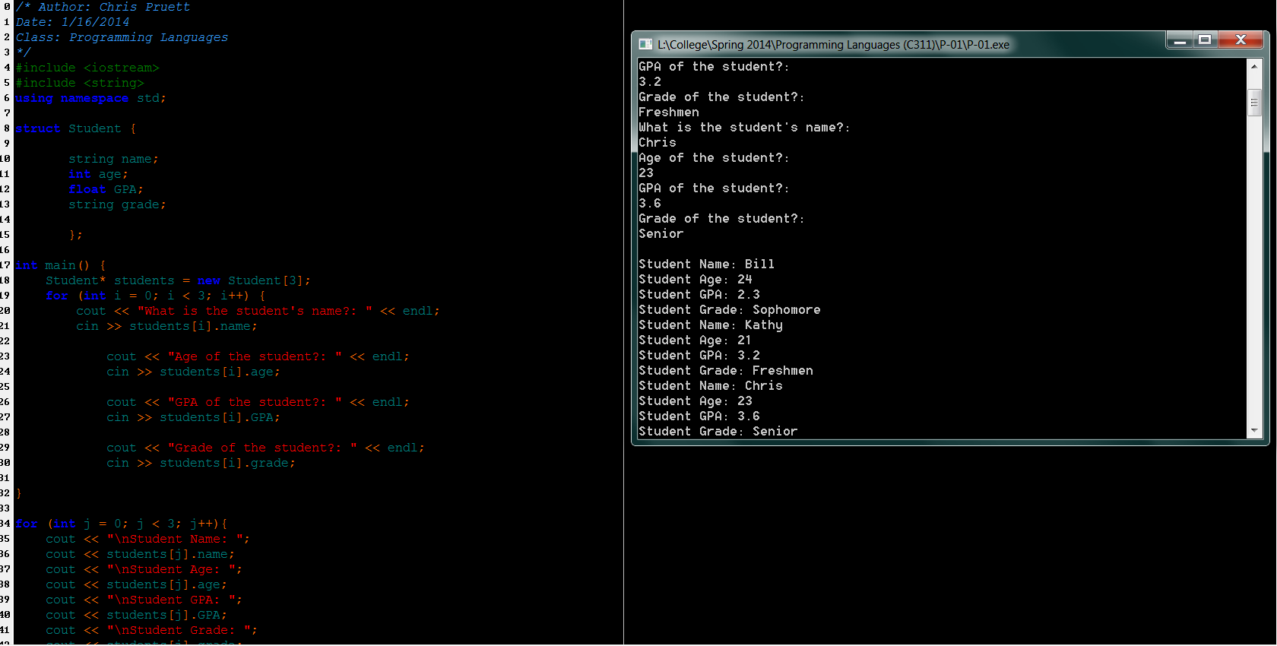

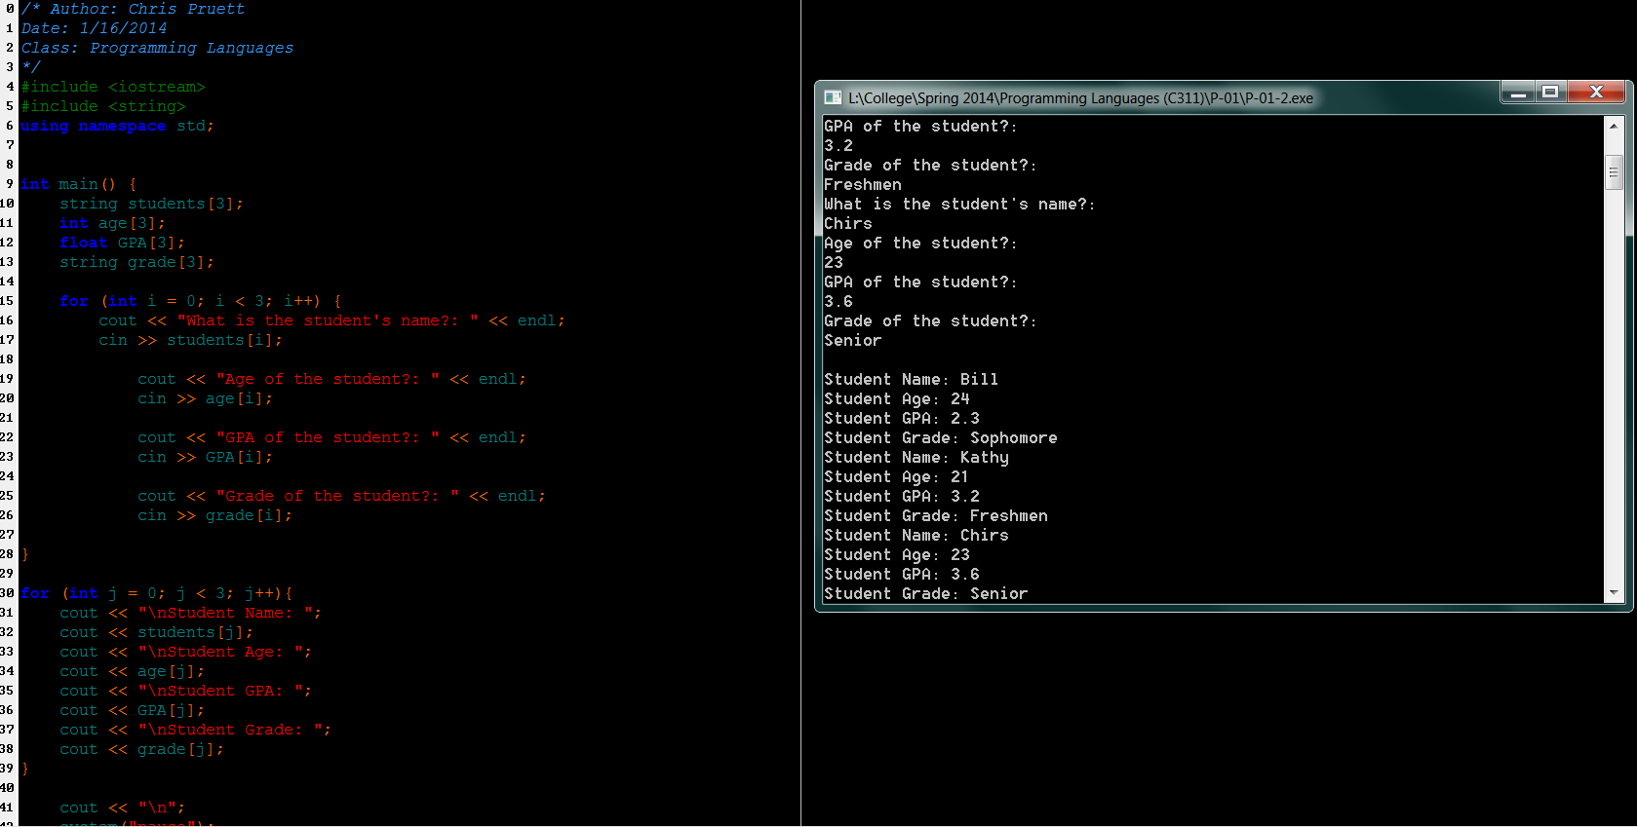

**Structure Program (first program above):**

/* Author: Chris Pruett

Date: 1/16/2014

Class: Programming Languages

*/

#include <iostream>

#include <string>

using namespace std;

struct Student {

string name;

int age;

float GPA;

string grade;

};

int main() {

Student* students = new Student[3];

for (int i = 0; i < 3; i++) {

cout << "What is the student's name?: " << endl;

cin >> students[i].name;

cout << "Age of the student?: " << endl;

cin >> students[i].age;

cout << "GPA of the student?: " << endl;

cin >> students[i].GPA;

cout << "Grade of the student?: " << endl;

cin >> students[i].grade;

}

for (int j = 0; j < 3; j++){

cout << "\nStudent Name: ";

cout << students[j].name;

cout << "\nStudent Age: ";

cout << students[j].age;

cout << "\nStudent GPA: ";

cout << students[j].GPA;

cout << "\nStudent Grade: ";

cout << students[j].grade;

}

cout << "\n";

system("pause");

return 0;

}

**Array Program (second program above):**

/* Author: Chris Pruett

Date: 1/16/2014

Class: Programming Languages

*/

#include <iostream>

#include <string>

using namespace std;

int main() {

string students[3];

int age[3];

float GPA[3];

string grade[3];

for (int i = 0; i < 3; i++) {

cout << "What is the student's name?: " << endl;

cin >> students[i];

cout << "Age of the student?: " << endl;

cin >> age[i];

cout << "GPA of the student?: " << endl;

cin >> GPA[i];

cout << "Grade of the student?: " << endl;

cin >> grade[i];

}

for (int j = 0; j < 3; j++){

cout << "\nStudent Name: ";

cout << students[j];

cout << "\nStudent Age: ";

cout << age[j];

cout << "\nStudent GPA: ";

cout << GPA[j];

cout << "\nStudent Grade: ";

cout << grade[j];

}

cout << "\n";

system("pause");

return 0;

}