Farkle
By: Colton Jenkins and Chris Pruett

Introduction:
Farkle is a command-line based game of chance as any game of dice is. However, players must also make decisions whether "one in the hand is better than two in the bush". In other words, does one risk current points for a chance to gain more points? Farkle has been played for many years in many countries and has many variations. One rule remains; whoever reaches a determined score first wins.
How to play:
Each player must score at least 500 points in one turn to get on the board or bank points. If a player farkles before reaching 500, their turn is over and they pass the dice to the next player. Once a player has gotten on the board they can quit at any time during their turn, regardless of how many points they scored during that turn.
Players begin by rolling all six dice. In order not to 'farkle', each roll in a turn must come up with something that 'counts'. Scoring dice are set aside and contribute their score for that turn. If a player decides to continue rolling during their turn, they use the remaining dice. If at any time 'all' the dice produce points, the player has the option to begin again with all six dice. This still counts as one turn and should they 'farkle' (roll and come up with nothing that scores) they will lose some points accumulated during that turn. Once points are recorded, they cannot be lost.
What Counts:
If the player rolls all six dice as the same number that is 1,000 points. If the player rolls three pairs, that is also 1,000 points. If the player rolls every number in one turn that is 1,000 points. If the player scores three ones, that is also 1,000 points. If a one is rolled, that is 100 points and if a five is rolled it will count as 50. The points the player gets from three of any number equals that number times 100. (except ones that equal 1000) For example, three twos equals 200 and three threes equals 300.
Implementation:
We used the MVC (Model View Controller) approach. The reason for this would be because of the increased manageability of code. The MVC separates the game logic, the rendering of the graphics, and the input from the mouse and keyboard. This makes organizing the functionality of the game ideal.
The models handles the game logic and the game-flow. The controllers handle the input from the mouse and keyboard. Lastly, the views manage the specific display of information.
The models developed include an InputModel, DisplayModel, RulesModel, Dice Model, and a ScoreModel. The views we implemented include a MenuView, ScoreBoardView, endGameView, and the GameView. The controllers implemented include an InputController, DiplayController, RulesController, DiceController, AIController, and a ScoreController.
The difference between, say, the InputModel and the InputController is that the controller handles the actual input from the user and the model determines what is to be done with it. For example, if the user typed "roll", the controller would store that and the model would go through the game logic to do the roll. Information is then sent back to the controller and then to the view for a defined display. A graphical display of this is shown in Figure 1.
Design:
The Model View Controller design pattern:
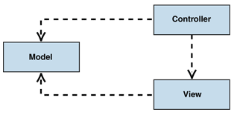
Figure 1: MVC Class Structure [2]
Our controllers will send data to the view procedures and the models. The view procedures will then send the data it acquired from the controllers to the models.
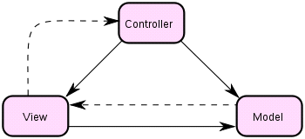
Figure 2: MVC Class Structure [1]
Here is another representation of the structure of MVC. The solid lines represent a direct association and the dotted lines represent an indirect association. The model responds to instructions to change states from the controller and responds to request for information about it's state from the view.

Results

What was promised:
We said we would have the player start out with six dice. The player would then proceed to roll the six dice to try and score points. Whatever dice the player scored with would be taken out and the player could decide if they wanted to risk their current points to try and get more. If the player scored with all of their dice then they get a bonus roll. If they roll and don't get any points then they farkle and lose some of the points they gained from their turn. First player to a pre-defined amount of points wins. The player can quit at any time after they have put up about 500 points.
What was accomplished:
The only thing that wasn't accomplished was the bonus roll. Time was a big factor for this project. Even so, almost everything the was promised was accomplished. We added the extra feature of playing against a computer opponent which adds to the re-playability of the game.
The Game:
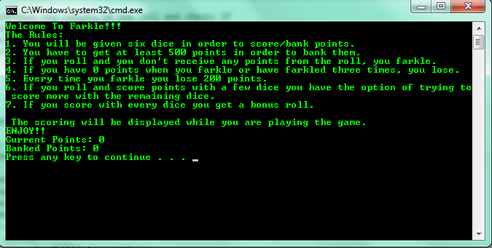

[1] http://en.wikipedia.org/wiki/Model%E2%80%93view%E2%80%93controller
[2] http://msdn.microsoft.com/en-us/library/ff649643.aspx

