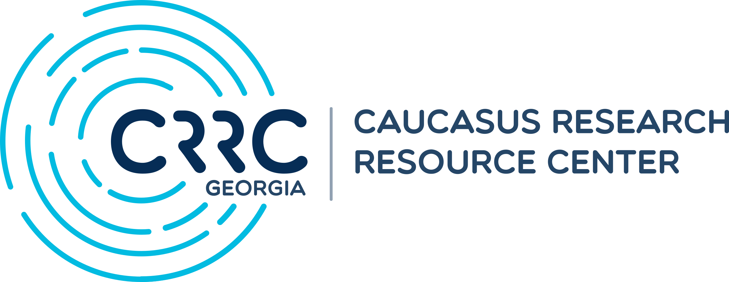  
July 2022 Omnibus Survey

Topline questionnaire

CRRC Georgia

2022-08-31

## Information about the current survey

The survey is representative of the population of Georgia, excluding territories currently under the control of Sukhumi and Tskhinvali authorities. Results are weighted and can be disaggregated by gender, age group, settlement type, and education level.

Respondents are drawn using Random-Digit-Dial (RDD) method, stratified by the available phone prefixes in Georgia. Phone numbers are generated proportional to cell phone resources, that is, the list of the potential cell phone numbers per prefix assigned to mobile phone operators in Georgia by the National Communications Commission (ComCom).

Overall, for the 13th wave of CRRC’s Omnibus survey 1,244 completed interviews were collected between July 20 and 30, 2022. As per standard definition of AAPOR, cases with >=50% completion rate are classified as complete.

CRRC-Georgia uses detailed demographic information from the 2014 Georgian National Census for weighting adjustments. This helps balance the proportions of those groups which might be underrepresented in the raw data. Base weights are an inverse of a respondent being selected out of the pool of the country’s adult population. Raw weights are further corrected (raked) using detailed population bins for gender, age, settlement type, ethnicity, and education derived from the 2014 National Census of Georgia. Average margin of error amounts to 2.8%, with 4.7% error for proportions close to 50%.

## About CRRC-Georgia’s Omnibus Surveys

CRRC-Georgia’s omnibus surveys are nationally-representative quarterly telephone surveys that poll Georgians on various issues of public interest. While generally CRRC’s omnibus poll is a commercial product, part of the results are available to the general public.

For further inquires on CRRC-Georgia’s omnibus surveys contact David Sichinava ([david@crrccenters.org](mailto:david@crrccenters.org)) and Makhare Atchaidze ([m.atchaidze@crrccenters.org](mailto:m.atchaidze@crrccenters.org))

## About CRRC-Georgia

CRRC-Georgia is a non-governmental, non-profit research organization, which collects, analyzes and publishes policy relevant data on social, economic and political trends in Georgia. CRRC-Georgia, together with CRRC-Armenia and CRRC-Azerbaijan, constitutes a network of research centers with the common goal of strengthening social science research and public policy analysis in the South Caucasus.