**Milestone 3 Part A**

Implementation of Mashup Features

**Jagrut Desai**

**Haoxuan Dong**

**Matteo Sarica**

**Patrick Truong**

**Hieu Tran**

**Keith Ngo**

May 1, 2015

CS 160 - 01

Group 4: Software Gurus

Source: Science NetLinks

Assigned domain: [http://www.sjsu-cs.org/cs160/sec1group4/](http://www.sjsu-cs.org/cs160/sec1group4/education.php)

**Content**

Individual Contribution Summary

Introduction

Hosted Website

What have been accomplished in this milestone

Implementation of Selected Features

Feature #1: Login / Registration

Feature #2: Front Page Slider

Feature #3: Search / Results

Feature #4: Bookmarks (aka “Like” feature)

Merge Data

Behavior Modeling

Overall Design

Sequence Diagram

Revised Specs

# Individual Contribution Summary

|  |  |  |  |
| --- | --- | --- | --- |
| **Student Name** | **Technical part** | **Report drafting** | **PPT** |
| Jagrut Desai | * Tested the feature implemented by other group members * Remove some more duplicates using phpmyadmin query engines. * Helped setup the server to through ftp. | * Worked on creating report and powerpoint * desingned the sequence diagram for website * Wrote on behavior modeling. | Yes |
| Haoxuan Dong |  |  | Yes |
| Matteo Sarica | * Developed the registration and login system for this milestone, and database to save user information * Test out features for errors | * Revised all documentation | No |
| Patrick Truong | * Helped with the implementation of the bookmark feature * Test out other features for errors | * Contributed to the documentation of Feature #4 Bookmark * Helped create powerpoint slide | Yes |
| Hieu Tran | * Implemented search function using keywords * Integrated search module with the template on front page * Tested other features * Improve displaying the results in the table format * Help adjusting the website using FTP | * Contributed to report:   + Contribution Summary   + Feature #3: search * Helped with creating powerpoint | Yes |
| Keith Ngo | * Implemented front page slider with dynamic content. * Implemented the “Like” and “Unlike” option for the bookmark feature. * Integrated the Registration/Login modules (implemented by Matteo) * Used Bootstrap framework to create the website design. * Used FTP to setup website directory * Created and imported the education and bookmark tables. * Performed unit tests on all features | * Created report and powerpoint templates * Contributed to report:   + Introduction   + Feature #2: Front page slider   + Feature #1: Login and registration   + Site maps * Revised site map to reflect design changes | Yes |

###### 

# Introduction

## Hosted Website

* [http://www.sjsu-cs.org/cs160/sec1group4/](http://www.sjsu-cs.org/cs160/sec1group4/education.php)

## 

## What have been accomplished in this milestone

* **Implementation of selected features**
  + Registration / Login
  + Front page slider
  + Search / Results
  + Bookmarks (aka “like” feature)
* **Merged scraped content**
  + Merged scraped content from all four groups into one database
* **Behavior modeling**
  + Provided a sequence diagram to describe overall design
* **Revised Specs**
  + Revised milestone 2 specs based on validation results

# Implementation of Selected Features

## Feature #1: Login / Registration

This feature allows users to registration for an account. After registration, users can log into their accounts and bookmark certain materials for later.

**Describe how you accomplish each implemented feature with open source code or your own code.**

* Created a module for registration form validation
  + Store information into our “members” table
* Created a module for login to query our database for existing user
  + Authenticate using user’s email address and password

.



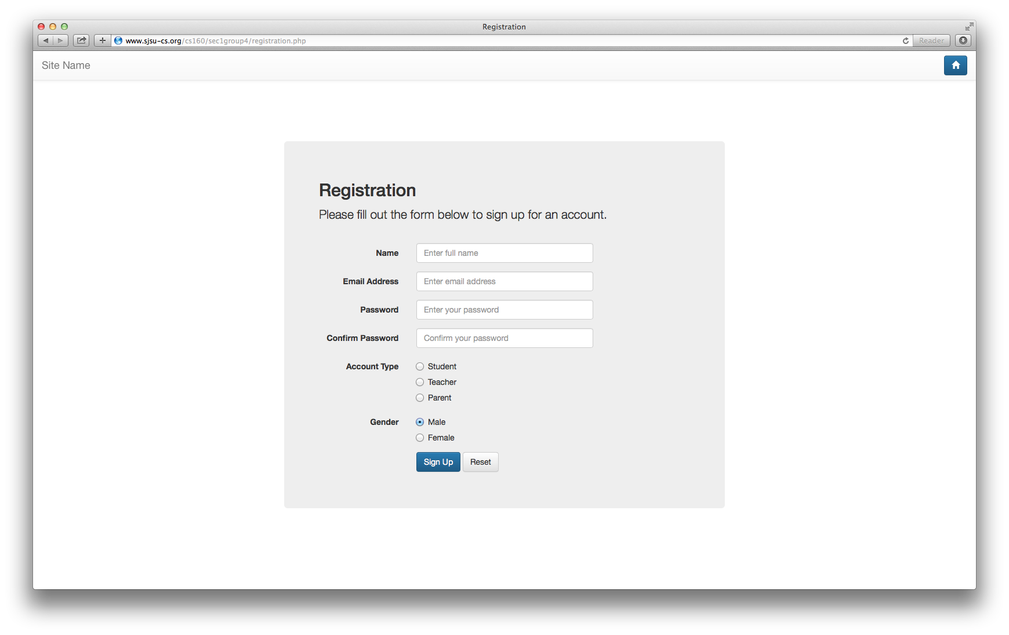

## Feature #2: Front Page Slider

The front page slider provides a preview of randomly picked topics. This feature assists users in finding new materials to learn. It is user-friendly and attractive.

**Describe how you accomplish each implemented feature with open source code or your own code.**

Similar to our overall design, the front page slider is implemented using Bootstrap framework.

* We used the bootstrap carousel element to render our slider.
* In order to render the data, we used PHP to query the database for randomly picked materials.
* For consistency, we only select materials with a lesson image.
* For better performance, we limit the number of materials to retrieve from our database. Everytime the page is loaded, another randomly selected set of materials will be retrieved.
* Images are clickable and it will redirect the user to the original site
* Query: SELECT * FROM education WHERE lesson_image != ‘’ LIMIT 25;
* Other technologies: PHP for MySQL access

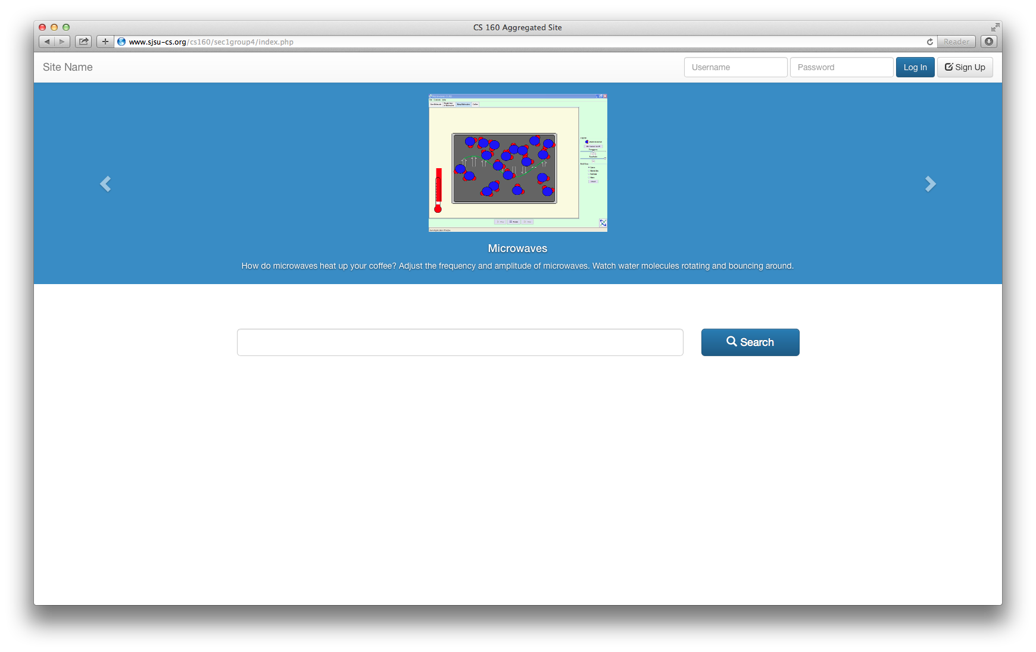

## Feature #3: Search / Results

Providing a simple interface, search module allows users to search for topics matching desired criteria. These criteria are defined by keywords, category, student grade and type.

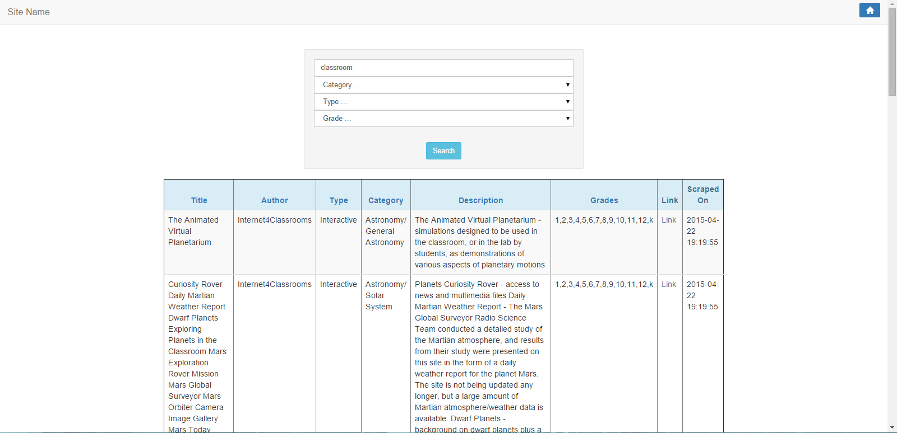

**Describe how you accomplish each implemented feature with open source code or your own code.**

* Based the user’s input, a query string is generated and appended to the url. Then, user will be redirected to the newly created link.
* On search page, the server parses the query string extracting query parameters and generates a SQL query accordingly.
  + Keyword: match using %<keyword>%
  + Category: match using %<category>%
  + Grade: match using %<grade>%
  + Type: exact match <content_type>
* The found entries are rendered as rows in a html table
* For better performance, indexes on category, content_type and student_grade are created.

** Note: since ‘category’ and ‘student_grade’ are stored as list format, LIKE / REGEXP statement is needed.

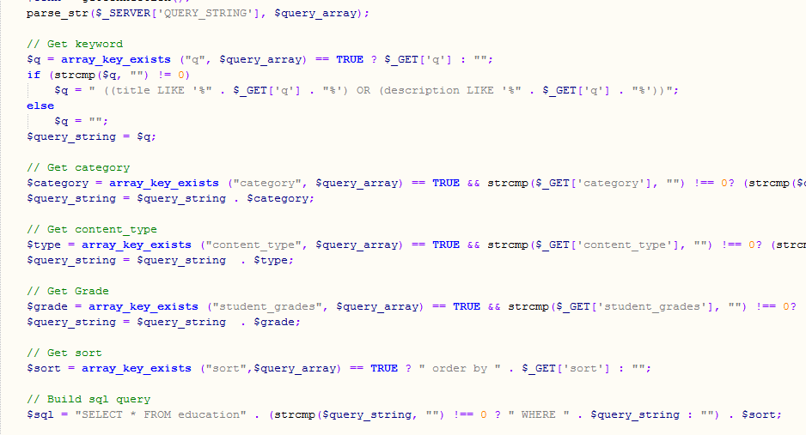

* When a single query parameter is changed, it will be replaced from the old url.

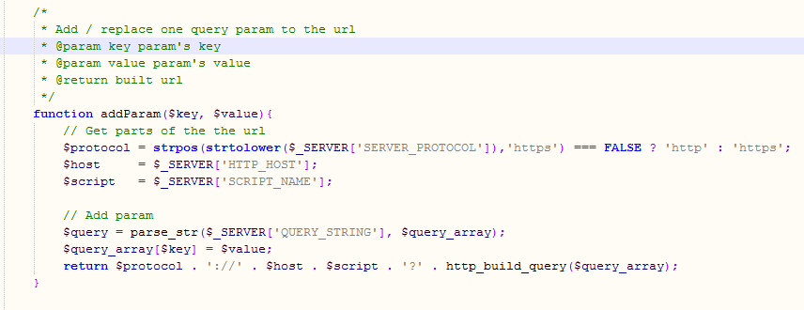

**Current Issue And Possible Solution**

* Irrelevant results might matched by keyword because keyword can be a part of bigger word (Ex: keyword ‘test’ will also match ‘contest’). **Solution:** matching words beginning with the keyword.
* There will be cases when there are too many entries are displayed at the same time. **Solution:** using pagination.

## Feature #4: Bookmarks (aka “Like” feature)

The bookmark feature is only for registered users only. If the user is registered they have access to a bookmark button on the search results. Users can click the bookmark button to add the lesson to their bookmark tab which is located on the home page. This allows users to quickly access their interested lessons quickly. Users can also remove the lesson from the bookmark if the desire so.

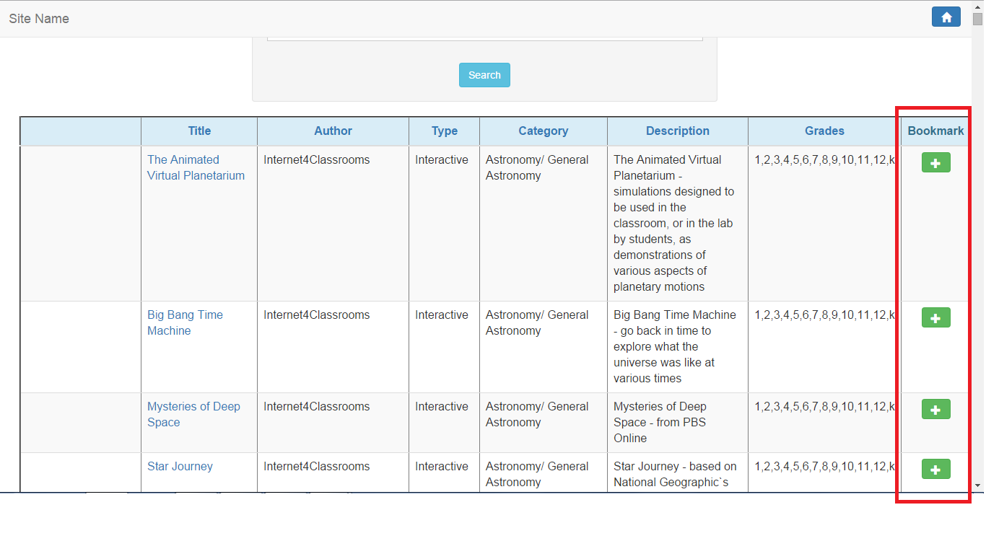

* The Bookmark column shows for logged in users

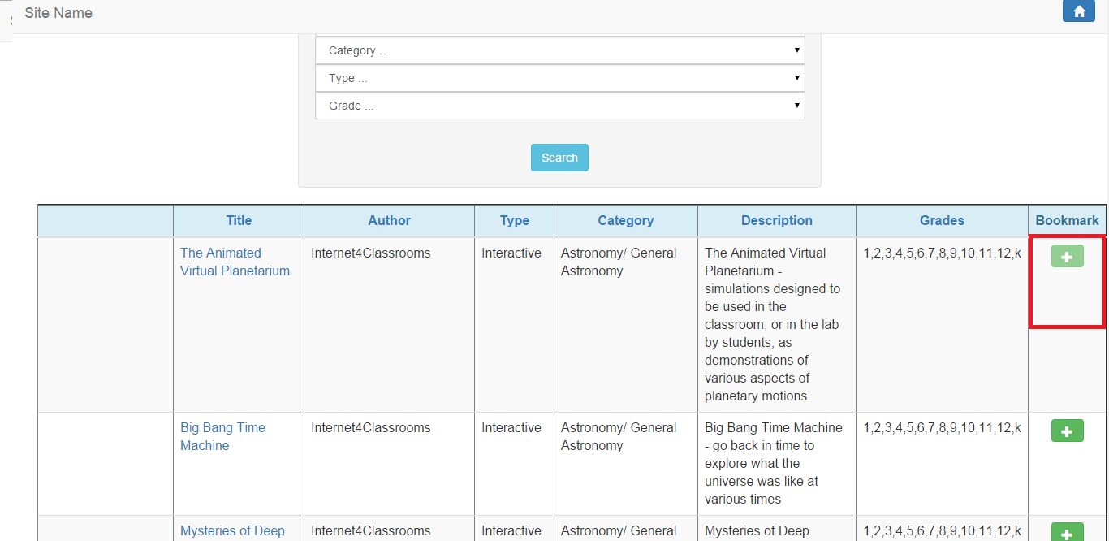

* After the button is clicked it becomes unclickable

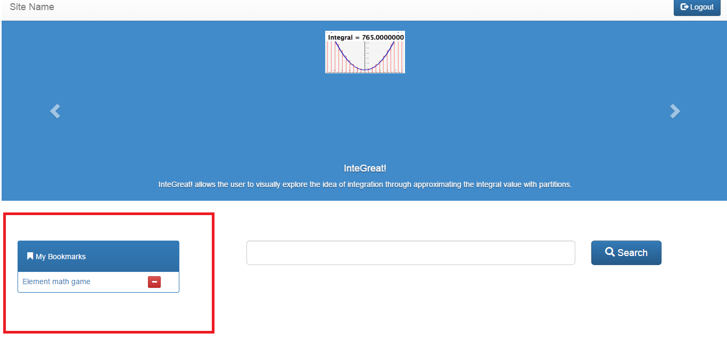

* Bookmark gets added to the My Bookmarks tab

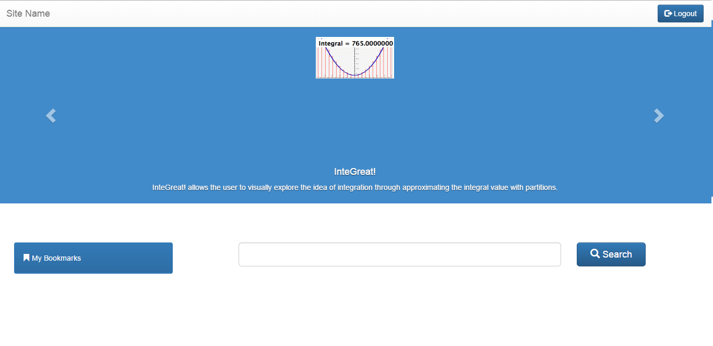

* By clicking the red “-” button, users can remove bookmarks from their My Bookmarks tab

* Technology Used:
  + PHP
    - To render HTML
    - To access our MySQL database
  + jQuery
    - Used AJAX POST to call PHP scripts
  + Bootstrap
    - To create Bookmark panel and table

# Merge Data

Remove duplicated lessons while you combine the data scraped from these 4 websites. Describe how you detect and remove duplicated lesson entries in your report.

First of all, we got all of the four tables merged into one master table with over 1000 rows,

then we run a SQL statement to get rid of all duplicate rows with the same lesson_link values

DELETE e1 FROM education e1

JOIN education e2 ON e1.lesson_link = e2.lesson_link

WHERE e1.id > e2.id

# 

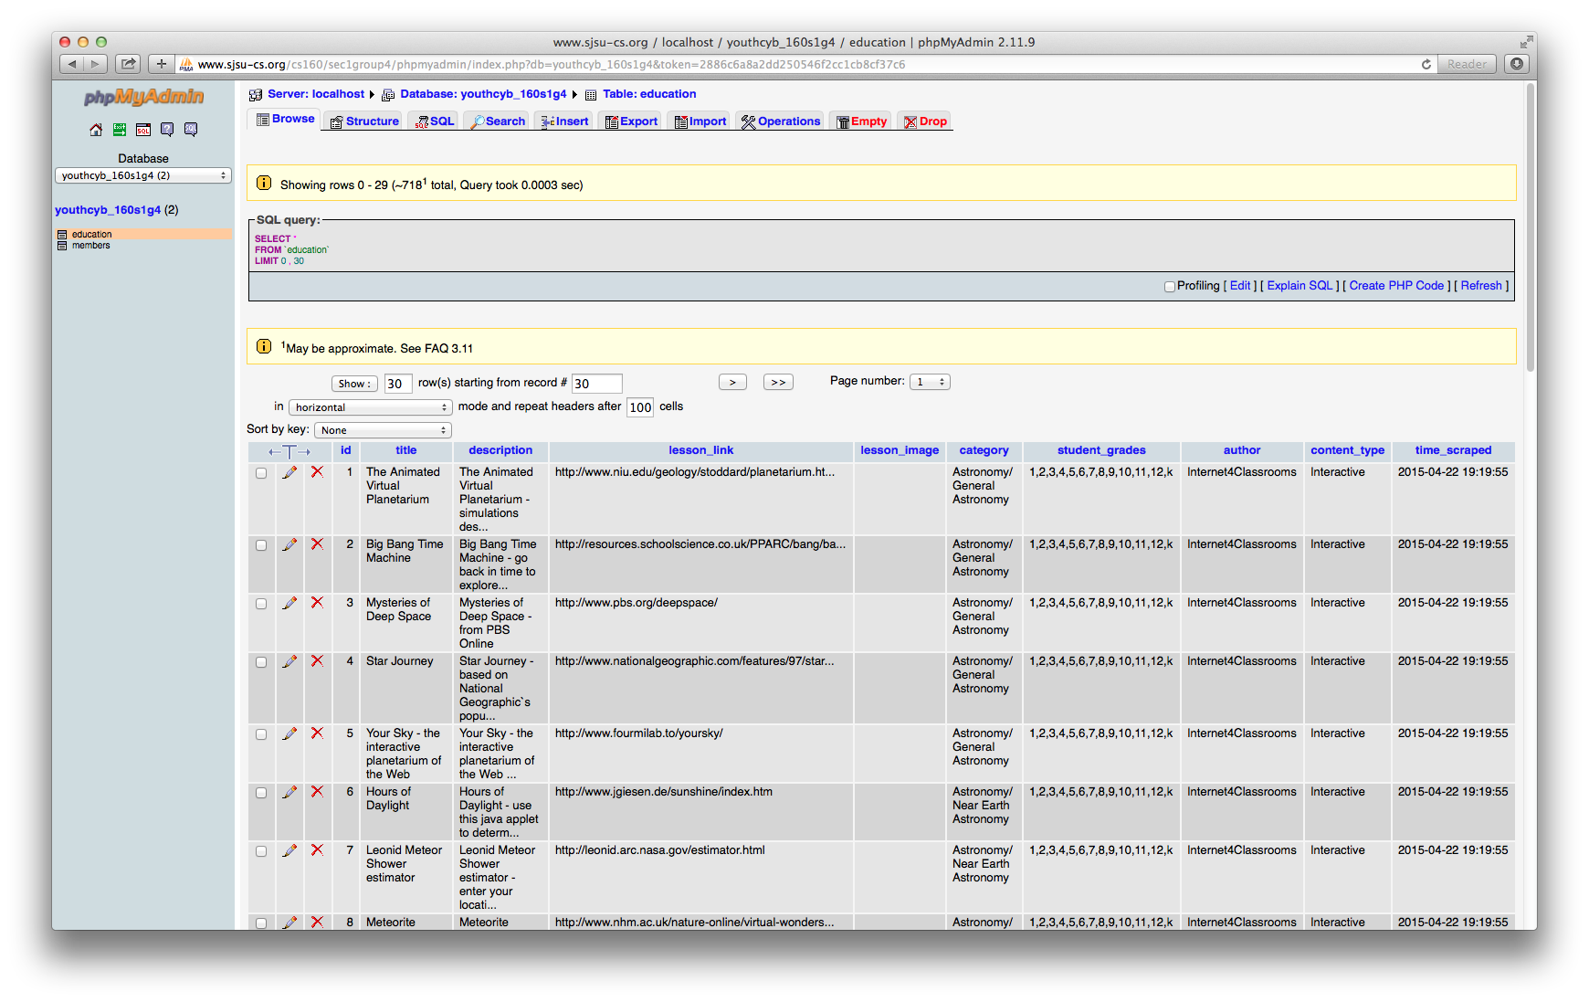

# Behavior Modeling

## Overall Design

The overall design of the website is very simple yet fulfilling to users needs. We have a main page with Login and Register feature up in right corner. We have slider in middle which picks random 20 interactive lesson and displays it to user with their title and part of description. we also have search bar located on main page for ease of users to search for particular lessons. All of the feature above is available to both registered and non registered users. A registered user have one extra feature which is bookmark lessons. A register user when search is taken to result page where they have options to save particular lessons. These lessons are stored on the database and showcased on main page when user logs in, so they can easily start off where they ended.

## Sequence Diagram

# Revised Specs

Revised site map to capture the overall design for the implemented features. Figure 1 shows the workflow for general users. Figure 2 shows the workflow for a registered user.

Key:

* Solid borders = Web page
* Normal borders = Actions
* Dotted borders = Embedded elements

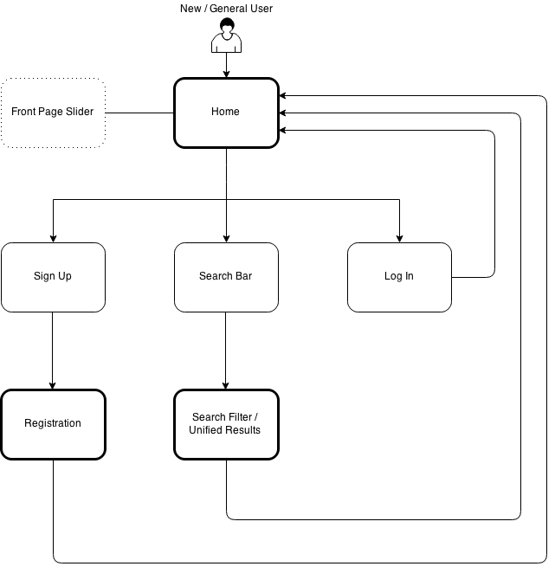

**Figure 1.** General user sitemap and flow

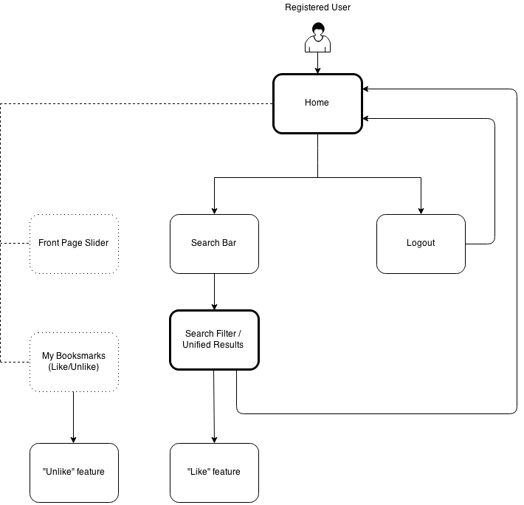

**Figure 2.** Registered user sitemap and flow.