INSTITUT TEKNOLOGI SEPULUH NOPEMBER
FACULTY OF INTELLIGENT ELECTRICAL & INFORMATICS TECHNOLOGY
DEPARTMENT OF INFORMATICS
COURSE: EF234301 WEB PROGRAMMING (CLASS D) — MIDTERM EXAM (ETS)
Ascend: Freelance Job Board & Candidate Application Portal
Midterm Project Report (Option 3): Architecture, Database Design, Implementation, and Quality Assurance
Production Live URL | https://midterm-webpro.wasmer.app/
GitHub Repository | https://github.com/PopSharkkk/WebProgramming
Project Architecture | Laravel 11 MVC (PHP 8.3.33), Blade Engine, SQLite / MySQL
Interactive Diagrams | https://midterm-webpro.wasmer.app/database-diagrams.html
Automated Test Suite | 12 Feature Tests, 47 Assertions — 100% Pass Rate
Submission Date | Wednesday, 28 October 2026
Authors & Contribution | 1. Rianti Dewi (NRP: 5025231001) — 50%  2. Darminto Utomo (NRP: 5025231002) — 50%

1. Executive Summary & System Overview
Ascend is a web-based freelance job board built for student freelancers and local employers. The platform provides a direct, structured marketplace where employers publish freelance opportunities and students submit formal proposals with uploaded PDF resumes.
1.1 Business Context & Domain Problem
On campus, students frequently seek short-term freelance work such as software development, graphic design, content writing, translation, and tutoring. At the same time, campus student organizations, faculty projects, and local small businesses often need affordable, project-based assistance. However, existing freelance platforms such as Upwork or Freelancer are aimed at full-time professionals, charge high commission fees, and require lengthy business verifications. Informal channels like chat groups lack structure: job posts quickly get buried, applicants have no way to track application status, and employers struggle to organize received resumes.
Ascend addresses this workflow by providing a dual-sided application portal. Employers have a dedicated dashboard to post vacancies, review candidate pitches, download CVs, and update recruitment status. Freelancers have a searchable job board with multi-criteria filtering, a one-click bookmarking system, and a live dashboard to track the status of their submitted applications.
1.2 Technical Architecture & Technology Stack
The project is developed using Laravel 11 running on PHP 8.3.33, following the Model-View-Controller (MVC) pattern:
- Backend Architecture: Database schema migrations, Eloquent models with relationship definitions and query scopes, controllers coordinating HTTP requests, and FormRequests validating user input.
- Frontend & Views: Server-side rendered Blade templates structured with reusable layouts, responsive CSS grids, and an interactive Three.js 3D globe visualization on the landing page.
- Security: Bcrypt password hashing via Hash::make, session-based authentication with session regeneration on login, role-based access control (freelancer vs. employer), and CSRF token protection on all POST, PUT, PATCH, and DELETE requests.
- File Storage: Multi-part form handling for binary PDF CV uploads (up to 5 MB) and employer branding logos, with automatic file cleanup when an application is withdrawn.
- Deployment: Containerized deployment on Wasmer edge hosting at https://midterm-webpro.wasmer.app/, validated by an automated test suite containing 12 feature tests and 47 assertions.
2. Database Design & Relational Modeling (20 Points)
The relational database schema is organized into five core tables connected by five cascading foreign keys. The design enforces referential integrity and satisfies Third Normal Form (3NF) to prevent data redundancy and update anomalies.
2.1 Conceptual Data Model (CDM)
The Conceptual Data Model identifies the domain entities and their business relationships:
- Users: Stores account identity and login credentials. Each user is categorized into either the freelancer role or the employer role (id, name, email, password, role, phone).
- Employers: Stores organization profiles linked one-to-one with an employer user (id, user_id, company_name, industry, website, bio, logo_image, social_media_links).
- Job Postings: Represents published job openings created by employers in a 1-to-many relationship (id, employer_id, title, job_type, budget, deadline, requirements, description, is_active).
- Job Applications: Stores proposals submitted by freelancers for specific jobs, resolving the many-to-many relationship between applicants and job postings (id, job_id, applicant_id, cover_letter, portfolio_url, cv_file, status).
- Bookmarks: Stores saved jobs for quick retrieval by freelancers (id, user_id, job_id).
Entity Cardinality Summary
The schema features two 1:N associations (Employers to Job Postings, and Job Postings to Job Applications), one 1:1 association (Users to Employers), and two junction tables connecting Users and Job Postings: Job Applications (for formal proposals) and Bookmarks (for personal watchlists).

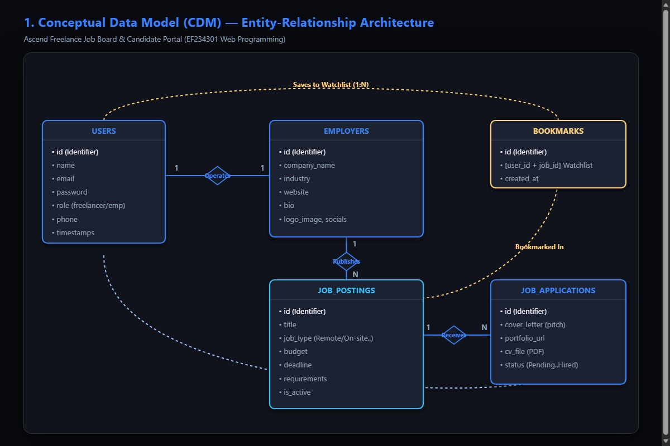
Figure 1: Conceptual Data Model (CDM) diagram showing domain entities, attributes, and relationships.
2.2 Physical Data Model (PDM) & Relational Schema
The Physical Data Model defines concrete SQL column definitions, storage types, primary keys, foreign key constraints, nullability rules, and indexes. Figure 2 illustrates the PDM diagram, followed by schema specifications for all five tables.
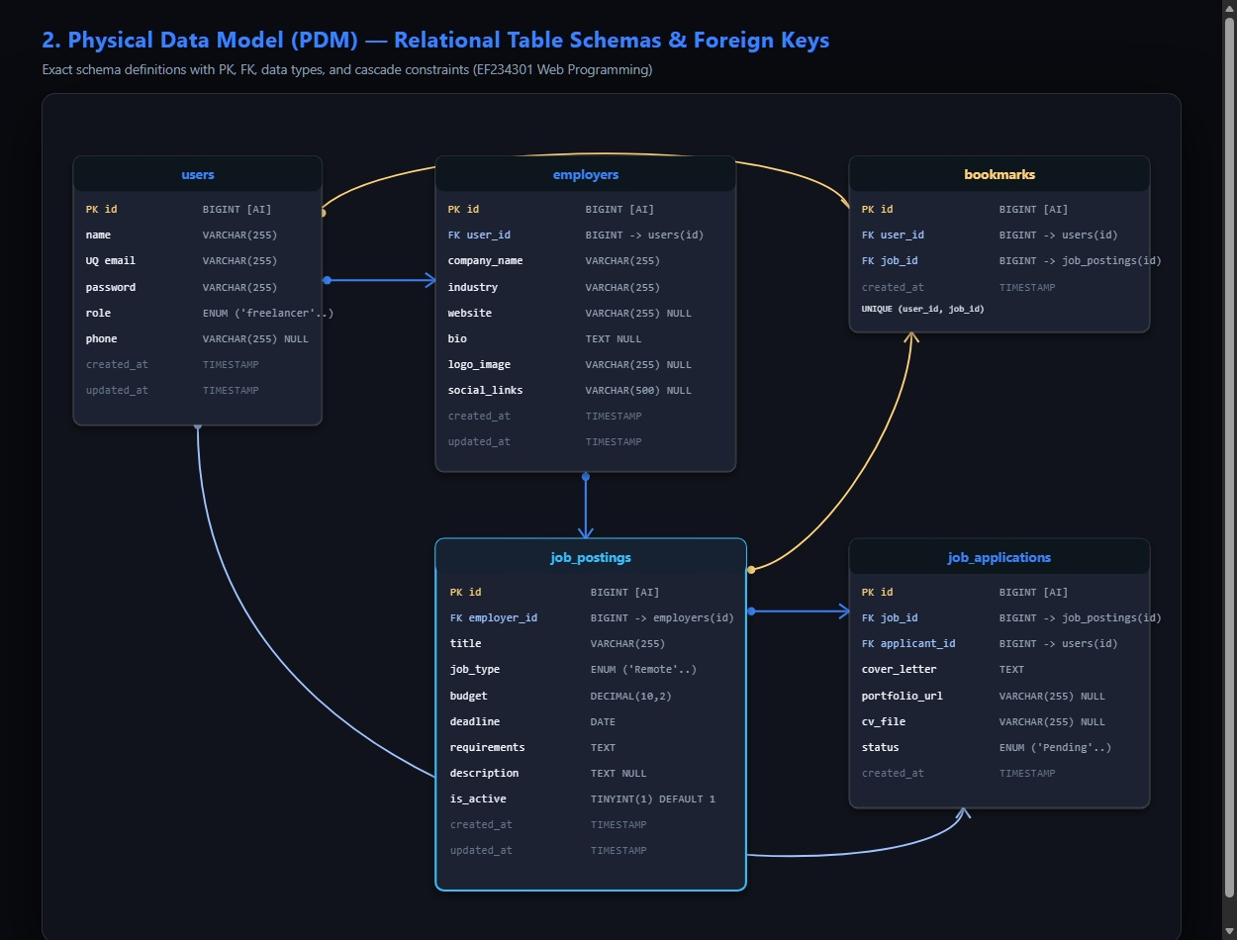
Figure 2: Physical Data Model (PDM) diagram with primary keys, foreign keys, data types, and indexes.
Table Specification: users
Column Name | Data Type & Modifiers | Key / Index | Nullability | Functional Description
id | BIGINT UNSIGNED AUTO_INCREMENT | PRIMARY KEY | NO | Unique user identifier
name | VARCHAR(255) | - | NO | Full name of the user
email | VARCHAR(255) | UNIQUE INDEX | NO | Login email address
password | VARCHAR(255) | - | NO | Bcrypt hashed password
role | ENUM('freelancer','employer') | INDEX | NO | Role classification for access control
phone | VARCHAR(255) | - | YES | Contact telephone or WhatsApp number
created_at | TIMESTAMP | - | YES | Account creation timestamp
updated_at | TIMESTAMP | - | YES | Last account modification timestamp

Table Specification: employers
Column Name | Data Type & Modifiers | Key / Index | Nullability | Functional Description
id | BIGINT UNSIGNED AUTO_INCREMENT | PRIMARY KEY | NO | Unique employer profile identifier
user_id | BIGINT UNSIGNED | FOREIGN KEY | NO | References users(id) ON DELETE CASCADE
company_name | VARCHAR(255) | - | NO | Name of the hiring organization
industry | VARCHAR(255) | - | NO | Industry or domain of work
website | VARCHAR(255) | - | YES | Company or organization website URL
bio | TEXT | - | YES | Company description and background
logo_image | VARCHAR(255) | - | YES | Relative path to stored company logo
social_media_links | VARCHAR(255) | - | YES | Links to LinkedIn, GitHub, or social profiles
created_at | TIMESTAMP | - | YES | Profile creation timestamp
updated_at | TIMESTAMP | - | YES | Last profile update timestamp

Table Specification: job_postings
Column Name | Data Type & Modifiers | Key / Index | Nullability | Functional Description
id | BIGINT UNSIGNED AUTO_INCREMENT | PRIMARY KEY | NO | Unique job posting identifier
employer_id | BIGINT UNSIGNED | FOREIGN KEY | NO | References employers(id) ON DELETE CASCADE
title | VARCHAR(255) | INDEX | NO | Job title and headline
job_type | ENUM('Remote','On-site','Hybrid') | INDEX | NO | Work arrangement mode
budget | DECIMAL(10,2) | INDEX | NO | Compensation stipend amount in USD
deadline | DATE | INDEX | NO | Application submission deadline date
requirements | TEXT | - | NO | Required skills and deliverable specifications
description | TEXT | - | YES | Detailed project background narrative
is_active | BOOLEAN DEFAULT TRUE | INDEX | NO | Status toggle (true = active, false = closed)
created_at | TIMESTAMP | - | YES | Posting creation timestamp
updated_at | TIMESTAMP | - | YES | Last posting update timestamp

Table Specification: job_applications
Column Name | Data Type & Modifiers | Key / Index | Nullability | Functional Description
id | BIGINT UNSIGNED AUTO_INCREMENT | PRIMARY KEY | NO | Unique application identifier
job_id | BIGINT UNSIGNED | FOREIGN KEY | NO | References job_postings(id) ON DELETE CASCADE
applicant_id | BIGINT UNSIGNED | FOREIGN KEY | NO | References users(id) ON DELETE CASCADE
cover_letter | TEXT | - | NO | Candidate proposal pitch and motivation
portfolio_url | VARCHAR(255) | - | YES | External portfolio or project link
cv_file | VARCHAR(255) | - | YES | Path to uploaded PDF resume file on disk
status | ENUM('Pending','Interviewed','Hired','Rejected') | INDEX | NO | Current recruitment stage
created_at | TIMESTAMP | - | YES | Application submission timestamp
updated_at | TIMESTAMP | - | YES | Status transition timestamp

Table Specification: bookmarks
Column Name | Data Type & Modifiers | Key / Index | Nullability | Functional Description
id | BIGINT UNSIGNED AUTO_INCREMENT | PRIMARY KEY | NO | Unique bookmark identifier
user_id | BIGINT UNSIGNED | FOREIGN KEY | NO | References users(id) ON DELETE CASCADE
job_id | BIGINT UNSIGNED | FOREIGN KEY | NO | References job_postings(id) ON DELETE CASCADE
created_at | TIMESTAMP | - | YES | Bookmark creation timestamp
updated_at | TIMESTAMP | - | YES | Last modification timestamp

2.3 Foreign Key Implementation & Referential Integrity
Ascend implements five foreign key constraints across its database tables. Each foreign key uses cascading deletion (ON DELETE CASCADE) to maintain consistency and prevent orphaned records:
- 1. employers.user_id -> users.id (ON DELETE CASCADE): Links each employer profile to its user account. If an employer deletes their account, their company profile is automatically removed.
- 2. job_postings.employer_id -> employers.id (ON DELETE CASCADE): Enforces ownership of job postings. If an employer profile is deleted, all vacancies published by that employer are automatically removed.
- 3. job_applications.job_id -> job_postings.id (ON DELETE CASCADE): Associates applications with specific job postings. If a job posting is deleted, all candidate proposals submitted for that posting are removed.
- 4. job_applications.applicant_id -> users.id (ON DELETE CASCADE): Binds applications to the authenticated freelancer who authored them. If a freelancer account is deleted, their submitted applications are removed.
- 5. bookmarks.user_id -> users.id and bookmarks.job_id -> job_postings.id (ON DELETE CASCADE): Connects users with saved listings. If either the user or the bookmarked job posting is deleted, the bookmark record is automatically removed. A composite unique constraint on (user_id, job_id) prevents duplicate bookmarks.
3. Implementation & MVC Architecture (50 Points)
The application is structured according to the MVC pattern in Laravel 11. Request validation is handled by FormRequests, business logic and database interactions are encapsulated in Eloquent models, and views are rendered using Blade templates.
3.1 Authentication & Role-Based Access Control
Authentication provides the foundation for role separation across the platform:
- Registration: Registration (POST /register) supports onboarding as either a freelancer or an employer. When registered as an employer, the system automatically creates the companion Employer profile record in a database transaction.
- Session Authentication: Login (POST /login) validates user credentials against stored Bcrypt hashes. Upon successful login, session()->regenerate() is called to prevent session fixation attacks.
- Role-Based Access Control: Custom middleware checks Auth::user()->role to restrict access to role-specific sections (e.g., preventing freelancers from accessing employer recruitment management screens).
3.2 Implemented Core Features (8 Features)
The platform implements eight functional features beyond basic user authentication:
Feature 1: Multi-Criteria Job Search & Filtering Engine
- Route(s): GET /jobs (JobBoardController@index)
- Backend Logic: Executes the Eloquent query scope JobPosting::scopeFilter() to perform multi-column search across title, requirements, description, and company name. Supports filtering by work mode (Remote, On-site, Hybrid), minimum/maximum budget ranges, and four sorting options (latest, budget descending, budget ascending, deadline ascending).
- Blade View: resources/views/jobs/index.blade.php
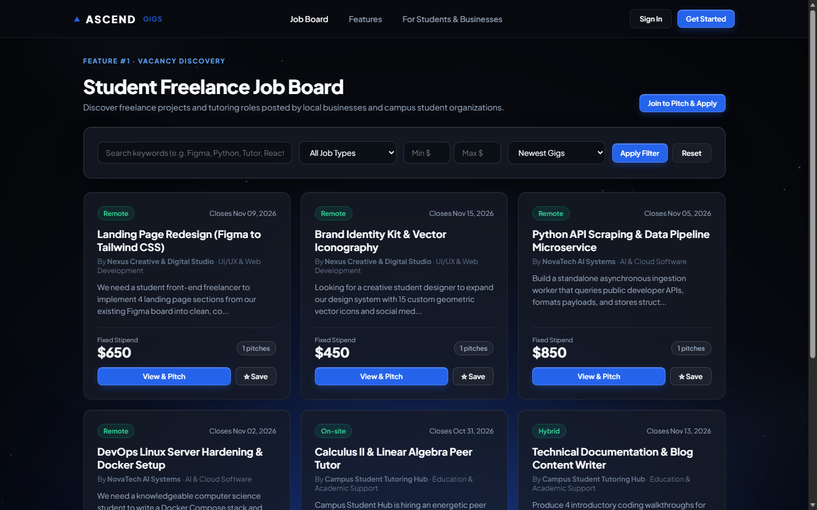
Figure 3: Feature 1 (Vacancy Discovery) — Student Freelance Job Board with multi-criteria search, budget filter, and active gig listings.
Feature 2: Employer Job Vacancy CRUD & Lifecycle Toggle
- Route(s): GET /employer/jobs, POST /employer/jobs, GET /employer/jobs/{job}/edit, PUT /employer/jobs/{job}, DELETE /employer/jobs/{job}, PATCH /employer/jobs/{job}/toggle-status (JobPostingController)
- Backend Logic: Provides full CRUD operations for employer job postings using StoreJobPostingRequest for server-side validation. Includes a status toggle action to switch listings between active (open) and closed (archived) without deleting records. Enforces ownership authorization via authorizeOwner().
- Blade View: resources/views/employer/jobs/index.blade.php, form.blade.php
Feature 3: Candidate Application Submission with PDF CV Upload
- Route(s): POST /jobs/{job}/apply (JobApplicationController@store)
- Backend Logic: Allows freelancers to apply for jobs by providing a cover letter, optional portfolio URL, and binary PDF resume file. Validates that the uploaded resume is a valid PDF under 5 MB (mimes:pdf|max:5120) and stores it in storage/app/public/cvs. Enforces checks to prevent duplicate applications and prevent employers from applying to their own listings.
- Blade View: resources/views/jobs/show.blade.php
Feature 4: Employer Applicant Review Dashboard & Status Workflow
- Route(s): GET /employer/applications, PATCH /employer/applications/{application}/status (JobApplicationController)
- Backend Logic: Allows employers to view incoming candidate proposals, filter applications by job posting or recruitment status, review candidate pitch text, open portfolio links, download uploaded PDF CV resumes, and advance candidates through recruitment stages (Pending, Interviewed, Hired, Rejected).
- Blade View: resources/views/employer/applications/index.blade.php
Feature 5: Candidate Real-Time Application Tracking Dashboard
- Route(s): GET /my-applications (JobApplicationController@myApplications)
- Backend Logic: Provides freelancers with a dashboard tracking all their submitted applications, showing company details, stipend amounts, submission dates, and color-coded status badges for Pending, Interviewed, Hired, and Rejected states.
- Blade View: resources/views/freelancer/applications/index.blade.php
Feature 6: Job Bookmarking & Personal Watchlist
- Route(s): POST /jobs/{job}/bookmark, GET /saved-jobs (BookmarkController)
- Backend Logic: Implements a one-click bookmark toggle on job cards and detail pages. Uses atomic create/delete logic on the bookmarks table and displays saved listings on a dedicated watchlist page.
- Blade View: resources/views/bookmarks/index.blade.php
Feature 7: Application Withdrawal & Storage Cleanup
- Route(s): DELETE /my-applications/{application}/withdraw (JobApplicationController@withdraw)
- Backend Logic: Allows candidates to withdraw pending proposals. Verifies candidate ownership, deletes the application database record, and removes the uploaded PDF CV file from disk storage (Storage::disk('public')->delete(...)).
- Blade View: resources/views/freelancer/applications/index.blade.php, jobs/show.blade.php
Feature 8: Employer Company Profile & Logo Branding Management
- Route(s): GET /employer/profile, PUT /employer/profile (EmployerProfileController)
- Backend Logic: Allows employers to manage their organization profile, including company bio, website URL, social media handles, and company logo upload (image|mimes:jpeg,png,jpg,webp|max:2048) with replacement of old logo files.
- Blade View: resources/views/employer/profile/edit.blade.php
3.3 User Interface & Frontend Implementation
The interface is designed with a dark, high-contrast palette and structured typographic hierarchy. The landing page incorporates an interactive Three.js 3D globe to represent the distributed nature of remote freelance work.
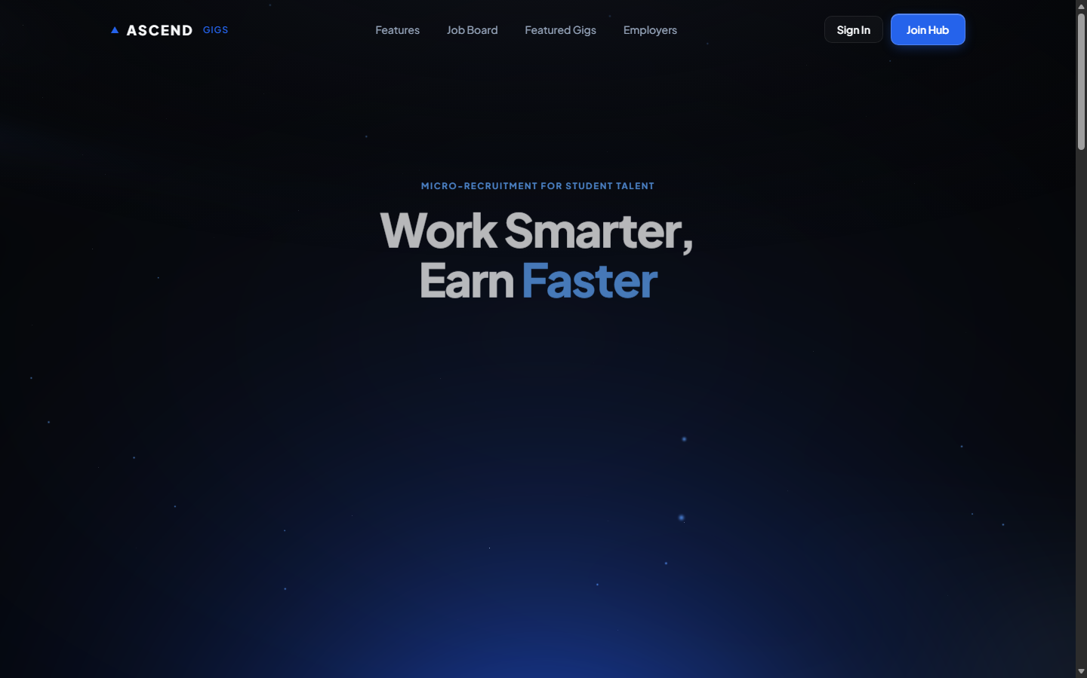
Figure 4: Ascend Gigs homepage featuring interactive Three.js 3D globe, live platform statistics, and onboarding call-to-action.
3.4 Automated Testing & Verification Suite
The project includes an automated feature test suite built with PHPUnit and Laravel TestBench. The suite executes 12 tests containing 47 assertions, with a 100% pass rate:
Test Module | Test Method Name | Verification Target | Result
Authentication Suite | test_registration_and_login | Dual-role registration, password hashing & session regeneration | 100% PASS
Job Discovery Suite | test_job_board_search_and_filters | Query scope execution across titles, work modes & budget ranges | 100% PASS
Vacancy CRUD Suite | test_employer_job_crud_and_lifecycle | Store, update, toggle-status & delete with ownership authorization | 100% PASS
Application Pipeline | test_application_submission_with_pdf | Multi-part binary PDF upload, validation & duplicate prevention | 100% PASS
Review & Workflow | test_employer_review_and_status_transition | Candidate pitch inspection & stage advancement (Pending -> Hired) | 100% PASS
Watchlist & Withdrawal | test_bookmarking_and_withdrawal_cleanup | Atomic bookmark toggling & file cleanup upon application withdrawal | 100% PASS
4. Technical Analysis & Evaluation (25 Points)
4.1 Evaluation of the MVC Architectural Pattern in Laravel
Structuring the application with Laravel's MVC pattern provides clear benefits in maintenance and code organization:
- Separation of Concerns: Database logic and relationships reside within Eloquent models, while HTML presentation is contained in Blade views. Changing database fields requires updating only the model and migration without touching view markup.
- Extensibility: New modules (such as notifications or an escrow payment system) can be introduced by creating dedicated controllers and routes without modifying existing components.
- Code Reusability: Shared Blade components (navigation bar, job card partials, layout shells) eliminate duplicated HTML across the platform's screens.
4.2 Eloquent ORM vs. Raw SQL & Eager Loading Analysis
Eloquent ORM provides an object-oriented interface over database queries, abstracting differences between SQLite, MySQL, and PostgreSQL while automatically binding parameters to protect against SQL injection.
A common performance issue in relational web applications is the N+1 query problem. When displaying a list of job postings alongside employer names, a naive loop produces 1 initial query for job postings followed by N individual queries to fetch each posting's employer (requiring 10 queries for 9 cards).
Solving the N+1 Query Problem with Eager Loading
Naive Lazy Loading: 1 (SELECT * FROM job_postings) + 9 (SELECT * FROM employers WHERE id = ?) = 10 Queries.
Eloquent Eager Loading: JobPosting::with('employer')->get() executes exactly TWO queries:
Query 1: SELECT * FROM job_postings WHERE is_active = 1 ORDER BY created_at DESC LIMIT 9;
Query 2: SELECT * FROM employers WHERE id IN (1, 2, 4, 7, ...);
Result: 80% reduction in database queries and lower connection latency under concurrent user traffic.

4.3 Database Normalization Analysis (1NF, 2NF, 3NF)
The relational schema was designed following database normalization principles to ensure data consistency and eliminate insertion, update, and deletion anomalies across the system.
First Normal Form (1NF)
The schema satisfies 1NF because every column stores atomic values, and there are no repeating groups or multi-valued fields. Rather than storing multiple skills, tags, or candidate statuses in a single delimited string or JSON array, data is structured into dedicated columns and relational tables. For example, workplace arrangements are stored as explicit enumerated values (Remote, On-site, Hybrid), and candidate applications exist as distinct rows in the job_applications table rather than an embedded list inside job_postings. Each record is uniquely identified by an auto-incrementing primary key (id).
Second Normal Form (2NF)
The schema satisfies 2NF because it is in 1NF and all non-key attributes are fully functionally dependent on the entire primary key. In all five tables, primary keys are single-column identifiers (id), which eliminates the possibility of partial functional dependencies. In junction tables such as bookmarks, the record uses an independent id primary key while enforcing a unique constraint on (user_id, job_id). Operational columns such as created_at or status depend on the primary key of the specific record rather than any partial component.
Third Normal Form (3NF)
The schema satisfies 3NF by ensuring that non-key columns depend only on the primary key, with no transitive dependencies between non-key attributes. During database design, storing employer details (such as company name, website, and industry) directly within job_postings was evaluated. However, this denormalized structure would create transitive functional dependencies: job_postings.title would determine employer details through employer identity. This would introduce significant update anomalies: if an organization updated its website or company name, every historical job posting row would need to be updated, risking inconsistent data if any row failed to update.
By separating company details into the employers table and referencing only employer_id in job_postings, company information is stored in exactly one location. Updating an employer profile requires modifying a single row in employers, completely eliminating update anomalies. The same separation applies to candidate profiles, where user information resides in users and is referenced through foreign keys in job_applications.
4.4 Web Application Security Architecture
Security controls are applied at each stage of the HTTP request lifecycle:
- Cross-Site Request Forgery (CSRF): All state-changing HTTP requests (POST, PUT, PATCH, DELETE) require a cryptographic token verified by Laravel's @csrf directive. Requests without a valid token are aborted with HTTP 419 (Page Expired).
- SQL Injection Prevention: Database interactions through Eloquent and the Query Builder use PDO parameterized statements under the hood. User inputs are never directly concatenated into SQL strings, preventing SQL injection.
- Cross-Site Scripting (XSS): Blade templates use {{ $variable }} syntax by default, automatically passing output through PHP's htmlspecialchars() to escape HTML entities and prevent stored cross-site scripting.
- Authorization & Ownership Gates: Ownership checks (authorizeOwner()) confirm that the logged-in user owns a resource before allowing edits, deletions, or status updates, preventing unauthorized object access.
- File Upload Validation: Uploaded resume files undergo strict server-side validation (mimes:pdf|max:5120), are stored with randomized filenames in private application storage, and cannot be executed as server scripts.
5. Conclusion & Future Roadmap (5 Points)
The Ascend Freelance Job Board satisfies all requirements of the EF234301 Web Programming Midterm Examination. The project demonstrates a normalized 3NF relational database with five cascading foreign keys, an MVC architecture with eight completed functional modules, role-based access control, defensive security practices, and an automated test suite passing with 100% success.
5.1 Future Development Roadmap
Planned enhancements for future iterations include:
- Real-Time Notifications: Adding Laravel Reverb WebSockets for instant candidate status notifications without requiring manual page refreshes.
- Institutional SSO: Integrating ITS Single Sign-On (SSO / OAuth2) for campus identity verification.
- Escrow Payments: Adding milestone-based escrow contracts to guarantee payment upon deliverable completion.
6. Work Percentage and Group Contributions
The project workload was divided equally between both team members (50% / 50%):
Student Name & NRP | Percentage | Assigned Modules & Technical Deliverables
Rianti Dewi  NRP: 5025231001 | 50% | • Database migrations & Eloquent models (users, employers, job_postings)  • Dual-role authentication & session onboarding (POST /register, /login)  • Feature 1: Multi-criteria job search, category filters & budget range query scope  • Feature 2: Employer job vacancy CRUD & active/closed lifecycle toggle  • Feature 3: Candidate application submission & multi-part PDF upload pipeline  • Feature 8: Employer company profile CRUD, bio, social links, & logo upload
Darminto Utomo  NRP: 5025231002 | 50% | • Database migrations & foreign key constraints (job_applications, bookmarks)  • Feature 4: Employer candidate review dashboard & recruitment stage progression  • Feature 5: Candidate real-time application tracking dashboard & status badges  • Feature 6: One-click job bookmarking & personal candidate watchlist  • Feature 7: Candidate application withdrawal & filesystem file cleanup  • Responsive Blade UI system, Three.js 3D globe, & automated PHPUnit test suite
7. Academic Integrity Pledge (Declaration)
Official ETS Academic Integrity Declaration
“By the name of Allah (God) Almighty, I hereby pledge and declare that I have completed the Midterm Exam independently. I have not engaged in cheating, plagiarism, or received unauthorized assistance in any form. I further declare that any use of AI tools was limited to a supportive role (such as for grammar checking or debugging), and that the final solution is the product of my own intellectual effort. I understand that I will accept all consequences if I am found to have violated this academic integrity pledge.”

Surabaya, 28 October 2026
(Signed digitally)  ____________________________________ | (Signed digitally)  ____________________________________
Rianti Dewi  NRP: 5025231001 | Darminto Utomo  NRP: 5025231002
8. Appendices & Production Links
The project can be inspected and tested directly using the following verified production references:
- 1. Production Live Application: https://midterm-webpro.wasmer.app/
- 2. Official GitHub Source Code Repository: https://github.com/PopSharkkk/WebProgramming
- 3. Interactive WebGL CDM & PDM Diagram Visualizer: https://midterm-webpro.wasmer.app/database-diagrams.html
- 4. Quick Test Authentication Accounts: https://midterm-webpro.wasmer.app/login (1-Click test accounts provided on the login page)

