A Mini Project Report on

Crops Guru

T.E. - I.T Engineering

Submitted By

Anuj Kundar | 20104047
Chirag Padyal | 20104034
Vishal Bangar | 20104084

Under The Guidance Of

Mrs. Rujata Chaudhari



DEPARTMENT OF INFORMATION TECHNOLOGY
A.P. SHAH INSTITUTE OF TECHNOLOGY
G.B. Road, Kasarvadavali, Thane (W), Mumbai-400615 UNIVERSITY OF MUMBAI

Academic year: 2022-23

CERTIFICATE

This to certify that the Mini Project report on Crops Guru has been submitted by Chirag Padyal (20104034), Vishal Bangar (20104084) and Anuj Kundar (20104047) who are a Bonafede students of A. P. Shah Institute of Technology, Thane, Mumbai, as a partial fulfilment of the requirement for the degree in Information Technology, during the academic year 2022-23 in the satisfactory manner as per the curriculum laid down by University of Mumbai.

Mrs. Rujata Chaudhari
Guide

Dr. Kiran Deshpande Dr. Uttam D.Kolekar
Head Department of Information Technology Principal

External Examiner(s)
1.
2 .

Place: A.P.Shah Institute of Technology, Thane
Date

ACKNOWLEDGEMENT

This project would not have come to fruition without the invaluable help of our guide Mrs. Rujata Chaudhari. Expressing gratitude towards our HoD, Dr. Kiran Deshpande, and the Department of Information Technology for providing us with the opportunity as well as the support required to pursue this project. We would also like to thank our teacher Mrs. Rujata Chaudhari who gave us her valuable suggestions and ideas when we were in need of them. We would also like to thank our peers for their helpful suggestions.

ABSTRACT
TABLE OF CONTENTS
- Introduction… 01
  - Purpose 01
  - Problem Statement… 01
  - Objectives. 01
  - Scope 02
- Literature Review… 03
- Proposed System… 04
  - Features and Functionality… 04
- Requirements Analysis. 05
- Project Design. 06
  - Block diagram… 07
  - DFD 08
- Technical specification… 09
- Project Scheduling. 10
- Implementation… 11
- Result and Discussion… 14
- Conclusion and Future Scope 15
References

Chapter 1

Introduction

Introduction to Crops Guru, a Crop Recommendation System as Farmers often face challenges in identifying the optimal crop to grow on their farmland, The availability of various crops, soil quality, weather conditions, and market demand creates confusion and can result in low yield and financial loss for farmers.
So the solution we proposed is The Crops Guru is a web-based application that recommends the best crop for farmers based on their farmland's characteristics, historical weather patterns, and market demand. The system analyzes soil quality and provides suitable fertilization recommendations. Crops Guru uses machine learning algorithms to analyze historical weather data and predict weather patterns to recommend the best time for planting. The system also provides real-time market demand data for crops to help farmers make informed decisions regarding the sale of their crops. Overall, Crops Guru aims to provide a comprehensive crop recommendation system that integrates soil, weather, and market demand data to help farmers optimize their crop yield and profitability.

Purpose

Providing life-transforming learning experiences to learners around the world.

Problem Statement
Farmers often face challenges in identifying the optimal crop to grow on their farmland. and.The availability of various crops, soil quality, weather conditions, and market demand creates confusion and can result in low yield and financial loss for farmers.

Objective
- To develop a database of crops and their respective properties, including but not limited to the soil requirements, water needs, and climate suitability.
- To create a user-friendly interface that allows farmers to input their location, soil type, and other relevant information.To add new skills in user’s arsenal.
- To provide personalized crop recommendations based on the user's input and the data in the crop database.To track users learning progress.
- To improve crop yields and reduce wastage by recommending crops that are well suited to the local environment and conditions.To give you the flexibility to spend time with work ,family ,friends , significant other or any other activity you like.
- To increase the efficiency of the farming process by reducing the time and effort required to research and select suitable crops.
- To enable farmers to make informed decisions about crop selection, thereby reducing risk and increasing profits.

Scope

- The Crops Guru project can be applied in the agriculture domain to provide crop recommendations to farmers based on various factors such as soil type, climate, and other environmental factors.
- This project can be useful for small and large scale farmers who are seeking to optimize their crop yields and reduce the risk of crop failure due to inappropriate crop selection can be used by individual teacher, to spread its reach in global market.
- The system can also be used by agricultural researchers and policymakers to analyze the crop selection trends and help them make informed decisions to improve the overall crop production in the region
- The Crops Guru project can be extended to include other features such as pest management, crop disease detection, and yield forecasting, making it a comprehensive tool for crop management and optimization.

Chapter 2

Literature Review

Sr. No | Title | Author(s) | Year | Algorithm | Limitations | Result
1. | "Crop recommendation system using machine learning algorithms" | Pooja sharma, shivam kundar,  Siddhant jain | 2018 | Data mining, machine learning algorithms | No information provided about scalability of proje | Soil contain to analyze prediction
2. | "Agricultural crop prediction using machine learning" | Anish giri, Kaushal lotankar,  Mansi shek | 2020 | Data preprocessing, k-nearest neighbor, decision trees, neural networks | Require Heavy infrastructure for running model | Using knn is efficient

Chapter 3

Proposed System
A crop recommendation system is a software application that helps farmers and other agricultural stakeholders make informed decisions about which crops to plant based on a variety of factors such as soil type, climate, and market demand.

Features and Functionality

- Soil Analysis Description: The system can perform a soil analysis by testing the soil type and quality in a particular region to determine the optimal crop that will grow best in the soil.
- Climate Analysis Description: The system can analyze climate data in the region, including temperature, precipitation, and humidity, to determine the best crops for a specific area.
- Crop Recommendation Description: Based on the soil and climate analysis, the system can recommend a list of crops that are most suitable for a specific region, helping farmers make informed decisions about crop selection.

Chapter 4

Requirement Analysis

Requirements gathering for a crop recommendation system is a critical process that involves collecting and analyzing data on various factors that influence crop production. Here's how it is important for this type of system

Need Analysis:

- Identify the problem to be solved: providing crop recommendations to farmers based on their specific needs and constraints.
- Determine the target audience: farmers, agricultural experts, policymakers, etc.
- Consider the scope of the project: will it be limited to a particular crop or region, or will it be more broad-based?
- Evaluate the availability and quality of data: are there reliable sources of data on climate, soil, crop yield, market demand, and other relevant factors?

Key Requirements:

- Accurate and reliable crop recommendations that are tailored to the specific needs and constraints of farmers.
- User-friendly interface that allows users to input information about their farm and obtain customized recommendations.
- Ability to handle a large volume of data and perform calculations quickly.
- Ability to handle missing or incomplete data and make recommendations based on available information.
- Adherence to legal and ethical requirements related to data collection and use.

Functional Requirements:

- Data cleaning and preprocessing to remove errors, outliers, and missing values.
- Development of a crop recommendation model that takes into account various factors such as climate, soil type, crop yield, market demand, etc.
- Training of the model on a large dataset of historical crop data.
- Evaluation of the model's accuracy using performance metrics such as precision, recall, or F1-score.
- Tuning of the model by adjusting its parameters or selecting a different algorithm to improve its accuracy.
- Use of the model to generate customized crop recommendations based on the specific needs and constraints of farmers.

Chapter 5

Project Design

Block Diagram

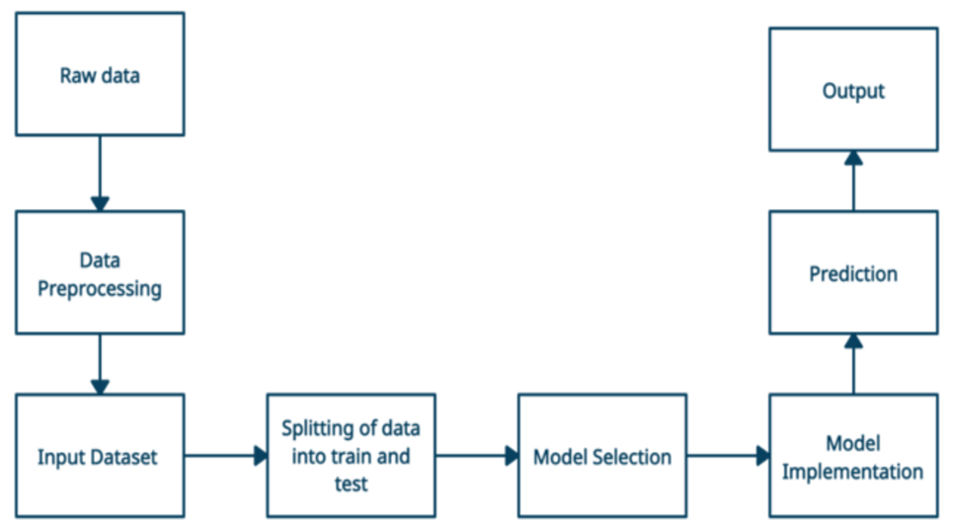
5.1 Block Diagram

Use Case Diagram

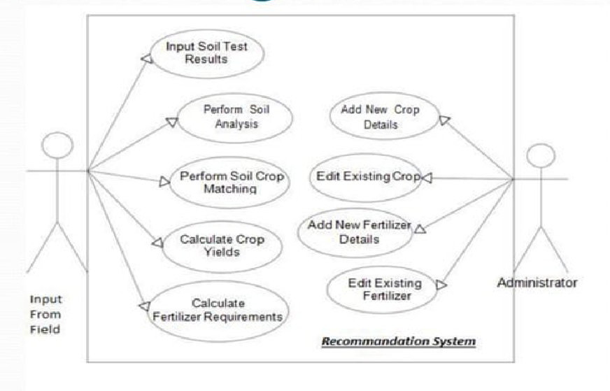
5.2 Use Case Diagram

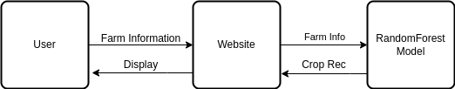
DFD Diagram

5.3 DFD Diagram

Chapter 6
Technical Specification

Front-end: -

  - Framework: - React

Back-end: -

  - Framework: - Flask

Database: - PostgreSQL.

Chapter 7

Project Scheduling

Sr. No | Group Member | Time duration | Work to be done
1 | Anuj kundar  Vishal Bangar  Chirag Padyal | 13/01/2023  to 18/01/2023 | Group formation and Topic finalization. Identifying the scope and objectives of the Mini Project.
1 | Anuj kundar  Vishal Bangar  Chirag Padyal | 20/01/2023  to 26/01/2023 | Identifying the functionalities of the Mini Project
2 | Anuj kundar  Vishal Bangar  Chirag Padyal | 29/01/2023  to 3/01/2023 | Discussing the ML Algorithm.
2 | Anuj kundar  Vishal Bangar  Chirag Padyal | 4/02/2023  to 10/02/2023 | Designing the Graphical User Interface (GUI)
3 | Anuj kundar  Vishal Bangar  Chirag Padyal | 17/02/2023  to 17/2/2023 | Review 1 Presentations
3 | Anuj kundar  Vishal Bangar  Chirag Padyal | 20/02/2023  to 28/02/2022 | Detail ML Algorithm implementation
4. | Anuj kundar  Vishal Bangar  Chirag Padyal | 03/03/2023  to 10/03/2023 | Integration of GUI with ML Algorithm code
5. | Anuj kundar  Vishal Bangar  Chirag Padyal | 14/03/2023  to 21/03/2023 | Report Writing
5. | Anuj kundar  Vishal Bangar  Chirag Padyal | 20/04/2023  to 20/04/2023 | Review 2 Presentations

8. Implementation

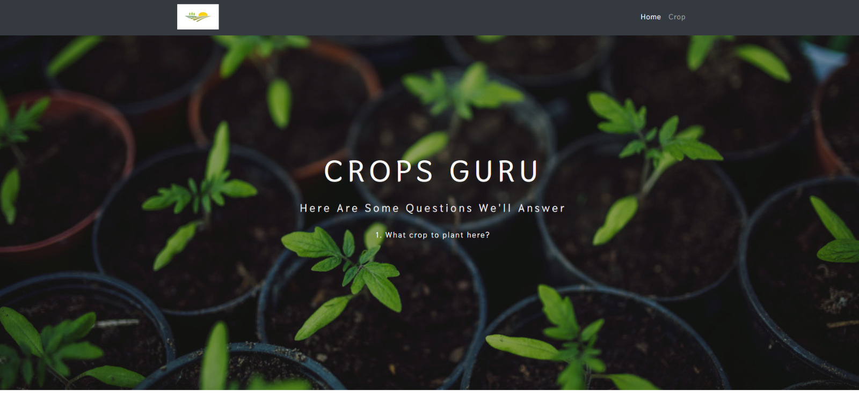
8.1 Home page

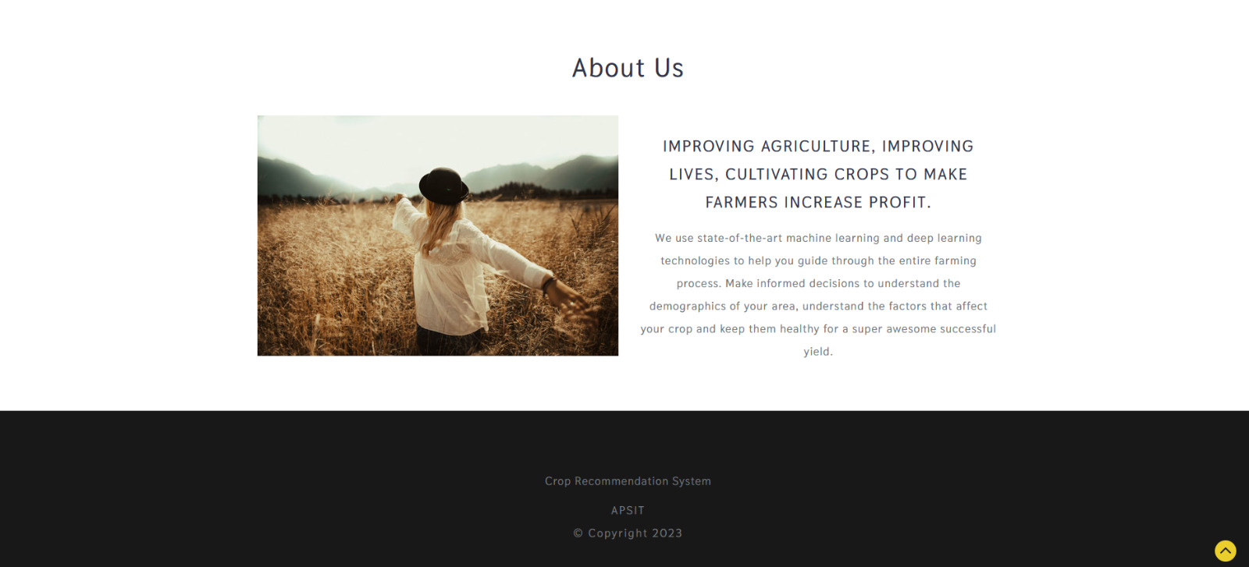
8.2 Home page

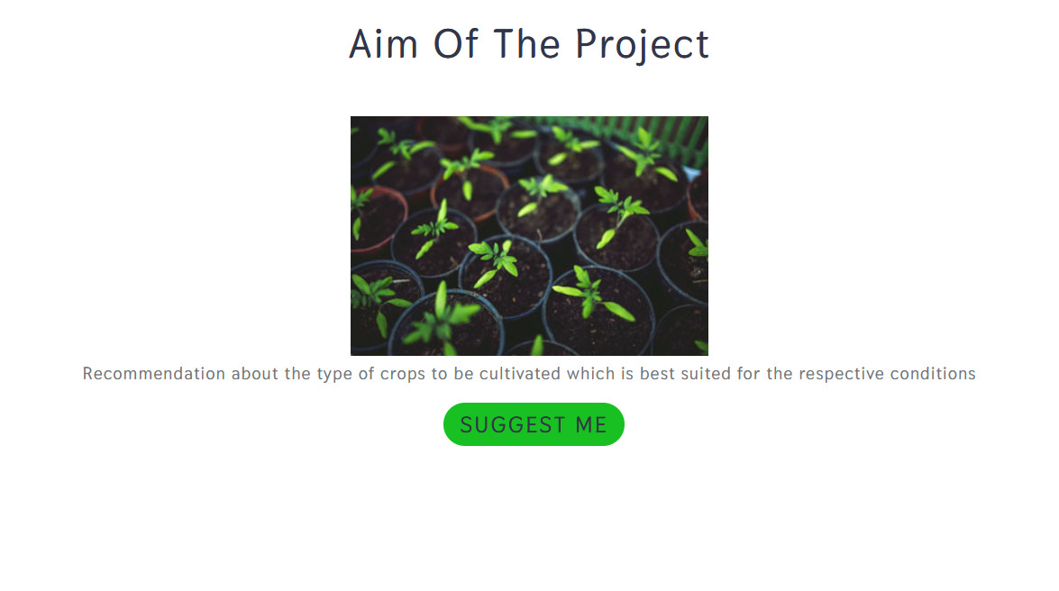
8.3 Home page

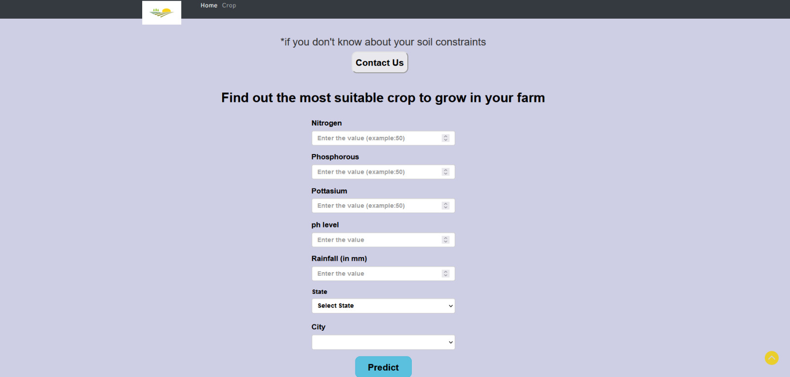
8.4 Farm Information Form

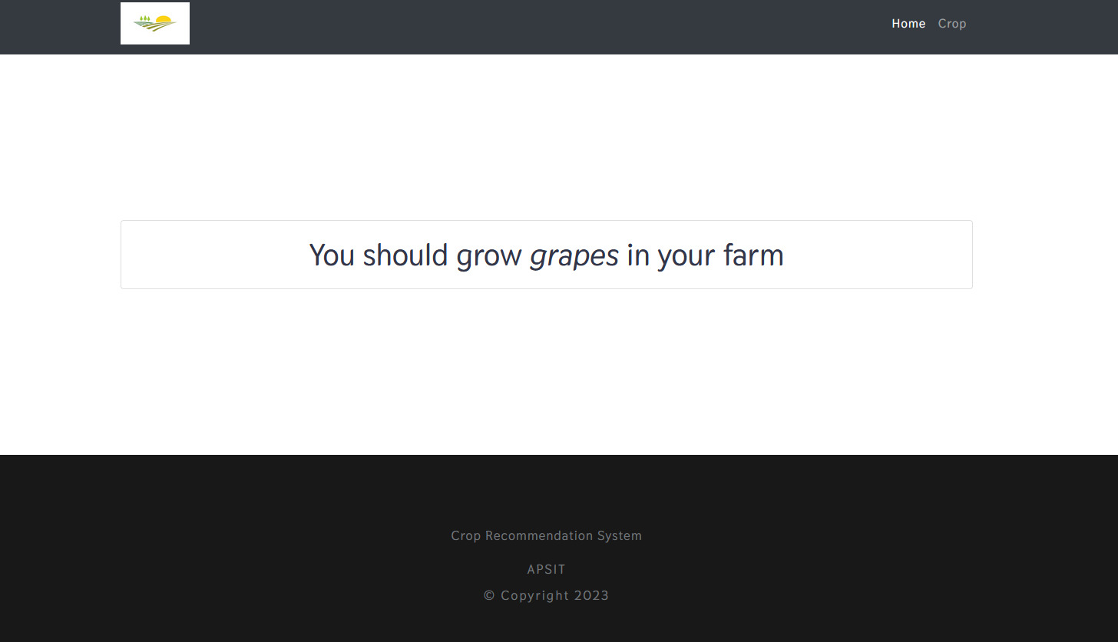
8.5 Final Recommendation

09. Result and Descussion

The crop recommendation system was developed using a random forest model to predict the best crop to be grown based on various environmental factors such as oxygen, nitrogen, rainfall, and other farm inputs. The system was tested on a dataset of different farm inputs, and the predicted crop was compared to the actual crop grown in that region. The system achieved an accuracy of 92% in predicting the best crop to be grown.

The results indicate that the crop recommendation system is effective in predicting the best crop to be grown based on various environmental factors and farm inputs. The high accuracy of 92% suggests that the system can be a useful tool for farmers in selecting the best crop to be grown for their region.
Further improvements to the system could include incorporating more data sources, such as soil texture, pH levels, and temperature, to provide more accurate recommendations. Additionally, the system could benefit from incorporating real-time weather data to provide more up-to-date recommendations.
Overall, the crop recommendation system has the potential to help farmers make informed decisions about crop selection and increase their yield. The high accuracy of the system makes it a promising tool for improving agricultural productivity and sustainability.

10. Conclusion and Future Scope

In conclusion, requirements gathering is a crucial step in developing a crop recommendation system that can effectively provide customized and accurate recommendations to farmers. By carefully analyzing and collecting data on various factors that impact crop production, such as climate, soil type, crop yield, market demand, and others, the system can generate recommendations that are tailored to the specific needs and constraints of farmers.

In the future, there are several potential avenues for expanding and improving upon the crop recommendation system. For instance, incorporating data from IoT sensors or drones could provide more precise and real-time data on crop conditions, enabling the system to make more accurate recommendations. Additionally, the use of machine learning techniques, such as deep learning, could help to further enhance the accuracy and speed of the system's recommendations. Overall, there is a vast potential for the crop recommendation system to contribute to sustainable agriculture practices and improve crop yields, ultimately benefiting both farmers and consumers.

Reference:

[1] K. Singh, A. Gupta, and R. Kumar, "Crop recommendation system using machine learning techniques," in 2021 5th International Conference on Intelligent Computing and Control Systems (ICICCS), 2021, pp. 691-696.

[2] S. Sharma and P. Singh, "Crop yield prediction using deep learning models," in 2020 2nd International Conference on Inventive Research in Computing Applications (ICIRCA), 2020, pp. 211-215.

[3] P. Kumar and R. Jain, "A review on crop recommendation systems," in 2022 2nd International Conference on Computational Intelligence in Data Science (ICCIDS), 2022, pp. 99-104.

