


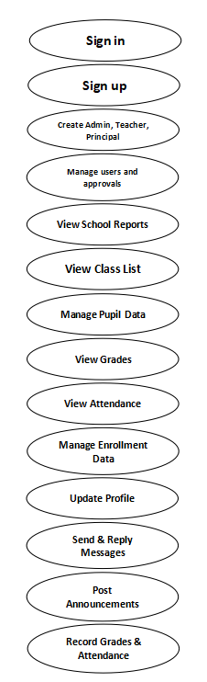

Principal
Admin




Pupil
Teacher
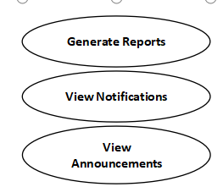

Sign in

Sign up

Create Admin, Teacher, Principal

Manage users and approvals

View School Reports

Generate Reports

View Notifications

View Announcements

Manage Enrollment Data

Update Profile

Send & Reply Messages

Post Announcements

ITS 403 - SECTION B
Capstone Title:

TUGAWE ELEMENTARY SCHOOL PUPIL MANAGEMENT SYSTEM
BY
BALDOMAR, NOIME T.
TRADIO, EJIR MAE S.
TUAYON, CRESTIAN B.

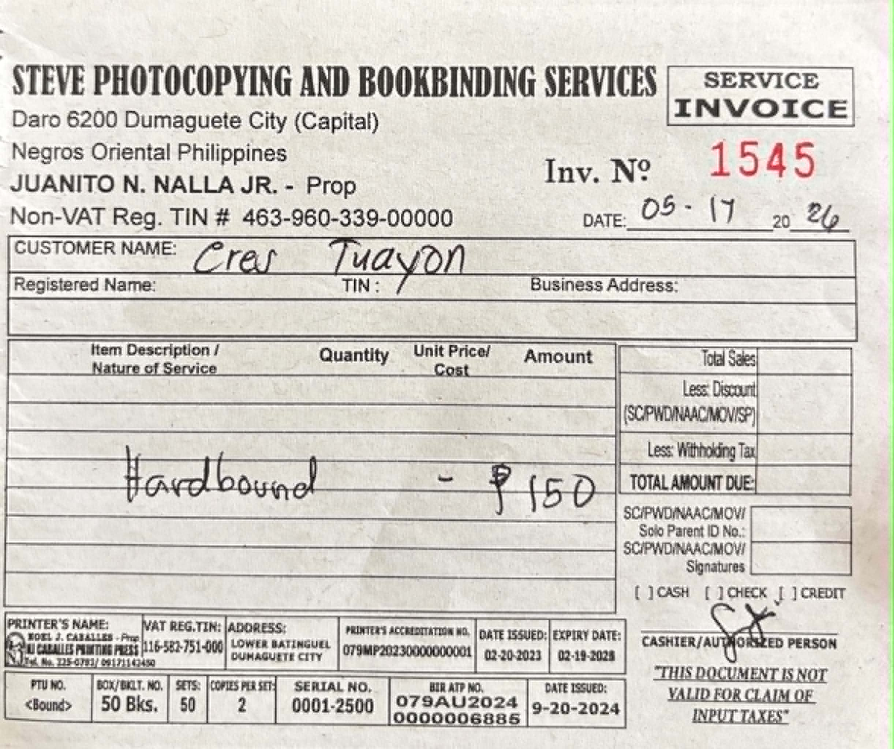

TUGAWE ES-PMS
TUGAWE ES-PMS

-

Mobile View Sign In (For all roles) & Registration Process (Pupil role only)

Dashboard Sidebar
Dashboard for Pupil
Praparing Dashboard…
Enter username & password
Click Sign In
Click Hamburger Icon
Enter URL
Open Browser
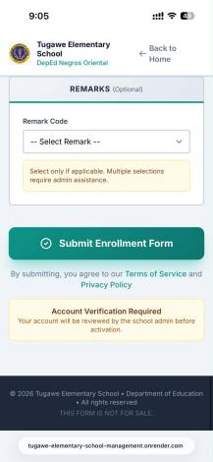

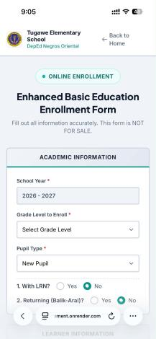

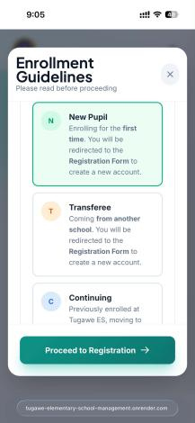
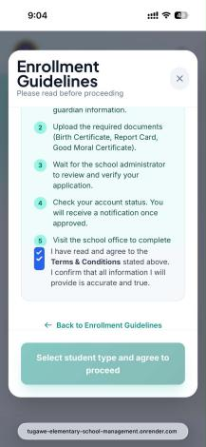
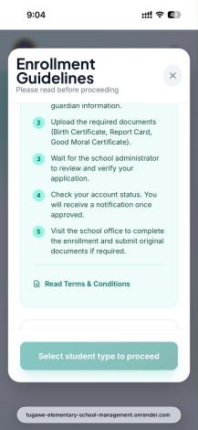
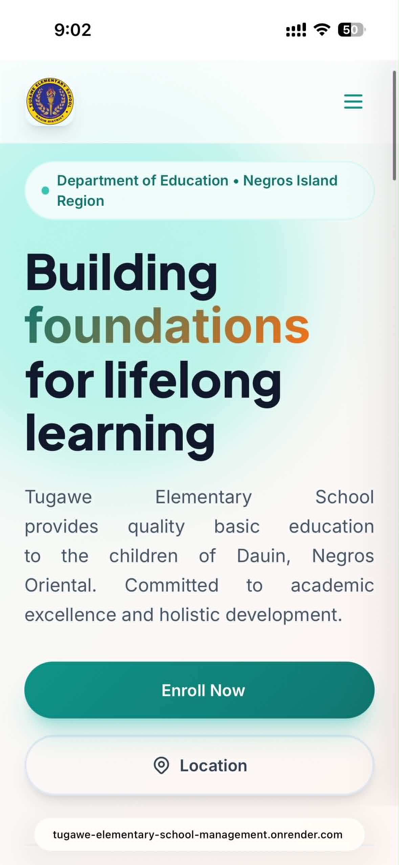
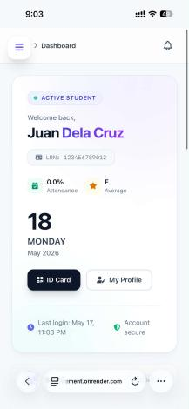

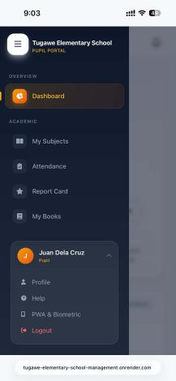

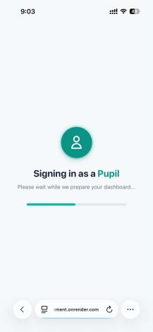

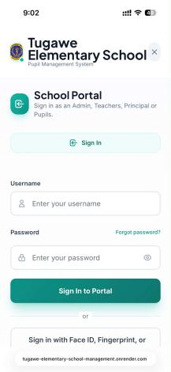
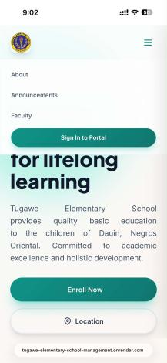




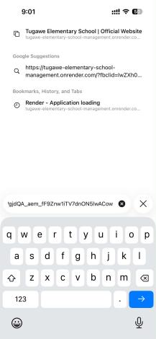
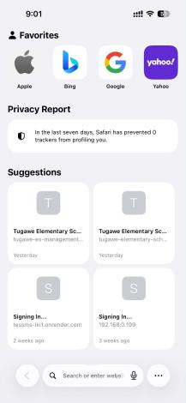






Select your Pupil Type
Registration Form, Fill out all required fields
Select your Pupil Type
Check the Terms & Conditions
Click Read Terms & Conditions
In Landing Page, click Enroll now to register

