Contents

Package medplot installation instructions 1

Prerequisites: 1

RAndFriends installation 1

Installation of medplot package 1

# Package medplot installation instructions

We will describe a typical installation of the *medplot* package. We hope it will work for you, as there seem to be some differences depending on which version of Excel you are using (2003, 2007, 2010).

## Prerequisites:

* MS Excel, 32 bit version, (versions 2003, 2007, 2010 should be supported; 64 bit versions are NOT supported)
* a working internet connection

## RAndFriends installation

Navigate to <http://rcom.univie.ac.at/download.html> and follow the instructions to download and run the RAndFriends installation package (several hundred megabytes in size, in case you have a slow connection, this will take a while). When following on screen instructions you can stick to the default options, in case of doubt. (*SWord* is actually not needed for medplot, but will be installed by default.)

## Installation of medplot package

Next you will install the medplot package, also via the R console. For the moment, only installation via GitHub is supported (CRAN installations are planned). Open your R console and proceed.

1. run:   
   install.packages("devtools")
2. You will need to download and install the Rtools package (not done via the R console). Use your web browser to navigate to the address:  
   <http://cran.r-project.org/bin/windows/Rtools/>
3. Download the latest available version of Rtools package (at time of writing Rtools216.exe). Remember where you saved it and then run it, to install Rtools. You can stick to the defaults, but not when asked about additional tasks - select both options when prompted:  
   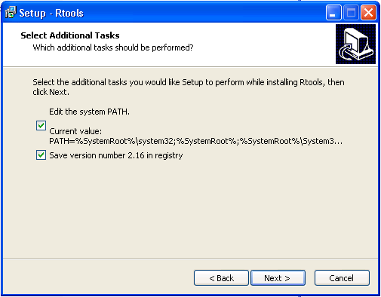   
   The option to edit the system PATH should be checked.
4. Restart windows after installing Rtools (because the system PATH needs to be reloaded at boot time).
5. From your R console, load devtools into library:  
   library(devtools)
6. Install the medplot package from GitHub:  
   install_github("medplot", username="crtahlin")  
   **Note:** If installation fails with an error mentioning the SVGAnnotation package, please check the note under step 6.
7. To check where your medplot package is installed, you can run the library() command from your R console, which will open a window with a list of library locations and names:   
   library()   
   These packages should be installed:

Cairo,

gplots,

RColorBrewer,

XML,

SVGAnnotation,

shiny,

scales,

reshape2,

ggplot2,

seriation,

medplot (This is our package; the others are needed for it to function. **Take note of the directory where this package is installed in** – it is listed in a line above the list of packages in it. You will need it a few steps later. See example screenshot below, showing path to the library.)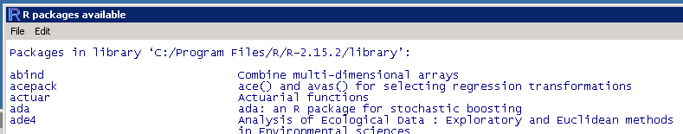

1. If it turns out some package is missing, try to install it manually by running:  
   install.packages("NAME_OF_PACKAGE")  
   For copy-paste ease of use, these are listed below:  
   install.packages("Cairo")  
   install.packages("RColorBrewer")  
   install.packages("shiny")  
   install.packages("scales")  
   install.packages("reshape2")  
   install.packages("gplots")  
   install.packages("ggplot2")  
   install.packages("seriation")  
   install.packages("XML")  
   **Note**: At the time of writing the SVGAnnotation package did not have an appropriate binary version on CRAN. For this package to install, run the installation from source:  
   install.packages("SVGAnnotation", repos="http://www.omegahat.org/R", type="source")  
   This package might be the reason that the installation of medplot package fails in the first place – you might try running this line first and then repeating step 4.
2. Load medplot package into library:  
   library(medplot)  
   This command will return something like *"... there is no package called 'medplot'*" if the installation of medplot failed for some reason. In that case you need to repeat medplot installation steps.
3. Look into the library (folder) on your computer, where the medplot package is installed (e.g.:   
   C:\Program Files\R\R-2.15.2\library\medplot ).  
   In this folder, you should find the Excel files which you will use in your work:  
   PlotTests.xlsm - plotting of test results   
   PlotSymptoms.xlsm - plotting of symptoms found
4. Copy the appropriate Excel file to the folder where you keep your work and open it. You have to click "Enable content" to enable macros and code that is used for functionality to work. If all is well, you will get a message that a "medplot toolbar" was created. You can find it under "Add-Ins" menu (under Excel 2010).  
   Different versions of Excel have different settings. Under Excel 2003, for example, it seems you have to set macro security lower than “high” for macros to work at all.
5. If you do not see the RExcel tab, you might try manually running the “Activate RExcel Add-in” program, probably found under Start->Programs->statconn->RExcel. And then run the “RExcel with RCommander” icon that is placed on your desktop and answer affirmatively to the questions if you want to install RExcel add-in permanently. This seems to be necessary on some systems running Excel 2003.
6. Finally, right click any tab in Excel and choose “View Code”. This opens the Visual Basic for Applications window. In it, navigate to Tools->References and make sure that the “RExcelVBAlib” option is checked. (as in screenshot below)  
   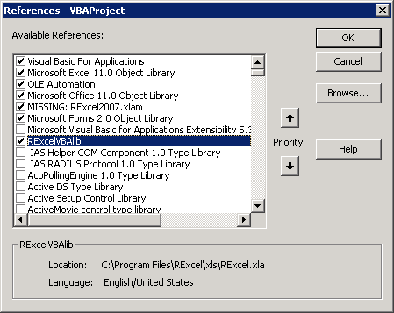   
   **Note**: If your situation is as in screenshot above, make sure to uncheck the “MISSING:RExcel2007.xlam” option.

You should now have your medplot package ready for work.