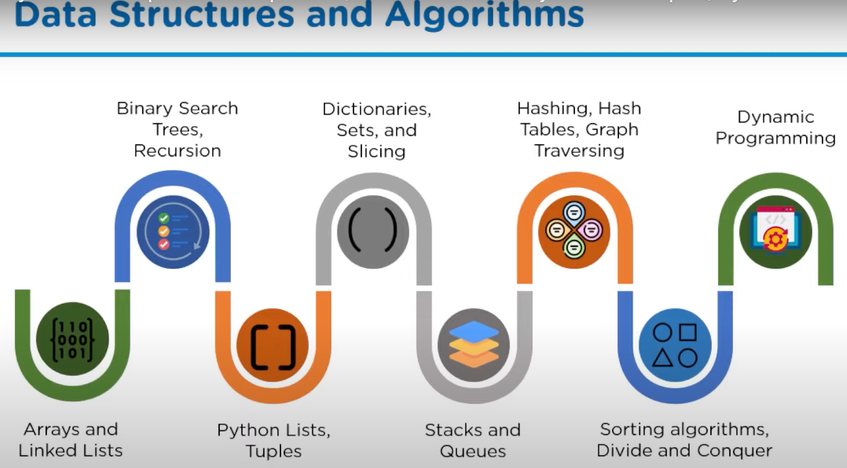

**Data Science:**

Matplotlib, Seaborn, Pandas, NumPy, Data visualization

**ML:**

Sci-kit learn, TensorFlow, Keras, Pytorch, ML Algorithms

What is a prediction Model in ML?

**Web Development:**

Django and Flask

**Web Scraping and Automation Testing:**

Selenium (Debugging), test complete etc.

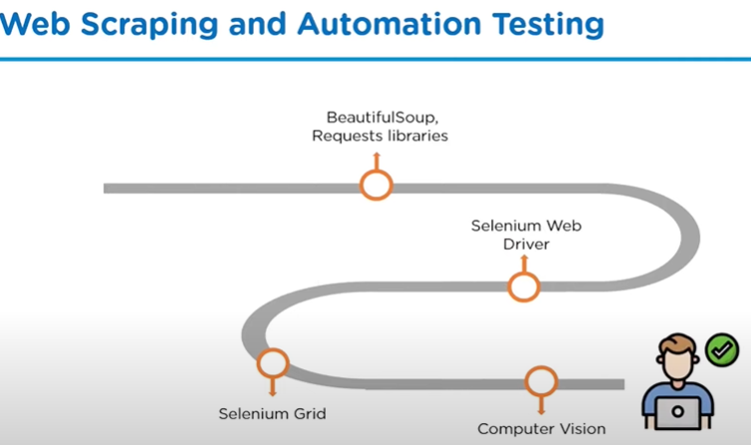

**Web development:**

* **Django 🡪 DRF** (Django Restful framework)
* **Flask**
* MySQL
* MongoDB
* Bottle
* Tornado
* Pyramid
* CherryPy