Student Name: Anish Pithakote

Student ID Number : 16441457

The bio section consists of a navigation bar, a wrapper and a footer at the bottom.

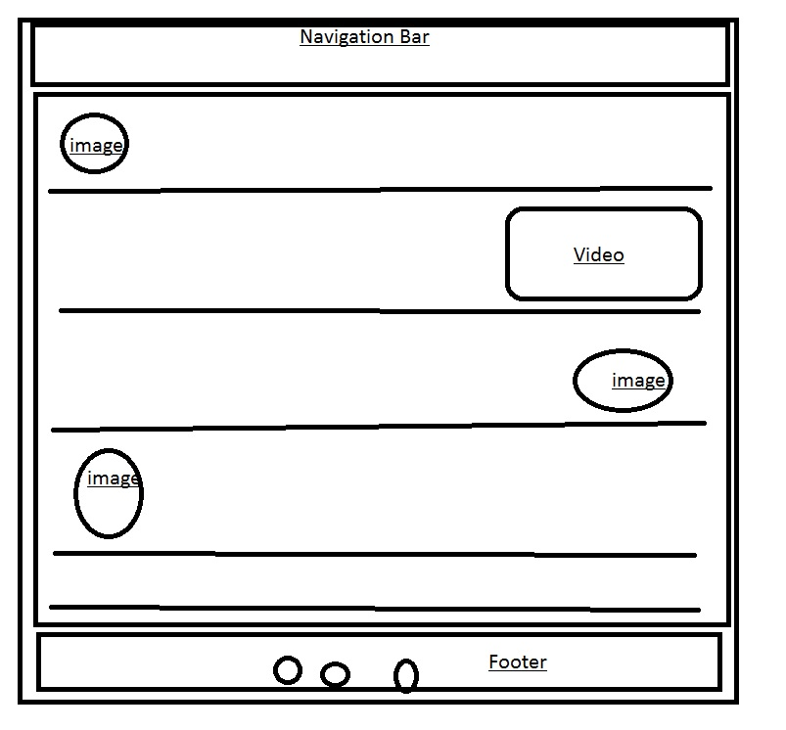

Fig: The basic wireframing of the Bio page.

The Navigation Bar: It consists of links to Index, CV, Bio and form pages. And a logo on the left side .

The Body (wrapper): It consists of the main content, where I have written all of my life’s details from my passions , hobbies and likes .

It has been further divided into five parts where first part tells about my bio in a brief version.  
from the second part, more contents like fitness, dancing and animals have been put up with their respective images and a video.

The footer : Consisting of icons linking to my social media sites.

After the completion of the index.html page, I moved on to the making of bio.html page . I finished this page on the third day from the starting of making this page.

After one week of finishing three of my pages i.e index, bio and form.html pages,I made this page responsive and changed the flex direction in to columns from rows.