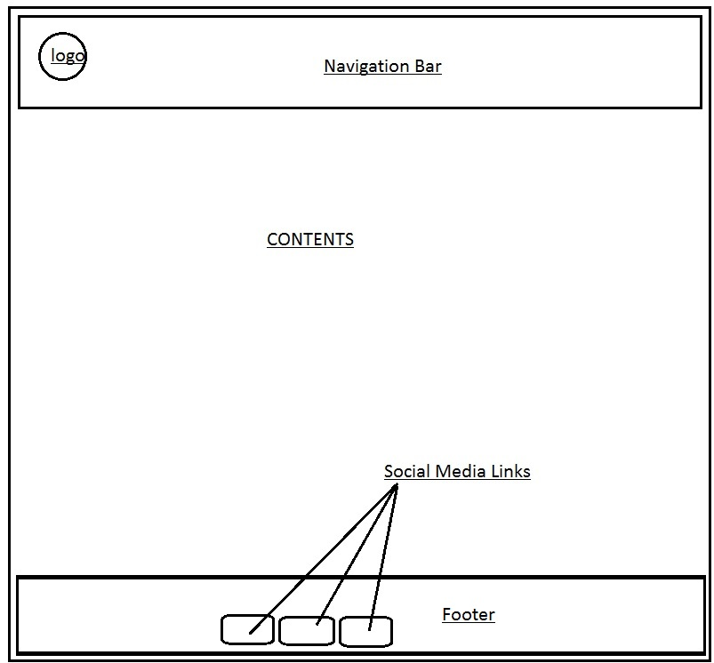

Fig (4): The wireframe of thr CV.html page.

The Navigation Bar: In this section, there are Home, CV, About Me and Contact Me buttons which are repectively linkedto their pages.

Logo : This section has a custom built logo which will be linked to the homepage.

Footer : The footer contains the Images of the social media sites which are linked to my social profiles .