|  |
| --- |
| NAMI College(University of Northampton) |
| Report On CSY1018-Assign1 |
| Web Development 1st Assignment |

|  |
| --- |
| Student’s Name:Anish Pithakote  Student ID:16441457  3/8/2017 |

|  |
| --- |
| CONTENTS page no   1. Introduction ………………………………………………………2 2. The Logo………………………………………………………….2 3. The Navigation Bar……………………………………………….3 4. The Footer………………………………………………………...3 5. The Pages…………………………………………………………4 6. The index page………………………………………………..4 7. The Bio page………………………………………………….5 8. The form page………………………………………………...6 9. The CV page………………………………………………….7 10. The responsiveness of the pages……………………………...8-10 11. Conclusion………………………………………………………..10 12. References………………………………………………………..10 |

1)INTRODUCTION

The web development assignment for the 1st Term 1st Year students was published by the University of Northampton. The assignment had instructed the students to create a website which was to be acted as an autobiography of that student. The website has had to have four compulsory html pages i.e the index.html , the bio.html , the CV.html and the form.html pages with their respective css and images in their respective folders.

Any webpage should be user-friendly and not too complicated to use and should not leave the users scratching their heads when they open the web page. In simple words, a web page should be a simple and user friendly. The webpages that I’ve created are the perfect examples of simple webpages.

Some of the things that have been included in all of my web pages are the Navigation Bar, The footer part and the logo.

We will now discuss these common things in detail:

2) The Logo



Fig: The logo of the page

This is a custom built logo used in this project.The logo will appear in all of the webpages on the top left corner of each page and when a user clicks of the logo, it will lead them to the main home page.

3)The Navigation Bar



Fig: The Navigation Bar Menu

This menu will be present in each of the pages in the website and through it, the users can navigate around the website by selecting which page would they like to visit.

The Navigation bar consists of Home, CV, About Me and Contact Me buttons which will guide the user to the home page, the CV page, the bio page and the contact me page respectively when clicked on.

4)The Footer



Fig:The footer part.

This footer part consists of the social media(facebook, twitter and Youtube) sites where the user can contact me throught the social media if they wish to do so.

5)WIREFRAMING

(a)THE INDEX PAGE

Started to create index page for my assignment.

I have decided to make my index page according to the following index wireframe.

I

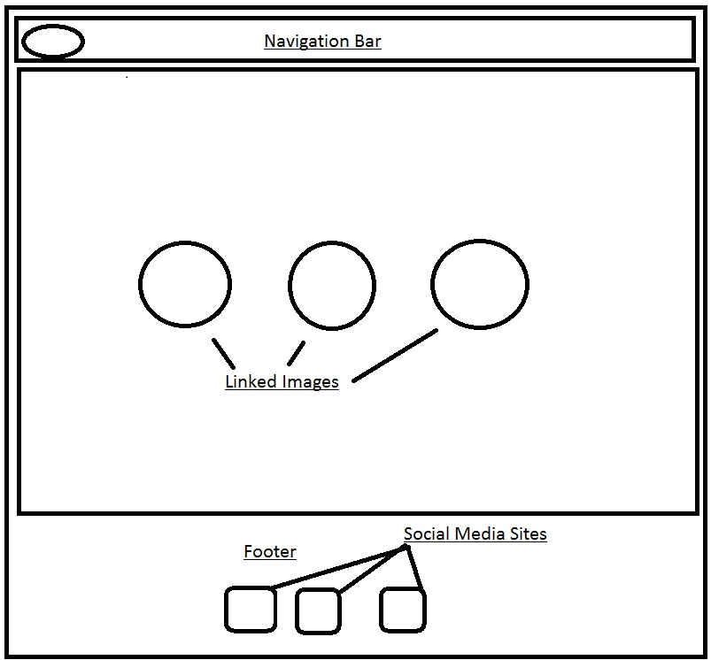

Fig(1): Wireframe for the index page.

Navigation Bar: This bar will contain Home, CV, Contact Me and About Me buttons linking to their respective pages.

Logo: My custom built logo will be placed there.

Images in Ovals: Pictures will be kept with a line describing them and linking to their respective pages.

Footer: The footer section will contain the links to my social media sites .

The web designing codes are also accompanied with their respective comments.

(b)THE BIO (ABOUT ME) PAGE

The bio section consists of a navigation bar, a wrapper and a footer at the bottom.

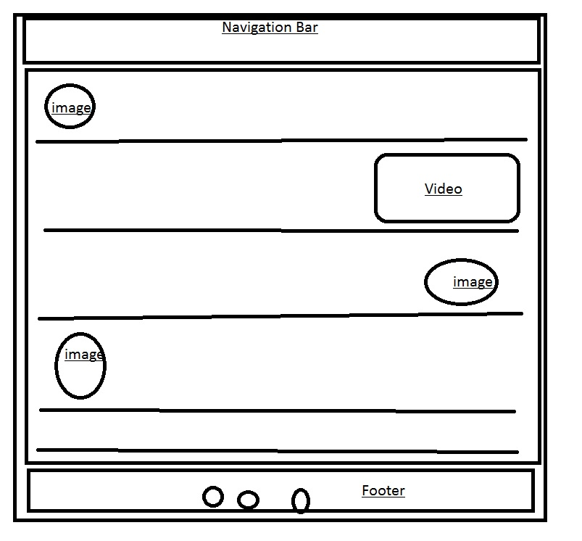

Fig(2): The basic wireframing of the Bio page.

The Navigation Bar: It consists of links to Index, CV, Bio and form pages. And a logo on the left side .

The Body (wrapper): It consists of the main content, where I have written all of my life’s details from my passions , hobbies and likes .

It has been further divided into five parts where first part tells about my bio in a brief version.  
from the second part, more contents like fitness, dancing and animals have been put up with their respective images and a video.

The footer : Consisting of icons linking to my social media sites.

After the designing of the bio page, I started working on the form page.

(c) THE FORM PAGE

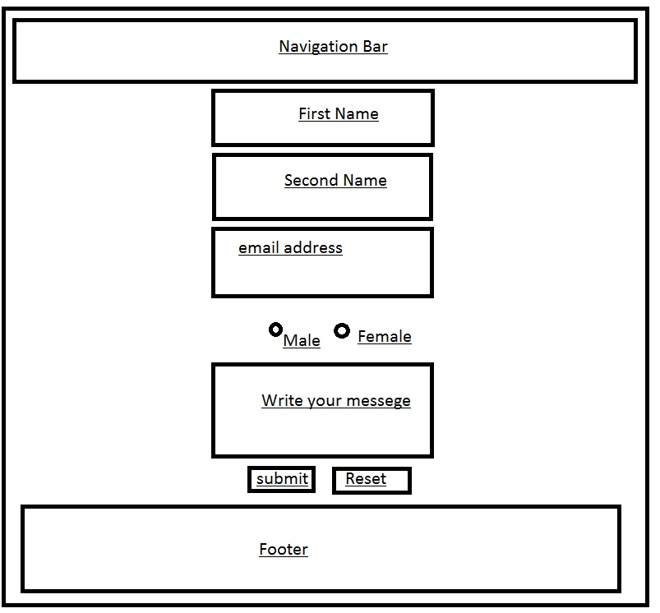

Fig(3):The basic woreframing of the form page.

The Navigation Bar: This bar consists of buttons linking to their respective pages.

The body (wrapper): This part consists of boxes, telling the people who are trying to contact me to enter

Their first name, last name , their email address , their gender and their messege .

They can click on submit to send that messege or if they want to erase everything they have written, the they can press the “reset” button.

After one and a half day of finishing three of my pages i.e index, bio and form.html pages,I made this page responsive and changed the flex direction in to columns from rows.

(d) THE C.V PAGE

This page was made at the last i.e I made this page when I was done with the previous three pages. (index.html ,bio.html, form.html).

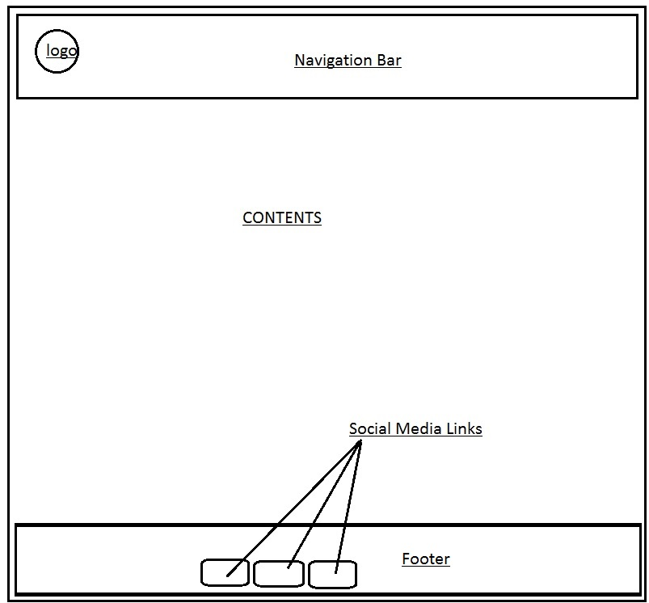

Fig (4): The wireframe of thr CV.html page.

The Navigation Bar: In this section, there are Home, CV, About Me and Contact Me buttons which are repectively linkedto their pages.

Logo : This section has a custom built logo which will be linked to the homepage.

Footer : The footer contains the Images of the social media sites which are linked to my social profiles

Contents : The contents contains the information about my experiences and skills.

**(e) THE RESPONSIVENESS OF THE PAGES** 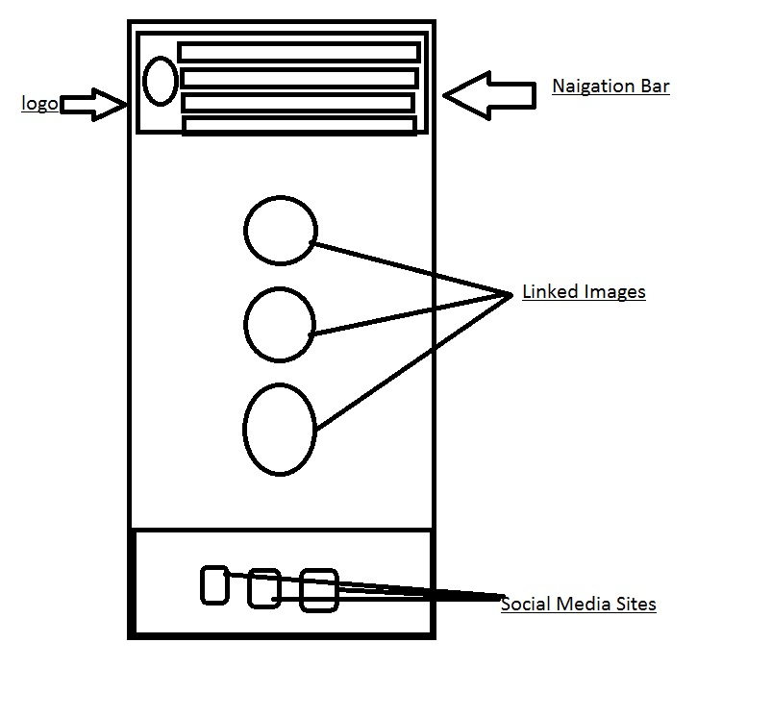 Fig(1.1)The Index page when the browser size is resized to 600px.

After a week of designing three of the pages,,  
I decided to make the index.html page responsive. The fields where the flex directions were set to “row” will now change to flex direction “column” when the window will shrink to 600px size.

The navigation bar, the pictures in the class “wrapper” will all align in a column.

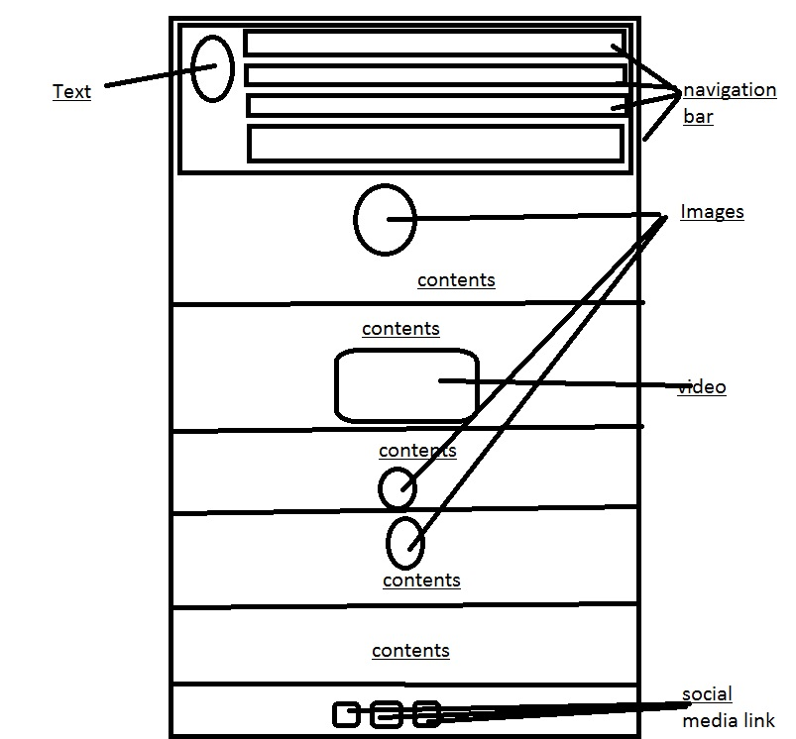

Fig (2.1) The responsive wireframe of the bio page.

The webpage was made responsive by using the “@media queries” and customizing the css file again under that condition.

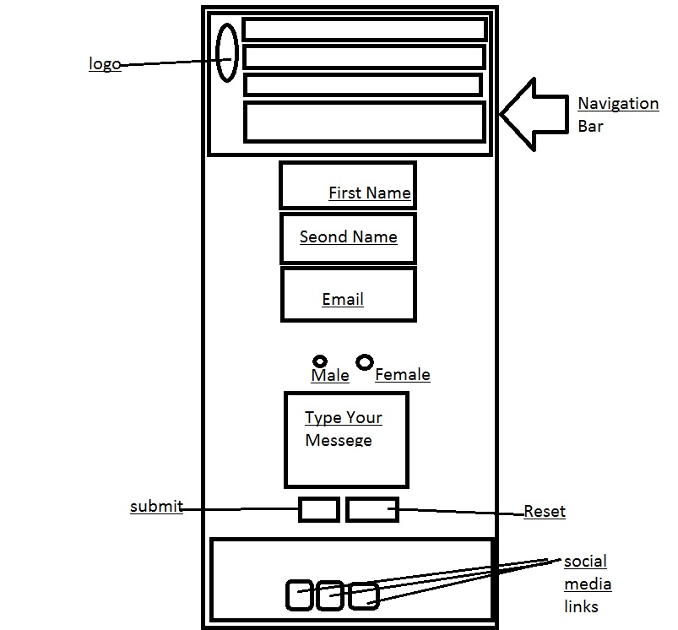

Fig(3.1):The responsie form.html page

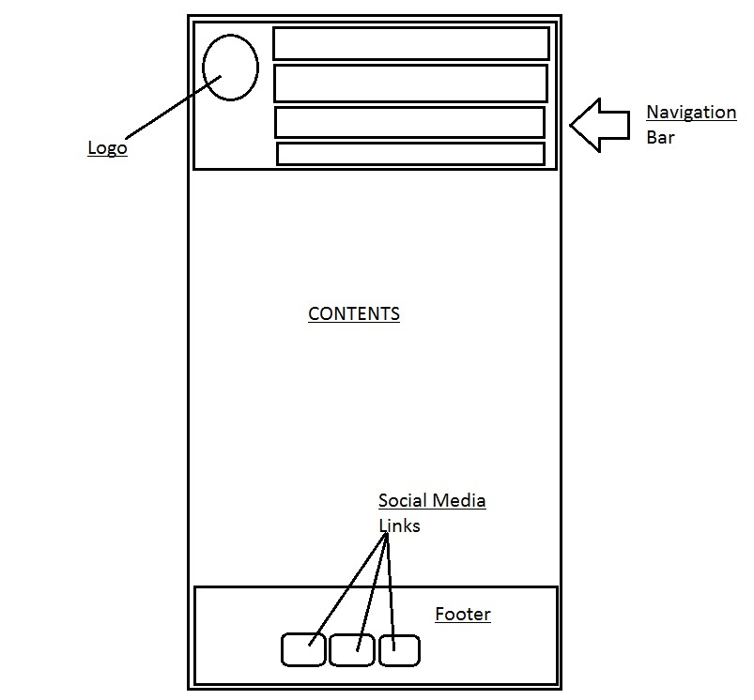

Fig(4.1): The responsive webpage of the CV.html

6)THE FINAL RESULT

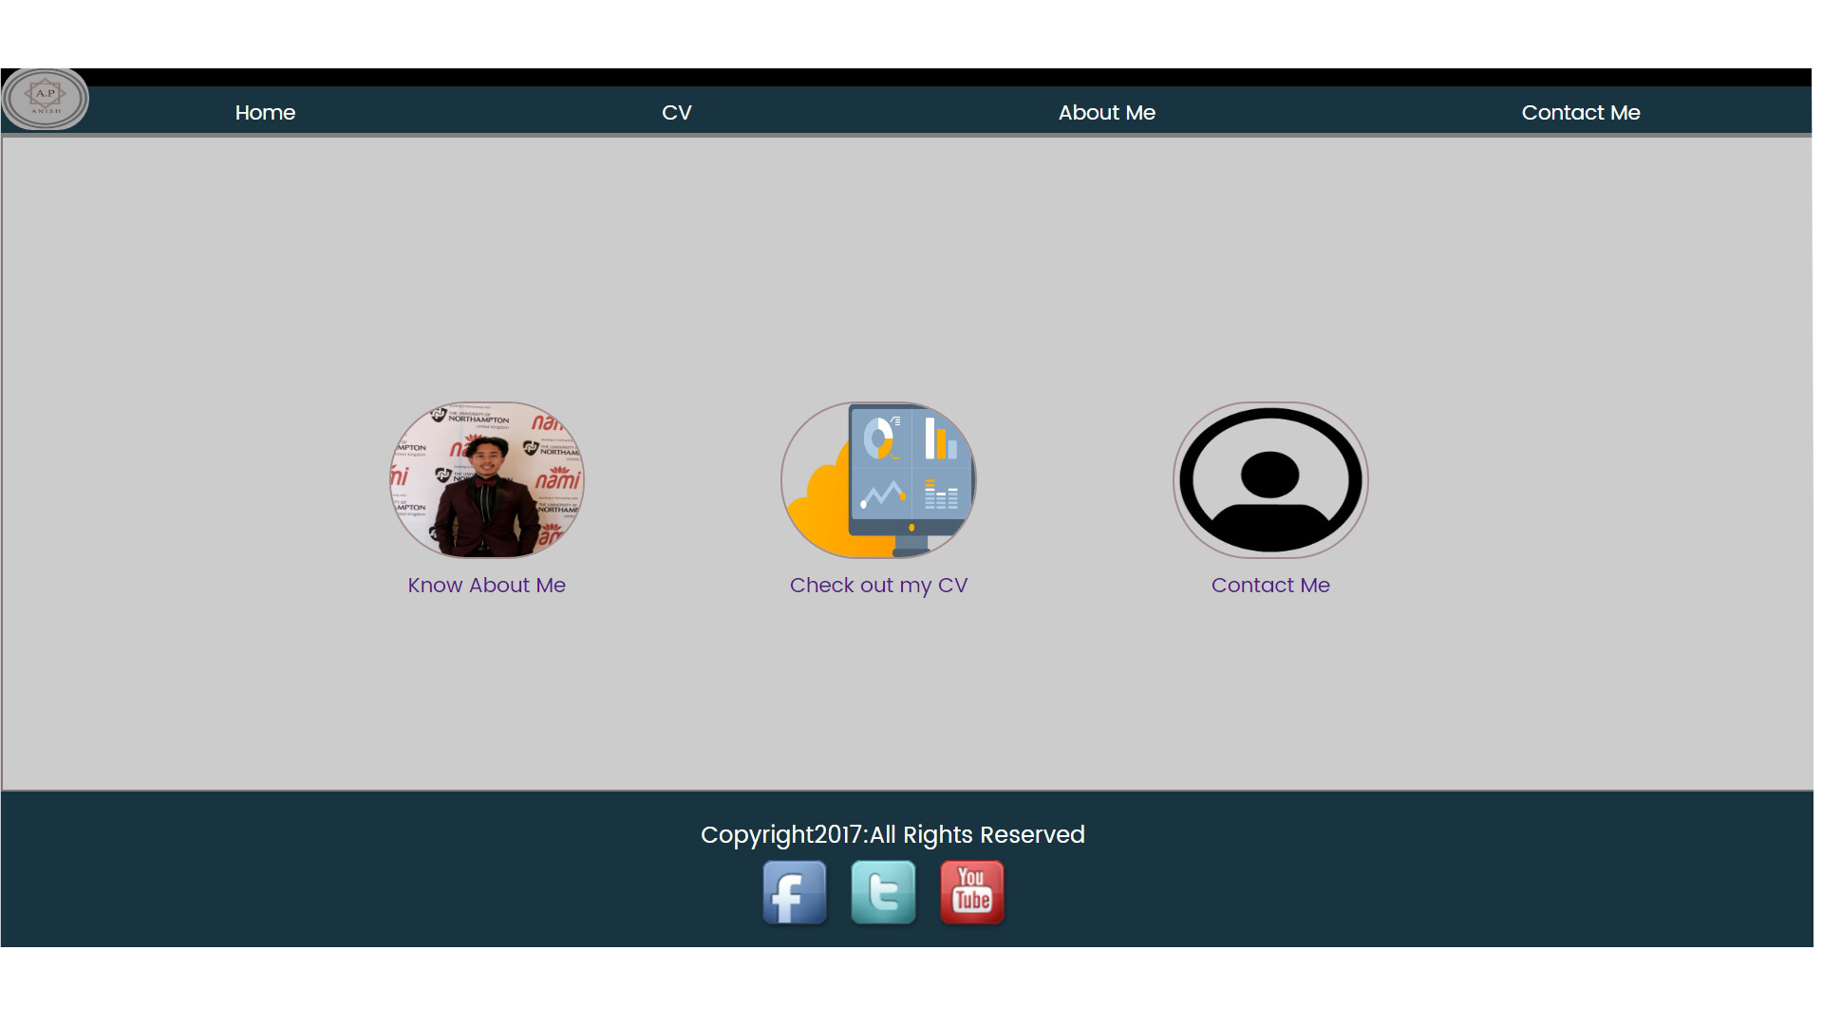

Fig:The final index page.

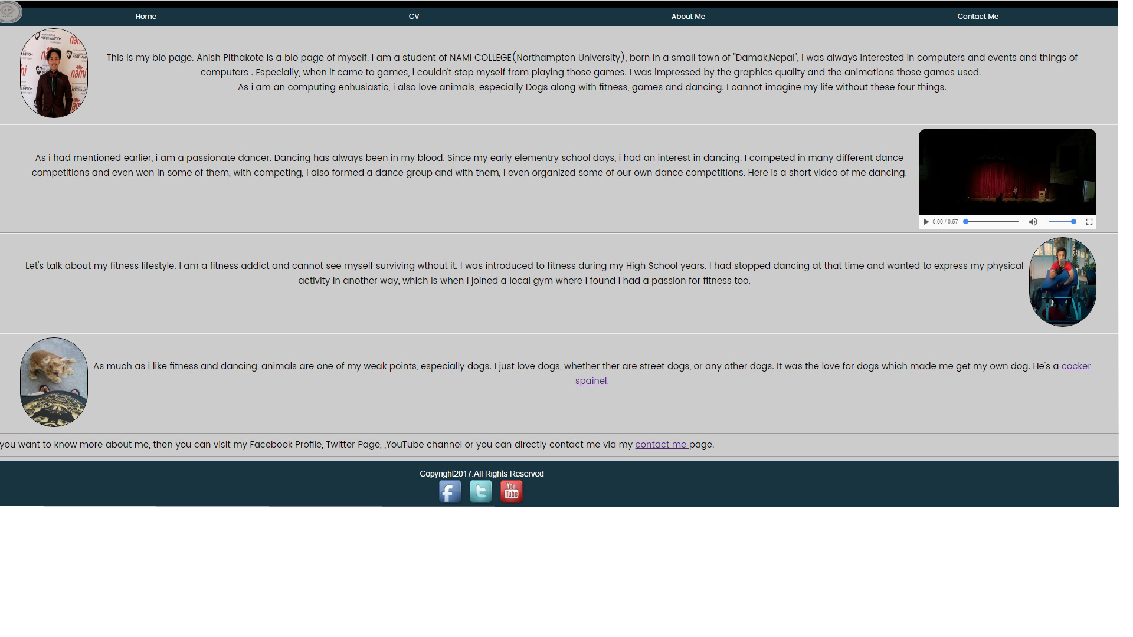

Fig: The final about me(bio) page.

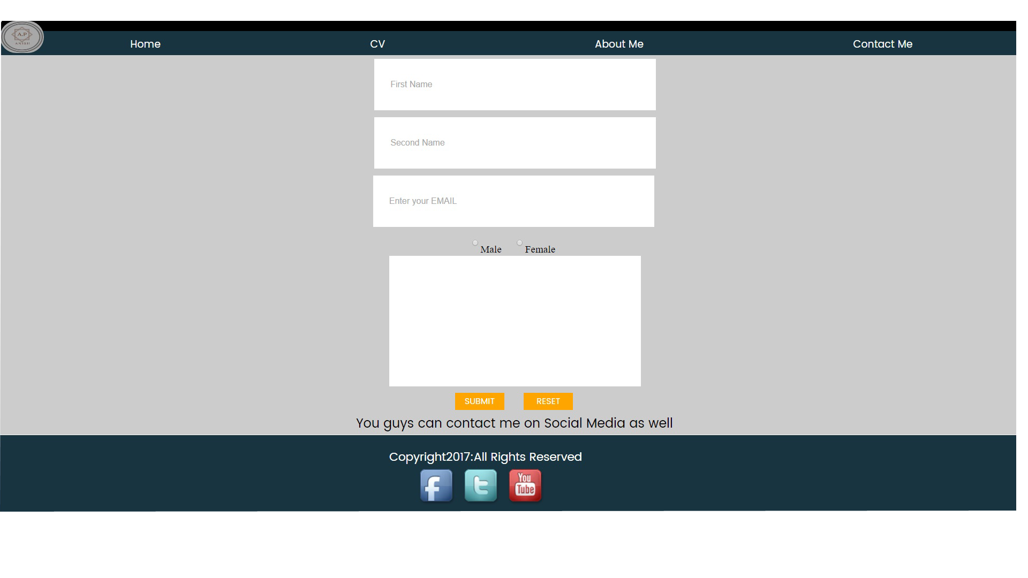

Fig: The final Contact Me(form) page.

7)CONCLUSION

Each of the webpages were designed at least for 3 to 4 hours per day. Each of the pages were finished designing at the 3rd to the 4th day, i.e each webpages took 3 to 4 days to finish. So approximately I spend nearly 64-70 hours just on designing the webpages.  
After I had finished designing the webpages, then I wanted to make them responsive. So , I added “@media “ to make the pages responsive if the browser window was to be shrunk to the size of 600px.

Once the browsers would be shrunk, the contents placed in the row , will appear to be in a column form.I completed making the pages responsive in 1 day working for 1 hour.

8)REFERENCES

Stanford.J(2015)Joel.sh.*Nile*[Online]https://joel.sh[Accessed 1st March 2017]

Kellyedmunds.co .uk

Ryanscherf.net

Rleonard.com/interactive-resume