Student’s Name : Anish Pithakote Magar

Student ID Number :16441457

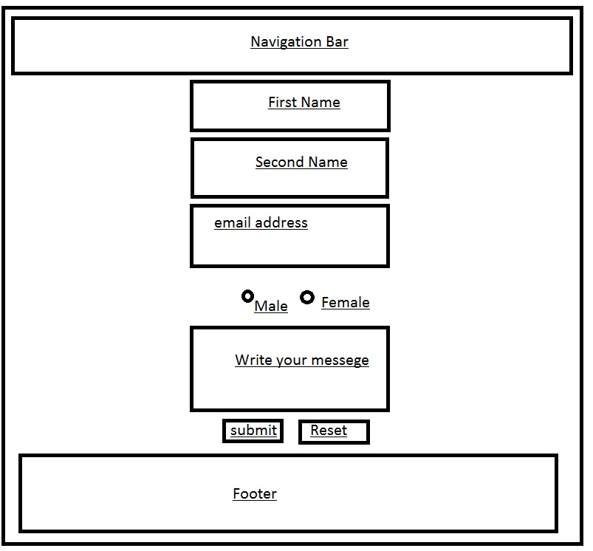

Fig:The basic woreframing of the form page.

The Navigation Bar: This bar consists of buttons linking to their respective pages.

The body (wrapper): This part consists of boxes, telling the people who are trying to contact me to enter

Their first name, last name , their email address , their gender and their messege .

They can click on submit to send that messege or if they want to erase everything they have written, the they can press the “reset” button.

After the designing of the bio page, I started working on the form page.

After one week of finishing three of my pages i.e index, bio and form.html pages,I made this page responsive and changed the flex direction in to columns from rows.