AutoFeeder

My idea was to get automatic feeder for pets. I need it, cause when my family is going for a vacation, nobody feeds our cat. But we don’t want It to be hungry. So, at first I searched for analogues in our local shops.

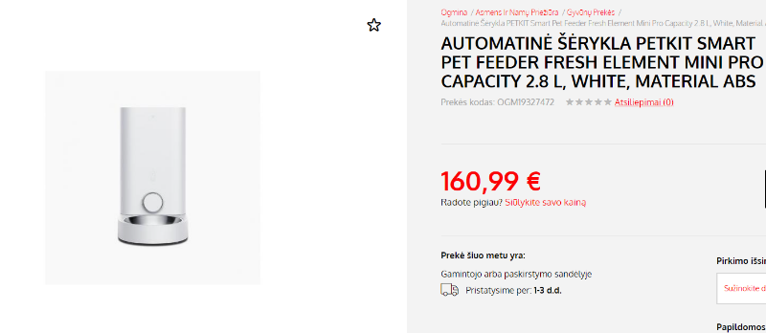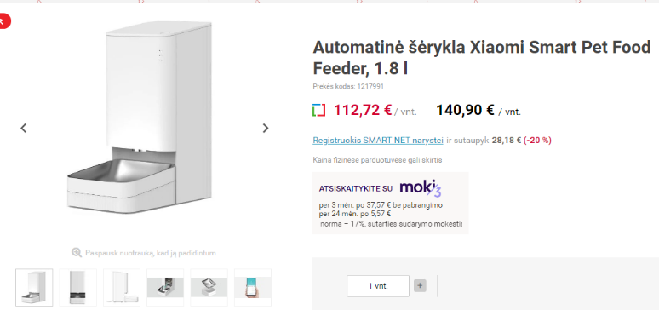

The average cost was about 130 euros. And on Amazon I found similar product for 60 euros. 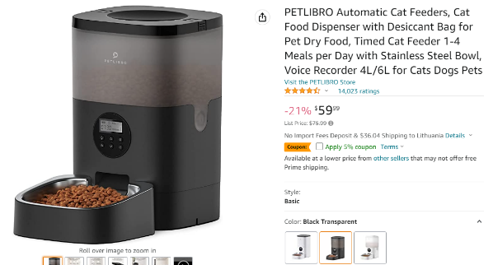

So I decided to create my own feeder. I already had an Arduino and a few modules that were bought from Aliexpress. Idea was that Arduino with ‘Real time clock’ module would rotate some mechanism with servo.

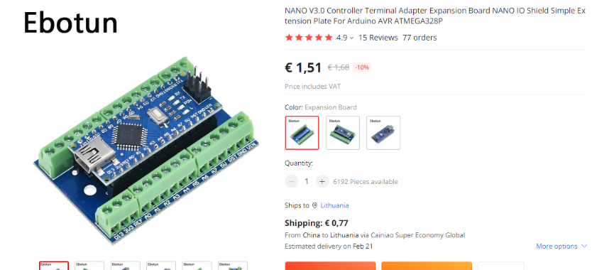

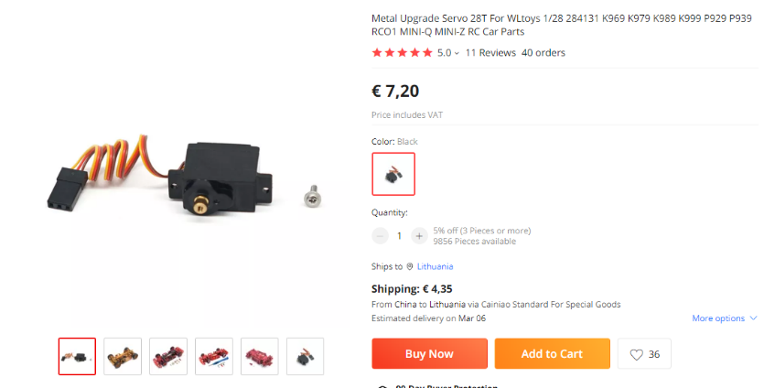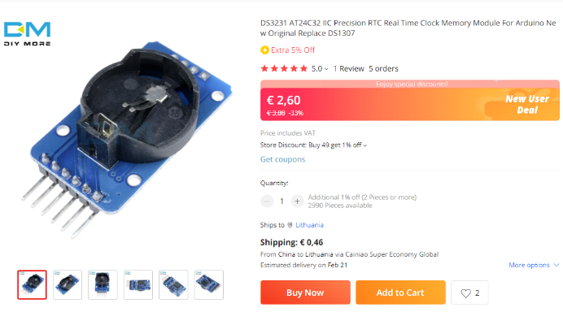

Total price: ~15 euros.

With those modules I started to create the frame of the feeder from used plumbing pipes and other materials found in the basement.

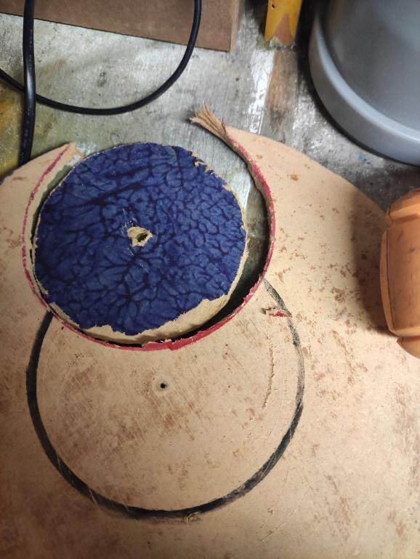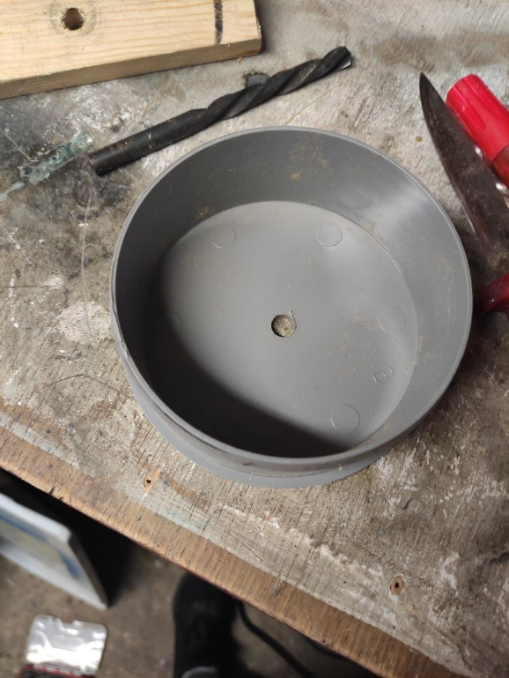

After a few tries I realised that I needed a 3D printer.

With my new Autocad skills I created some models.

Two caps: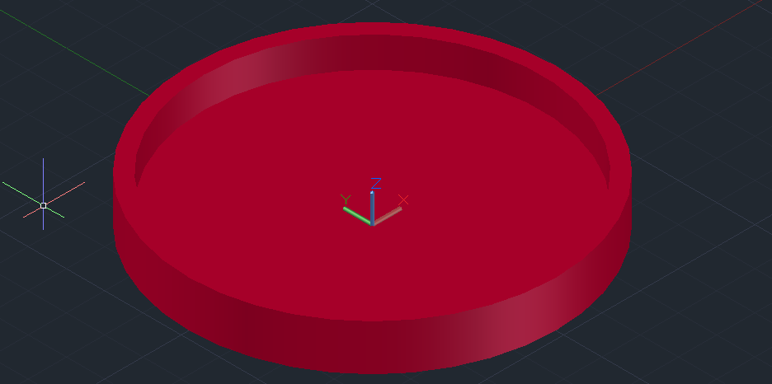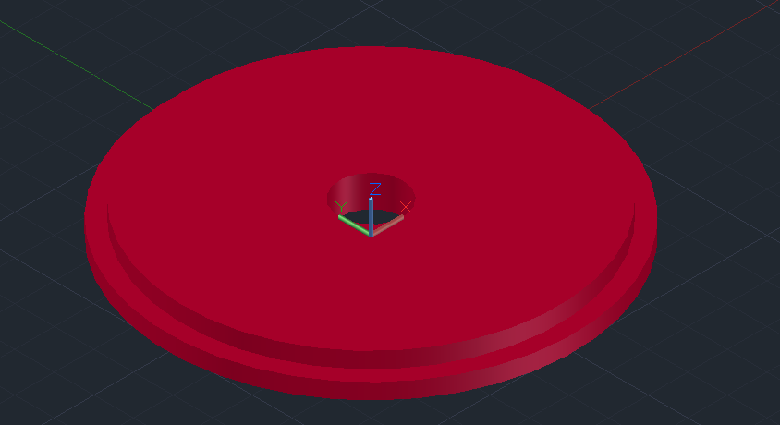

Rotating Mechanism:

Circle Funnel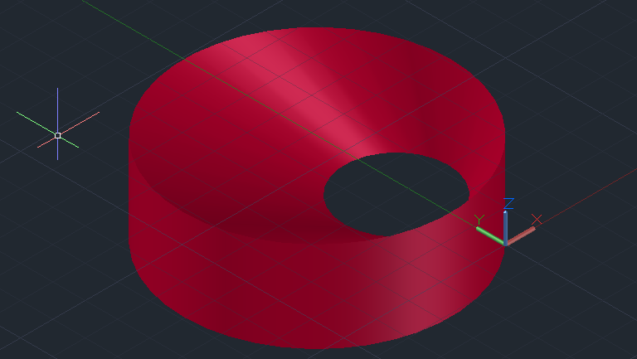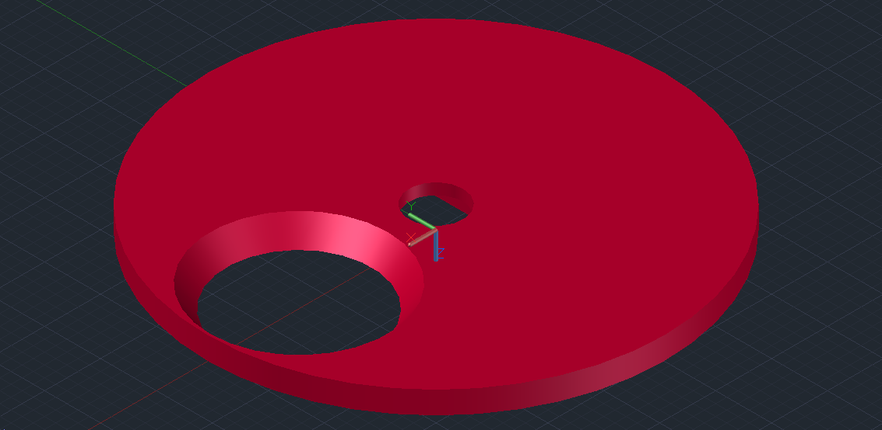

Frame: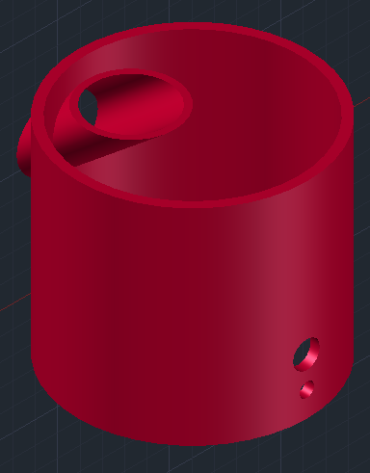

Food will go from the big tube(which is the main containter for food) to funnel then circle to the main frame and finally to a bowl of a pet.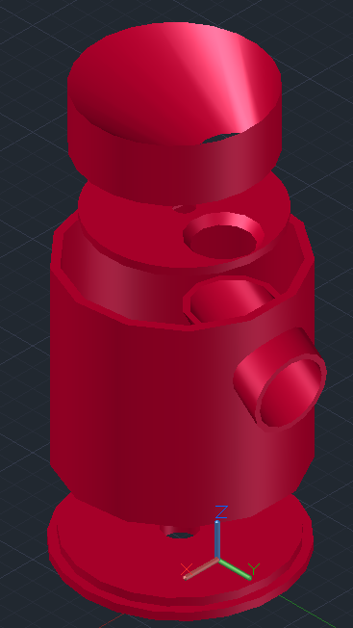

Some problems appeared: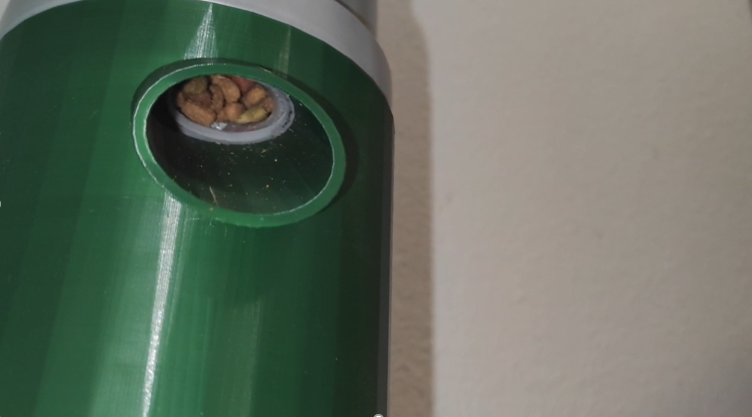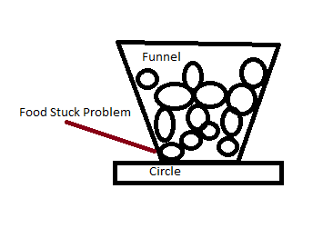

So I thought that if I add a tube which will be in rotation mechanism I would add portioning and there won’t be problems with food stucking.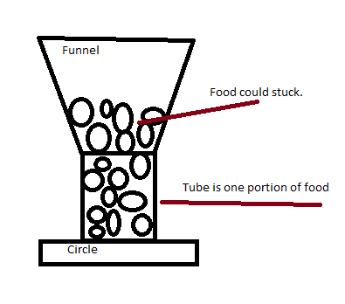

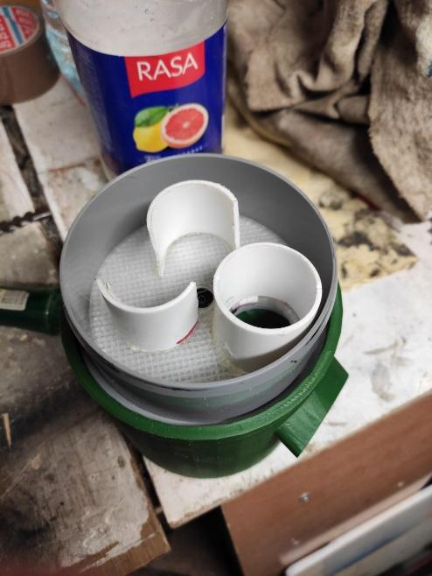

But problem remained. But it worked better. Because some food was falling every time, unlike before fix, when sometime there was no food at all. So in 2 cases out of 10 pet could be hungry. Problem could be fixed if everything would be designed in Autocad and printed with 3D printer. Everything must be ideal. 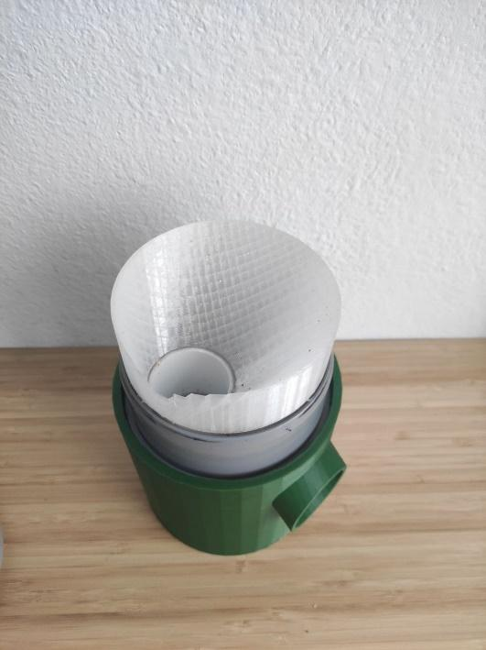

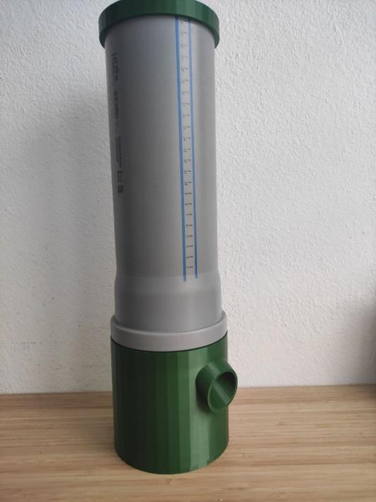

Model:

Schematics: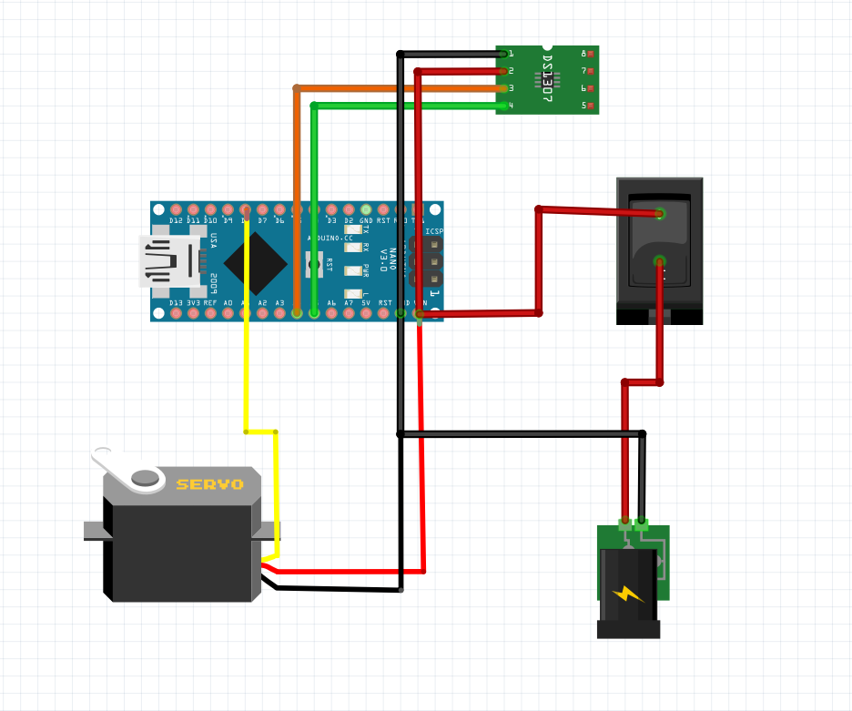

Improvement:

* Vibro module

It could make the food at the same level so it wont get stuck.

* Food Scale

Could help user see amount of food in the tube.

* Inner Battery

In the absence of owners. When the electricity goes out, the feeder will still work.

* Wifi module

With app user can see the amount of food in the tube.

* Camera

In the absence owner can watch their pet.

* Laser

Using camera user can play with their pet.

Creator: Konstantinas Ovčinikovas