**Observable Trends:**

* The analysis illustrated in the ‘City Latitude versus Max Temperature Plot’ supports the strong correlation between latitude and temperature. As expected, cities closer to the equator are more exposed to the high amount of sunlight and are generally experiencing warm temperatures. Cities located at mid-latitudes enjoy both the tropical heat and the arctic cold. Cities with high latitudes get limited sun rays as they receive small amount of sunlight, which results in extremely cold temperatures.

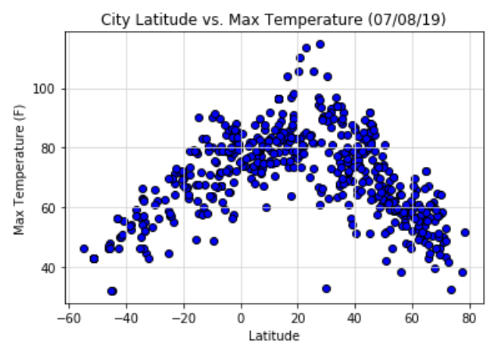

* Evidently, the quality of latitude and humidity as well as latitude and cloudiness relationships is weak. In both plots, the gatherings of cities are all over the place. Interestingly, there are more groups of cities visibly distributed within the 70 to 100 per cent humidity belt as shown in the ‘City Latitude versus Humidity Plot.’

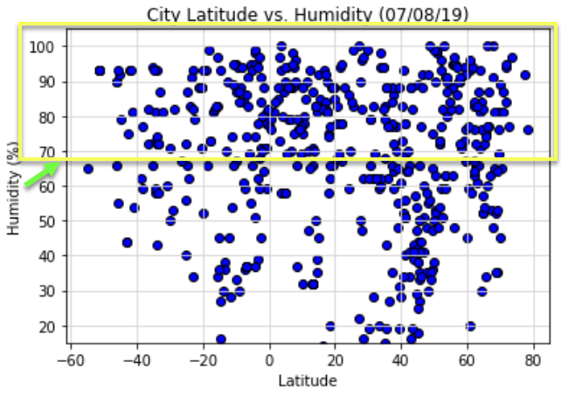

Equally fascinating is the linear formation of bunches of cities on certain regions (highlighted below) as displayed in the ‘City Latitude versus Cloudiness Plot.’

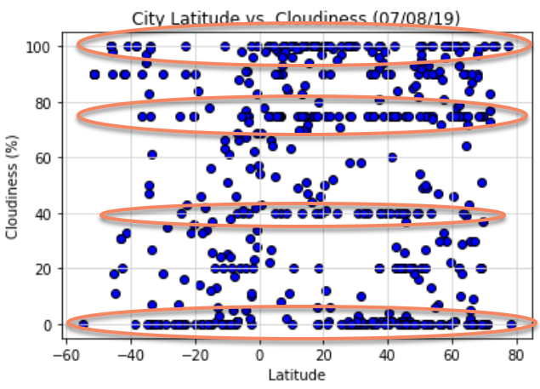

* The relationship between latitude and wind speed is unclear. But looking at the ‘City Latitude versus Wind Speed Plot,’ more clusters of cities are hovering around the 0 to 20 mph wind speed zone at any latitude rate.

