

Portable Appliance Test Certificate

Health and Safety at Work (etc) Act 1974
Electricity at Work Regulations 1989
Management of Health and Safety at Work Regulations 2003
Provision and Use of Work Equipment Regulations 1998

This is to certify that
an inspection and test of Electrical equipment
owned/managed by

Client name and location here

was carried out by
Artistek

on
Insert date of inspection

The inspection and tests were carried out in accordance with the above legislation, and in accordance with the guidance laid down by the Institution of Engineering and Technology in their Code of Practice for In-Service Inspection and Testing of Electrical Equipment. The schedule which is provided with this certificate details the appliances tested and the results that were obtained.

Number of appliances tested: 0000
Certificate reference: 0000

Signed
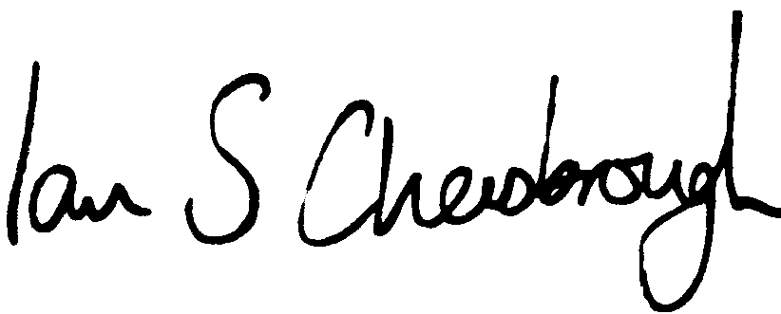
Artistek,
Flat 1 Bay View Court,
7 Cluny Crescent,
Swanage,
Dorset,
BH19 2BP

