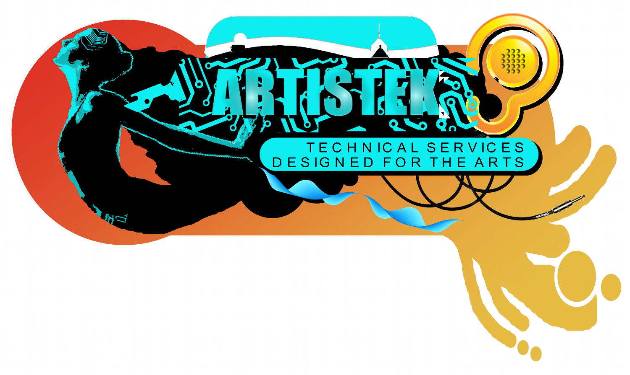

Portable Appliance Test Certificate

Health and Safety at Work (etc) Act 1974
Electricity at Work Regulations 1989
Management of Health and Safety at Work Regulations 2003
Provision and Use of Work Equipment Regulations 1998

This is to certify that
an inspection and test of Electrical equipment
owned/managed by

Millbrook Guest House,
56 Kings Road West,
Swanage,
Dorset,
BH19 1HR
was carried out by
Artistek

on
15th June, 2015

The inspection and tests were carried out in accordance with the above legislation, and in accordance with the guidance laid down by the Institution of Engineering and Technology in their Code of Practice for In-Service Inspection and Testing of Electrical Equipment. The schedule which is provided with this certificate details the appliances tested and the results that were obtained.

Number of appliances tested: 62
Certificate reference: MILLBROOK201506

Signed
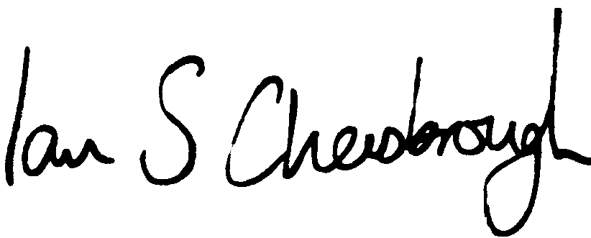
Artistek,
Flat 1 Bay View Court,
7 Cluny Crescent,
Swanage,
Dorset,
BH19 2BP

