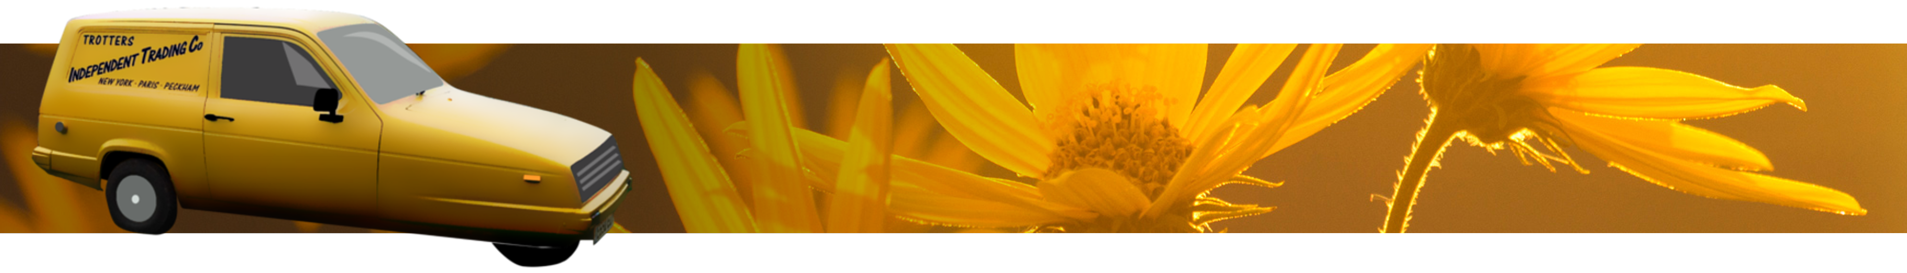
Only Fools and Hearses of Dorset,
Only Fools and Hearses of Dorset
Flat 11 Seacombe Lodge,
Priests Way,
Swanage,
Dorset,
BH19 2RS
07748900384
Dear Sirs,
I have great pleasure in introducing my company “Only Fools and Hearses of Dorset”.
My name is Derek Trotter (Del-Boy, yes really!) and I have extensive experience in the funeral industry, currently working for one of Dorset's best-known family funeral directors.
I am proud to be able to offer my “Only Fools and Horses” themed three-wheeler with an original 1898 horse-drawn hearse. The hearse has been specially adapted to be towed by my three-wheeler.
There are clearly a large number of fans of “Only Fools and Horses” and I felt that I could provide a few laughs and smiles with my three-wheeler, of course giving a 100% professional service.
Our services are available throughout the UK and I will provide an experienced chauffeur on the day of the funeral to lead the cortege. We are happy to leave from a private residence or meet directly at a crematorium or cemetery. Please bear in mind that the horse-drawn hearse is permitted to travel at no more than 12 mph.
Even though this is a small company, I am happy to work with your client's budget, but please take into consideration the cost of preparation, travel and insurance.
I look forward to hearing from you in the near future and am happy to answer any questions regarding hire of these vehicles.
Triffic!
Derek Trotter

