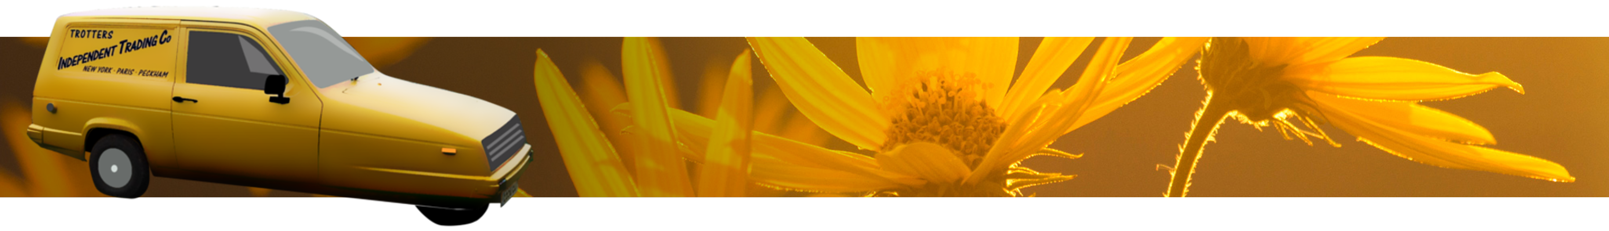
Only Fools and Hearses of Dorset,
Only Fools and Hearses of Dorset
Flat 11 Seacombe Lodge,
Priests Way,
Swanage,
Dorset,
BH19 2RS
07748900384
Dear Mr. Challis,
My name is Derek Trotter. That really is my name and, as you can imagine, that is often greeted with polite amusement, outright laughter, or anything in between. Embracing this reality, I am the owner of a little yellow three-wheeler in the style of Trotter's Independent Traders, which is both my everyday car and also the centre of my small business "Only Fools and Hearses of Dorset". The car can pull my original 1898 horse-drawn hearse and is also hired out on its own for people who are planning an "Only Fools and Horses" themed party. There are more people nowadays wishing to bring some lightheartedness to the funeral of their dear departed and fans of "Only Fools and Horses" will appreciate the play on words.
I would be most grateful if you would allow me to use a photograph of you to help draw attention to my car and hearse. A colleague of mine already has an informal photograph of you when he quite by chance met you whilst on holiday and I wondered if you might permit me to use that as well as some of your official photographs. If possible, could I use official signed photographs of "Boycie and Marlene" together, or yourself and Mrs Holderness if you'd rather not use those characters?
There is a trade show coming up, which I wish to attend with my three-wheeler and hearse carriage. It would be a great privilege for me if I could also display signed photographs bearing the greeting "To Derek Trotter of Only Fools and Hearses from Boycie and Marlene".
If you would like to find out some more about my business before replying, my web site is at www.onlyfoolsandhearsesdorset.co.uk.
I have also included some photographs of my three-wheeler and hearse as well as the informal photograph mentioned earlier..

Thank you for your time.
Yours sincerely,
Derek Trotter

