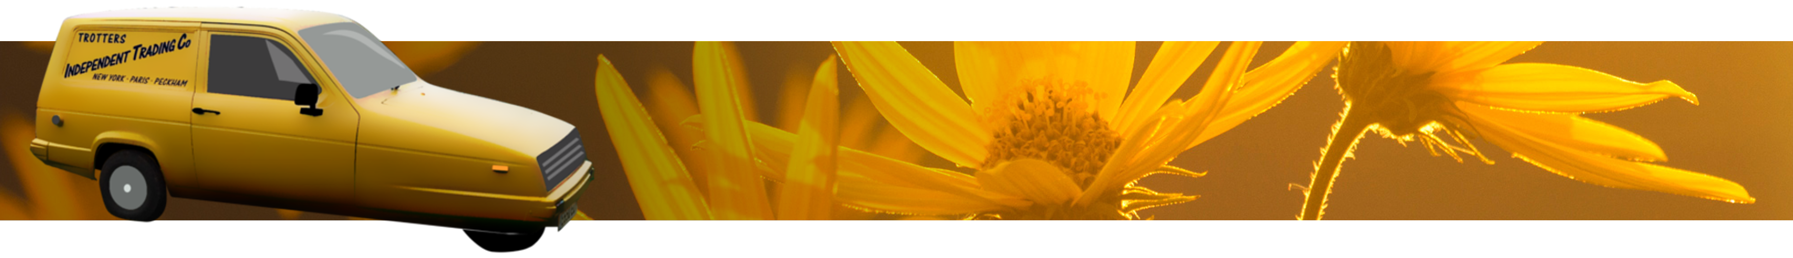
Only Fools and Hearses of Dorset,
Only Fools and Hearses of Dorset
Flat 11 Seacombe Lodge,
Priests Way,
Swanage,
Dorset,
BH19 2RS

