Contents
1)MMBasic 2
2)F746-Port 2
3)STM32F746-Discovery 2
4)Differences Maximite <> F746-Port 3
4.1)Display and Colors 3
4.2)Fonts 3
4.3)Touch 4
4.4)Keyboard 4
4.5)Console connection 4
4.6)External Drives 5
4.7)Sprites / Maps 5
4.8)3D-Objects 5
4.9)UART 6
4.10)SPI 6
4.11)I2C 7
4.12)Sound 7
4.13)GPIO-Pins 8
4.14)FLASH 8
4.15)Autorun 8
4.16)External Devices 8
5)GPIO-Ports 9
5.1)Pinout 10
6)Actual software state 11
7)Operators 11
8)Predefined read only variables 12
9)Commands 13
10)Functions 18
11)Other MMBasic commands 20
12)New commands for the F746-MMBasic 21
13)Syntax of the new commands in F746-MMBasic 23
13.1)aCos 23
13.2)aSin 23
13.3)CalcCos 23
13.4)CalcSin 23
13.5)Circle 23
13.6)Ellipse 24
13.7)Triangle 24
13.8)Sprites 25
13.9)Maps 25
13.10)Pixel 26
13.11)Layer 26
13.12)Quad 27
13.13)3D-Objects 28
13.14)Polygons 29
13.15)Joystick 33

MMBasic
MMBasic is a powerfull BASIC-Interpreter written by Geoff Graham
for a PIC32 Microcontroller from Microchip.
Link to MMBasic : http://mmbasic.com/
Link to Geoff's Maximite-Project : http://geoffg.net/maximite.html

F746-Port
The „MMBasic-STM32F746“ is a port from the original Version to
a STM32F746 Microcontroller from ST.
The starting point of the Firmware is MMBasic for the Maximite in Version 4.5.
The Hardware base is a STM32F746-Discovery Board from ST.
The authors are : Uwe Becker and Fabrice Muller
Link to the German webblog : http://mikrocontroller.bplaced.net/wordpress/?page_id=5487
(here you can find the binary from the newest version)
Link to an English forum : http://www.thebackshed.com/Forum/forum_posts.asp?TID=7969&PN=1

STM32F746-Discovery
The Discovery Boards includes all necessary parts for a stand alone system.
INPUT : USB-Connector (to plug in a standard USB-Keyboard)
OUTPUT : 4,3 inch Display (480x272 Pixel @ 65k Color)
DRIVES : uSD-Slot (Drive b:) and USB-Connector for a USB-Drive (Drive c:)
COM : UART connection (@ USB and VCP) to a terminal program
GPIO : 22 User defined IO-Signals (IO, UART, SPI, I2C etc)
and has additional parts like :
RAM : 8Mbyte (to store Graphics, Sounds etc)
TOUCH : 4,3 inch Multitouch (to realize a GUI)
FLASH : 16MByte (to store user settings, programs, files)
SOUND : Stereo Audio-DAC (for Music)
ETHERNET : for LAN connection

Differences Maximite <> F746-Port
There are some differences in the implementation of MMBasic between
the Maximite and the F746 Version.

Display and Colors
A big difference between Maximite and F746-Port is the Video system.
Maximite : 480 x 432 Pixel (monochrome)
Color-Maximite : 480 x 432 Pixel (8 colors)
F746-Port : 480 x 272 Pixel (65535 colors)
All Graphic commands are changed to handle 65535 colors.
There are no need for different color modes so the „MODE“ command is deleted.
Also the „SCANLINE“ command is deleted.
8 default colors are :
"BLACK","WHITE","RED","GREEN","BLUE","CYAN","PURPLE","YELLOW"
8 new default colors are defined :
"ORANGE","BROWN","LRED","DGREY","GREY","LGREY","LGREEN","LBLUE"
and you can use any RGB656 color code between 0x0000 and 0xFFFF
You can disable/enable the output for the "PRINT" command in a basic program with :
OPTION VIDEO OFF (disable output)
OPTION VIDEO ON (enable output)
You can store the default color for background and text in Flash with :
CONFIG BGCOLOR #color
CONFIG FGCOLOR #color

Fonts
At the Moment 6 different Fonts are installed in Flash.
#1 to #3 are the same as in the Maximite Version :
#1 = 6x12 Pixel (standard Font for Editor)
#2 = 13x20 Pixel
#3 = 24x23 Pixel (only Chars : '+,-.',Space,'0...9')
#4 to #6 are generated from UB :
#4 = 8x8 Pixel (C64-Font)
#5 = 8x13 Pixel
#6 = 10x15 Pixel
All Fonts can be used in Basic Programs with the "FONT #nr" command.
All Fonts (except #3) can be stored in Flash as default Font with :
CONFIG FONT #nr

Touch
The Multi-Touch can handle up to 5 touch positions at a time.
The standard BASIC command „TOUCHED()“ works like the TFT-Maximite Version
and readout only the first touch position.
With the new „MTOUCHED()“ command all 5 positions can be used without loosing speed.

Keyboard
You can connect a standard USB Keyboard at CN13 (USB_FS).
3 Keyboard Layouts are implemented, use command :
CONFIG KEYBOARD US (for US QWERY Layout)
CONFIG KEYBOARD GR (for German QWERZ Layout)
CONFIG KEYBOARD FR (for France AZERTY Layout)
There are two Keyboard shortcuts with :
ALT+F11 = switch Keyboard-Layout (QWERTZ, QWERTY, AZERTY)
ALT+F12 = send display screenshot (as BMP-File) to console output
You can setup the function keys F1 to F12 with a short string like :
example : OPTION F1 "Run" + CHR$(13)

Console connection
The USB/ST-Link-Port (CN14) is used as UART connection to a terminal
(TeraTerm recommended). Setting is : 115200 Baud, 8N1
You can disable/enable the output in a basic program with :
OPTION USB OFF (disable output)
OPTION USB ON (enable output)
To change baudrate use :
CONFIG BAUDRATE #baudrate

External Drives
You can connect a Micro-SD card at CN3 and a USB-Drive at CN12 (USB_HS).
Both drives must be formatted with FAT filesystem.
To change the active drive :
DRIVE A: (a = internal Flash, not supported)
DRIVE B: (b = uSD)
DRIVE C: (c = USB)
To list the directory of the active drive :
FILES (list all files and directorys)
FILES "*.bas" (list all BAS-Files)
FILES "H*.*" (list all files with first char "H")
FILES "?H*.*" (list all files with second char "H")
To change the directory :
CHDIR <name> (change into <name>)
CHDIR .. (change in parent directory)
Other commands :
KILL <filename> (delete file <filename>)
MKDIR <name> (create directory <name>)
RMDIR <name> (delete direcotry <name>)
To setup the default drive use :
CONFIG DRIVE [A/B/C]

Sprites / Maps
Because of the better graphic capabilities of the F746-Port there are many
differences in the sprite and maps handling.
So many BASIC commands are different in function and/or syntax
and the files are not compatible with the Maximite Version.
A spritefile can now handle different sprite sizes up to 32x32 pixel
and supports ARGB1555 color format.
Maps for Background also supports the ARGB1555 Format
and can have a size up to 1.000.000 Pixel.
The CPU fit the map in every window size like 480x272 or 300x150 or whatever.

3D-Objects
These Graphic-Objects are a new feature and made by Fabrice.
Please read the command description for details.

UART
COM1 and COM2 can be used with these Baudrates :
115200, 57600, 38400, 19200, 9600, 4800 [9600 = default]
Stopbits one or two
FlowControl only works at COM2
BufferSize is fixed at 256 Bytes
RS485 is not supported
OpenCollector Output is not supported
Interrupt functions not supported
Com1 or COM2 can used as console in/out.
GPIO-Pins automatically configured by the basic-command "open"
so there is no need to set input,output with the "setpin" command.
Before the basic program is started, all com-ports are closed.
(Except the port is defined as console)

SPI
SPI1 and SPI2 can be used as "Master" with these settings :
Frame : 8bit
Speed : 0...7 (default=3)
Mode : 0,1,2,3 (default=3)
Bitorder : MSB, LSB
SlaveSelect-Pin : can be automatically handelt
GPIO-Pins automatically configured by the basic-command "spi open"
so there is no need to set input,output with the "setpin" command.
Before the basic program is started, all spi-ports are closed.
Speed | 0 | 1 | 2 | 3 | 4 | 5 | 6 | 7
SPI-1 | 195kHz | 390kHz | 781kHz | 1,56MHz | 3,12MHz | 6,25MHz | 12,5MHz | 25MHz
SPI-2 | 390kHz | 781kHz | 1,56MHz | 3,12MHz | 6,25MHz | 12,5MHz | 25MHz | 50MHz

I2C
I2C1 can be used as "Master" with these settings :
Slave-Adress : 8bit
Speed : 10...400 (kHz)
Timeout : 100...n (ms)
Option : 0
GPIO-Pins automatically configured by the basic-command "i2c open"
so there is no need to set input,output with the "setpin" command.
Before the basic program is started, i2c-port is closed.
I2C-Frq : 10,20,30,40,50,60,70,80,90,100,200,300,400 [kHz]

Sound
At the moment you can load WAV-Files from SD- or USB-Drive and play them in background.
Output is the Headphone Mini-Jack (CN10).
There is space to hold 20 Files (or max 1MByte).
WAVE-Format must be : PCM, 16bit, Mono or Stereo, 8kHz - 48kHz
To load a wave use : "WAVE LOAD"
There are two commands to play the sound "WAVE PLAY" and "WAVE LOOP"
and one command to stop the sound "WAVE STOP"
You can play up to 4 WAV-Files simultaneously (wav formates must be equal).
To unload all WAV-Files use "WAVE CLEAR" (only if no wave is playing).

GPIO-Pins
Not all GPIO-Modes are implemented yet.
At the moment only OFF, INTL, INTH, INTB, DIN, DOU, AIN are working.
Before the basic program is started, all GPIO-Pins are set to "OFF"
(except the LED-Pin and the Console-Pins if opened)
Digital-Inputs (DIN) can have 3 internal resistor Modes : "NONE", "UP", "DOWN"
(default is "NONE") e.g. "setpin 1,DIN,DOWN"
Interrupt-Inputs (INTL,INTH,INTB) can have 3 internal resistor Modes : "NONE", "UP", "DOWN"
(default is "NONE") e.g. "setpin 1,INTL,UP,1000"

FLASH
Some settings are stored in the external Flash
If the Flash is not initialized (at the very first start) the default settings are stored.
After that, every time the basic-command "config" is used to store new settings.
The Flash can be erased up to 100.000 times.

Autorun
After PowerOn the default drive is checked for a file with the name "Autorun.bas".
If this file is found then it will be automatically loaded and started.
To configure this option :
CONFIG AUTORUN OFF (disable autorun)
CONFIG AUTORUN ON (enable autorun)

External Devices
You can connect some external Devices to the STM32F7 IO-Ports.
We have build in a few Basic-Commands to have easy access to these devices :
Device | Function | IO-Connection | Basic-Command
PCF8563 or  PCF8586 | RealTimeClock | I2C-Bus | RTC
MPU6050 | 3 axis Gyro and  Acceleration-Sensor | I2C-Bus | MPU6050
Joystick | 4 direction Joystick  with 2 Firebuttons | 6x Digital-IO | JoyInit  JoyGet

GPIO-Ports
Pin-Nr / Name | CPU | Pinhead | Function-1 | Function-2 | Supported Modes
0 | nc | nc | Not used |  | nc
1 / D0 | PC7 | CN4/1 | COM1_RX |  | INTL,INTH,INTB,DIN,DOUT
2 / D1 | PC6 | CN4/2 | COM1_TX |  | INTL,INTH,INTB,DIN,DOUT
3 / D2 | PG6 | CN4/3 |  |  | INTL,INTH,INTB,DIN,DOUT
4 / D3 | PB4 | CN4/4 |  |  | INTL,INTH,INTB,DIN,DOUT
5 / D4 | PG7 | CN4/5 |  |  | INTL,INTH,INTB,DIN,DOUT
6 / D5 | PI0 | CN4/6 |  |  | INTL,INTH,INTB,DIN,DOUT
7 / D6 | PH6 | CN4/7 |  |  | INTL,INTH,INTB,DIN,DOUT
8 / D7 | PI3 | CN4/8 |  |  | INTL,INTH,INTB,DIN,DOUT
9 / D8 | PI2 | CN7/1 |  |  | INTL,INTH,INTB,DIN,DOUT
10 / D9 | PA15 | CN7/2 |  |  | INTL,INTH,INTB,DIN,DOUT
11 / D10 | PA8 | CN7/3 | SPI1_SS |  | INTL,INTH,INTB,DIN,DOUT
12 / D11 | PB15 | CN7/4 | SPI1_MOSI |  | INTL,INTH,INTB,DIN,DOUT
13 / D12 | PB14 | CN7/5 | SPI1_MISO |  | INTL,INTH,INTB,DIN,DOUT
14 / D13 | PI1 | CN7/6 | SPI1_SCK | User-LED | INTL,INTH,INTB,DIN,DOUT
15 / D14 | PB9 | CN7/9 | I2C_SDA |  | INTL,INTH,INTB,DIN,DOUT
16 / D15 | PB8 | CN7/10 | I2C_SCL |  | INTL,INTH,INTB,DIN,DOUT
17 / A0 | PA0 | CN5/1 |  |  | INTL,INTH,INTB,DIN,DOUT,AIN
18 / A1 | PF10 | CN5/2 |  |  | INTL,INTH,INTB,DIN,DOUT,AIN
19 / A2 | PF9 | CN5/3 | COM2_CTS | SPI2_MOSI | INTL,INTH,INTB,DIN,DOUT,AIN
20 / A3 | PF8 | CN5/4 | COM2_RTS | SPI2_MISO | INTL,INTH,INTB,DIN,DOUT,AIN
21 / A4 | PF7 | CN5/5 | COM2_TX | SPI2_SCK | INTL,INTH,INTB,DIN,DOUT,AIN
22 / A5 | PF6 | CN5/6 | COM2_RX | SPI2_SS | INTL,INTH,INTB,DIN,DOUT,AIN
23 | PI11 | nc |  | User-Button | INTL,INTH,INTB,DIN

Pinout
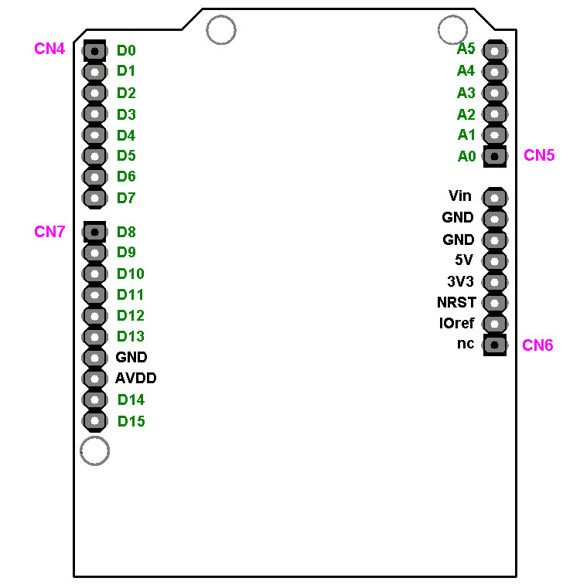

Actual software state
In the following table i tried to comment all implemented features.
Should work : the command should work like the original one
Not implemented yet : the command is not implemented in the current version
Changed syntax : the command has a different syntax to the original one
Not necessary : the command is not used in F746-Version

Please use the MMBasic Language Manual from Geoff for a detailed description
of all the functions, commands and the syntax.

If you found errors in the list or bugs in the software,
please write a comment and send it back to me so i can correct it in the next version.

Operators
Here the arithmetic and logic operators
^ | exponentiation | a = b ^ c
* | multiplication | a = b * c
/ | division | a = b / c
\ | integer division | a = b \ c
Mod | modulus | a = b MOD c
+ | addition | a = b + c ; a$ = b$ + c$
- | subtraction | a = b - c
NOT | logical NOT | a = NOT b
AND | logical AND | a = b AND c
OR | logical OR | a = b OR c
XOR | logical XOR | a = b XOR c
<< | logical shift left | a = b << c
>> | logical shift right | a = b >> c
"=", "<", ">", "<=", ">=", "< >" | comparison | if(a=3) then print "a=3"  if(a>=3) then print "a>=3"

Predefined read only variables
MM.HRES | Should work
MM.VRES | Should work
MM.HPOS | Should work
MM.VPOS | Should work
MM.VER | Should work
MM.DEVICE$ | Should work
MM.DRIVE$ | Should work
MM.FNAME$ | Should work
MM.CMDLINE$ | ?
MM.ERRNO | ?
BLACK | Should work
BLUE | Should work
GREEN | Should work
CYAN | Should work
RED | Should work
PURPLE | Should work
YELLOW | Should work
WHITE | Should work
MM.I2C | Should work
MM.ONEWIRE | Not implemented yet

Commands
program command-line | Not implemented yet
' (single quotation mark) | Should work
? (question mark) | Should work
AUTO | Should work
BLIT | Changed syntax :  BLIT x,y,w,h,xd,yd,roll  x,y = source position  w,h = size  xd,yd = destination offset  roll = 0:no, 1=yes
CHAIN | Not implemented yet
CHDIR | Should work
old : CIRCLE (x,y),r [,c [,aspect [,F]]] | Changed syntax :  CIRCLE (x,y),r [,c1 [,c2 [,F]]]  c1=outcolor, c2=incolor  if aspect <> 1 use the new command ELLIPSE
CLEAR | Should work
CLOSE #nbr | Should work  (Files not implemented yet)
CLOSE CONSOLE | Should work
CLS | Should work
COLOR | Should work
CONFIG | Should work  Implemented settings :  VIDEO [ON / OFF]  FONT [1...6]  CASE [LOWER / UPPER / TITLE]  KEYBOARD [US / FR / GR]  TAB [2 / 4 / 8]  DRIVE [A / B / C]  BGCOLOR [0...65535]  FGCOLOR [0...65535]  AUTORUN [ON / OFF]  BAUDRATE [2400...115200] --> restart
CONTINUE | Should work
COPY | Not implemented yet
COPYRIGHT | Should work
DATA | Should work
DATE$ | Should work
DELETE | Should work
DIM | Should work
DO / LOOP | Should work
DRIVE | Should work  a: = Flash (not implemented yet)  b: = uSD  c: = USB-Drive
DS18B20 | Not implemented yet
EDIT | Should work
ELSE / ELSEIF | Should work
END | Should work
END FUNCTION / END SUB | Should work
ERASE | Should work
ERROROK | Should work
EXIT | Should work
FILES | Should work  (wildcards '*' or '?')
FONT | Should work
FONT LOAD / FONT UNLOAD | Not implemented yet
FOR | Should work
FUNCTION | Should work
GOSUB | Should work
GOTO | Should work
IF / THEN / ELSE | Should work
INPUT | Should work
INPUT #nbr | Should work  (Files not implemented yet)
IR | Not implemented yet
IRETURN | Should work
KILL | Should work
KEYPAD | Not implemented yet
LET | Should work
LCD | Not implemented yet
LIBRARY | Not implemented yet
LINE | Should work
LINE INPUT | Should work
LINE INPUT #nbr | Not implemented yet
LIST | Should work
LOAD | Should work
LOADBMP "File.bmp" [,x[,y]] | Changed syntax :  LOADBMP "File.bmp" [,x[,y[,layer]]]
LOCAL | Should work
LOOP | Should work
MEMORY | Should work
MERGE | Not implemented yet
MKDIR | Should work
MODE | Not necessary in F746-Version
NAME | Not implemented yet
NEW | Should work
NEXT | Should work
ON | Should work
ON KEY | Should work
OPEN „fnam“ | Not implemented yet
OPEN „comspec“ as #nbr  or  OPEN „comspec“ as console  comspec :  COMn:bd,buf,int,intlevel,FC,DE,OC,S2  e.g. : open "COM1:" as 1 | Opens a seriell port „COM1“ or „COM2“  bd = 115200, 57600, 38400, 19200, 9600, 4800  fixed buf size  interrupt not implemented yet  FC only at COM2  DE not implemented yet  OC not implemented yet  S2 = two stopbits
OPTION | Should work  Implemented settings :  BASE, ERROR, PROMT, USB,  BREAK, VIDEO, Fnn
PAUSE | Should work
PIN | Should work
PIXEL | Should work
PLAYMOD | Not implemented yet
POKE | Not implemented yet
PORT | Should work
PRINT | Should work
PRINT @ | Should work
PRINT #nbr | Should work  (Files not implemented yet)
PULSE | Not implemented yet
PWM | Not implemented yet
QUIT | Not necessary in F746-Version
RANDOMIZE | Should work
READ | Should work
REM | Should work
RESTORE | Should work
RETURN | Should work
RMDIR | Should work
RTC  RTC GETTTIME [typ]  RTC SETTIME y,m,d,h,m,s [,typ] | Changed syntax :  [typ] can be :  PCF8563 (default)  PCF8583 (in this case year must be 2015-2018)
RUN | Should work
SAVE | Should work
SAVEBMP | Should work
SCANLINE | Not necessary in F746-Version
SEEK #fnbr | Not implemented yet
SETPIN pin,mode [,resistor] | Should work  Implemented Modes :  OFF, DIN, DOUT,AIN  (DIN can have a 3rd parameter for resistor)  NONE,UP,DOWN (default is "none")
SETPIN pin,mode [,resistor], target | Should work  Implemented Modes :  OFF, INTL, INTH, INTB  can have a 3rd parameter for resistor  NONE,UP,DOWN (default is "none")
SETTICK | Should work
SPRITE | Should work
SUB | Should work
SYSTEM | Not necessary in F746-Version
TIME$ | Should work
TIMER | Should work
TONE | Not implemented yet
TROFF | Should work
TRON | Should work
WATCHDOG | Not implemented yet
XMODEM | Not implemented yet

Functions
ABS | Should work
ASC | Should work
ATN | Should work
BIN$ | Should work
CHR$ | Should work
CINT | Should work
CLR$ | Should work
COLLISION | Not implemented yet
COS | Should work
CWD$ | Should work
DATE$ | Should work
DEG | Should work
DIR$ | Not implemented yet
DISTANCE | Not implemented yet
DS18B20 | Not implemented yet
EOF(#nbr) | Should work  (Files not implemented yet)
EXP | Should work
FIX | Should work
FORMAT$ | Should work
HEX$ | Should work
INKEY$ | Should work
INPUT$(nbr, [#]fnbr) | Should work  (Files not implemented yet)
INSTR | Should work
INT | Should work
KEYDOWN | Should work
LEFT$ | Should work
LEN | Should work
LOC([#]fnbr) | Should work  (Files not implemented yet)
LOF([#]fnbr) | Should work  (Files not implemented yet)
LOG | Should work
LCASE$ | Should work
MID$ | Should work
OCT$ | Should work
PEEK | Not implemented yet
PI | Should work
PIN | Should work
PORT | Should work
POS | Should work
PIXEL | Should work
RAD | Should work
RIGHT$ | Should work
RND | Should work
SGN | Should work
SIN | Should work
SPACE$ | Should work
old : SPI(rx,tx,clk[,dat[,speed]]) | Changed syntax :  SPI(port_nr,dat)  port_nr is 1 or 2 for SPI-1 or SPI-2  dat is the data byte to be send
SQR | Should work
STR$ | Should work
STRING$ | Should work
TAB | Should work
TAN | Should work
TIME$ | Should work
TIMER | Should work
UCASE$ | Should work
VAL | Should work

Other MMBasic commands
CAN | Not implemented yet
I2C | Should work  Only in Master-Mode  Speed = 10kHz to 400 kHz  Option must be 0
ONEWIRE | Not implemented yet
TOUCHVAL | Should work
TOUCH | Should work with TouchObj nr [0...31]  Implemented Modes :  CREATE (B,P,S,C,R,L,H,V)  SIZE (default = 80 x 25)  DISABLE  ENABLE  REMOVE  hint : RadioButtons (R) with the same color are  in the same group  hint : Push-Buttons (B) must be cleared by user with TouchVal(nr)=0  hint : Obj S,H,V don't use the Text-Field  hint : size of Vertical-Sliders (V) must be  defined first e.g. with "Touch Size 25,80"
TOUCHED(#S)  or  TOUCHED(#X)  or  TOUCHED(#Y)  or  TOUCHED(nr) | Should work  Implemented Modes :  #S = reads the status (0=released, 1=pressed)  #X = reads the x-position  #Y = reads the y-position  nr = check the touch status of TouchObj nr  (0=untouched, 1=touched)

New commands for the F746-MMBasic
MTOUCHED(#S)  or  MTOUCHED(#X,nbr)  or  MTOUCHED(#Y,nbr) | #S:  must be done before #X and #Y  reads the number of touch contacts (0 to 5)  #X:  reads the x-position from contact (nbr=1 to 5)  #Y:  reads the y-position from contact (nbr=1 to 5)
MM.FONTHEIGHT  MM.FONTWIDTH | current font height in pixel  current font width in pixel
ACOS, ASIN, CALCCOS, CALCSIN | trigonometric functions
<<, >> | logic functions (shift left, shift right)
INTRND | random integer (0...65535)
ORANGE, BROWN, LRED, DGREY,  GREY, LGREY, LGREEN, LBLUE | default colors
SPI OPEN port_nr [,speed [,mode [,first [,SS]]]  or  SPI CLOSE port_nr | opens or close a SPI-Port  port_nr is 1 or 2 for SPI-1 or SPI-2  speed is optional and can be 0 to 7  mode is optional and can be 0 to 3  first is optional : 'L' or 'M' for LSB/MSB  'SS' is optional and activates the SlaveSelect-Pin
TRIANGLE  ELLIPSE  QUAD  RECT x,y,width,height,c1[,c2,F]  ROUNDRECT x,y,width,height,r,c1[,c2,F] | draws a triangle  draws a ellipse  draws a rectangle (with a given angle)  draws a rectangle (F=filled)  draws a rounded recrangle (r=radius, F=filled)
SETLAYER #nr  a = GETLAYER  SHOWLAYER #nr  COPYLAYER #source,#destination | set the active layer to draw into  get the active layer number  show the layer at the lcd  copy one layer to another  (#nr = layer number 0..2)
MAP | draws a map
LOADJPG "File.jpg" [,x[,y[,layer]]] | loads a JPG and draw at x,y on a layer
WAVE LOAD "File.wav",ID  WAVE PLAY ID,Volume  WAVE LOOP ID,Volume  WAVE STOP ID  WAVE CLEAR | load one WAVE File (ID = 0 to 20)  play one WAVE File (once)  play one WAVE File (in a loop)  Stop playing  Clear all WAVE Files in RAM

OBJ3D | draws a 3d object
POLYPOINT  POLYCENTER  POLYGON  POLYMOVE  ROTATEPOLY  LOADPOLY | defines a polygon point  defines a center point from a polygon  draws a polygon  moves a polygon  rotates a polygon  load a polygon (use Polygon.exe to create)
MPU6050 INIT  MPU6050(#S)  or  MPU6050(#GyroX)  MPU6050(#GyroY)  MPU6050(#GyroZ)  or  MPU6050(#AccX)  MPU6050(#AccY)  MPU6050(#AccZ)  or  MPU6050(#Temp) | Inits a MPU6050 on I2C-Port  #S  must be done before #Gyro and #Acc  reads all Data from the MPU (-1=err, 0=ok)  #Gyro  reads the Gyro-Data  #Acc  reads the Accelerometer-Data  #Temp  reads the Temperature
JoyInit  JoyGet | Inits a Joystick at Digital-IOs  Read one Joystick direction

Syntax of the new commands in F746-MMBasic

aCos
aCos(x)
Give back the inverse Cosine of x

aSin
aSin(x)
Give back the inverse Sine of x

CalcCos
CalcCos(angle)
Give back the pre computed Cosine from Angle , the angle is rounded to integer.

CalcSin
CalcSin(angle)
Give back the pre computed Sine from Angle , the angle is rounded to integer.

Circle
Circle(x,y),radius,outcolor[,incolor[,F]]
x,y : Coordinate from the Circle center
radius : Radius from the Circle
outcolor : Circle border color
incolor : Circle Fill color
F : Circle is filled
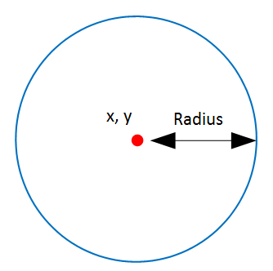

Ellipse
Ellispse(x, y), radiusx, radiusy, outcolor, incolor, F
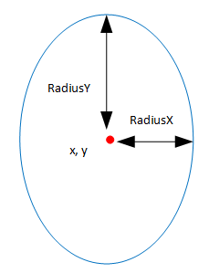
x, y : Coordinate from the Ellipse center
radiusx : Radius in the x direction (left/right)
radiusy : Radius in the y direction (up/down)
outcolor : Border color
incolor : Fill color
F : Ellipse is filled

Triangle
Triangle(x1, y1, x2, y2, x3, y3), outcolor, incolor, F
x1, y1 to x3, y3 : The 3 coordinate that represent your triangle
outcolor : The border color
incolor : The fill color
F : The triangle is filled
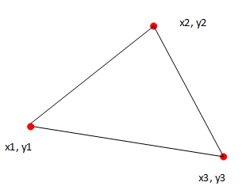

Sprites
Sprite are no more compatible with the PIC32 Maximite version.
The Sprite Editor can Load the 2 colors and 8 colors Sprite from Maximite and convert them to the
new Binary format.
You can load up to 500 Sprites, each of them can be up to 32 x 32 pixels.
Syntax:
Sprite Load “spritefile.bin”
The command will Load all sprites from the file and put them in memory.
The first Sprite loaded will be the Sprite 0.
Sprite Set source,destination
Information from the Sprite Source will be copied into the destination array to be able to use
this Sprite. For example, if you want to animate Sprites you just have to copy another source
sprite number into the same destination one.
Sprite ON Sprite_number, x, y
The Sprite will be shown at coordinate x, y on screen.
Note that the Sprite number have to be set with Sprite Set command in first case.
The x, y coordinate represent the upper left corner from the sprite.

Maps
With map you can load Games map for use with your game, you can also use it to store another picture. This map is saved into the SDRAM and can be up to 1Million pixels.
The Height and Width from the map is not limited so long the (Height * Width) is less than 1
Million Pixels. For be able to load a Map file you have to convert your picture with the Map converter.
Syntax:
Map Load “mapfile.map”
The command will Load the Map from the file and put it in Map memory.
Map ON startx, starty, width, height, destx, desty, transparent, transparent color.
The command will get a part from the map graphics and show it on screen.
If you get a part of the Map that is bigger than the screen (480*272), the result will be
clipped on screen.

Pixel
The pixel function is still compatible with the original Maximite, but, I added the ability to get the pixel color from Any of the Layer.
Syntax:
Color = Pixel(x, y)
The function return the actual color from the pixel at x,y from the current used graphics
layer.
Color = Pixel(x, y, layer)
This one return the pixel color at x, y from the defined layer.
Layer number can be 0, 1, 2 or 10 for Map buffer. (See Layer command)

Layer
The STM32F7 can use 2 layer for build picture on screen.
You can set a layer, draw on this layer, then show the layer.
This method prevent flickering on screen
I added one working layer that can be copied to one of the other layer.
It’s good for put in GUI graphics that never change or other graphics element we want often copy to
other layer.
Syntax :
SetLayer number
Set the layer where we want draw
Number can be 0, 1, 2
ShowLayer number
Show the layer set with number
Number can be 0 or 1
CopyLayer source, destination
Copy from one layer to another one
Source and destination can be 0, 1, or 2
You cannot copy one layer to itself!

Quad
Quad(x, y, width, height, angle), outcolor, incolor, F
The Quad is a rectangle like polygon that can be rotated
x, y : Middle coordinate from the Quad
width, height : Size of the Quad
angle : Rotation angle from the Quad
outcolor : border color
incolor : Fill color
F : The Quad is filled
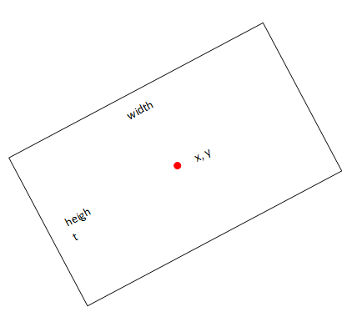

3D-Objects
You have the ability to show 3D Object on this version of MMBasic.
The actual limitation are:
You can load a maximum of 25 object (0 to 24)
Each object can have a maximum of 600 Vertex and 600 Faces
The 3D Object converter take 3D Studio ASC file format and save it in a form that can be read with
MMBasic. (make sure to deactivate "UV")
For convert OBJ, DAE etc. … to 3DS ASC, I use AcuTrans3D.
The not registered version can save in ASC and its easy to use!
Syntax:
Obj3D Load “obj.b3d”, Objnumber, incolor, outcolor
Here we Load the file “obj.b3d”
Objnumber can be 0 to 24
Incolor is the border color from vertices
Outcolor is the fill color
Obj3D Set Objnumber, x, y, z, ax, ay, az, zoom, active
We give parameter to a loaded 3D Object for specify where we want it to draw, the angle
and the size.
Objnumber : Number from the object from 0 to 24
x, y, z : Coordinate from the object in 3D Space
ax, ay, az : Angle to apply on each axis from the object
Zoom : For resize the object, zoom of 1 will show the original size
Active : 1 will set this object active, 0 will set the object inactive and it will not be shown
Object3D ON filled
We show all loaded and active object to screen.
Filled : If filled is set to 1, all 3D Objects will be filled

Polygons
The easy way to draw little more complex form is to use the Polygon command (or Polygon.exe).
A polygon is defined from a list of points.
Actually a polygon can have up to 100 points (0 to 99)
You can define 100 different Polygons, Polygon number must be between 0 and 99
They are several easy to use commands for set , move, rotate Polygons (and load from file).
Syntax:
PolyPoint Poly_number, Point_number, x, y
We have to use this command to set all points from a polygon.
Poly_number : Number from the Polygon (0 to 99)
Point number : Number from the point we set the coordinate (0 to 99)
x, y : Coordinate from this point
PolyCenter Poly_number, x,y
We set the center point from the Polygon
This point will be used if you want rotate the Polygon
This point can be set everywhere, you don’t have to place it into the Polygon itself.
Poly_number : Number from the Polygon (0 to 99)
x, y : Coordinate from the Polygon center point
Polygon Poly_number, Point_count, outcolor [, incolor[, F]]
Draw a Polygon on screen.
Poly_number : Number from the Polygon (0 to 99)
Point_count : Number of point defining this polygon, if you have defined point 0 to 23 then this polygon have 24 points.
Outcolor : border color
Incolor : fill color
F : The polygon is filled ‘optional’
PolyMove Poly_number, x,y
Use this command for move the Polygon somewhere on the screen.
It is like you move the center point and the rest of the Polygon follow it.
Poly_number : Number from the Polygon (0 to 99)
x, y : New Coordinate from the Polygon center point (All other points follow)
RotatePoly Poly_number, Point_count, angle, outcolor [, incolor[, F]]
Draw a Polygon rotated to the given angle.
The Polygon will rotate around his Center point defined with the PolyCenter command.
Poly_number : Number from the Polygon (0 to 99)
Point_count : Number of point defining this polygon, if you have defined point 0 to 23
then this polygon have 24 points.
Angle : angle we rotate the polygon
Outcolor : border color
Incolor : fill color
F : The polygon is filled ‘optional’

PolyPoint example :

Point 0 to 11 define this Polygon , it’s a 12 points Polygon

PolyPoint 0,0,100,20 set the point 0 from polygon 0 to coordinate 100 , 20
PolyPoint 0,1,200,20 set the point 1 from polygon 0 to coordinate 200 , 20
……
PolyPoint 0,11,100,30 set the point 11 from polygon 0 to coordinate 100 , 30

You will get a polygon with this form :

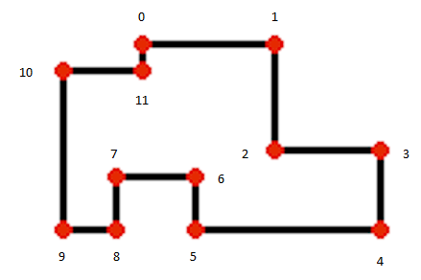
PolyCenter example :

Now we are going to set the Center from the Polygon ,
or if you prefer the coordinate from where the Polygon can be rotated

PolyCenter 0,140,60 set the Center point to coordinate 140 , 60

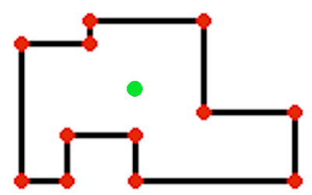
Polygon example :

The polygon is now complete and can be drawn on screen with :
Polygon 0,12,Red draw the 12 points polygon 0 with Red outer line
Polygon 0,12,Red,Blue,F draw the 12 points polygon 0 with Red outer line and Filled with Blue color.

PolyRotate example :

You can also Rotate the polygon like this :

PolyRotate 0,12,45,Red It will show the polygon rotated to 45 degrees around the center point.

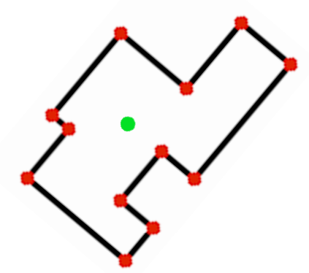

Note that the center point is invisible and just drawn here for information.

Polymove example :

Now we are going to move the Polygon somewhere else on the screen.

PolyMove 0,340,150 Move the polygon from the original 140,60 coordinate to 340,150 coordinate.
This will move the Center point with the Polygon
For move the Center point alone use the PolyCenter command.

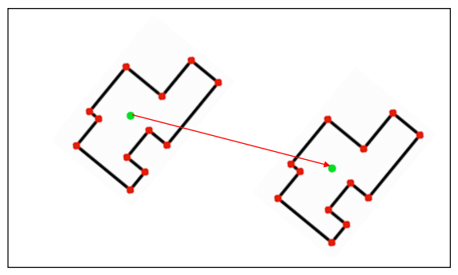
LoadPoly example :

Instead of creating a polygon at runtime with the "polypoint" command you can also use
the external program "Polygon.exe". Here you can create polygons and save it to a file.

To load a polygon you have to know the number of points (see "Nb Point")

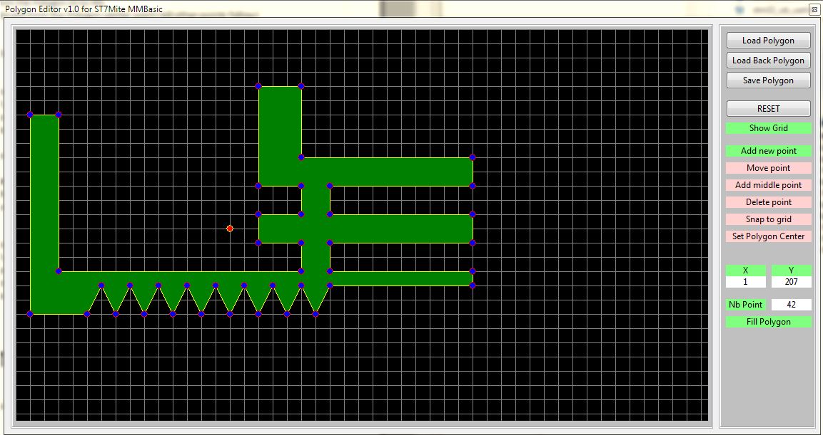
Syntax : LoadPoly "Filename.pol" , Poly_number Loads a polygon from file

Joystick
You can connect a Joystick with 4 directions and two firebuttons at the GPIO-Pins :
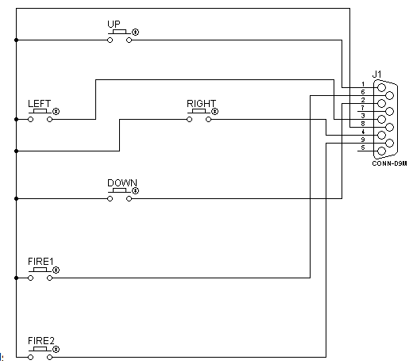
JoyInit(up, down, left, right, button1, button2)
Use this command to init a Joystick at the GPIO-Pins.
Each of the parameter correspond to a pin number on the Arduino connector.
For example , if you use : JoyInit(3,4,5,6,7,8)
Pin 3 is UP
Pin 4 is DOWN
Pin 5 is LEFT
Pin 6 is RIGHT
Pin 7 is Fire button 1
Pin 8 is Fire button 2
The JoyInit command setup the needed pin and activate the internal pull-up resistor.
It means that the status from a non-used direction or button will be 1.
JoyGet(#UP) : Give back the UP direction
JoyGet(#DOWN) : Give back the DOWN direction
JoyGet(#LEFT) : Give back the LEFT direction
JoyGet(#RIGHT) : Give back the RIGHT direction
JoyGet(#B1) : Give back the Button1 status
JoyGet(#B2) : Give back the Button2 status

