Topic Modeling of Low Starred Reviews on Restaurants

Yang Yuzhong

11/10/2015

## Introduction

*“The most important thing in communication is hearing what isn't being said. The art of reading between the lines is a life long quest of the wise.”*  
― Shannon L. Alder

The following report seeks to assist restaurant businesses to answer the question on the Top 10 related topics that reviewers have to say when giving restaurants negative reviews.

Topics generated from *Latent Dirichlet Allocation*, a Topic Modelling algorithm, show that customers generally give 1-2 stars review if they:

1. Went to the restaurant at night

2. Long waiting time

3. Accompanied by friends

4. Had orders taken back to the kitchen

5. Ate at the restaurant

6. Had interactions with the service staff

7. Enjoyed great service and food (probably hard to please)

8. Tend to have fried chicken

9. Pricing of the restaurant menu

10. Not a returning customer

## What is Topic Model and Latent Dirichlet Allocation?

Topic Models is a research field in Natural Language Processing and Machine Learning. The models which are built on a collection of documents, are probabilistic in nature and seeks to discover abstract "topics" in the collection of documents. In short, attempts to cluster words into bags of "topics".

The topic modelling algorithm used in the report is Latent Dirichlet Allocation (LDA) which is a Bayesian Network and a probabilistic model.

The algorithm performs topic discovery with the following steps:

1. Pre-defining the number of topics or find the LDA model with the highest statistical certainty (logisitic likelihood).

2. Assign every word to a temporary topic in a semi-random manner (using Dirichlet distribution).

3. Update the topic assignments based on prevalence of the particular word across topics and prevalence of topics in the particular document

## Data Preprocessing Methods

### Obtaining the data

The zip file containing the dataset was downloaded from this [link](https://d396qusza40orc.cloudfront.net/dsscapstone/dataset/yelp_dataset_challenge_academic_dataset.zip) on the Coursera Course mainpage. This was then extracted into *"raw*data"_ directory.

### Importing the data

The relevant data, namely business and reviews, were imported and saved in *"imported*data"_ using jsonlite package.

library(jsonlite)  
  
# Setting variables for individual JSON files  
json_business <- "raw_data//yelp_academic_dataset_business.json"  
json_review <- "raw_data//yelp_academic_dataset_review.json"  
  
# Reading in each json file and store as RData object for ease of loading  
business <- stream_in(file(json_business))  
save(business, file="imported_data//business.RData")  
  
review <- stream_in(file(json_review))  
save(review, file="imported_data//review.RData")

### Extracting the relevant data

Following this, the data from restaurant business category was extracted from the business dataset and joined with review dataset using the column business_id. After the join, restaurant related reviews of 1-2 stars were extracted for preprocessing in the next step.

# load data  
load("imported_data//business.RData")  
load("imported_data//review.RData")  
  
#Filter businesses to target only Restaurants  
restaurants<-business[grep("Restaurants",business$categories),]  
  
#Filter reviews for restaurants  
restaurantreview <- review[review$business_id %in% restaurants$business_id,]  
  
#Obtain low star reviews  
lowstarreview<-restaurantreview[restaurantreview$stars < 3, ]  
  
#Number of reviews to perform text mining on  
length(lowstarreview$stars)

### Preprocessing and Cleaning of the Corpus

The text from low starred restaurant reviews were put into a Corpus which then undergo the following data cleaning steps:

1. Removal of non-ASCII characters

2. Setting all characters to lower case

3. Removal of stop words (words like *the, is, at, which* etc)

4. Removal of numbers

5. Removal of puncuations

6. Stemming to obtain the English root word

7. Filtering of words below 3 characters

8. Filtering of words that are rarely found across all reviews

Lastly, irrelevant reviews with words that were filtered by the previous steps were also removed from the Corpus.

library(tm)  
library(SnowballC)  
library(stringi)  
library(slam)  
  
#Function for removing non ascii characters  
removeNonASCII <- function(x)   
{  
 iconv(x, "latin1", "ASCII", sub="")  
}   
  
#Create Corpus  
reviewCorpus <- Corpus(VectorSource(lowstarreview$text))  
save(reviewCorpus,file="work_data//originalCorpus.RData")  
   
  
#Clean Corpus  
reviewCorpus <- tm_map(reviewCorpus, content_transformer(removeNonASCII))  
reviewCorpus <- tm_map(reviewCorpus, content_transformer(tolower))  
#Create DTM  
reviewDtm <- DocumentTermMatrix(reviewCorpus, control = list(

stemming = TRUE,   
 stopwords = TRUE,  
 removeNumbers = TRUE,   
 removePunctuation = TRUE,   
 minDocFreq=2,   
 minWordLength=3))  
save(reviewDtm,file="work_data//reviewDtm.RData")  
  
#Remove Sparse Terms  
reviewDtmCompact <- removeSparseTerms(reviewDtm, sparse=0.9)  
  
#Find rows with empty documents  
rowTotals <- apply(reviewDtmCompact , 1, sum)  
  
#remove empty documents from the existing corpus and build a new one  
reviewDtmCompact <- reviewDtmCompact[rowTotals> 0, ]  
save(reviewDtmCompact,file="work_data//reviewDtmCompact.RData")

## Preliminary Data Exploration

### Word Cloud and Exploring the feasibility of the Question

reviewDtmCompact$nrow

## [1] 183176

reviewDtmCompact$ncol

## [1] 90

After the data preprocessing and removal of reviews that contains irrelevant terms, the number of reviews we are left with is 183176 and number of terms is 90.

Before diving deeper to perform the LDA modelling on the 1-2 star restaurant reviews, a wordcloud is used to determine whether there are distinct words with high frequency in the 1-2 star restaurant review corpus to answer the question on the Top 10 related topics that reviewers have to say when giving restaurants negative reviews.

library(wordcloud)  
corpus.matrix <- as.matrix(reviewDtmCompact)  
corpus.sorted <- sort(colSums(corpus.matrix), decreasing=TRUE)  
terms <- names(corpus.sorted)  
terms.df <- data.frame(word=terms, freq=corpus.sorted)  
wordcloud(terms.df$word, colors=c(3,4), random.color=FALSE, terms.df$freq, min.freq=35000)

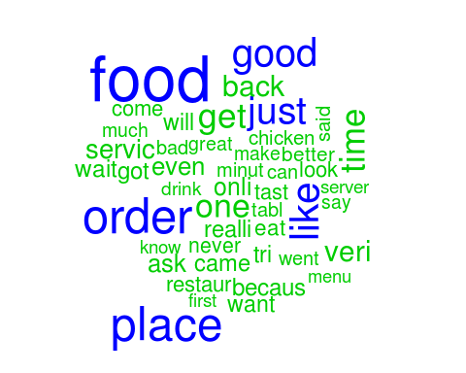

From the wordcloud, we could pick up terms like *order*,*place*,*food* that will be relevant to answering our question. Also, terms like *like*,*just*,*good* may not assist us much in determining the resulting topics. Despite the preliminary word term exploration show that there may not be 10 distinct topics on 1-2 star restaurant reviews, we could still look at the resulting LDA model and find topics that will be relevant to the question.

## Topic Modelling and Results Discussion

### Searching for the Best Fit LDA Model

As we would not be able to identify the number of topics the review dataset would yield beforehand, LDA modelling was performed for 5-20 topics (due to computer limitations).

library(tm)  
library(SnowballC)  
library(topicmodels)  
  
# Due to the vast amount of reviews, I will only run this for 100 iterations  
topicNum <- seq(5, 20, 1)  
burnin <- 100  
iter <- 100  
keep <- 50  
fitted_many <- lapply(topicNum, function(k) LDA(reviewDtmCompact,   
 k = k,  
 method = "Gibbs",  
 control = list(

burnin = burnin,  
 iter = iter,   
 keep = keep)))

After running LDA models on 5-20 topics, each model would yield a logistic likelihood, which is the statistical significance of the model. Using this, we could derive the harmonic mean of each LDA model and determine the likelihood of the review dataset given the number topics. In other words, the higher the harmonic mean, the higher the likelihood of the dataset would yield the number of topics.

library(Rmpfr)  
#Function to calculate harmonic mean  
harmonicMean <- function(logLikelihoods, precision = 2000L) {  
 llMed <- median(logLikelihoods)  
 as.double(llMed - log(mean(exp(-mpfr(logLikelihoods,  
 prec = precision) + llMed))))  
}  
  
#Extract logliks from each topic  
logLiks_many <- lapply(fitted_many, function(L)

L@logLiks[-c(1:(burnin/keep))])  
  
#Compute harmonic means  
hm_many <- sapply(logLiks_many, function(h) harmonicMean(h))

With the harmonic mean from each of the LDA model of 5-20 topics, the topic number is plotted against harmonic mean to choose the best fit model.

ldaplot <- ggplot(data.frame(topicNum, hm_many), aes(x=topicNum, y=hm_many)) + geom_path(lwd=1.5) +  
 theme(text = element_text(family= NULL),  
 axis.title.y=element_text(vjust=1, size=16),  
 axis.title.x=element_text(vjust=-.5, size=16),  
 axis.text=element_text(size=16),  
 plot.title=element_text(size=20)) +  
 xlab('Number of Topics') +  
 ylab('Harmonic Mean') +  
 ggtitle(expression(atop("LDA Analysis of Negative Restaurant Reviews")))  
ldaplot

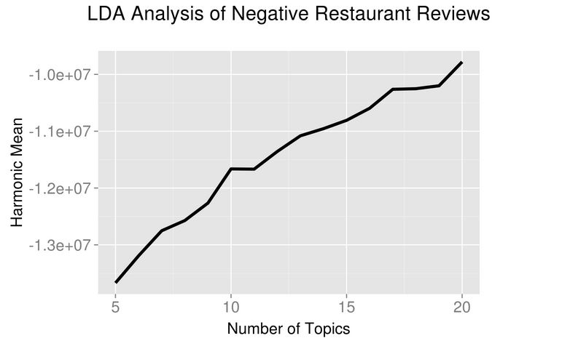

From the results of the plot, the LDA model with 20 topics was chosen to derive the top 10 topics on 1-2 star reviews for restaurants.

# Obtain the 20 topic LDA model for further analysis  
model<-fitted_many[[16]]

## Results of the LDA

With the 20 topic LDA model, the top 5 terms related to the 20 topics were extract and put into topicLabel and take a look at the resultant topics.

review.terms <- as.data.frame(terms(model, 30), stringsAsFactors = FALSE)  
topicTerms <- gather(review.terms, ReviewTopic)  
# Rank the topics  
topicTerms <- cbind(topicTerms, Rank = rep(1:30))  
# Filter the top 5 terms for each topic  
topTerms <- filter(topicTerms, Rank < 6)  
topTerms <- mutate(topTerms, ReviewTopic = word(ReviewTopic, 2))  
topTerms$ReviewTopic <- as.numeric(topTerms$ReviewTopic)  
topicLabel <- data.frame()  
# Combine the top 5 terms in each topic as label  
for (i in 1:20){  
 term <- filter(topTerms, ReviewTopic == i)  
 combined.frame <- as.data.frame(paste(term[1,2], term[2,2],   
 term[3,2], term[4,2],  
 term[5,2], sep = " " ),   
 stringsAsFactors = FALSE)  
 topicLabel <- rbind(topicLabel, combined.frame)  
}  
colnames(topicLabel) <- c("Label")

We could group reviewers giving restaurant 1-2 star reviews based on the top 5 terms from the top 10 topics in the LDA model.

topicLabel[1:10,]

## [1] "night use went back still" "wait minut waitress tabl anoth"  
## [3] "got friend one went even" "order came take took back"   
## [5] "eat can here peopl make" "ask said server told came"   
## [7] "food servic service great good" "tast chicken like fri good"   
## [9] "better price much way noth" "never will back again ever"

## Discussion on the Topics from LDA model

### Inference of Topics based on terms

Based on the top 10 topics of 1-2 star reviews tend to be given to restaurants, we could infer the following customer behaviour that results in low star reviews:

1. Went to the restaurant at night
2. Long waiting time
3. Accompanied by friends
4. Had orders taken back to the kitchen
5. Ate at the restaurant
6. Had interactions with the service staff
7. Enjoyed great service and food (probably hard to please)
8. Tend to have fried chicken
9. Pricing of the restaurant menu
10. Not a returning customer

### Further Topic model exploration through visualization with LDAvis

The top 10 topics inferred using the top 5 probability of terms appearing in a topic may not represent the topic correctly, hence, the R LDAvis package is used to generate an interactive visualization to explore topics related to 1-2 star restaurant reviews.

Firstly, the corpus is transformed into a JSON file to be read into the visualization.

#Function to transform LDA model into JSON for display  
topicmodels_json_ldavis <- function(fitted, corpus, doc_term){  
 # Required packages  
 library(topicmodels)  
 library(dplyr)  
 library(stringi)  
 library(tm)  
 library(LDAvis)  
   
 # Find required quantities  
 phi <- posterior(fitted)$terms %>% as.matrix  
 theta <- posterior(fitted)$topics %>% as.matrix  
 vocab <- colnames(phi)  
 doc_length <- vector()  
 for (i in 1:length(corpus)) {  
 temp <- paste(corpus[[i]]$content, collapse = ' ')  
 doc_length <- c(doc_length, stri_count(temp, regex = '\\S+'))  
 }  
 temp_frequency <- inspect(doc_term)  
 freq_matrix <- data.frame(ST = colnames(temp_frequency),  
 Freq = colSums(temp_frequency))  
 rm(temp_frequency)  
   
 # Convert to json  
 json_lda <- LDAvis::createJSON(phi = phi, theta = theta,  
 vocab = vocab,  
 doc.length = doc_length,  
 term.frequency = freq_matrix$Freq)  
   
 return(json_lda)  
}  
  
# Convert reviewDtmCompact back to corpus for LDAvis json creation  
dtm2list <- apply(reviewDtmCompact, 1, function(x) {  
 paste(rep(names(x), x), collapse=" ")  
})  
reviewCorpus <- VCorpus(VectorSource(dtm2list))  
  
# Generate JSON to be passed into serVis to display the LDA visualization  
ldavis_json<-topicmodels_json_ldavis(model,reviewCorpus,reviewDtmCompact)  
  
# To upload the visualization to github for sharing  
serVis(ldavis_json, as.gist=TRUE)

The uploaded visualization of the 20-topic LDA model can be accessed from [link](http://bl.ocks.org/crusainte/raw/8c348220ad876284d667/#topic=0&lambda=1&term=).

## Citations

1. Topic Modeling in R by David Meza - <http://davidmeza1.github.io/2015/07/20/topic-modeling-in-R.html>
2. Latent Dirichlet Allocation by Martin Ponweiser - <http://epub.wu.ac.at/3558/1/main.pdf>
3. Topic Modeling using LDA in R - <http://www.codemiles.com/r-examples/topic-modeling-using-lda-in-r-t11119.html>