Lab2: Mobile Application Development

1

Usama Bin Iftikhar - 021-19-0053
  
March 31, 2022

1 Emoji Mood Changer

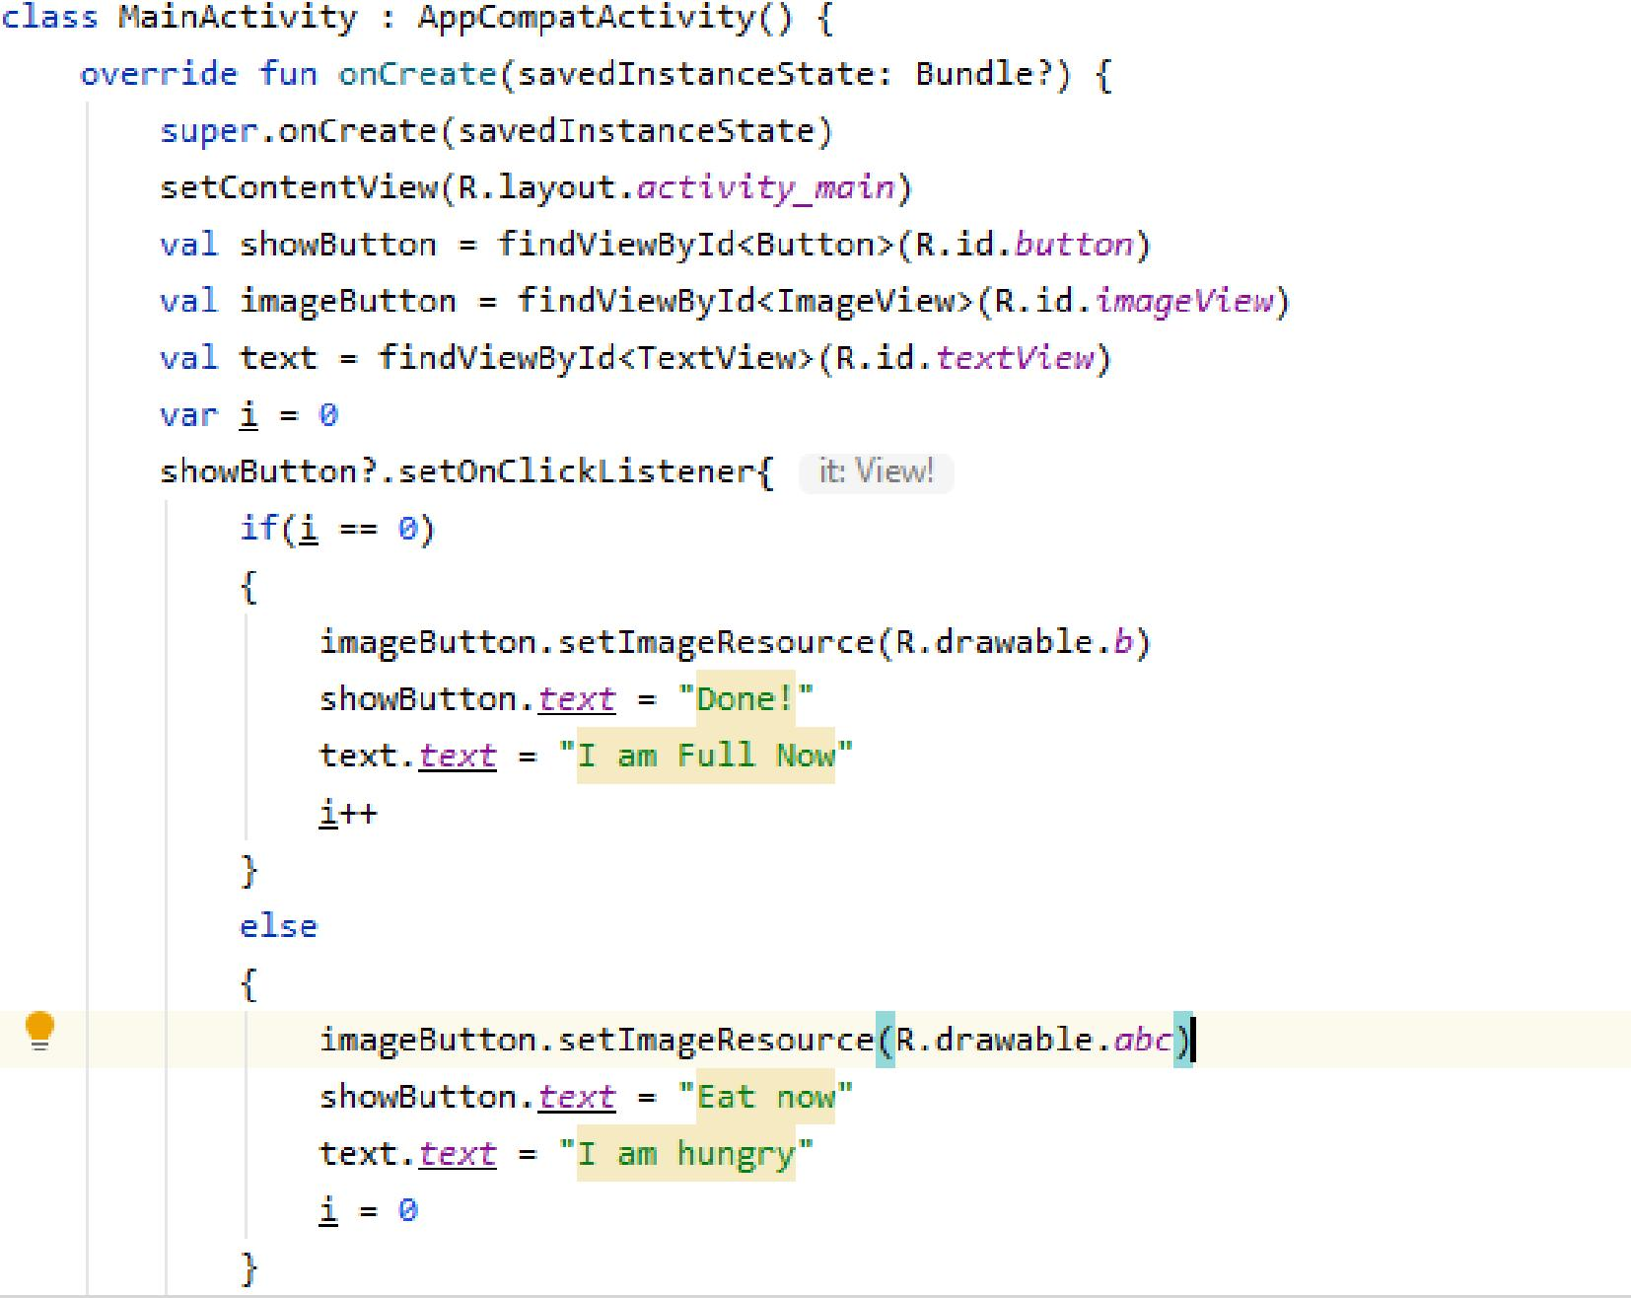

Figure 1: Code For Emotions Change

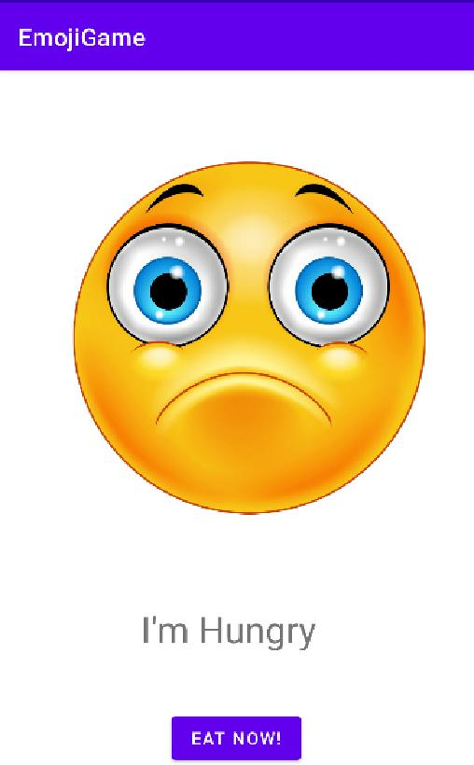

Figure 2: Hungry Mood

2





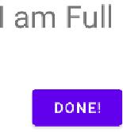

Figure 3: Happy Mood after meal

2 Coffee Shop

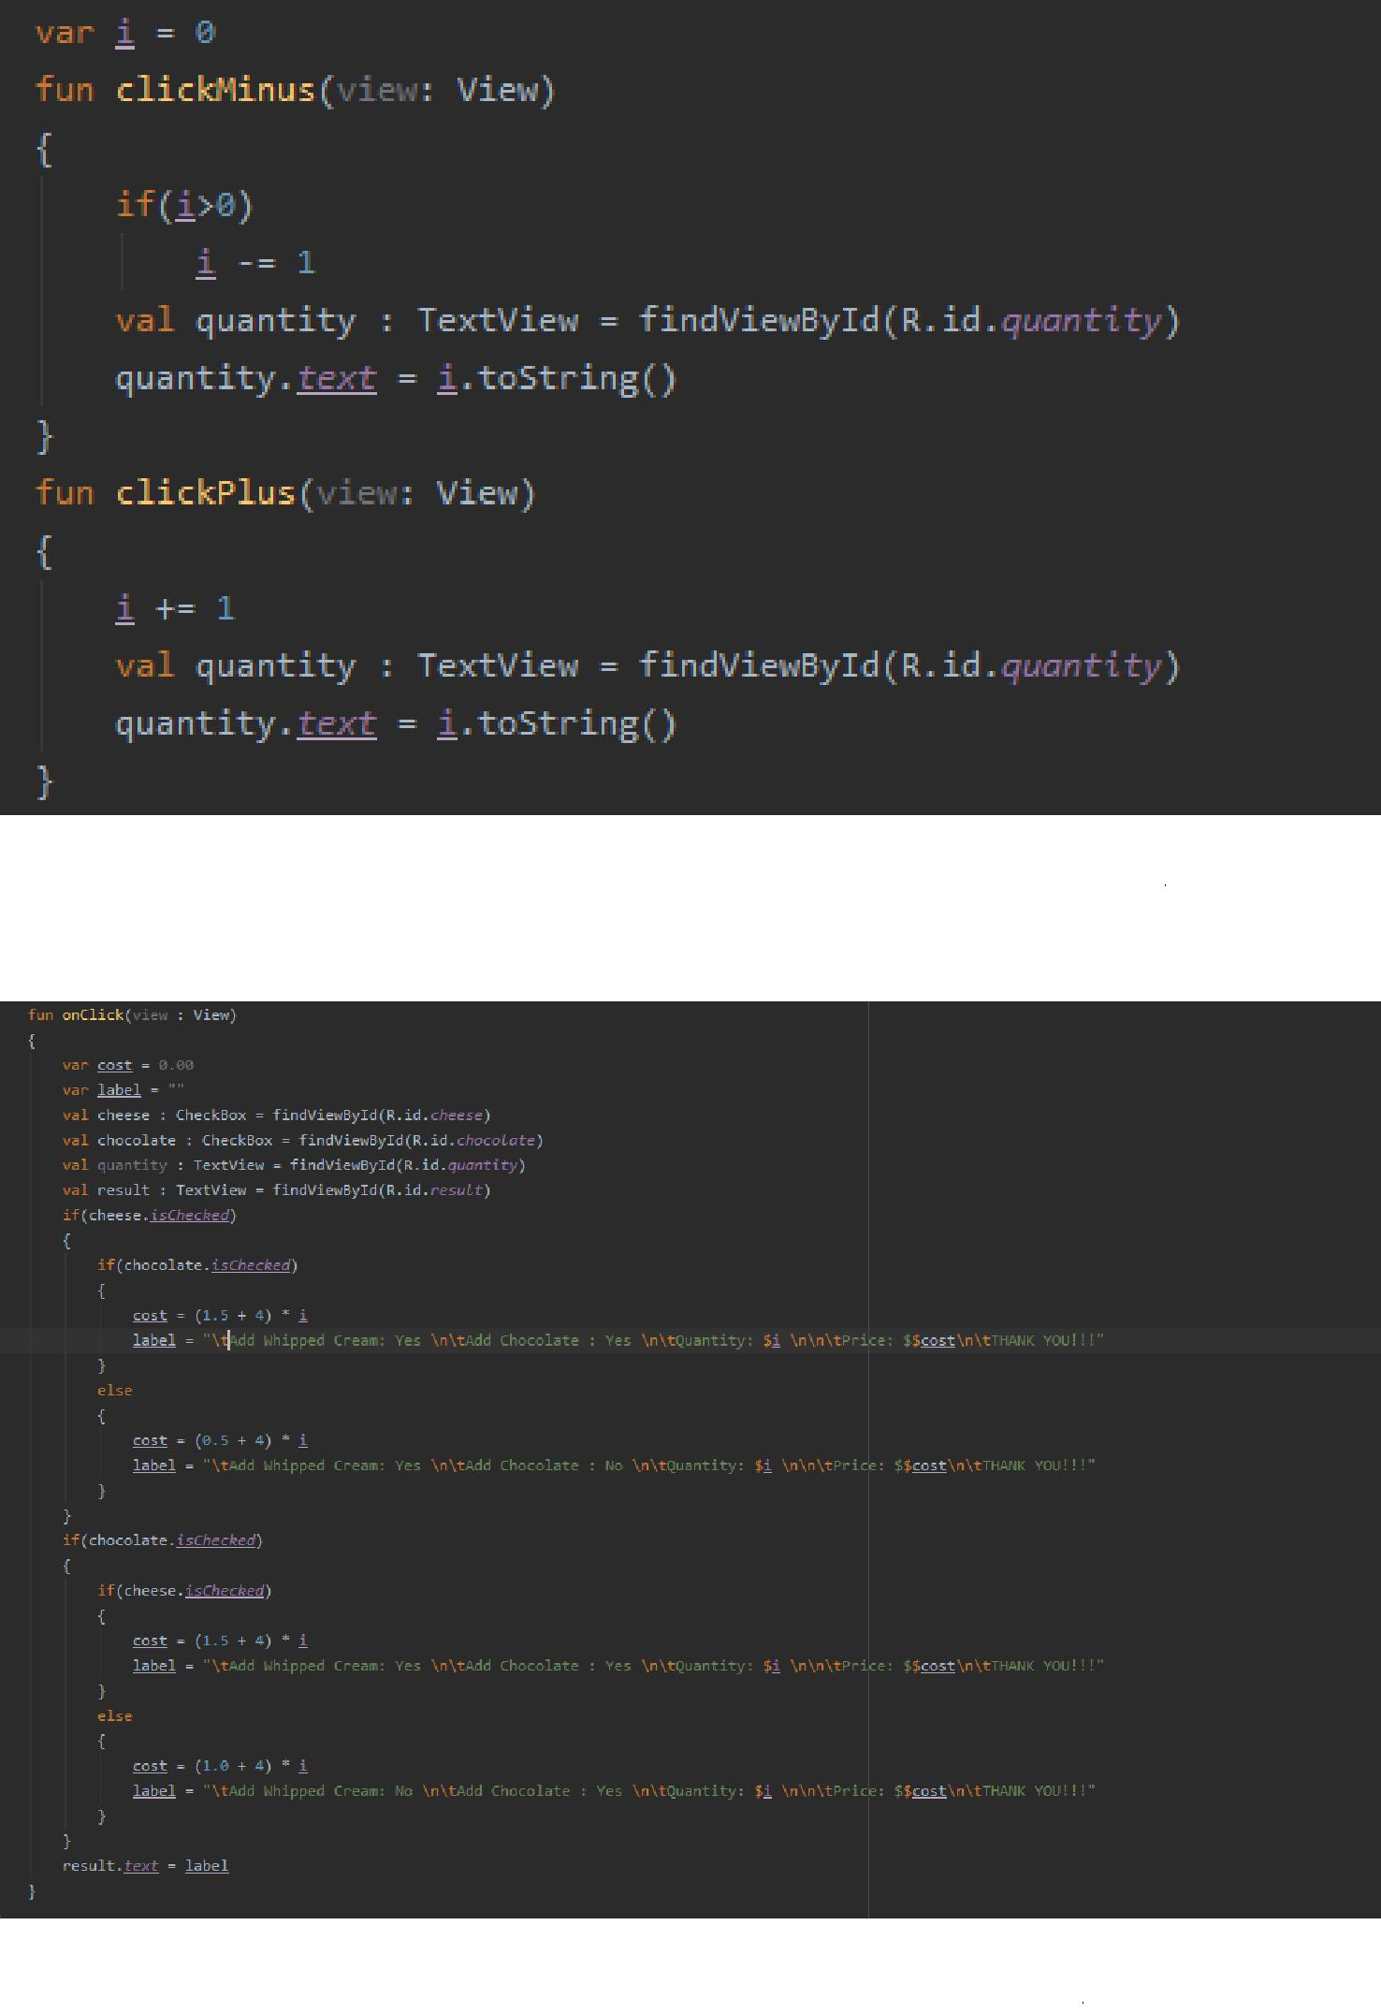

Figure 4: On Click Methods for minus and plus counter

Figure 5: On Click Methods for Order Button

3

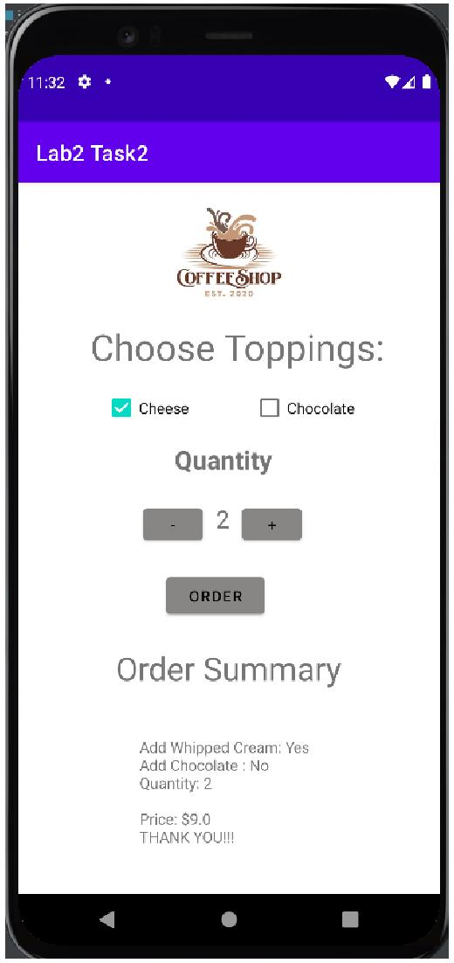

Figure 6: Interface of Coffee Shop

4

3 Calculator

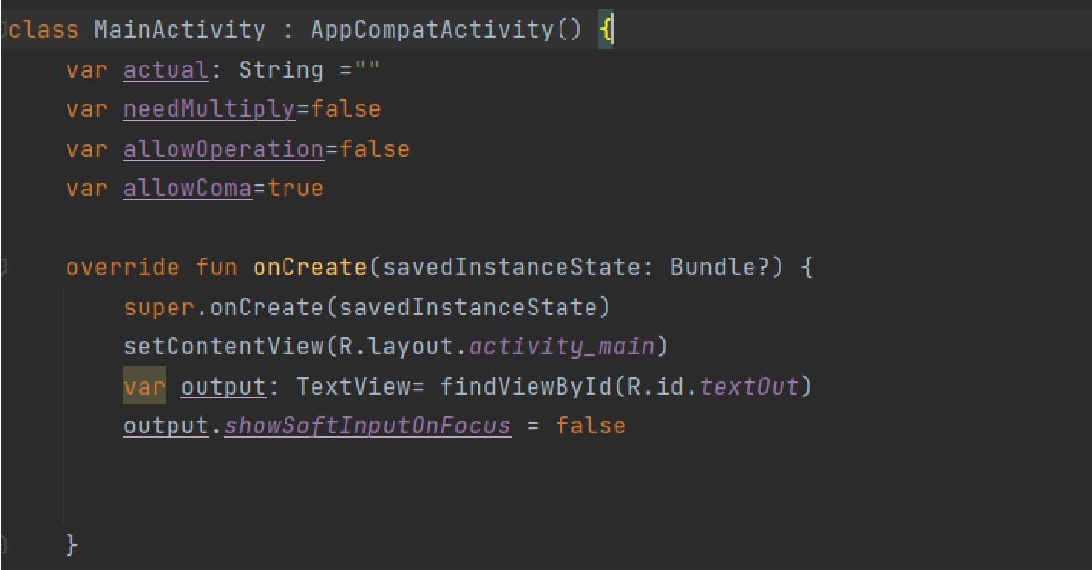

Figure 7: OnCreate Method

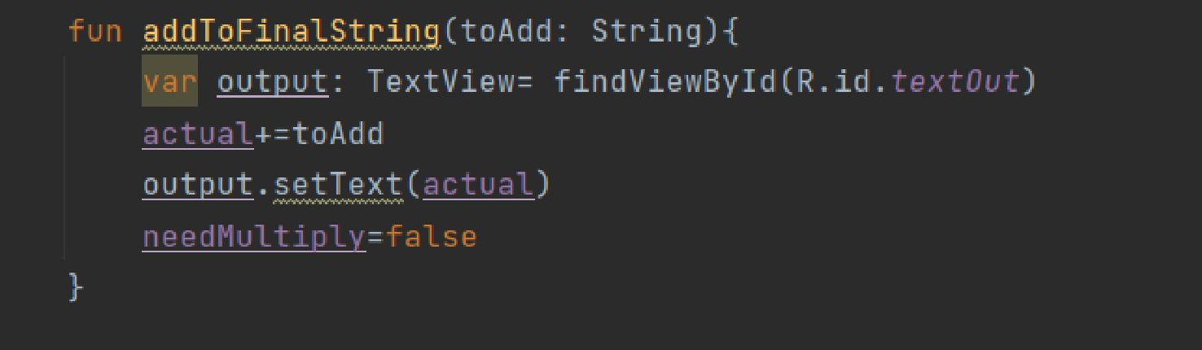

Figure 8: Add to final String

5

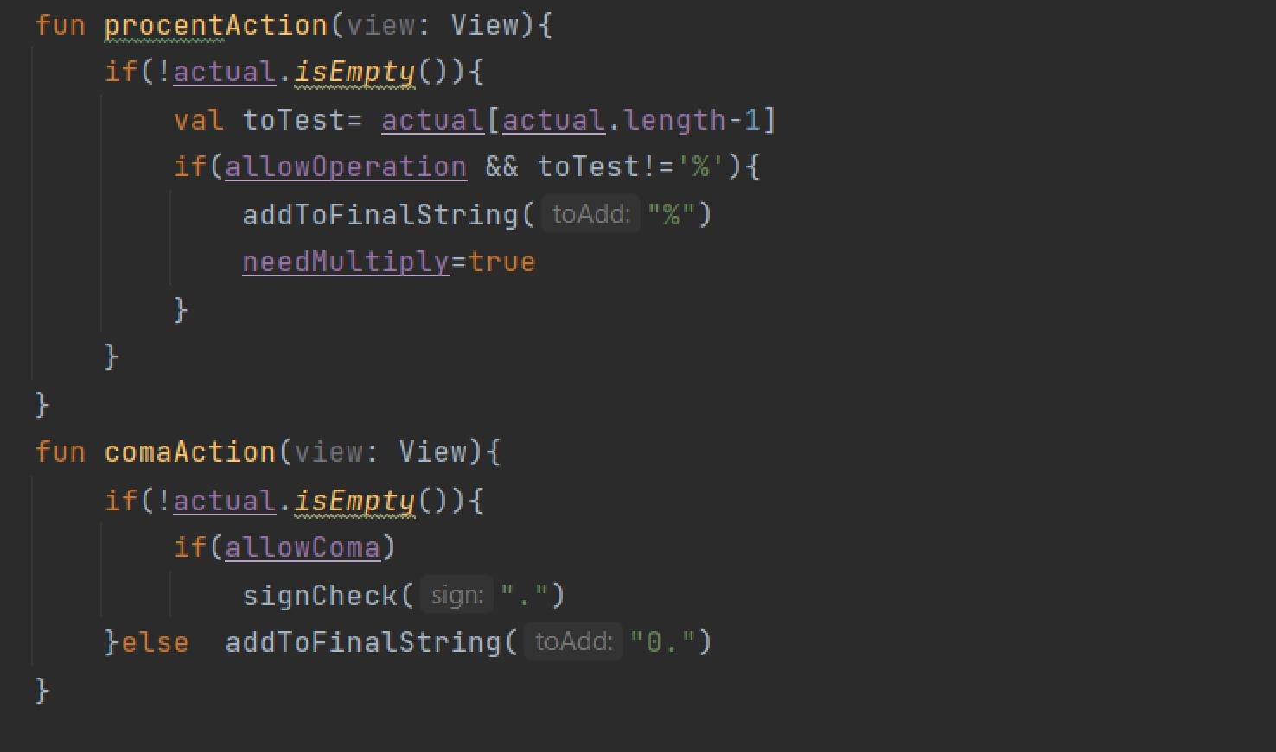

Figure 9: Percent and Coma Action

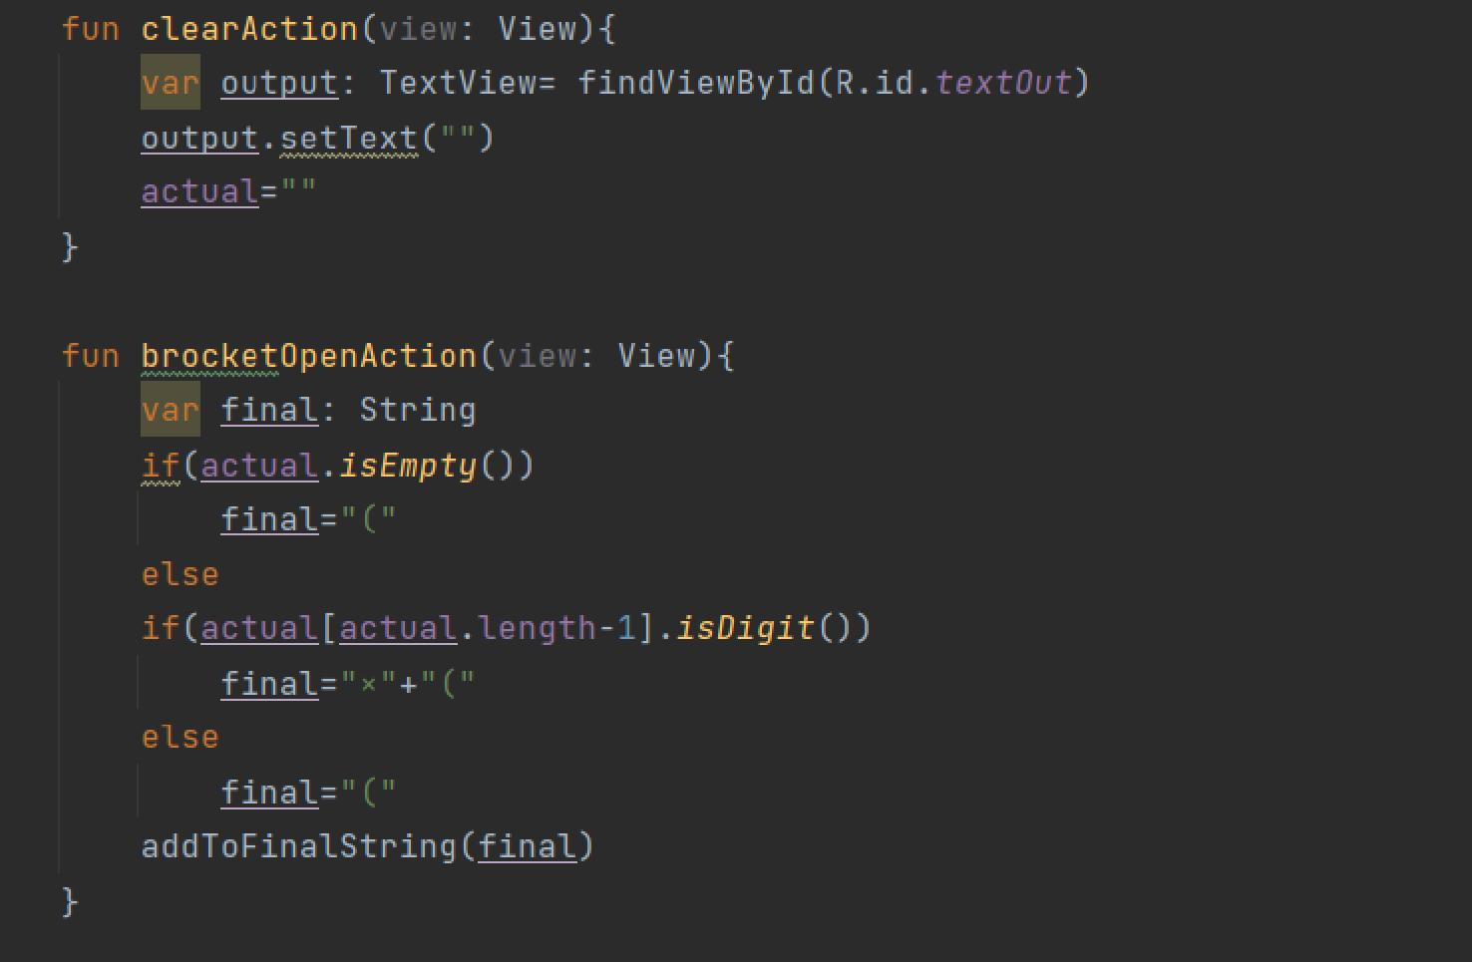

Figure 10: Clear and Bracket Open Action

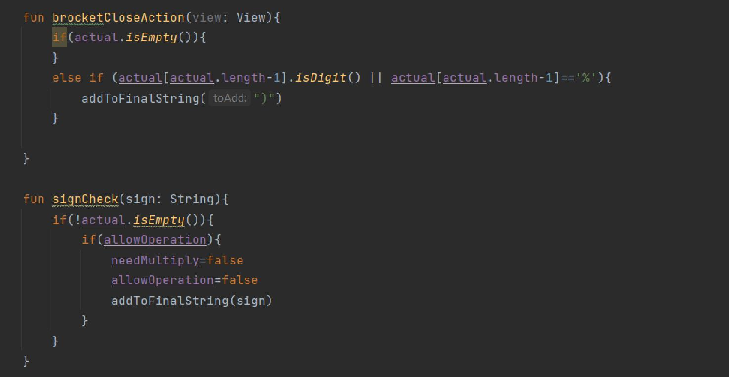

6

Figure 11: Bracket Close and sign Check Action

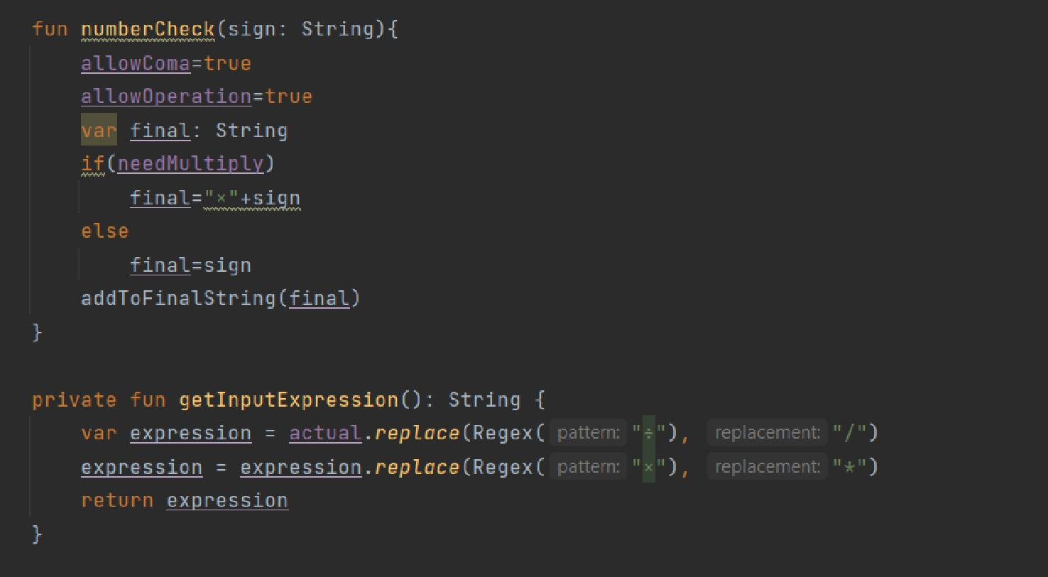

Figure 12: number check and get input

7

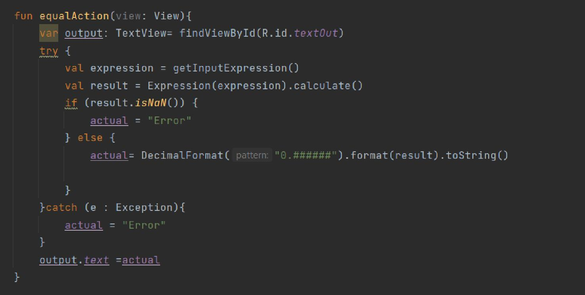

Figure 13: equal action

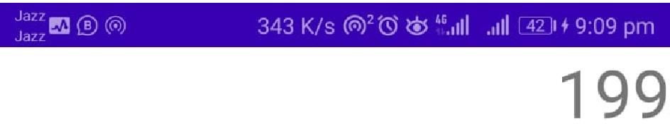

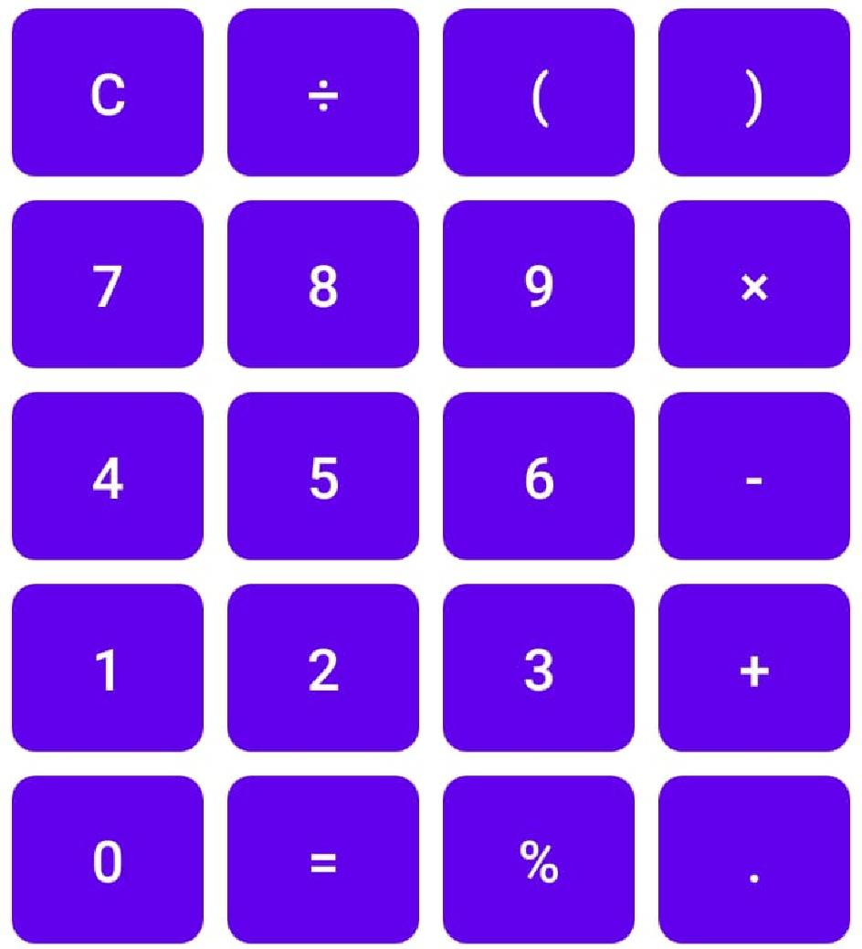



Figure 14: Output

8

4 Hangman

9

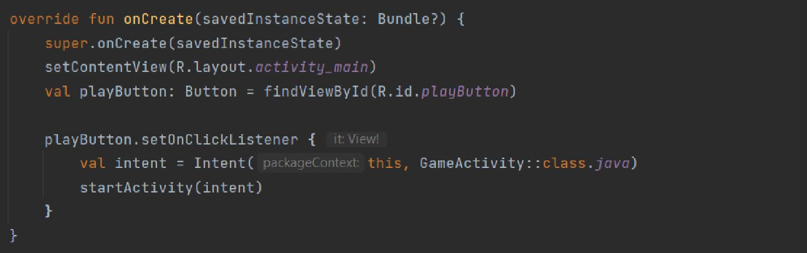

Figure 15: Main Activity

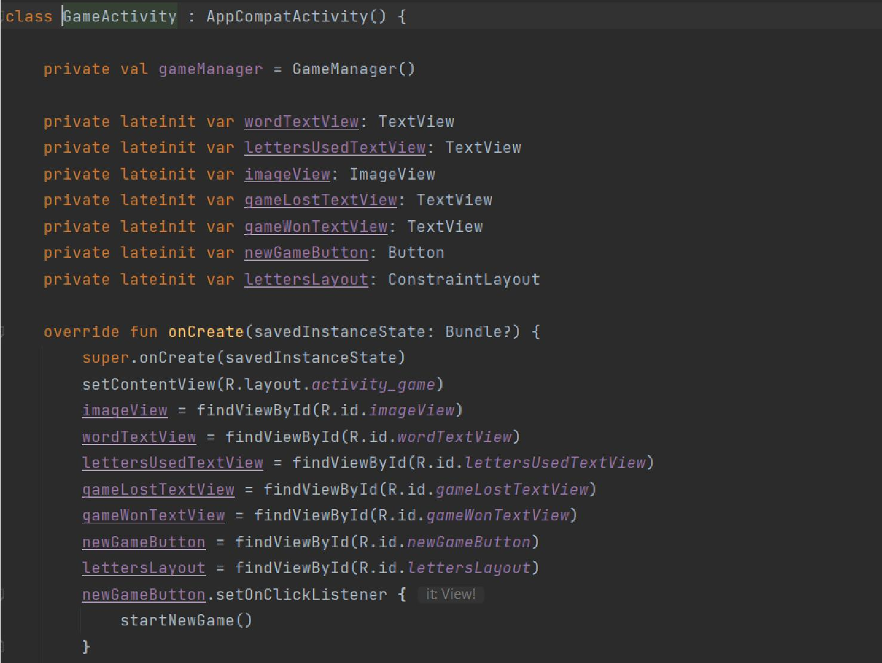

Figure 16: Game Activity

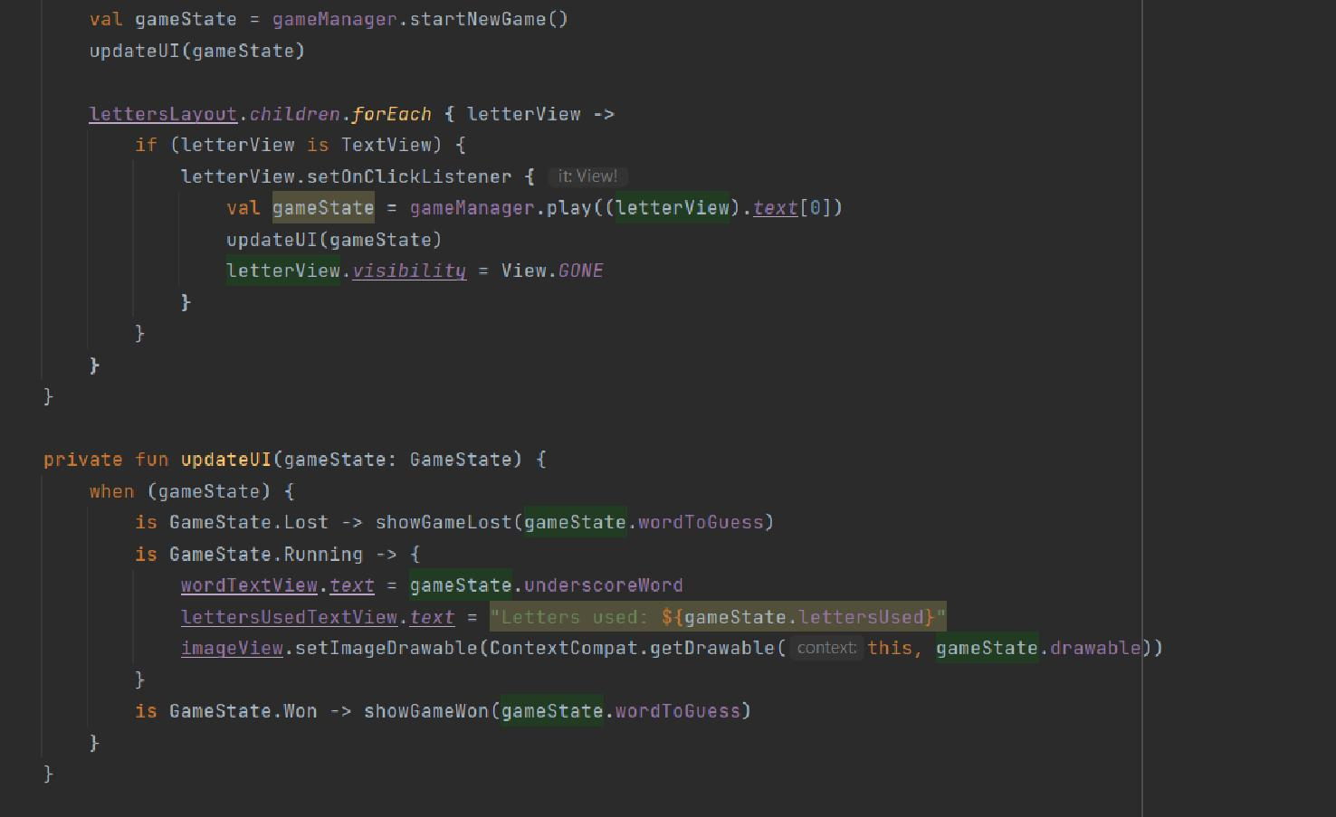

Figure 17: Update UI

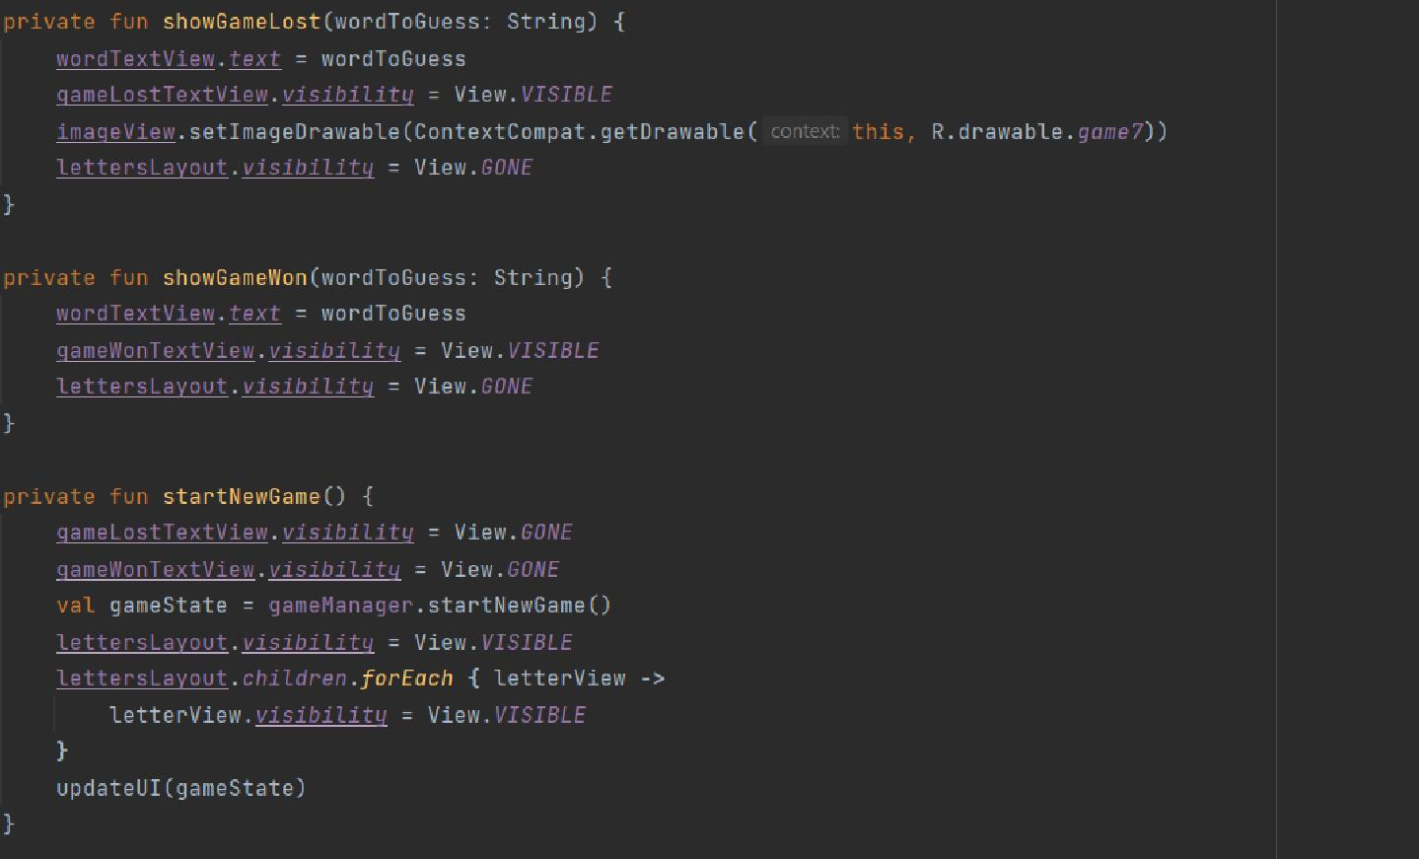

Figure 18: Show game Won/Lost and Start

10