Search for Radionuclide-Drug Conjugate Information for Particular Drug Entity in RDCdb
In the “RDC Search” section, users can search the full-text content of the RDCdb database to identify relevant RDC entries by entering keywords such as RDC drug names, target names, ligand names, linker names, radionuclide names, chelator names, and other related terms.
To perform a search, users simply enter a keyword in the main search box and submit the query. The search results page will display comprehensive information on all RDC drugs directly associated with the search term, including the RDC name, drug development stage, drug type, ligand name, linker name, chelator name, radionuclide name, and detailed links to the corresponding target information.

In order to facilitate a more customized input query, the wild characters of “?” are also supported.
(1) If search “[68Ga]Ga-C1-FAP-2286”, find a single API entry which is named “[68Ga]Ga-C1-FAP-2286”;
- If search “FAP-2286, finds a series entries with RDC names.
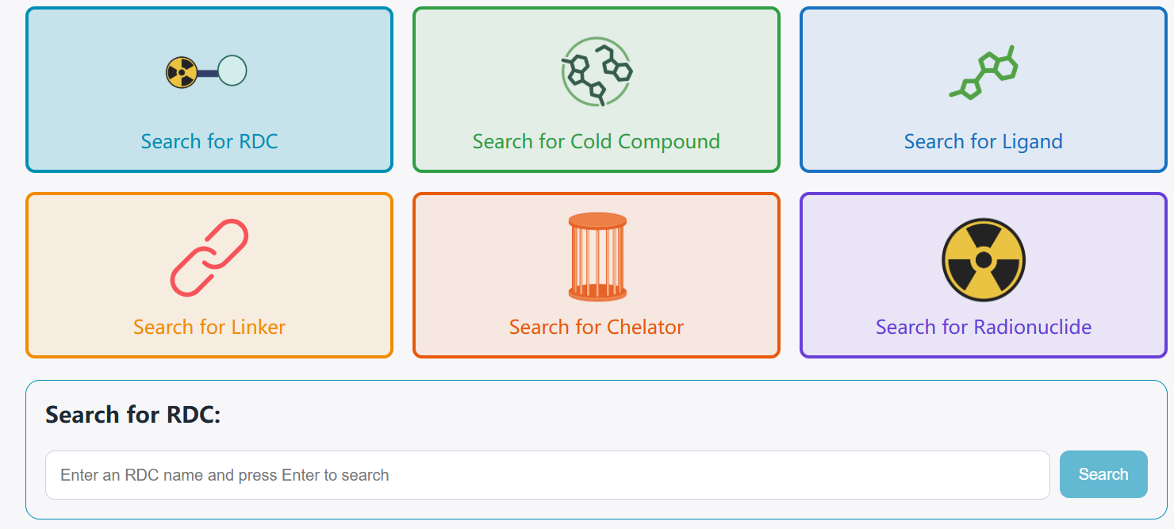
The search results for “[68Ga]Ga-C1-FAP-2286” display the Radionuclide-drug conjugate ID, RDC name, drug status, drug type, cold compound name, linker name, ligand name, chelator name, radionuclide name, and target name.
The “RDC Information” button redirects users to the RDC drug detail page for [68Ga]Ga-C1-FAP-2286. The “Cold Compound Information” button redirects users to the detail page of the unlabeled RDC drug. The “Ligand Information” button redirects users to the detail page for FAP-2286. The “Linker Information” button redirects users to the detail page for the linker(S)-2-amino-3-(((S)-1-(ethylamino)-1-oxo-3-sulfopropan-2-yl)amino)-3-oxopropane-1-sulfonic acid. The “Chelator Information” button redirects users to the detail page for DOTA. The “Radionuclide Information” button redirects users to the detail page for Gallium-68. The“Target information” button redirects users to the detail page for FAP.
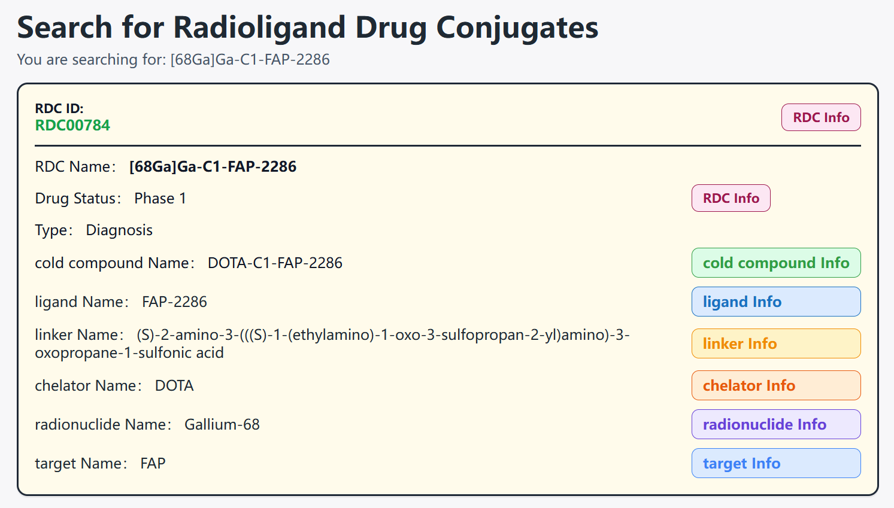

  - By clicking the “RDC Info” button, the detailed information page for RDC will be displayed
Using [68Ga]Ga-C1-FAP-2286 as an example, the “General Information of This RDC” section displays the General information of [68Ga]Ga-C1-FAP-2286, including RDC ID, drug name, synonyms, drug status, indications, chemical structure, mechanism of action, external links, and other relevant details. In addition, this section also presents General information related to [68Ga]Ga-C1-FAP-2286, including the cold compound name, ligand name, linker name, chelator name, radionuclide name, and radiochemistry information.
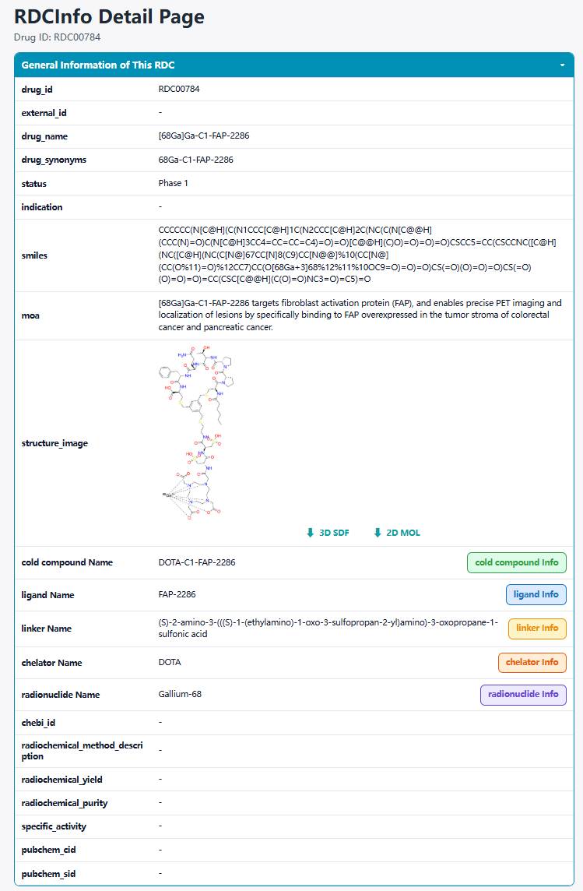
In the “Full List of Activity Data of This RDC” section, three types of activity data are provided: in vitro activity data, in vivo animal data, and human activity data.
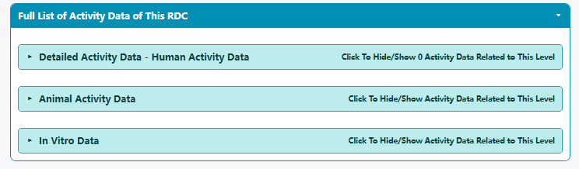
Under the “Detailed Activity Data - Human Activity Data” subsection, users can view information on indications, patient characteristics, efficacy data, and related descriptions.
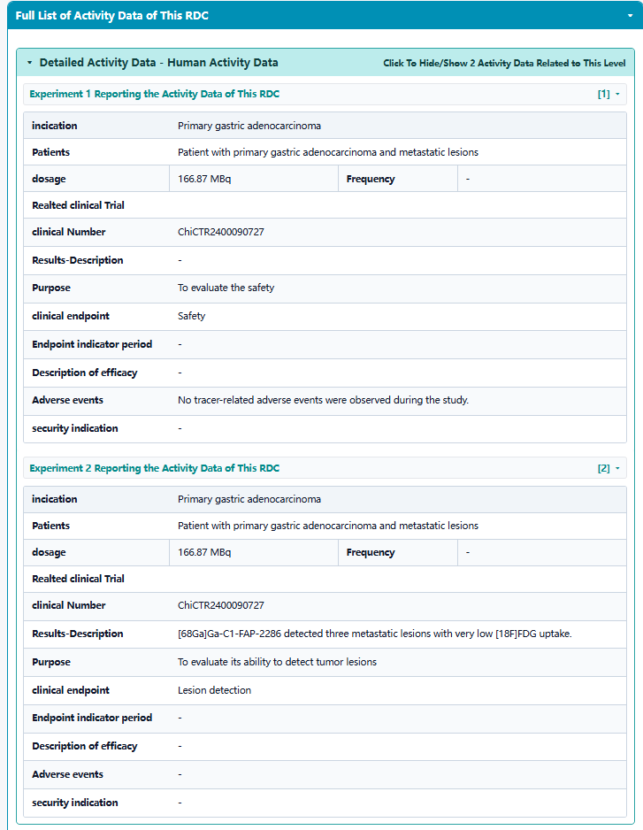
Under the “Animal Activity Data” subsection, imaging or ex vivo biodistribution data are presented, including animal models, cell models, metabolism and excretion information, tumor retention time, therapeutic efficacy, and visualized activity data. For key data, the T/B values are calculated and displayed in tabular format.
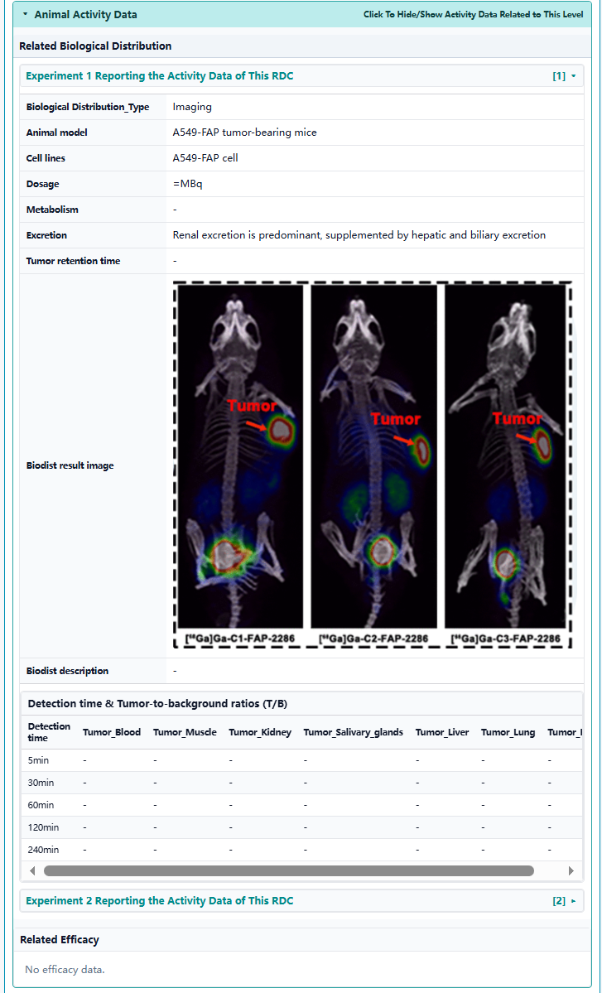The “in vitro data” section presents the lipophilicity coefficient, relevant binding affinity data, and related descriptions.
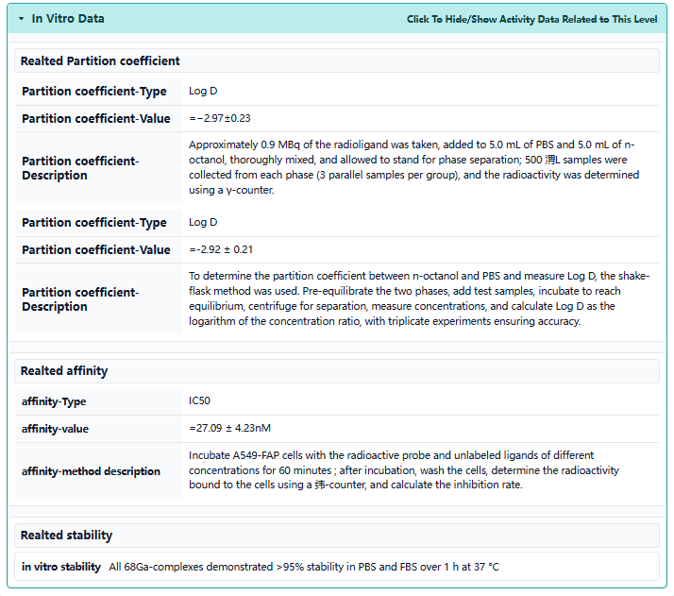
  - By clicking the “cold_compound Info” button, the detailed information page will be displayed.
Using [68Ga]Ga-C1-FAP-2286 as an example, the “General Cold Compound Information” section displays the General information of the cold compound, including its name, aliases, chemical structure information such as SMILES and formula, physicochemical properties (It should be noted that the physicochemical properties are calculated using the RDKit tool), and external links.
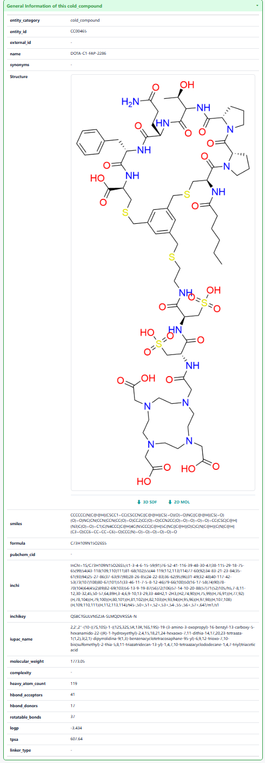
The “Related RDCs” section displays the radionuclide-conjugated drugs associated with this cold compound. Clicking each button will redirect users to the corresponding detail page for that RDC.
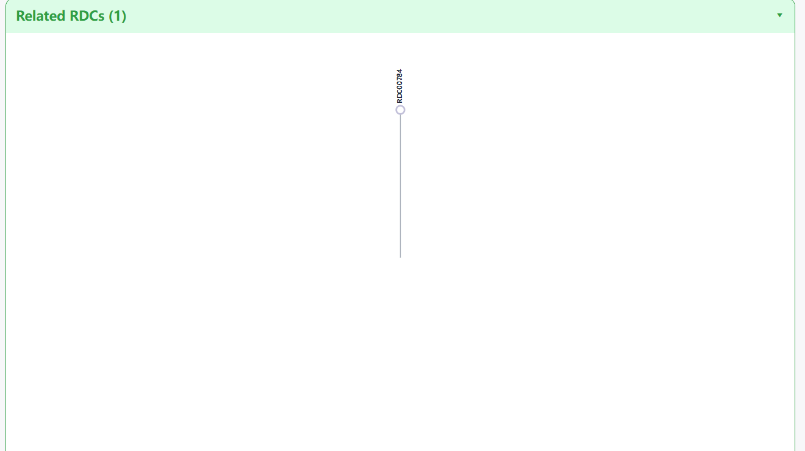
The “Full information of the Activity Data of RDC(s) Related to this cold compound” section systematically displays various RDCs associated with this cold compound. The list presents different radionuclide conjugates and their respective development stages. Users can view an overview of activity data at different levels for each radionuclide drug conjugate (RDC), or click the RDC information to quickly navigate to the corresponding activity detail page for that radionuclide drug conjugate (RDC).
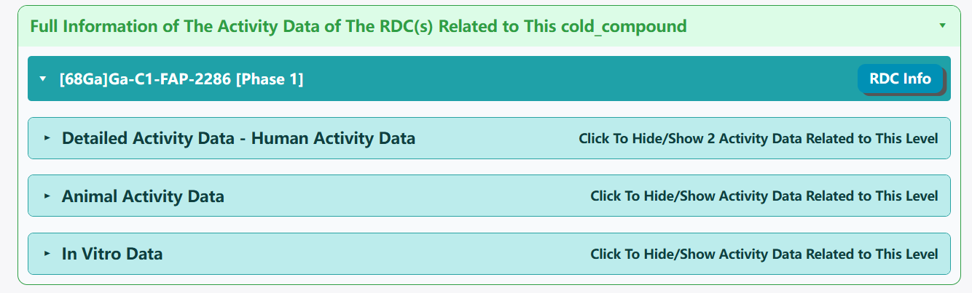
1.3 By clicking the “Ligand Info” button, the detailed ligand information page for will be displayed.
Using FAP-2286 as an example, the “General Information of this ligand” section displays the General information of the ligand, including the ligand ID, name, synonyms, external links, chemical structure, molecular formula, SMILES , formula, InChI identifier, InChIKey, IUPAC name, physicochemical properties, and ligand type. It should be noted that the physicochemical properties are calculated using the RDKit tool.
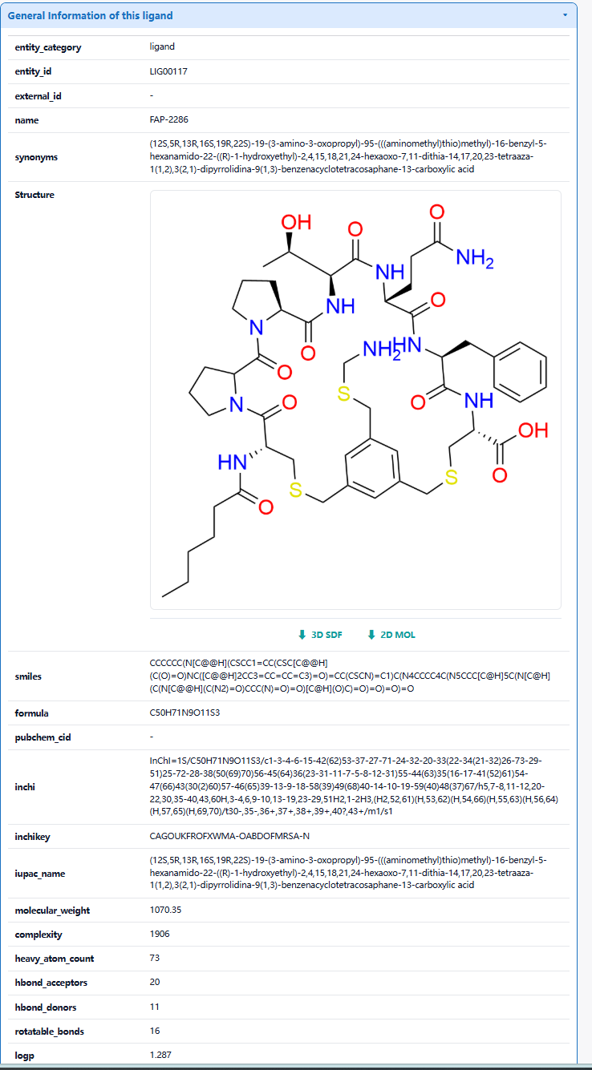
The “Related RDCs” section displays the radionuclide-conjugated drugs associated with thisligand. Clicking each button will redirect users to the corresponding detail page for that radionuclide drug conjugate (RDC).
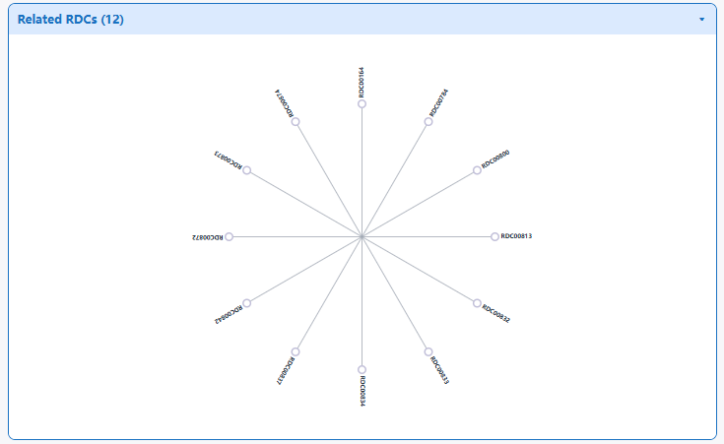
The “Complete List of RDCs related with This Ligand” section systematically displays the RDCs bound to this ligand. The list presents different types of RDCs with their structural component information. Users can browse the different RDCs as a whole or click the RDC information to quickly navigate to the corresponding RDC activity page.
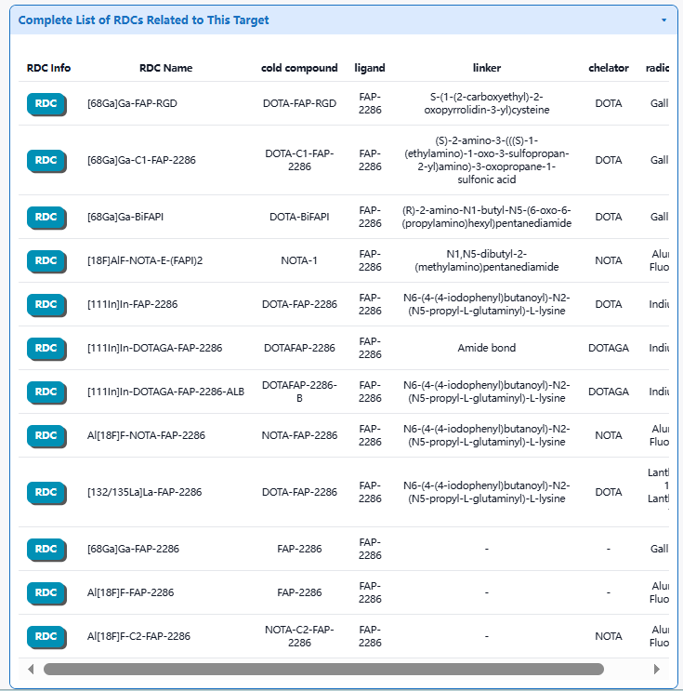

1.4 By clicking the “Linker Info” button, the detailed linker information page for will be displayed.
Using (S)-2-amino-3-(((S)-1-(ethylamino)-1-oxo-3-sulfopropan-2-yl)amino)-3-oxopropane-1-sulfonic acid as an example, the “General Linker Information” section displays the General information of the linker, including the linker ID, name, synonyms, external links, chemical structure, molecular formula, SMILES notation, formula, InChI, InChIKey, IUPAC name, physicochemical properties, and ligand type. It should be noted that the physicochemical properties are calculated using the RDKit tool.
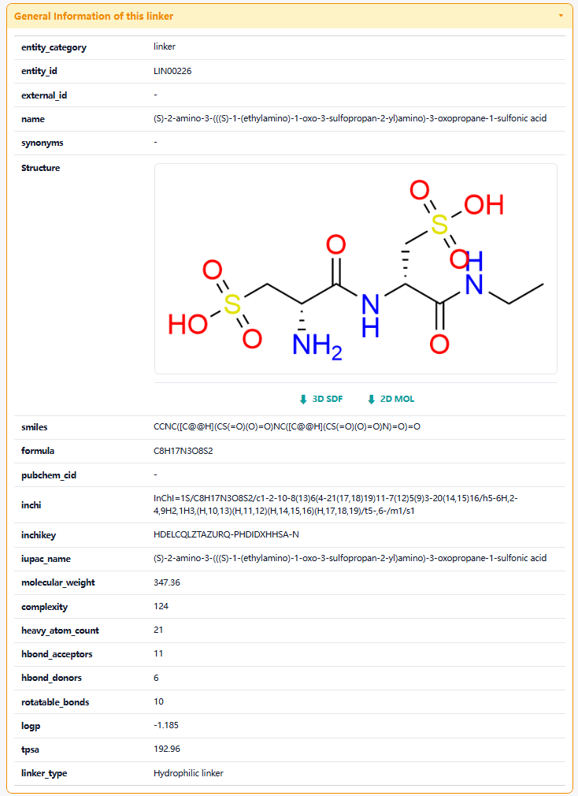
The “Related RDCs” section displays the radionuclide conjugate drugs paired with this linker. Users can click each button to navigate to the corresponding activity page for that radionuclide conjugate drug.
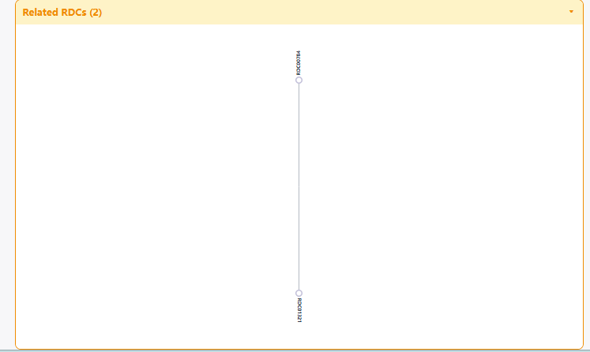
The “Full information of The Activity Data of The RDCs Related to this linker” section systematically displays various radionuclide conjugates (RDCs) associated with this linker. The list presents different radionuclide drug conjugates (RDCs) and their respective development stages. Users can view an overview of activity data at different levels for each radionuclide drug conjugates (RDCs), or click the RDC information to quickly navigate to the corresponding activity detail page for that radionuclide conjugate (RDC).
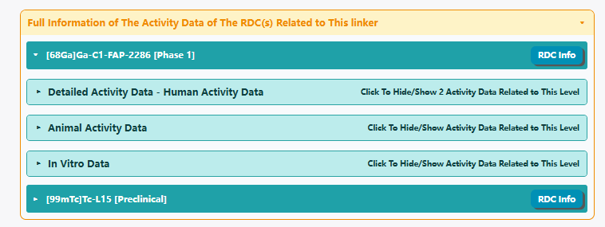
1.5 By clicking the “Chelator Info” button, the detailed Chelator information page for will be displayed.
Using DOTA as an example, the “General Information of This Chelator” section presents the General information of the chelator, including its chelator ID, name, synonyms, external links, chemical structure, molecular formula, SMILES notation, InChI , InChIKey, IUPAC name, physicochemical properties, and ligand type. Please note that the physicochemical properties are calculated using the RDKit tool.
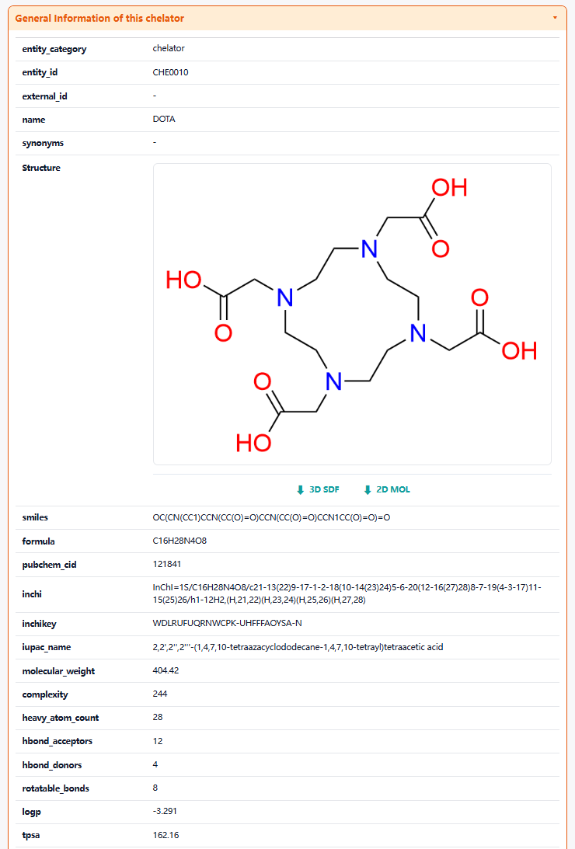
The “Each Radionuclide Conjugate Related to This Chelator” section displays the radionuclide drug conjugates (RDCs) associated with this chelator. Clicking each button will redirect users to the corresponding detail page for that radionuclide drug conjugate (RDC).
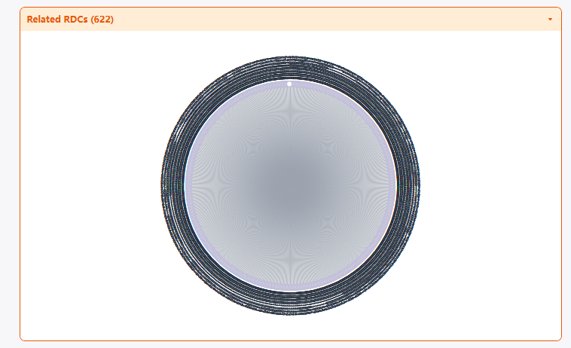
1.6 By clicking the “Radionuclide Info” button, the detailed Radionuclide information page for will be displayed.
Using Gallium-68 as an example, the “General Information of This Radionuclide” section presents the General information of the Radionuclide, including its Radionuclide ID, name, synonyms, Radionuclide_half_life, Radionuclide-emission, Radionuclide_energy .
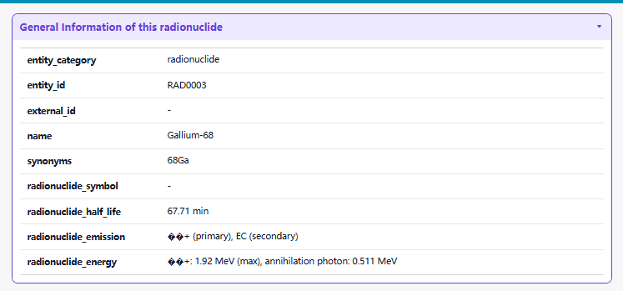
The “Related RDCs” section displays the radionuclide drug conjugates (RDCs) associated with this radionuclide. Clicking each button will redirect users to the corresponding detail page for that radionuclide drug conjugated (RDC).
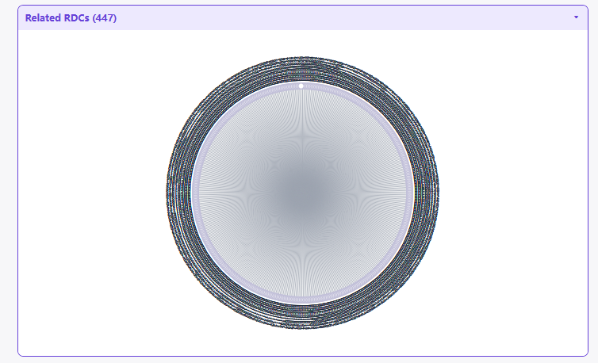
1.7 By clicking the “Target Info” button, the detailed Target information page for will be displayed.
Using FAP as an example, the “General Information of This Target” section presents the General information of the Target, including its Target ID, name, external_ID, related-description.
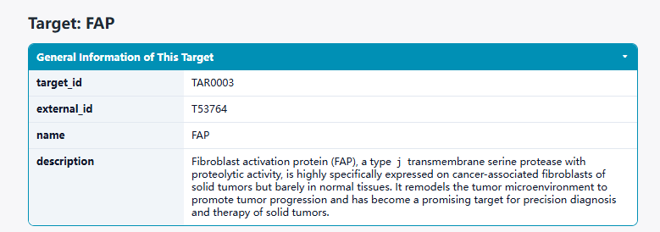
The “Each Radionuclide Conjugate Related to This target” section displays the radionuclide drug conjugates (RDCs) associated with this Target. Clicking each button will redirect users to the corresponding detail page for that radionuclide drug conjugate (RDC).

