Search for Ligand Information for Particular Ligand Entity in RDCdb
In the "RDC Search" section, users can search the full-text content of the RDCdb database to identify relevant RDC entries by entering keywords such as RDC drug names, target names, ligand names, linker names, radionuclide names, chelator names, and other related terms.
To perform a search, users simply enter a keyword in the main search box and submit the query. The search results page will display comprehensive information on all RDC drugs directly associated with the search term, including the RDC name, drug development stage, drug type, ligand name, linker name, chelator name, radionuclide name, and detailed links to the corresponding target information.
In order to facilitate a more customized input query, the wild characters of "?" are also supported.
(1) If search "FAPI-04", find a single API entry which is named "FAPI-04";
(2)If search "FAPI", finds a series entries with Ligand names.
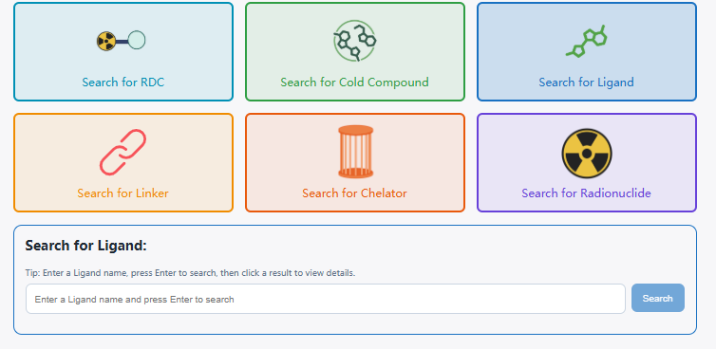
The search results for "FAPI-04" display the Ligand ID, name, synonyms, structure chemical structure, mechanism of action, external links, and other relevant details.

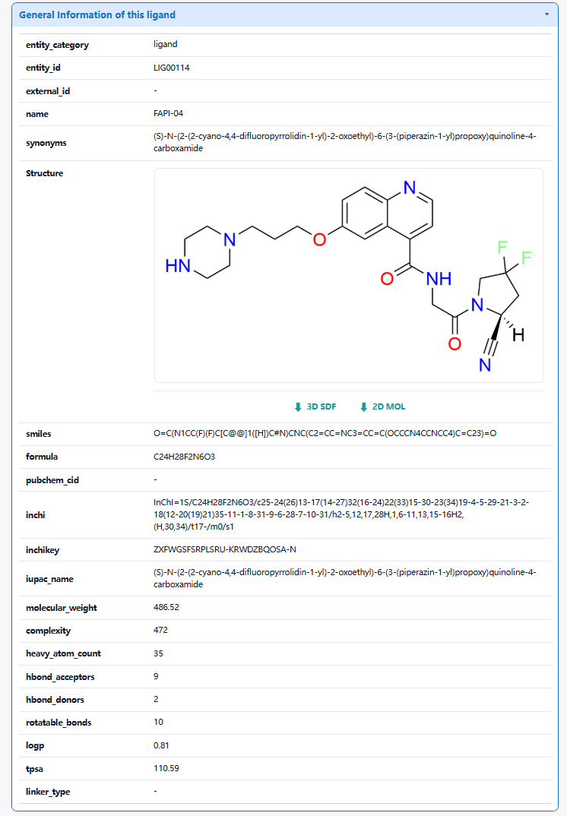
The "Related RDCs"section is about Each Radionuclide Conjugate Related to This Ligand, which displays theradionuclide drug conjugates (RDCs) associated with this Ligand. Clicking each button will redirect users to the corresponding detail page for that radionuclide drug conjugate (RDC).

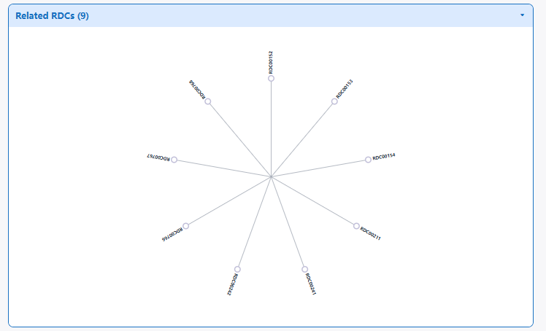
The "Complete List of RDCs Associated with This Ligand" section systematically displays the RDCs bound to this ligand. The list presents different types of RDCs along with their structural component information. Users can browse the different RDCs as a whole or click the RDC information to quickly navigate to the corresponding RDC activity page.
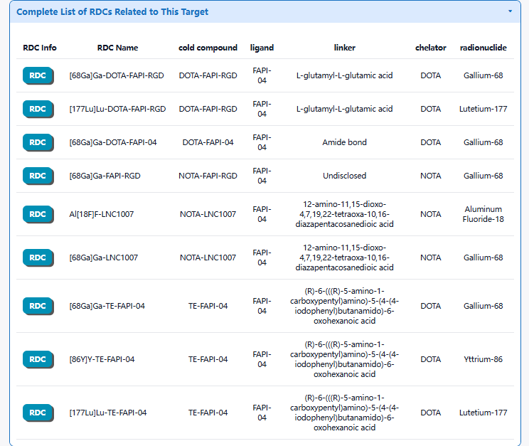
3.1 By clicking the "RDC Info" button, the detailed information page for particular RDC will be displayed
Using [177Lu]Lu-TE-FAPI-04 as an example, the "General Information of This RDC" section displays the General information of [177Lu]Lu-TE-FAPI-04, including its ID, drug name, aliases, drug status, indications, chemical structure, mechanism of action, external links, and other relevant details. In addition, this section also presents General information related to [177Lu]Lu-TE-FAPI-04, including the cold compound name, ligand name, linker name, chelator name, radionuclide name, and radiochemistry information.
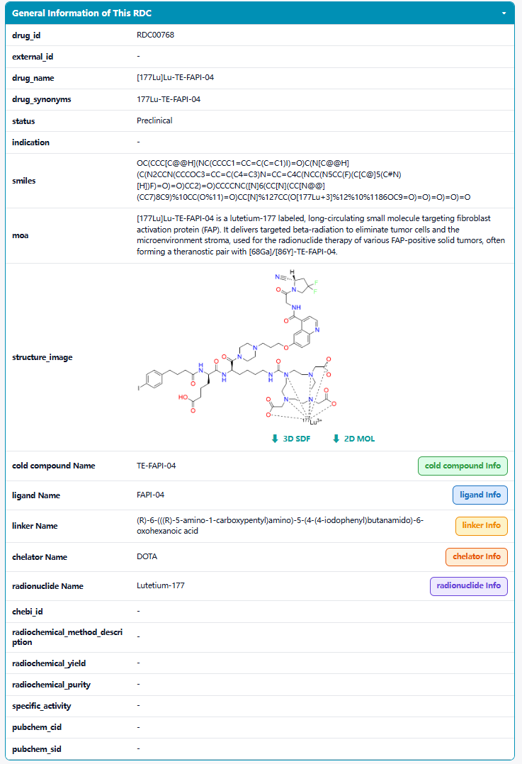

In the "Full List of Activity Data of This RDC" section, three types of activity data are provided: in vitro activity data, in vivo animal data, and human activity data. Under the each subsection, users can view information.
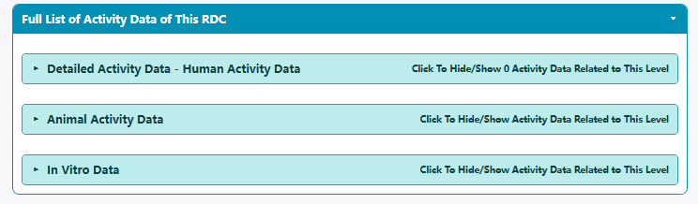

3.2 By clicking the "cold_compound Info" button, the detailed information page will be displayed.
Using FAPI-04 as an example, the "General Cold Compound Information" section displays the General information of the cold compound, including its name, aliases, chemical structure information such as SMILES and formula, physicochemical properties, and external links.
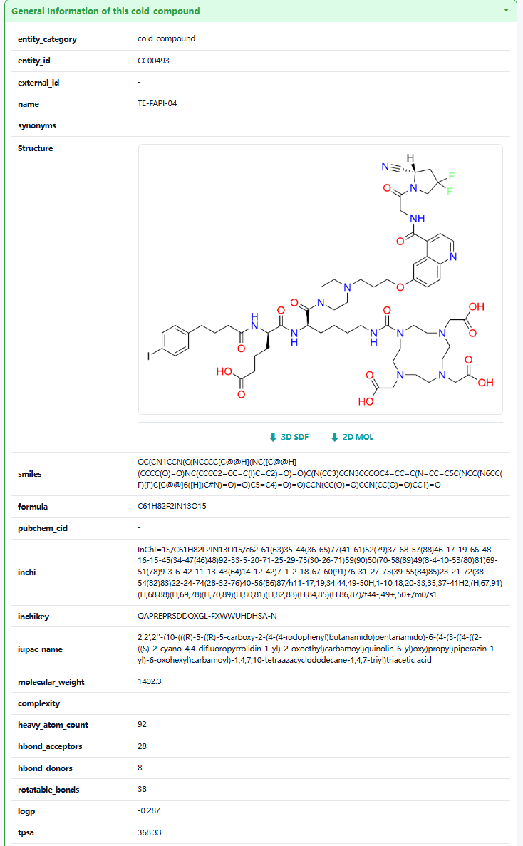
The "Full Information of The Activity Data of The RDC(s) Related to This cold_compound" section systematically displays various radionuclide drug conjugates (RDCs) associated with this cold compound. The list presents differen tradionuclide drug conjugates (RDCs) and their respective development stages. Users can view an overview of activity data at different levels for each radionuclide drug conjugate (RDC), or click the RDC information to quickly navigate to the corresponding activity detail page for that radionuclide drug conjugate (RDC).
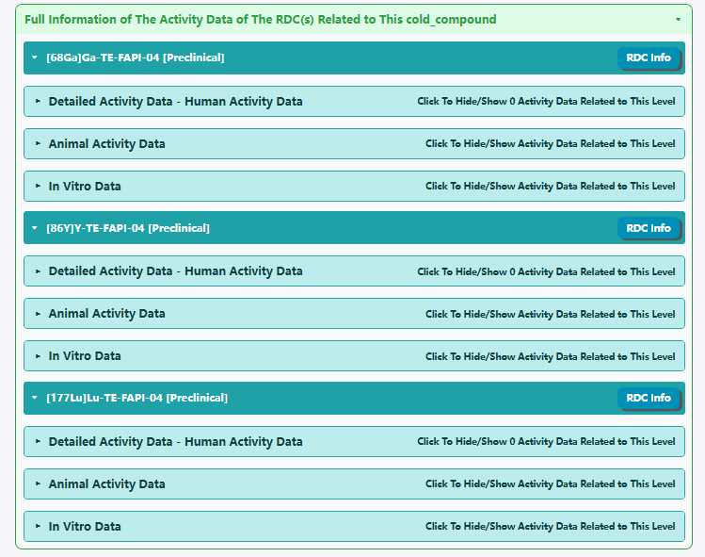
The "Related RDCs" section is about Each Radionuclide Conjugate Related to This cold compound, which displays the radionuclide drug conjugates (RDCs) associated with this cold compound. Clicking each button will redirect users to the corresponding detail page for that radionuclide drug conjugate (RDC).
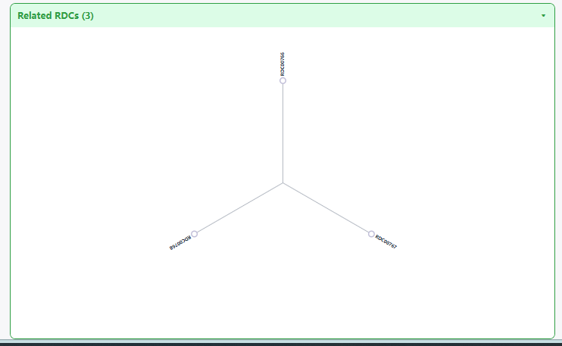
3.3 By clicking the "Ligand Info" button, the detailed information page will be displayed.
Using FAPI-04 as an example, the "General Ligand Information" section displays the General information of the ligand, including the ligand ID, name, synonyms, external links, chemical structure, molecular formula, SMILES notation, formula, InChI, InChIKey, IUPAC name, physicochemical properties, and ligand type. It should be noted that the physicochemical properties are calculated using the RDKit tool.
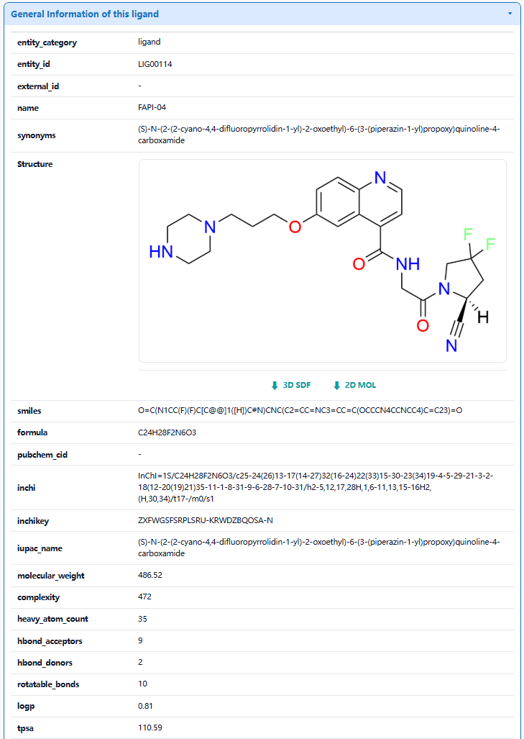
The "Related RDCs" section is about Each Radionuclide Conjugate Related to This ligand, which displays the radionuclide drug conjugates (RDCs) associated with this ligand. Clicking each button will redirect users to the corresponding detail page for that radionuclide drug conjugate (RDC).

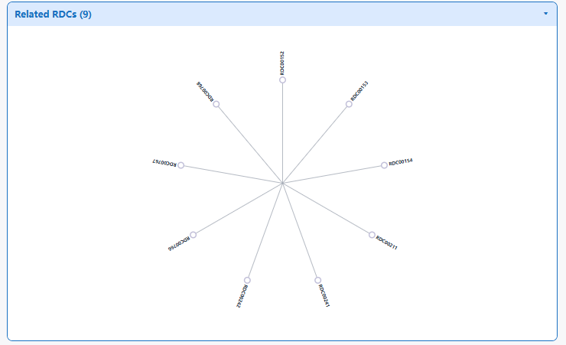
The "Complete List of RDCs Associated with This Ligand" section systematically displays the RDCs bound to this ligand. The list presents different types of RDCs along with their structural component information. Users can browse the different RDCs as a whole or click the RDC information to quickly navigate to the corresponding RDC activity page.

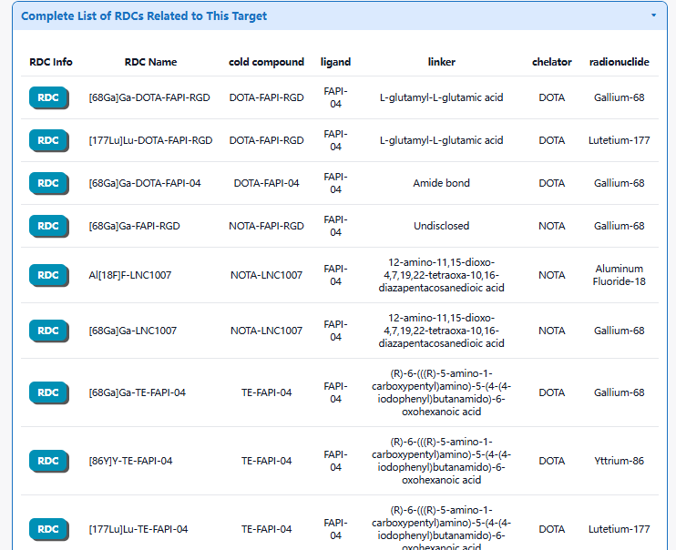
3.4 By clicking the "Linker Info" button, the detailed linker information page for will be displayed.
Using LIN00247 as an example, the "General Ligand Information" section displays the General information of the ligand, including the ligand ID, name, synonyms, external links, chemical structure, molecular formula, SMILES notation, formula, InChI identifier, InChIKey, IUPAC name, physicochemical properties, and ligand type. It should be noted that the physicochemical properties are calculated using the RDKit tool.

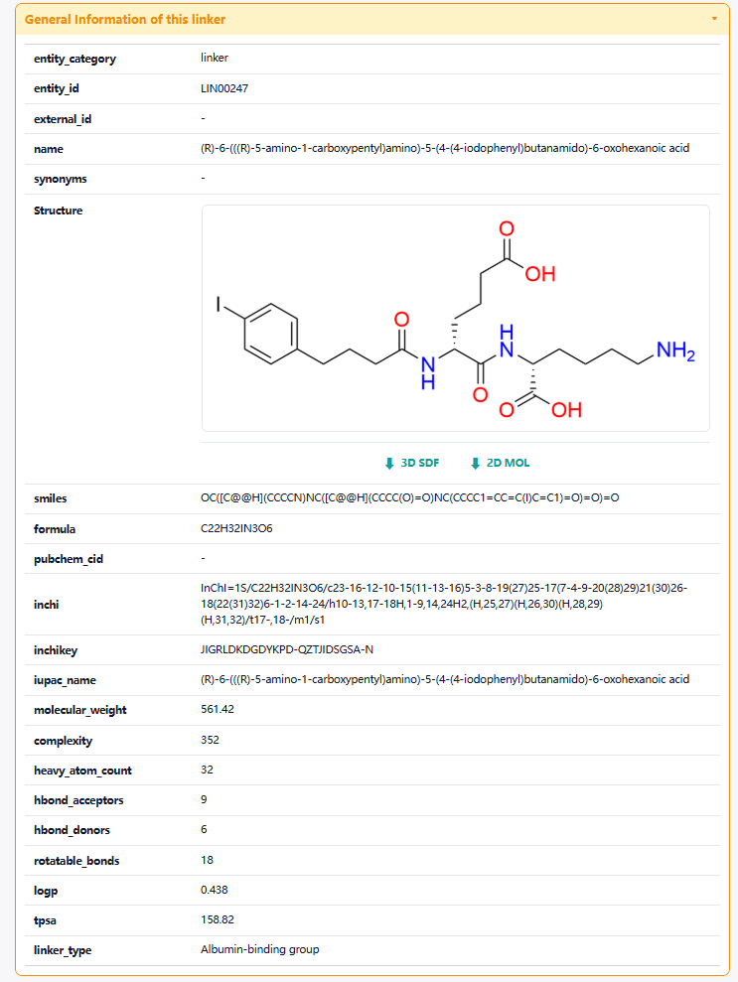

The "Full Information of the Activity Data of the RDC(s) Related to This Linker" section systematically displays various radionuclide conjugates (RDCs) associated with this linker. The list presents different radionuclide drug conjugates (RDCs) and their respective development stages. Users can view an overview of activity data at different levels for each radionuclide drug conjugate (RDC), or click the RDC information to quickly navigate to the corresponding activity detail page for that radionuclide drug conjugate (RDC).
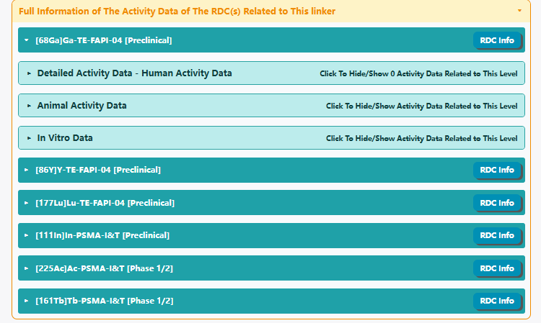
The "Related RDCs" section is about Each Radionuclide Conjugate Drug Associated with This Linker, which displays the radionuclide drug conjugates (RDCs) paired with this linker. Users can click each button to navigate to the corresponding activity page for that radionuclide drug conjugate (RDC).
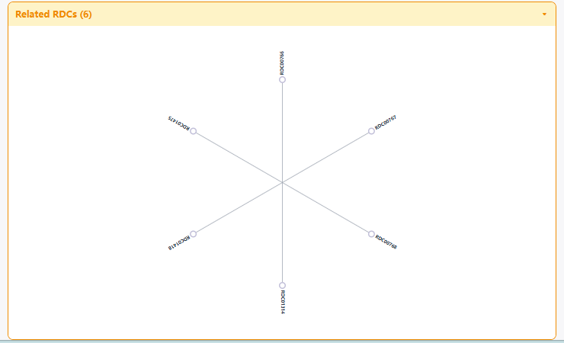
3.5 By clicking the "Chelator Info" button, the detailed Chelator information page for will be displayed.
Using DOTA as an example, the "General Information of This Chelator" section presents the General information of the chelator, including its chelator ID, name, synonyms, external links, chemical structure, molecular formula, SMILES notation, InChI , InChIKey, IUPAC name, physicochemical properties, and ligand type. Please note that the physicochemical properties are calculated using the RDKit tool.
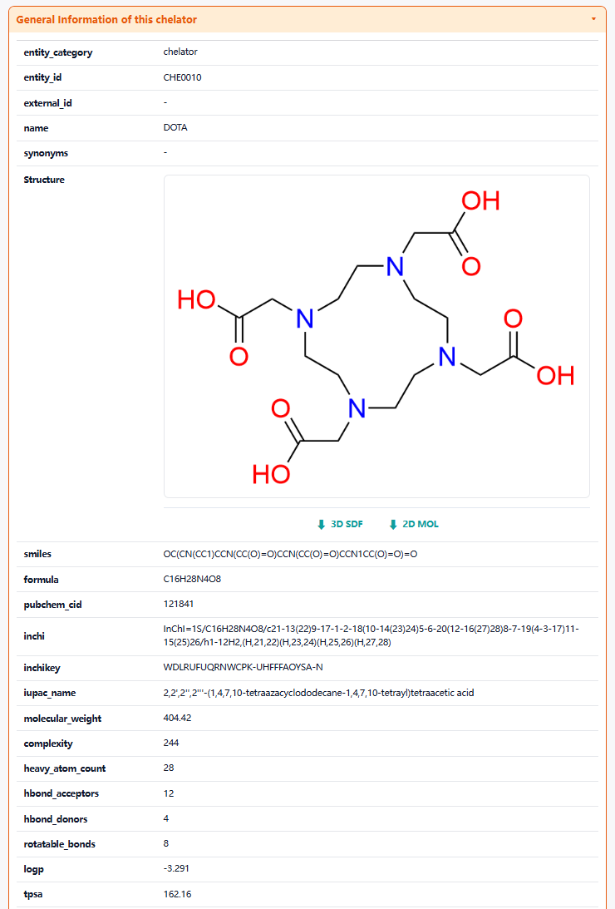
The "related RDCs" section is about Each Radionuclide Conjugate Related to This Chelator, which displays the radionuclide drug conjugates (RDCs) associated with this chelator. Clicking each button will redirect users to the corresponding detail page for that radionuclide drug conjugate (RDC).
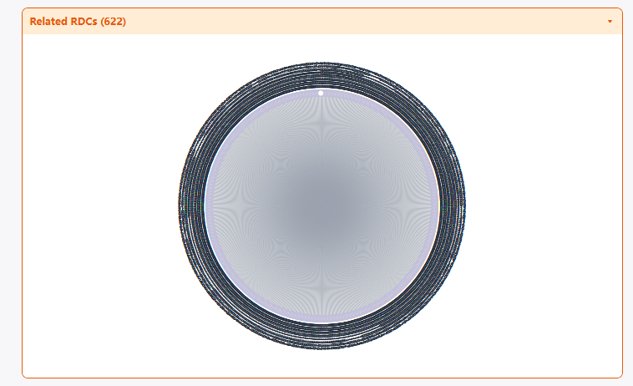

3.6 By clicking the "Radionuclide Info" button, the detailed Radionuclide information page for will be displayed.
Using Gallium-68 as an example, the "General Information of This Radionuclide" section presents the General information of the Radionuclide, including its Radionuclide ID, name, synonyms, Radionuclide_half_life, Radionuclide-emission, Radionuclide_energy .
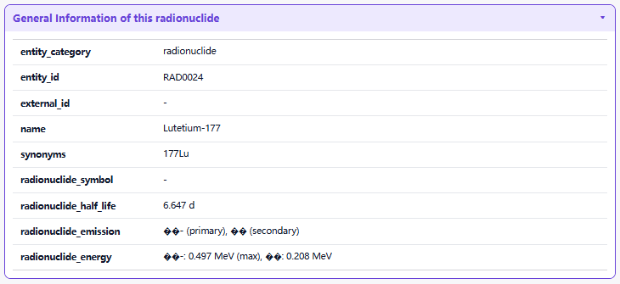
The "Related RDCs" section is about Each Radionuclide Conjugate Related to This Radionuclide, which displays the radionuclide drug conjugates (RDCs) associated with this Radionuclide. Clicking each button will redirect users to the corresponding detail page for that radionuclide drug conjugate (RDC).
