Search for Chelator Information for Particular chelator Entity in RDCdb
n the “RDC Search” section, users can search the full-text content of the RDCdb database to identify relevant RDC entries by entering keywords such as RDC drug names, target names, ligand names, linker names, radionuclide names, chelator names, and other related terms.
To perform a search, users simply enter a keyword in the main search box and submit the query. The search results page will display comprehensive information on all RDC drugs directly associated with the search term, including the RDC name, drug development stage, drug type, ligand name, linker name, chelator name, radionuclide name, and detailed links to the corresponding target information.
In order to facilitate a more customized input query, the wild characters of "?" are also supported.
(1) If search "DOTA-MAL", find a single API entry which is named "DOTA-MAL";
(2)If search "DOTA", finds a series entries with chelator names.
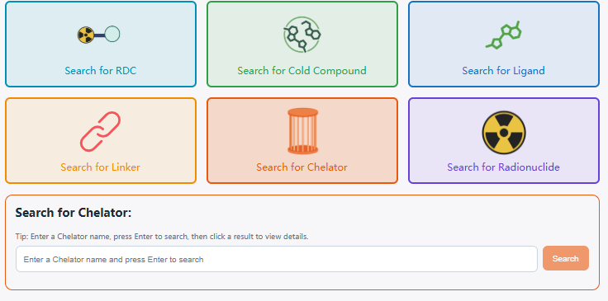
Using DOTA as an example, the “General Information of This Chelator” section presents the basic information of the chelator, including its chelator ID, name, synonyms, external links, chemical structure, molecular formula, SMILES, InChI, InChIKey, IUPAC name, physicochemical properties, and ligand type. Please note that the physicochemical properties are calculated using the RDKit tool.
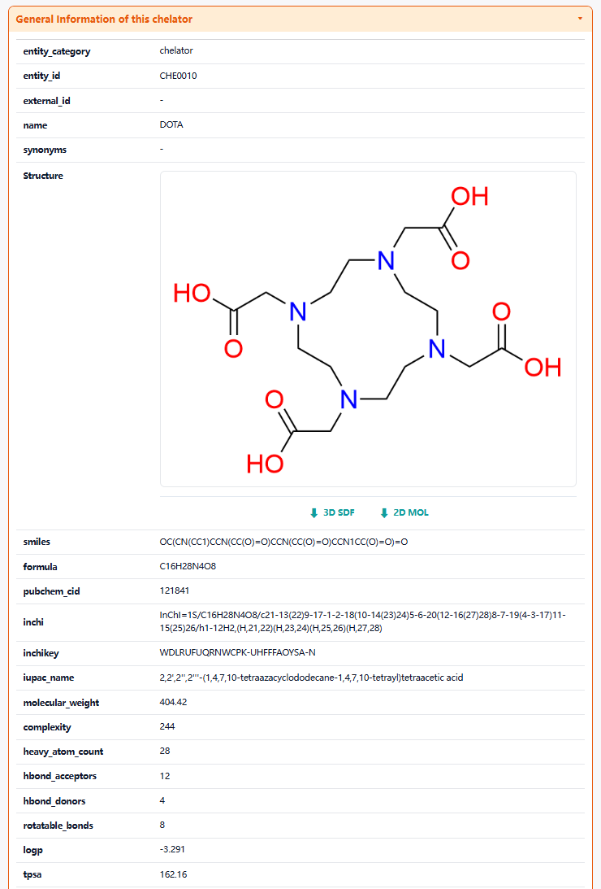
The "Related RDCs" section is about Each Radionuclide Conjugate Related to This Chelator, which displays the radionuclide drug conjugates (RDCs) associated with this chelator. Clicking each button will redirect users to the corresponding detail page for that radionuclide drug conjugate (RDC).
